

**INDUSTRIAL VISIT – COOL CODE**

**SEMESTER 1 2017/2018**

**TECHNOLOGY AND INFORMATION SYSYTEM**

**(SCSP1513-09)**

**LECTURE DR. ARYATI BINTI BAKRI**

**GROUP ASSIGNMENT:**

**LEE CHEN HONG (A18CS0094)**

**MUHAMMAD ALIFF SOLAHUDDIN BIN NORDIN (A18CS0124)**

**NUR ASNANI BINTI HASSAN (A18CS0186)**

**Table of Contents**

1. INTRODUCTION 3

2. DETAILS OF JOURNEY 4

3. DETAILED DESCRIPTION 5

3.1 ORGANIZATION STRUCTURE OF COOL CODE 5

3.2 SERVICES 6

3.3 PRODUCTS 6

3.4 ACHIEVEMENT 8

3.5 INFORMATION SYSTEMS THAT HAVE BEEN DEVELOPED 9

4. REFLECTION 10

5. BIBLIOGRAPHY 11

# INTRODUCTION

An industrial visit report had made for a visit to the Cool Code on 15 November 2018. Cool Code Sdn Bhd is a registered company which is also known as Sejuk Studio. The Cool Code are active in arena of IT development with trending technology. Cool Code is located at 55-2 Jalan Setia Tropika 1/18, Setia Tropika, 81200 Johor. Cool Code is a software development company that focused on web, mobile application, mobile games and interactive content development The founder of Cool Code is Arif Tukiman which has experienced as Chief Executive Officer with a demonstrated history of working in the information technology and services industry. The Cool Code was established in 2014 with a symmetrical size that can accommodate 15 workers. Cool Code Sdn. Bhd. is one of a cool team of passionate that give suggestion great solution and products to their customer and they also will ease our problem away. Plus, Cool Code also worked with government agencies includes Ministry of Higher Education, private companies and constitution.

The vision of Cool Code are provides the coolest products and services and represent Malaysia as most popular and trusted mobile application developer. The mission of Cool Code are want to be a great multinational company in developing great game and mobile application, to provide the best innovative products, and to be a reliable and responsive in ICT business partners.

There are specific fields of IT that the company specialized in and they are mobile application development, game development, web system development, web design & portal development, interactive contents and training course & consultation. Firstly, mobile application development which serious native development on mobile platform such as Android and iOS but also do hybrid development for multi-platform deployment platform includes Windows phone. Second, game development which focus on educational and casual games. Thirdly, web system development which do implement latest and up-to-date framework technology. Fortly,is web design & portal development which they expert in most CMS (content Management System) based development such as WordPress and Joomla. E-commerce such as Magento and OpenCart are also included. Fifthly, is interactive contents which include interactive eBook with EPUB3 format and also works with Augmented Reality. Lastly, is training course & consultation which provide various training courses for mobile application and system development under Cool Code Academy.



Figure 1 Cool Code Logo

# DETAILS OF JOURNEY

The journey was held at Setia Tropika, Johor Bharu on 15th November which is starts from 2:00 p.m until 5:30 p.m. Student who taking course Technology and Information System must attend to this visits. In the beginning of the program, a talk was given by the CEO of Cool Code, Mr Arif Tukiman. During the talk, Mr Arif talks about the history before the Cool Code were founded.

Then, Mr Arif give students opportunity to play games on a tablet. The games were created by Cool Code team. After that, Students also can meet with other team in cool code. Students can see how the games were created in various process such as programming, rendering and many more. Then, all students, lecturer and Cool Code team take a photograph session.

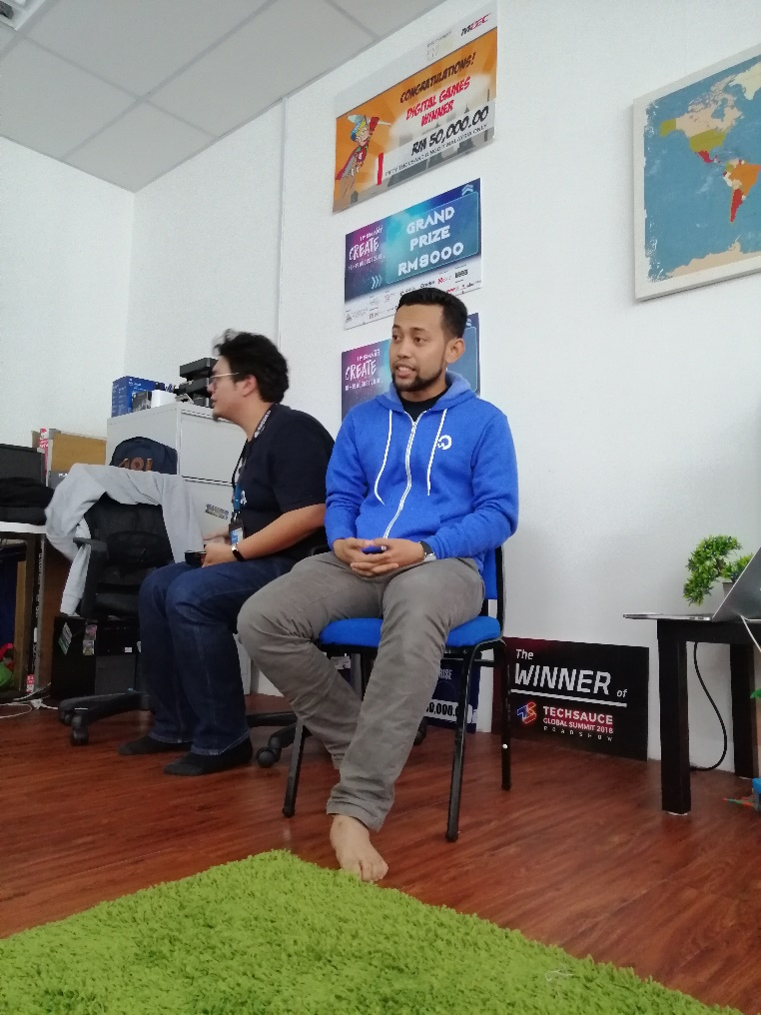

Figure 2 CEO Cool Code give talk to students SCSV

# DETAILED DESCRIPTION

## ORGANIZATION STRUCTURE OF COOL CODE

The head of all the operations in Cool Code is the CEO (Chief Executive Officer). The CEO of Cool Code is Arif Tukiman . Another professional workers from Cool Code are Ahmad Fikrizaman as Chief Technology Officer (CTO) while Amir Fazwan is Chief Operating Oficcer (COO). Next, Muhammad Ridzwan is one of workers in Cool Code which has position as Project Executive while Muhamad Ariff Aizat as a Business Development Executive.

Other than that, Muhammad Hafizuddin has position of Creative Content Developer in Cool Code and Sharif Tariq as Senior Game Developer. Position under Sharif Tariq is Mohd Alwi as junior game developer. Next , in part Web System Developer ,Cool Code has Muhammad Kamarool as senior Web System Developer while Muhammad Nazrin and Muhammad Asyraf as junior Web System Developer. Other member including Muhammad Haqqi as Digital Marketing Executive, Badrul Hisyam as Account and Finance and Nadia as Sales Executive.

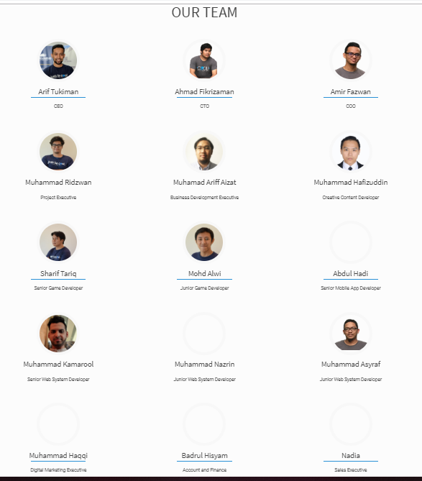

Figure 3 organization of Cool Code

## 3.2 SERVICES

The service Cool Code have provide is in the development of mobile applications, web systems and mobile games. For all the service of the Cool Code they have their goal hope to be achieved. The goal of mobile APP development of Cool Code is to prioritise user experience to enhance and ensure user satisfaction. The goal of web system development is to emphasize on speed and security in system development. The goal of mobile game development is to ensure every single game gives a meaningful experience for player

## PRODUCTS

Cool Code has produced many well-known products even though their company is new-four-year operated. This is because they love to help community and give education value through games and interactive way. One of their products is Didi & Friends Playtown which has one million downloaded. Didi & Friends Playtown is a combination of 12 games based on the popular Didi & Friends children songs. Each song has an interesting game concept and a different approach. This game has made by Cool Code and collaboration with DD Animation Studio and Astro Malaysia Holdings Berhad.

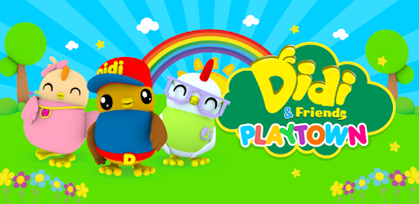

Figure 4 Didi & Friends Playtown

Other than that, they have Rainbow Jawi which has variety of activities for children to learn basic Jawi interactively and fun. This application already has 10,000+ users who have downloaded the game. In this game, there are two main modules, namely module and game modules. Both of these modules covering various aspects of Jawi learn where to start children are given the opportunity to Jawi, write, recognize limbs and animals and many more.

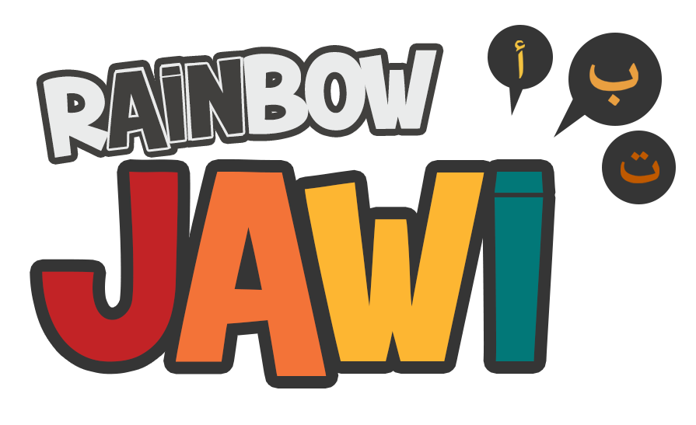

Figure 5 Rainbow Jawi

Next, Cool Code also produced Rainbow IQRA’ which can helps who want learning IQRA’ through Adventure-educational game with interactive and games puzzle (Iqra’ 1- 6). Iqra is a quick method to learn Quran and widely used within the South East Asia region. It consist of phonic method to construct words and pronunciation to learn Quran reading in a short time. This application has 1000+ users that have been downloaded this game.

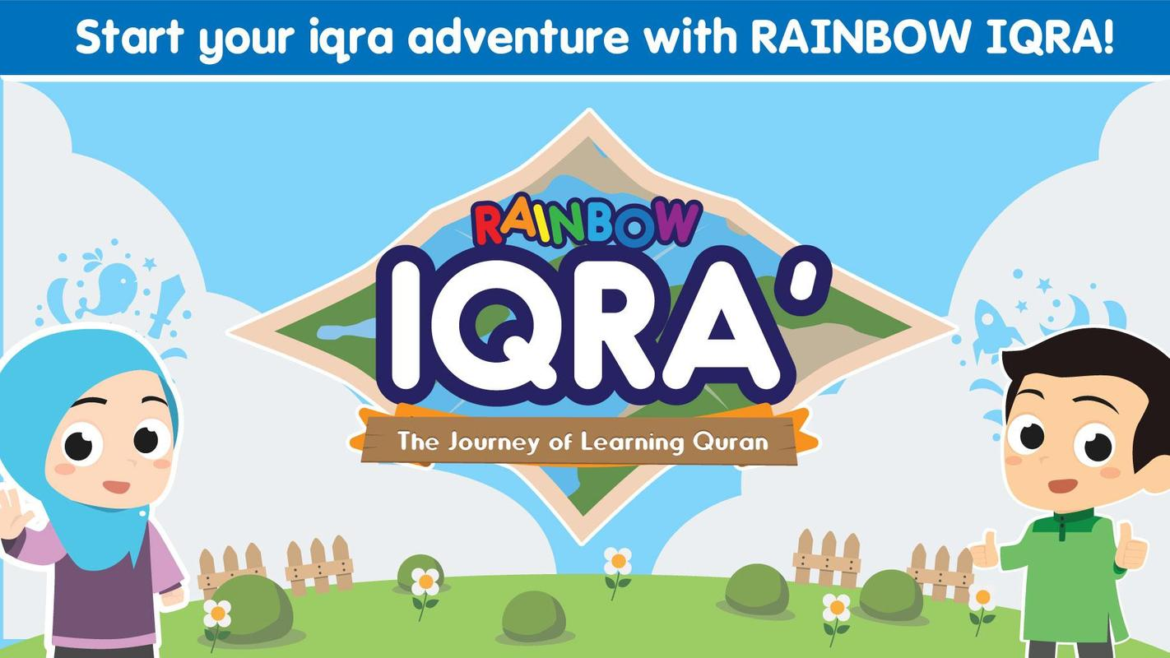

Figure 6Rainbow Iqra'

Cool Code also produced one application which has been named as Remember Asma’ Ul Husna. Remember Asma’ Ul Husna is flash card game application to help memorize the 99 names of Allah. Every single cards comes with sound and writing in English or malay translation. This application comes with mini game test and match suitable meanings for eah names.

In addition, current development if Cool Code is Omar & Hana which it will launched in December 2018. Then, Smart Tabika Kemas also one of product of Cool Code which help teacher and student in teaching and learning through gamifications.

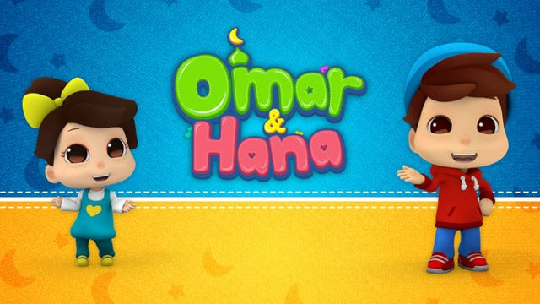 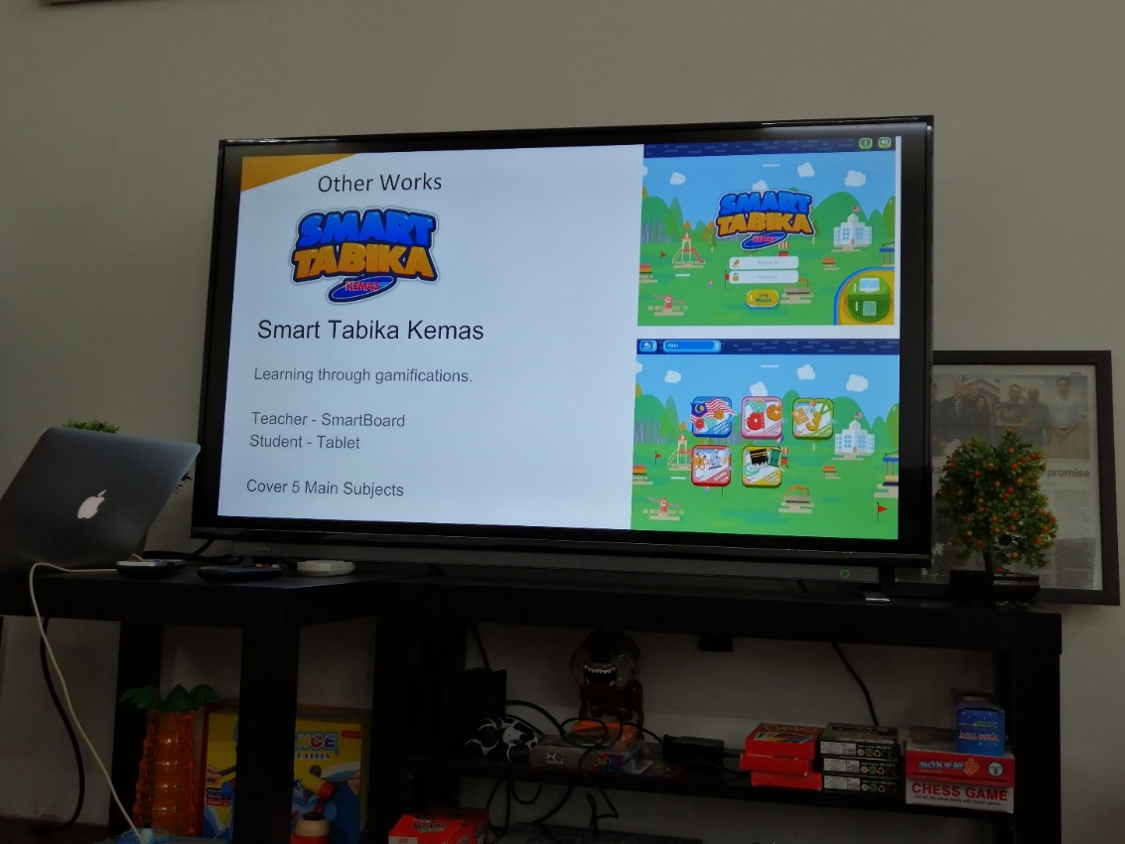

Figure 8 Omar & Hana and Smart Tabika Kemas

## 3.4 ACHIEVEMENT

Cool Code have achieve many achievement since it was founded. In 2016, Didi & Friends Playtown that was created by Cool Code featured list as Best Game of 2016 in Google Play Store. The game also getting as Top Educational Games in Google Play Store. Cool Code team was declared as the Best Student Enterprise in Ministry of Higher Education Entrepreneurial Awards in 2015. In 2017, Rainbow Jawi was featured in TV Alhijrah for “Aplikasi Pilihan” segment. Team Cool Code was selected as winner of the JomLaunch Choice Project, a JomWeb community member program at Menara TM.

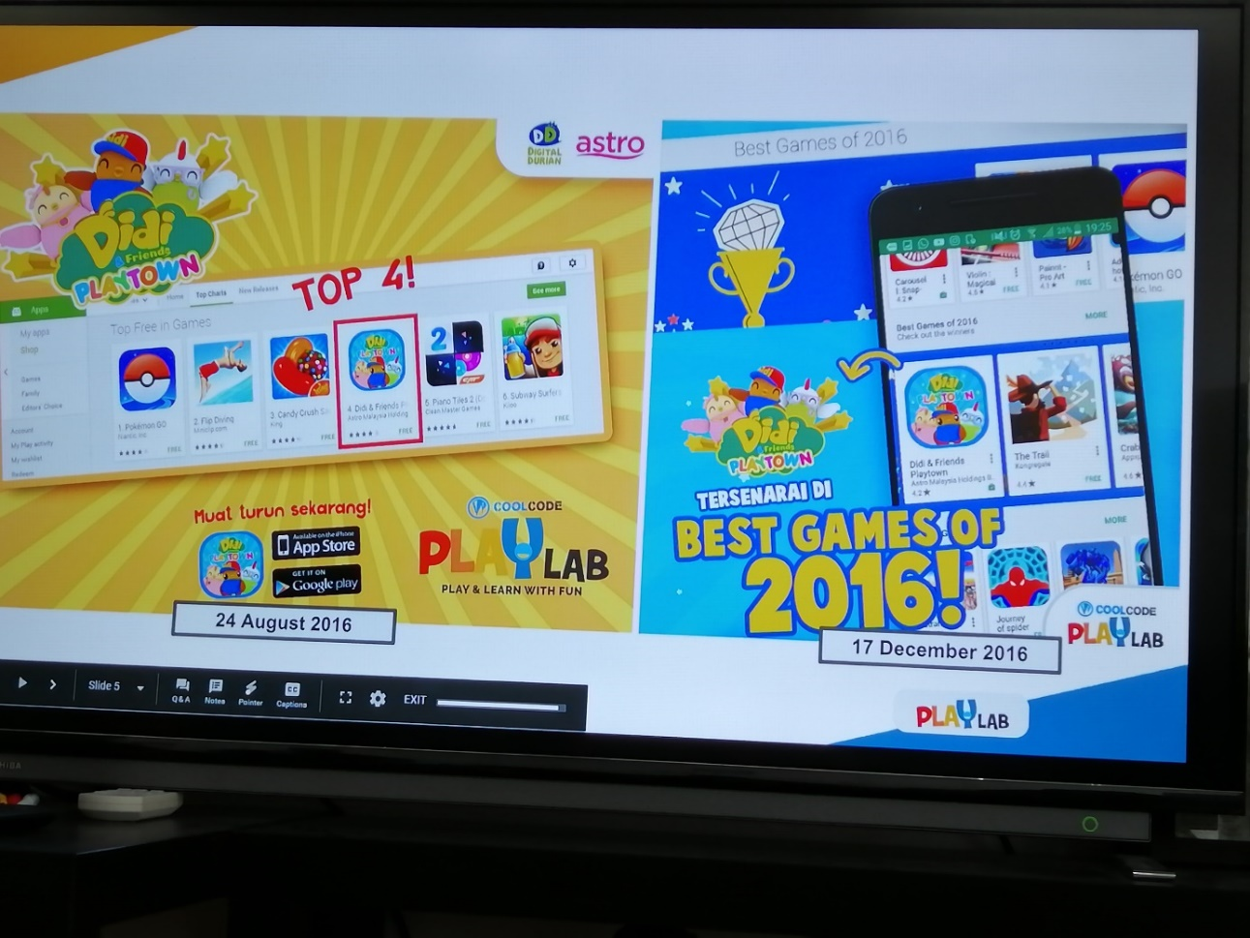

## 3.5 INFORMATION SYSTEMS THAT HAVE BEEN DEVELOPED

There are many project that have been developed by Cool Code such as Didi & Friends Playtown. Didi & Friends Playtown is a combination of 12 games based on the popular Didi & Friends children songs. Each song has an interesting game concept and a different approach. Second one is Rainbow Jawi. Rainbow Jawi has a variety of activites for children to learn Jawi interactively and fun. Third one is Remember Asma UlHusna. This game has interactive flash cards to learn and remember Asma Ul-Husna (99 Names of Allah), with audio, and mini games puzzle. The last one is Rainbow Iqra’ which is kids can learn Iqra’ through Adventure-educational game with interactive and games puzzle (Iqra’ 1 - 6).

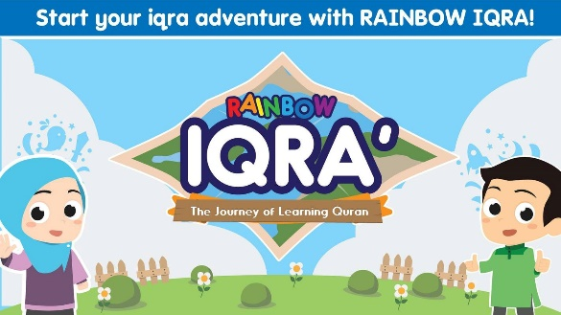

Figure 2- Didi&Friends Playtown

Figure 1 - Rainbow Jawi

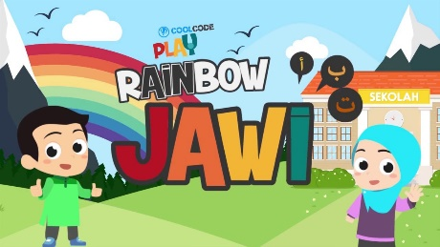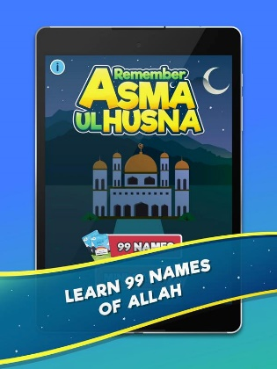

Figure 4- Remember Asma Ul-Husna

Figure 4 - Rainbow Iqra'

# REFLECTION

There are several goals we hope to achieve when we have the industrial visit for the Cool Code. First of our goals is to prepare ourselves to get used to working life before stepping into the industry workplace. It is purpose to make us able to achieve our ambition with life goal and to get the dreaming job we are seeking for after the graduation. Our second goal is to learn some lessons from their experiences in the works of development so we take them as references and consultations.

After the visit, we think the visit had gave us many impact to our goal. First, we have known more about the organisation of their corporation, the work content of their worker, and their achievement in their field of program development. Then, we also had realised that what skill is still lacking and have to be more improved. We are much admired to the harmonious working environment they had built and the team sprit between their colleagues.

So to improve our potential in the digital industry, we known we need some plan and action we should be taking. First, we have to pay attention to our study in our courses to learn more technique and skill to be used after take a job in the digital industry. Besides, we need to improve our cooperation of our course members so we can able to accomplish our task as best as possible and to make us learn and growth together. Finally, we known we still need to encourage ourselves to try different solving way to build our ability of innovation.

# BIBLIOGRAPHY

1. *About Arif Tukiman*. (n.d.). Retrieved from linked in: https://www.linkedin.com/in/ariftukiman/
2. 2. *About Cool Code Team*. (n.d.). Retrieved from Cool Code Sdn Bhd: https://coolcode.my/our-team/
3. *Cool Code*. (2011). Retrieved from facebook: https://www.facebook.com/coolcodemy/
4. *PlayLab*. (2016). Retrieved from Cool Code PlayLab: http://playlab.coolcode.my/