**AMINE GAS TREATING UNIT PROCESS**

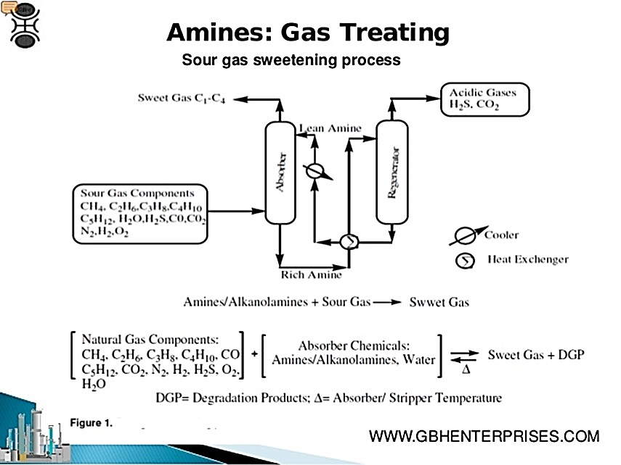

Amine gas treating, also known as gas sweetening and acid gas removal, refers to a group of processes that use aqueous solutions of various alkylamines which commonly referred to simply as amines, to remove hydrogen sulfide (H2S) and also carbon dioxide (CO2) from gases.

It is a common unit process used in refineries, and is also used in petrochemical plants, natural gas processing plants and other industries. Processes within oil refineries or chemical processing plants that remove hydrogen sulfide are referred to as "sweetening" processes because the odor of the processed products is improved by the absence of hydrogen sulfide.

**THE PROCESS FLOW OF AMINE TREATING**

INLET GAS KNOCKOUT:

Before entering the absorber , the gas are passed through an inlet separator where entrained droplets or slugs of liquid are removed from the gas stream by impaction devices.

TRAY TOWER ABSORBER:

The sour gas ,enters the bottom of absorber. Usually the absorber is a try column are often used. The objective is to provide intimate contact between the gas and amine solvent to transfer H2S and CO2 from gas phase to the solvent liquid phase.

Chemical substances :natural gases, alkylamine and sweet gas

THREE PHASE FLASH TANK:

Amine solution is send to a flash skimmer tank to recover hydrocarbons that may have dissolved or condensed in the amine solution in absorber. The pressure of the solution is dropped as it enters the tank ,allowing lightest of hydrocarbons to flash , while heavier hydrocarbons remain as liquid but separate from aqueous amine , forming a separate liquid layer.

Chemical substances : amine solution and hydrocarbons

LEAN/RICH HEAT EXCANGER:

The rich solvent is preheated before entering the stripper. As the lean amine exiting reboiler must be cooled before entering absorber , thereby reducing the heat load on the reboiler

REGENERATOR:

The preheated rich amine enters near the top of the column and flows down counter current to a gas stream of steam, H2S and CO2. The stream generated in the reboiler, lowering the partial pressure of H2S and CO2  in the gas stream , enhancing driving force of the acid gases from the amine solution.

Chemical substances:Amine,H2S and CO2

FILTRATION:

Mechanical filters remove particulate material while call filters remove chemical contaminants such as entrained hydrocarbons and surface-active compounds. Locating the filters in the rich line upstream of the lean rich heat exchanger will protect both heat exchanger and stripper from plugging and reduce the corrosion rate in the heat exchanger.

Chemical substance: Chemical contaminants