

**SEM 1 20202021 : SECTION 01**

# **PROGRAMMING TECHNIQUE 1**

ASSIGNMENT 1

**Group Num#** : 7

**Students Information**

**Name** : Shahril Bin Saiful Bahri (A20EC0144)

Gui Yu Xuan (A20EC0039)

Phang Cheng Yi (A20EC0131)

Nurzarifah Binti Azizan (A20EC0127)

**Lecturer** : Dr Zuraini Binti Ali Shah

**Question 1**

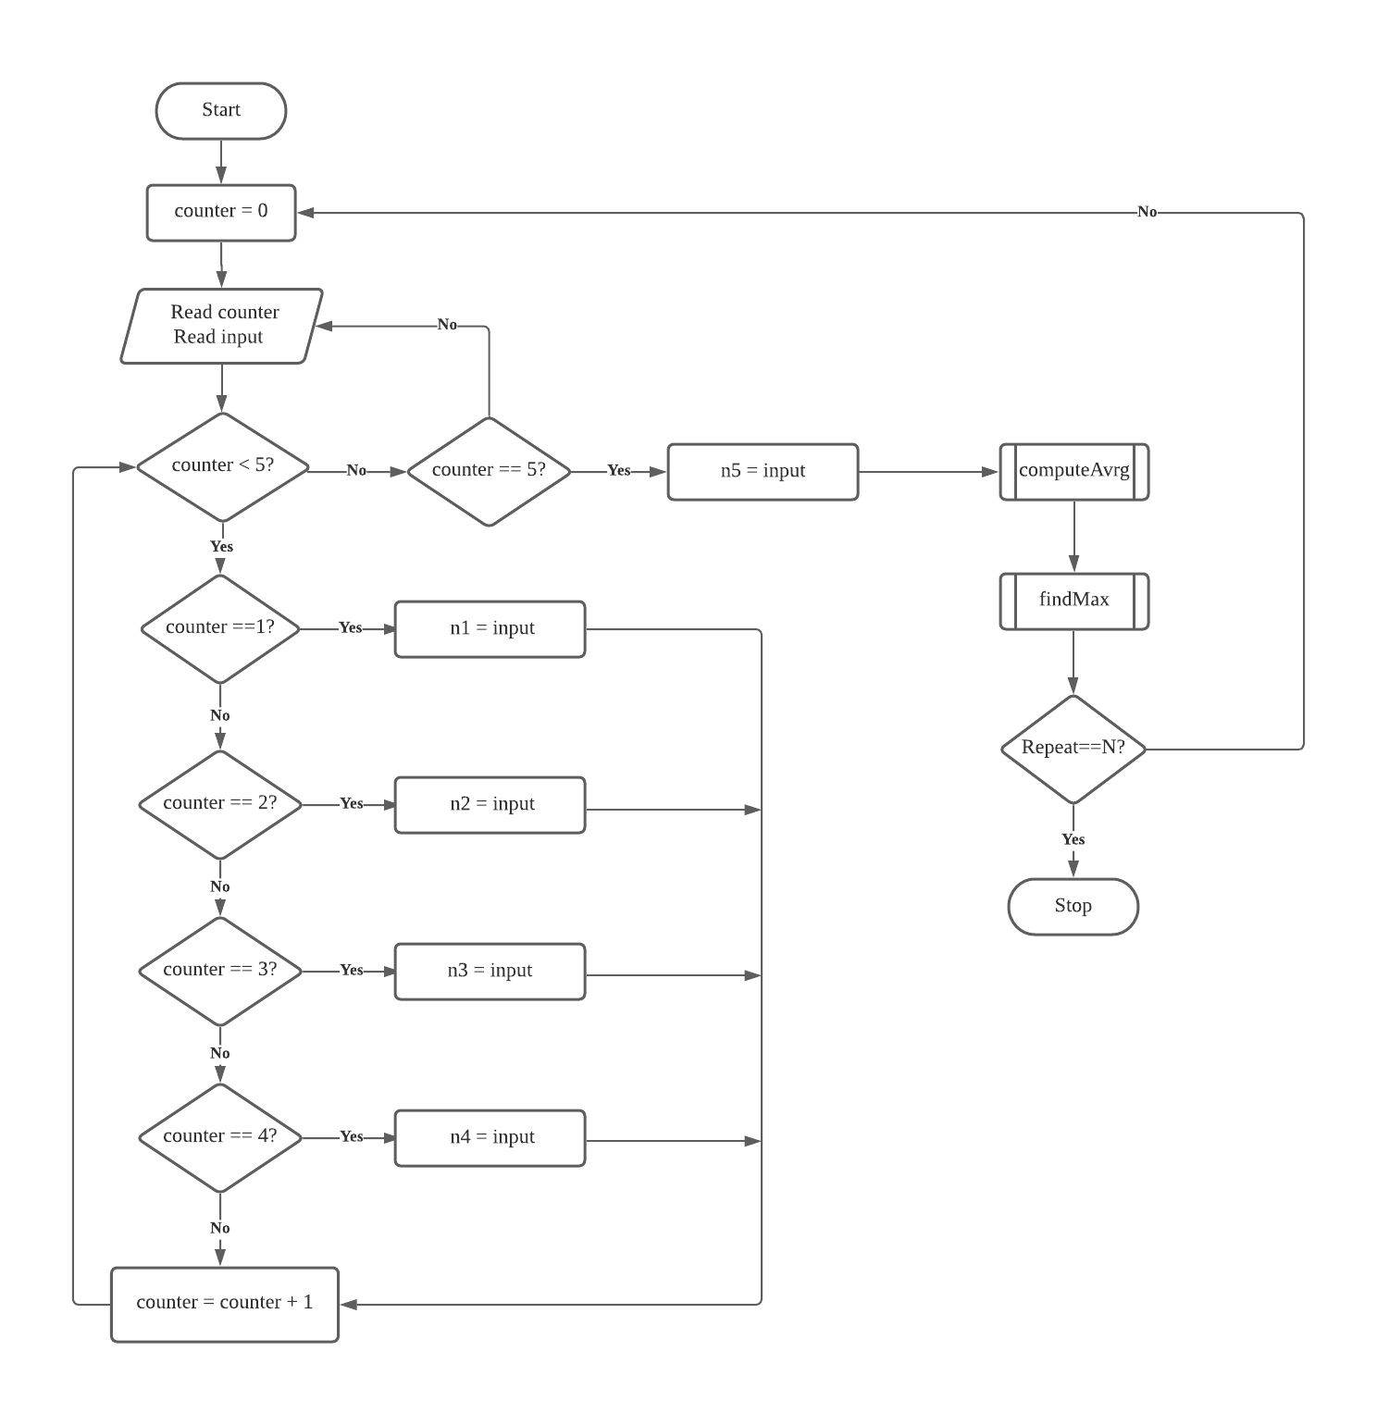

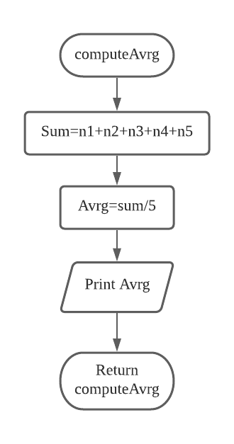

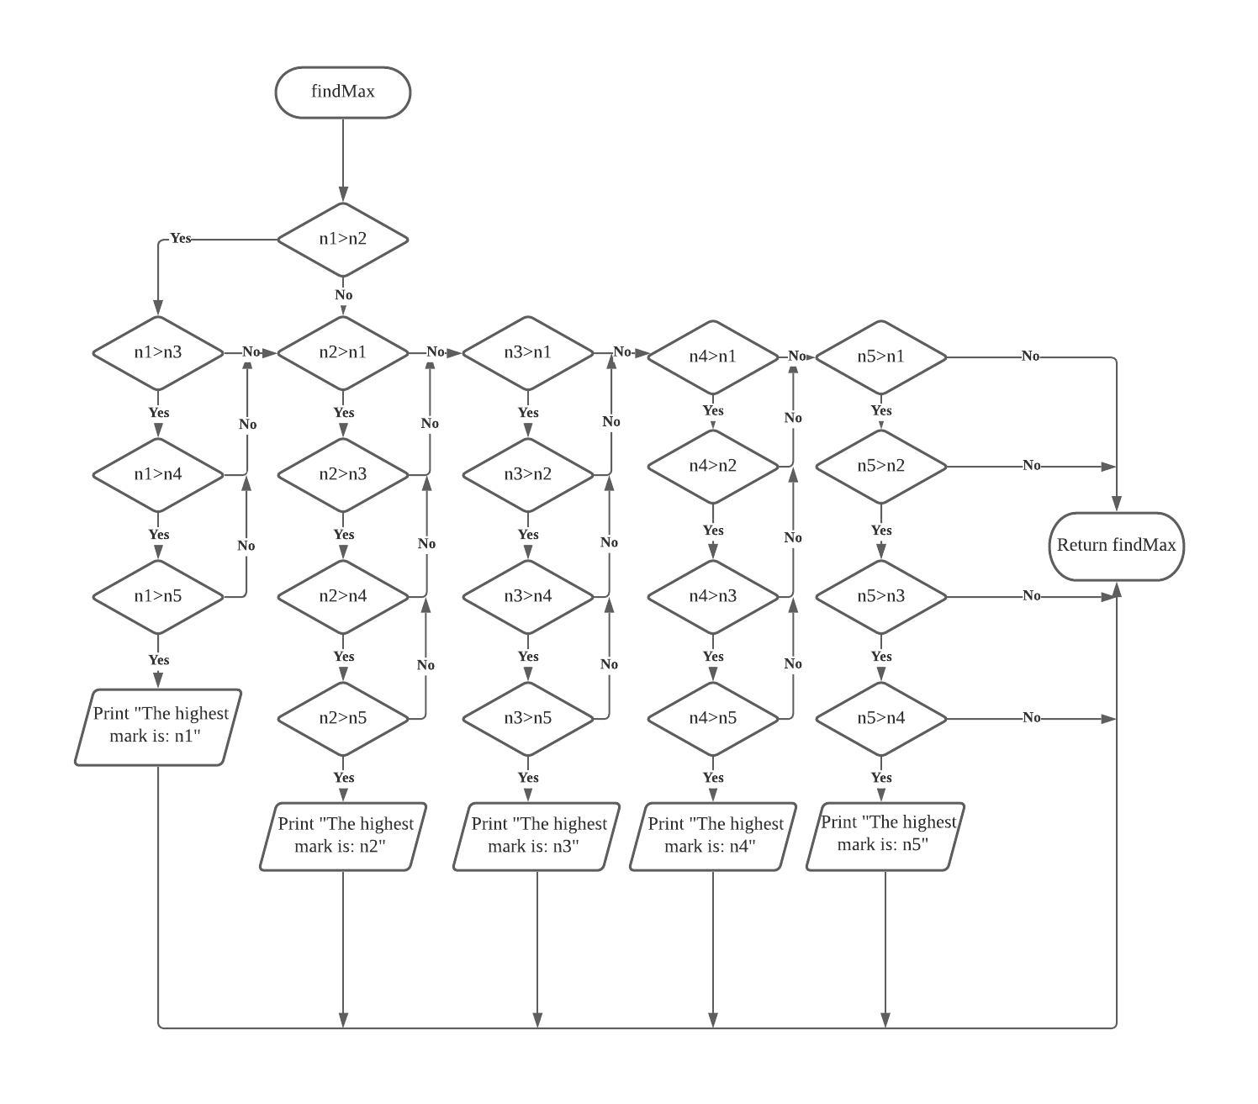

**Question 2**

