Reflective Report on A Visit to Laboratory

On 14 November 2018, all students of SKEE 1012 - Section10 visited Institute of High Voltage and High Current (IVAT) Laboratory. It is located at P06, Universiti Teknologi Malaysia. We were guided by a senior lecturer of UTM, Dr. Zulkarnain Ahmad Noorden. We were first introduced by watching a short video that explains the IVAT. From the video, I knew that the IVAT of the School of Electrical Engineering, Universiti Teknologi Malaysia was established in 1991. It was initially an educational laboratory which provides facilities for carrying out experiments, research and consultancy services in high voltage engineering beginning as early as the 1970s.

There are three main research divisions, which are Lightning Research and Safety Division (LRSD), High Voltage Condition Monitoring and Diagnostics Division (HVCMDD) and Dielectrics and Electrical Insulation Division (DEID). There is also a division dedicated to services which is High Voltage Services, Consultancy and Training Division (HVSCTD). LRSD aims to improve knowledge and understanding related to lightning phenomenon, lightning characterization and localization, lightning protection, grounding systems, lightning simulation and lightning safety while HVCMDD focuses on the condition monitoring of high voltage equipment, diagnosis and fault analysis, forensic investigation and material assessment. DEID focuses on electrical discharge detection and monitoring, partial discharge analysis on polymeric insulating materials and also plasma and ozone generation applications. A new division, Discharges, Dielectrics and Diagnostics Division has been formed by the merger of Dielectrics and Electrical Insulation Division and High Voltage Condition Monitoring and Diagnostics Division.

Dr. Zulkarnain introduced us the facilities in the laboratory. AC/DC/Impulse Kit consists of 100kV power transformer that generates high voltage AC, rectifier, capacitor and high voltage divider. It is used to breakdown and withstand AC or DC. It also generates AC, DC and impulse voltage. Besides that, glass insulator is used to insulate the voltage between [transmission](https://en.wikipedia.org/wiki/Electric_power_transmission) lines and [transmission towers](https://en.wikipedia.org/wiki/Transmission_tower). 250kV AC System is used to measure AC voltage until 250kV and to detect partial discharge. It can withstand AC until 250kV. The largest lab equipment in the UTM is the 2MV lightning impulse voltage generator that can generate lightning impulse voltage up to 2MV and high voltage divider that measures the voltage generated by the lightning impulse voltage generator. This equipment is used for the calibration, testing, consultancy and training services.

An AC Withstand Test on High Voltage Insulator is performed by Assistant Engineers, Mr. Mohamad Syahrin Mohamad and Mr. Hairoisyam Abd. Rani. The water was first being sprayed on the glass insulator. Then, the AC voltage increased gradually from 10kV to 40kV as there was spark on the insulator when the AC voltage is 40kV. Since there is one insulator being tested, we knew that the insulator can withstand until 40kV. If there are two insulators, so the insulators can withstand until 80kV.

It was an interesting visit to IVAT laboratory. I learnt something new about high voltage and high current. I felt ashamed because a lot of information told by 1Dr. Zulkarnain I did not know at all. After this visit, I must study more about electrical such as how AC is transformed to DC. It also motivates me to work harder so that I would keep moving forward for a better life.

In conclusion, high voltage and high current are essential for our life. We all use electricity everyday but most of us do not how the voltage is transmitted to our houses. Hence, we need to know at least the basic concept of how it works. I, as the students of Electronics Engineering, will take it seriously as it might be my future career.

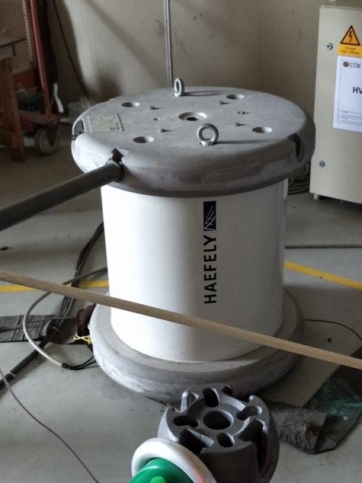 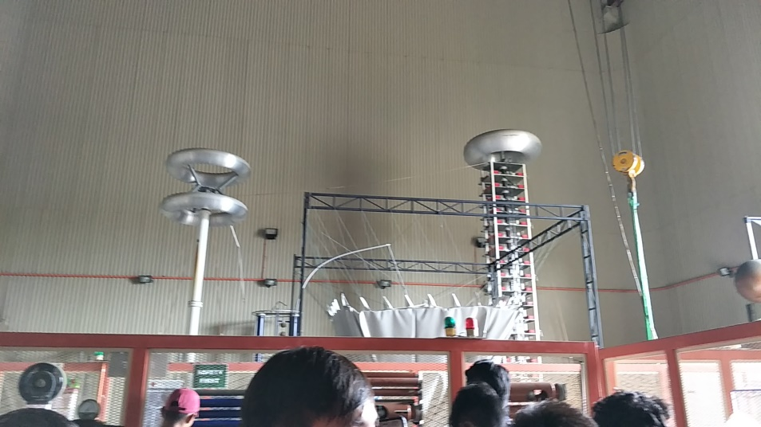

Left side: High Voltage Divider

Right side: 2MV Lightning Impulse Voltage Generator

100kV Power Transformer

References

1. ivat.utm.my
2. https://en.wikipedia.org/wiki/Insulator_(electricity)#Use