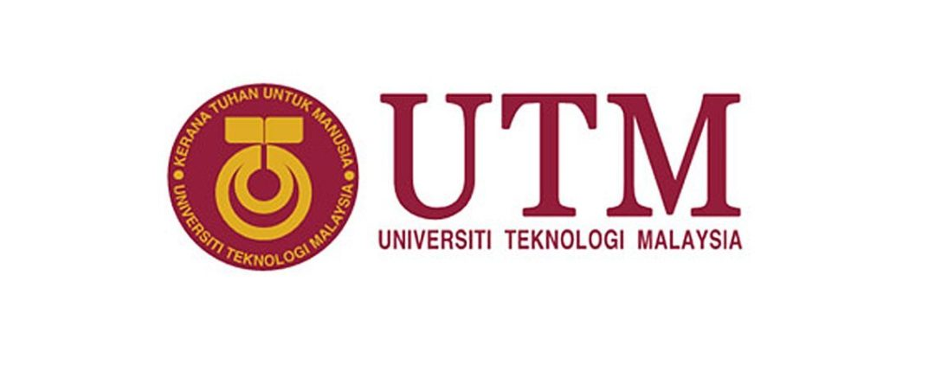TECHNOLOGY AND INFORMATION SYSTEM

SECP1513 (SECTION 01)

INDUSTRIAL VISIT – CICT UTM

LECTURER NAME:

DR. ZURAINI BT. ALI SHAH

GROUP MEMBERS:

LEE BAO YI (A19EC0066)

NURUL HAZLEEN NATASYA BINTI YUSNI (A19EC0143)

NISHA PRITY A/P P.RAVICHANDAR (A19EC0120)

XU CHANG (X19EC0027)

1

Table of Contents

**1.** **Introduction** 3

**2.** **Details of The Visits** 3

**3.** **Detailed Descriptions** 3

3.1 Camera Process 3

3.2 IBM 550 Power Server 5

3.3 Microfilm Reader ‘ALLEN MICRO MODEL’ 6

3.4 PYE MODEL-CAMBRIDGE, England Radio 7

3.5 Microfilm Camera ‘Zeutschel Ok 102 Model’ 7

3.6 Microfiche Reader ‘Micron 750 Model’ 8

3.7 Typewriter 9

3.8 IBM Personal System/2 Model 70 386 10

3.9 Image Magnifying Machine ‘Dunco 67C Model’ 10

3.10 Microfilm 11

**4.** **Reflections** 12

**5.** **Tasks for each member** 13

2

# **Introduction**

Centre for Information and Communication Technology (CICT) is a support unit provided by UTM to ensure all staffs and students have access to learning, teaching and research ICT resources. CICT is striving its best to acquire, develop and support new and emerging technologies and systems. The access to digital resources across the university’s campuses is also provided by CICT in order to fulfil the needs of staffs and students. CICT offers ICT services to all UTM students and staffs, especially in ICT infrastructure, system development and academic or administrative activities.

# **Details of The Visits**

The visit of CICT was carried out on 21 October 2019 (Monday) at Level 2, CICT Galerium, Perpustakaan Sultanah Zanariah (PSZ). This visit of CICT started from 3.30pm and lasted for one hour, until 4.30pm. After attending the talk, we were taking a tour to CICT Galerium. There are different types of devices being displayed.

# **Detailed Descriptions**

# 3.1 Camera Process

The Camera Process was manufactured by Hunter Penrose Ltd., a company which based in the United Kingdom were thousands of these were sold worldwide in1890 until 1962. Department of Survey and Mapping Malaysia (JUPEM) was given this camera as a gift and was used since the British colonial. This initial model is fully mechanical and it has been used to facilitate students in understanding the principles and procedures of photography production. It is a KLIMCH ‘horizontal process camera’ was used during the early 1980s until the late 1990s in the Cartography Department, Faculty of Surveying. To produce maps and graphics in a conventional method, the students who undertook land surveying course drew map sketches on tracing papers or papers using technical pens.The manuscript or final drawing is considered as a scientific document which can be used for various application specifically in the planning and development of land or landfill. The result of the sketch will be displayed onto a specific location which is the focal point of the camera lens. To produce black-and-white maps or coloured maps, plates and films containing terracotta contour images were processed. Printed topographic maps were treated as ‘CONFIDENTAL’ and ‘LIMITED’ and used only for teaching and learning purpose in the faculty. In early 2004, this application of camera was ceased due to the advent of digital technology. 3

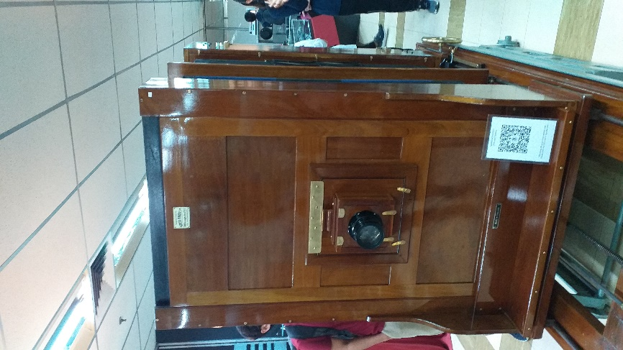 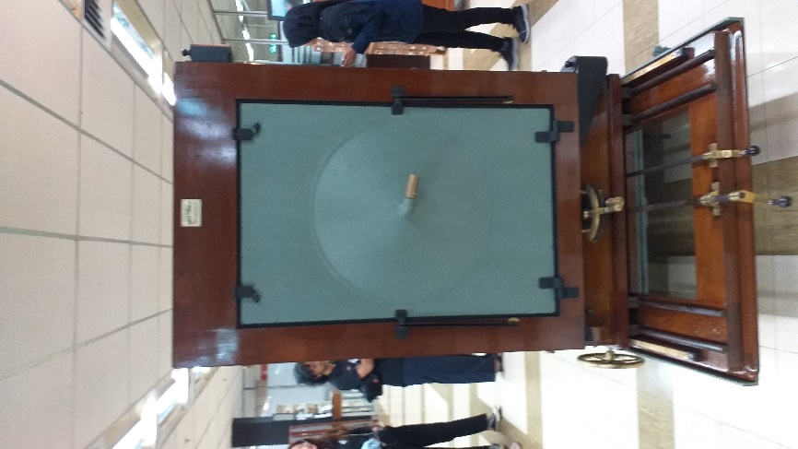

Figure 3.1: Front side of process camera Figure 3.1.2: Back side of process camera

4

# 3.2 IBM 550 Power Server

During 1990’s technology the IBM 550 Power Server boasted an outstanding performance with its fastest chip in the world. It was considered as an apt system for a medium-sized database at the time. In relation to the Librarian’s technology, the application of the library management system on a ‘freeze’ terminal which operated on a Mainframe was seen as the starting point of the information technology evolution and played a great impact on UTM Library’s history.

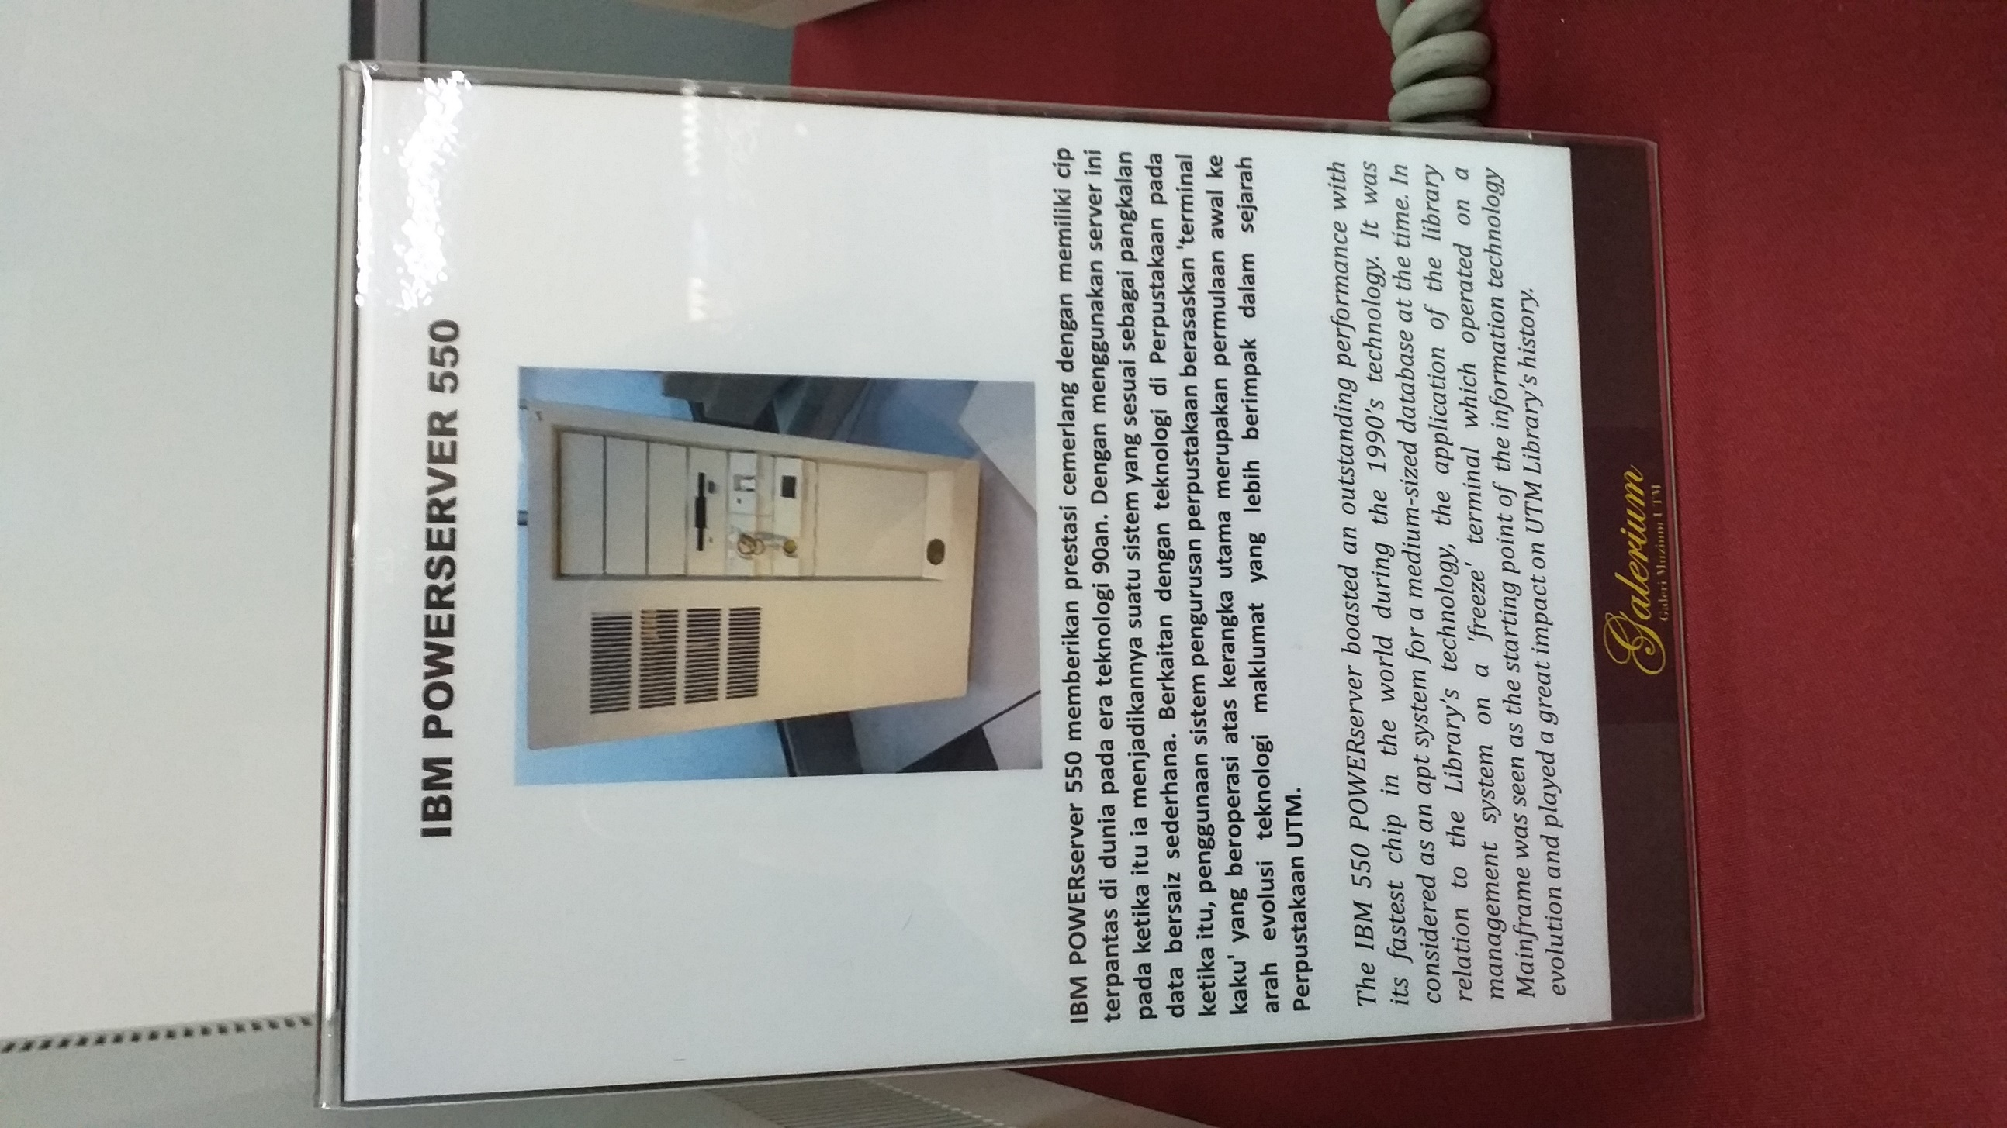

Figure 3.2: Photo of IBM 550 Power Server

5

# 3.3 Microfilm Reader ‘ALLEN MICRO MODEL’

Around early 1980’s and early 2000’s, the microfilm reader was first used in UTM Library. It was used for reading thesis content (text and images) which was stored in microfilms and displayed on the machine’s screen. At the same time, the online information development was very limited and it gave an impact to user references approach. Microfilms became one of the main sources of information in UTM Library. The microfilm was considered essential in the library’s collection as a mean of storing a large amount of data with a small medium.

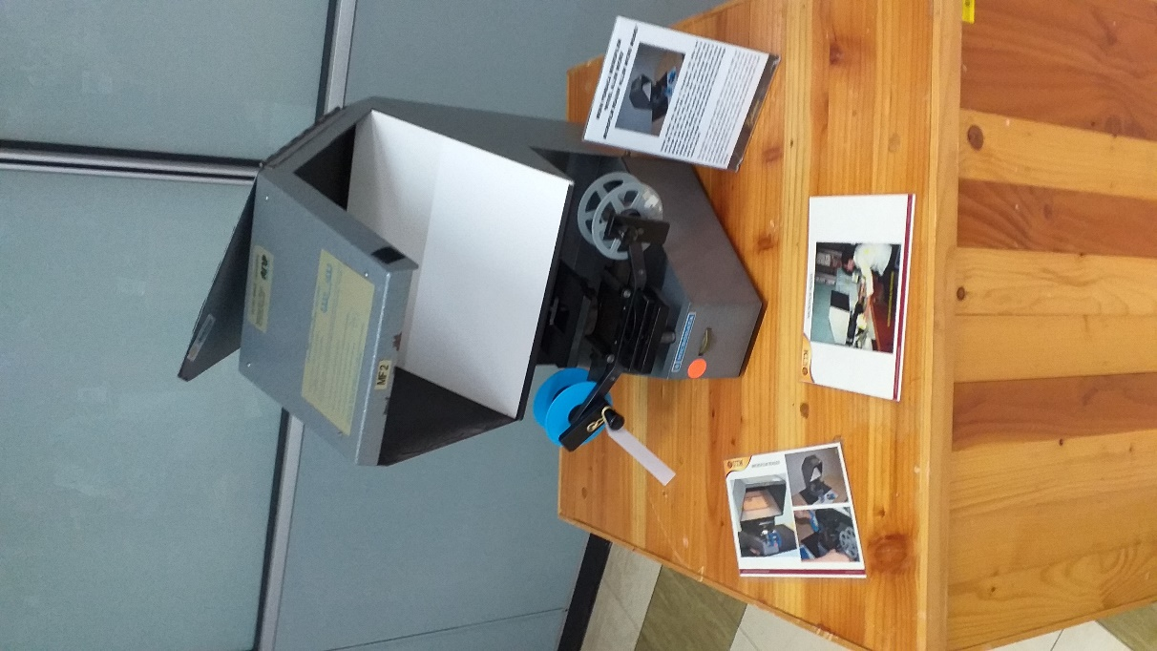

Figure 3.3: Microfilm Reader ‘ALLEN MICRO MODEL’ Machine

6

# 3.4 PYE MODEL-CAMBRIDGE, England Radio

This radio which was produced in the 1950’s was used during the 1960’s until 1970’s in Technical College, Kuala Lumpur. It was used as one of the medium of information dissemination and with the purpose of supporting the learning and teaching activities.

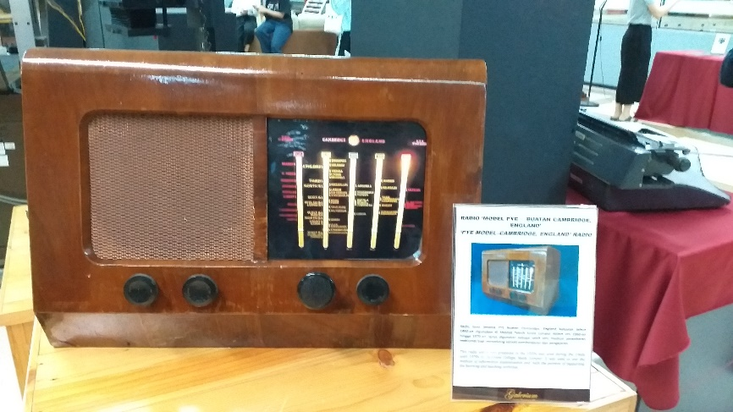

Figure 3.4: PYE MODEL-CAMBRIDGE, England Radio

# 3.5 Microfilm Camera ‘Zeutschel Ok 102 Model’

This Microfilm Camera ‘Zeutschel Ok 102 Model’ is a high accuracy camera used to photograph small images of UTM theses. The images were recorded into microfiche or microfilms. It utilised a special film which called ‘Kodak Ektacrhrome’ which was 35mm in size, and with a capacity of 100 feet per film roll. This machine was first used in UTM Library in 1986 until around 2007.

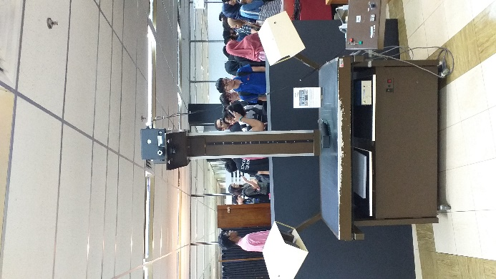

Figure 3.5: Microfilm Camera ‘Zeutschel Ok 102 Model’ Machine

7

# 3.6 Microfiche Reader ‘Micron 750 Model’

This Microfiche Reader was used to read the content of microfiche and it was a source of information in the form of a flat film sheet and contained text and images. The content of microfiche film was read according to the order of letters on the machine and display could be expanded when needed. A total of 500 titles of microfiche are available in UTM Library collection covering various sources such as technical reports, journals, proceedings and other general references.

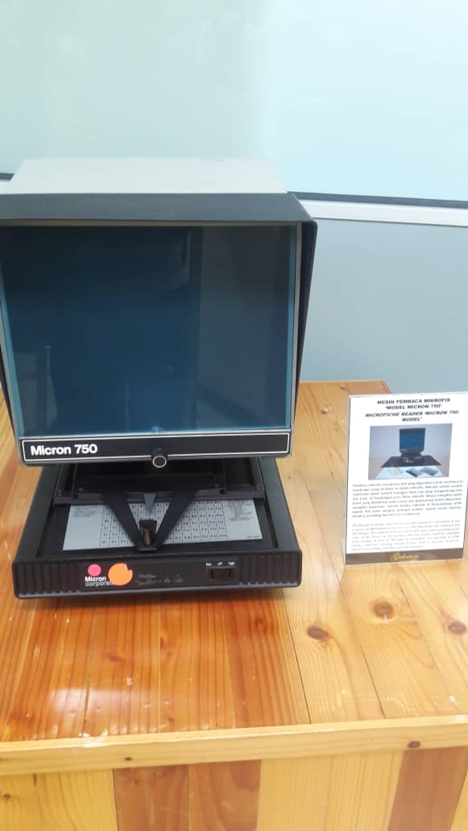

Figure 3.6: Microfiche Reader ‘Micron 750 Model’ Machine

8

# 3.7 Typewriter

The typewriters were used in the Library during the 1970s until early 1980s. Before the application of computers in 1985s, the typewriter was once used for administrative tasks such as printing letters and memos.

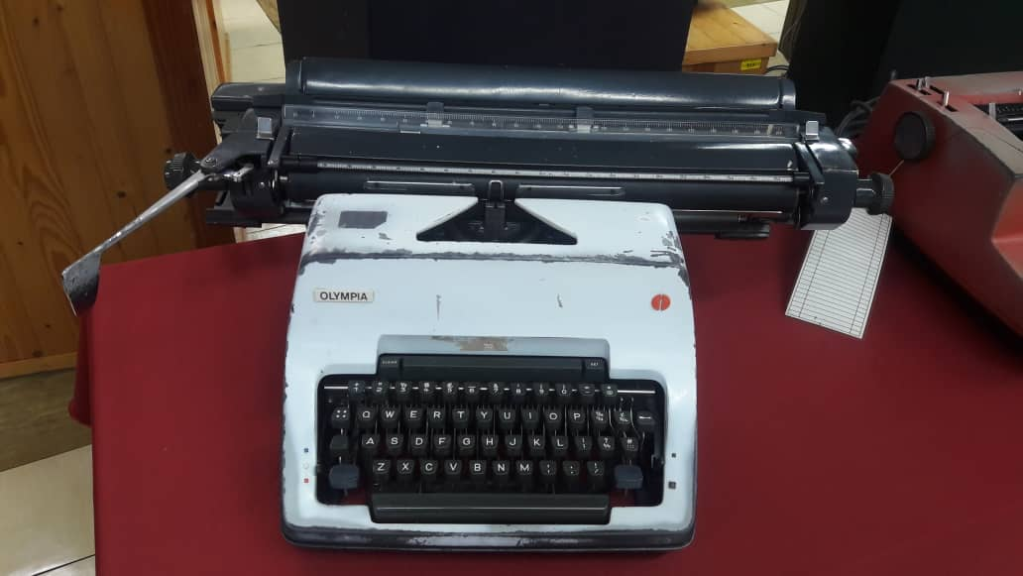

Figure 3.7.1: Olympia Typewriters: A German Original

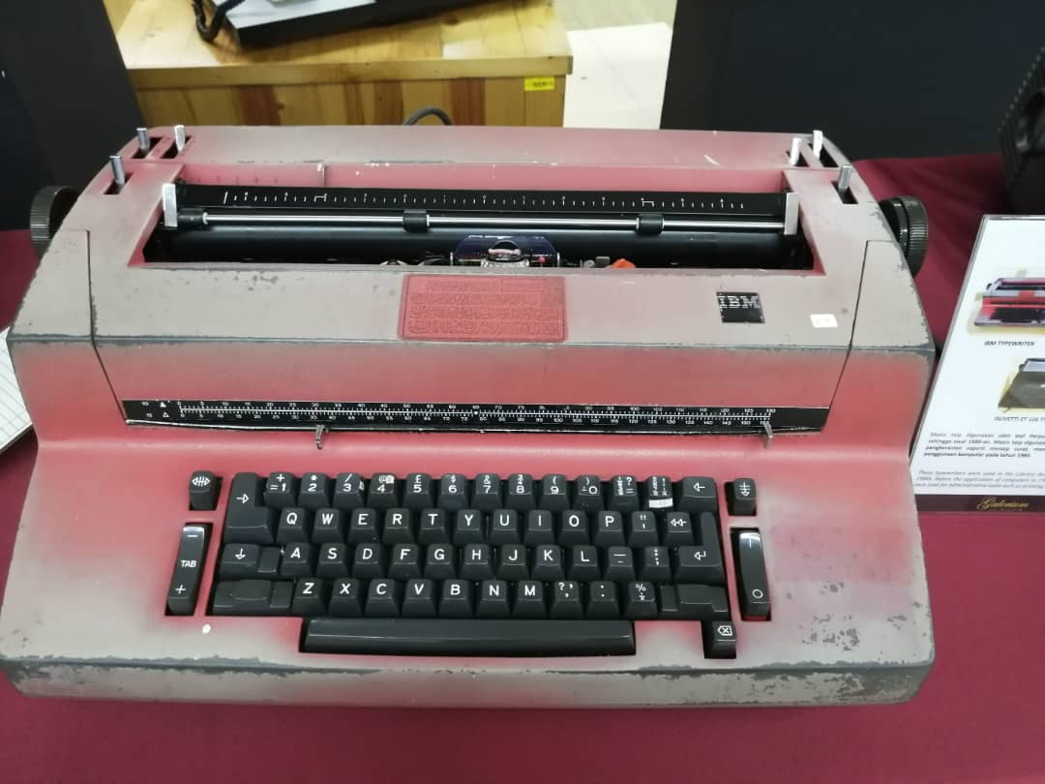

Figure 3.7.2: IBM Typewriters

9

# 3.8 IBM Personal System/2 Model 70 386

This IBM Personal System/2 Model 70 386 enhances the IBM Personal System/2 family of systems by offering a new level of performances in desktop units. The system is highlighted by the Micro Channel Architecture with a 16 or 20MHz 80386 32-bit microprocessor, high density memory technology, and a wide range of integrated features.

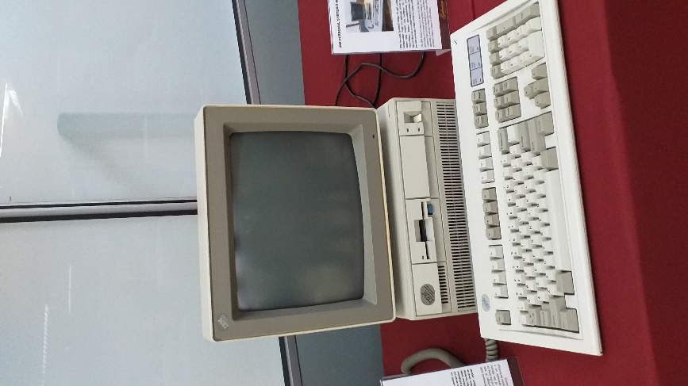

Figure 3.8.1: IBM Personal System/2 Model 70 386 Computer

# 3.9 Image Magnifying Machine ‘Dunco 67C Model’

The ‘Film Enlarger’ is a tool used to enlarge images to produce photo prints from negative films. It could be modified according to a preferred images size. The film magnifier only used in the darkroom to prevent light from entering.

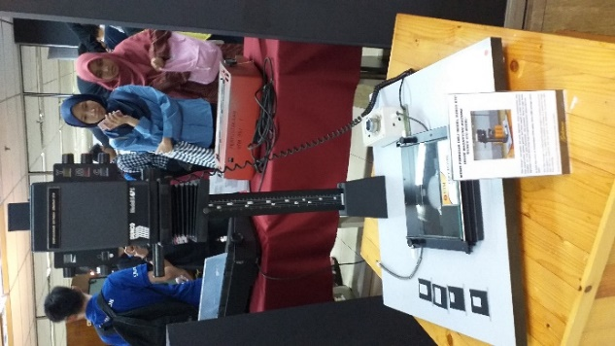

Figure 3.9.1: Image Magnifying Machine ‘Dunco 67C Model’ Machine

10

# 3.10 Microfilm

A microfilm is a media item which was heavily used as a learning and references medium in UTM back in 1980s until early 200s. It used a special 35 mm size film and was stored in boxes for easy storage. There are almost 15 000 titles of microfilms in UTM Library collection ranging from theses, international journals, acts, newspapers and others. The library’s efforts in carrying out microfilming process began as early as the 1990s and 2007 and it focused on duplication of theses and research project. The initiative was carried out to preserve the security of the intellectual property of the university and to ensure that this primary source of information can still be referred from time to time. The microfilms collection is stored in an environmentally controlled storage at the Media Materials Room, UTM Library.

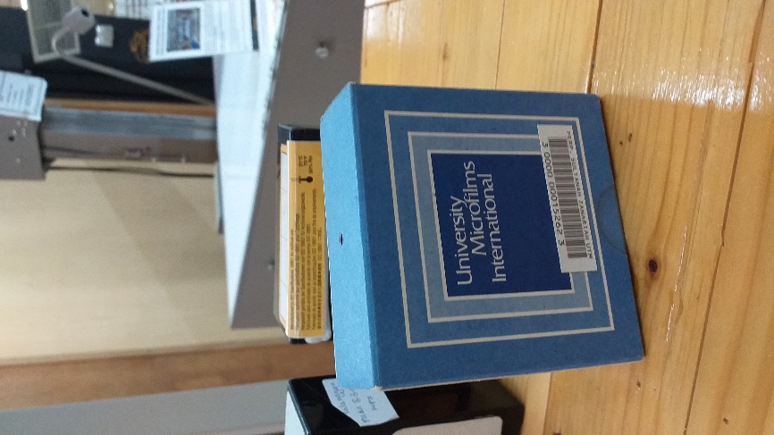

Figure 3.10.1: Microfilm

11

# **Reflections**

In conclusion, we had a chance to know more about Centre for Information and Communication Technology (CICT) where it acts a support unit provided by UTM to ensure all staffs and students have an access into learning, teaching and research ICT resources. It has been always fulfilling the needs of every individuals in UTM. CICT plays a vital role in ICT infrastructure, system development and academic or administrative activities. As bioinformatics is mainly about specialised computer software evaluation of biological structure, our prior intention is to develop tools that helps in sorting out any data accurately and effectively. Firstly, camera process has been used to facilitate students in understanding the principles and procedures of photography production. The manuscript or final drawing is considered as a scientific document which can be used for various application specifically in the planning and development of land or landfill. IBM 550 Power Server played a great impact on UTM Library’s history. Besides that, Microfilm Reader ‘ALLEN MICRO MODEL’ was considered essential in the Library’s collection as a mean of storing a large amount of data with a small medium. Apart from that, PYE MODEL-CAMBRIDGE, England Radio was used as one of the medium of information dissemination and with the purpose of supporting the learning and teaching activities. In addition, Microfiche Reader was used to read the content of microfiche and it was a source of information in the form of a flat film sheet and contained text and images. These machines were created in ancient times and had their own functions and play a vital role in today’s technology aspects. So, as a technology-oriented student, we must be able to come up with a machine with benefits. This shows how skilful are we as in future employees who are skilful enough will be hired at working place to maintain the performances of their company. Overall, as technology plays a vital role in our life especially in computing field, we should have a bigger exposure on technology to succeed in this field by cultivating our learning skills in all aspects to be a successful person.

12

# **Tasks for each member**

Each member is assigned to a different task based on the differences in the academic foundation, learning ability, personality traits, areas of expertise, and gender of each member of the group. Cooperative learning requires each team member to take turns to complete each task.

The team leader is the leader of the group activities, and the responsibilities mainly include organizing the group's study and conducting regular group management. The learning tasks is assigned to each member of the team to accomplish the task better.

Each of us did one part of the report respectively. Bao Yi took the part of introduction and details of the visits, Hazleen took the part of detailed descriptions, Nisha did the reflections while Xu Chang did the part of tasks for each member. The parts of the report were sent in the discussion group to be compiled. Lastly, Bao Yi is responsible in compiling and editing the report from each member and the compiled report is checked by the group members before submitted.

Communication is based on the independent learning of team members. Everyone can benefit from communication. The team works together to complete the assignment and submit it on time. The team members must actively assume personal responsibilities, but also support and cooperate closely to effectively complete the group's learning tasks. Each team member plays a pivotal role in collaborative learning.

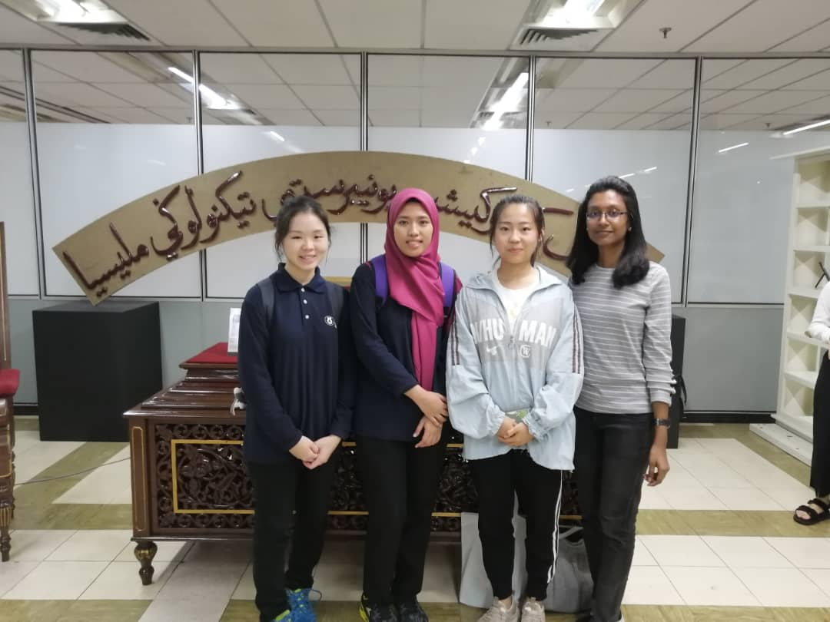

Figure 5.1: Group photo

13