

**Graduate Success Attributes**

**(UHAK 1012 Section 21)**

**SESSION 2018/2019 SEMESTER 1**

**Individual Case Study**

**Title : Gadget Addiction**

**Among Children and Teenagers**

Name : Choy Wan Ling

Matrix Number : A18CS0049

IC Number : 980822 – 06 - 5468

Course : Computer Science - Network and Security (SCSR)

Lecturer : Dr. Nurwina Akmal binti Anuar

**Gadget Addiction Among Children and Teenagers**

KUALA LUMPUR: Giving children aged between one and six or teenagers to play with gadgets such as smartphones without exercising any control can make them vulnerable to mental disorders and ‘Pseudo-Autism’.

The scenarios below show that teenagers are suffer in gadget addiction and get sick in the disease called “cell phone disease”.



The picture above show that teenagers only focus on playing smartphone although they are stand in the LRT.

(Source from South China Morning post Asia) <https://www.scmp.com/news/asia/article/1533017/psychiatrists-singapore-launch-effort-have-smartphone-addiction-recognised>



The picture above show that teenagers with gadget are not involve themselves in any conversation with their friends.

(Source from Global Times)

<http://www.globaltimes.cn/content/868344.shtml>

What are the effects of gadget addiction to children and teenagers? First at all, the direct effect is definitely on their mental and physical health. Early Childhood Education specialist, Dr Putri Afzan Maria Zulkifli said ‘Pseudo-Autism’ could happen if they spent too much time playing with gadgets or watching television. Actually, it is not a real mental illness but it is a vary expressions ways of children and teenagers who have gadget addiction. The common ‘Pseudo-Autism’ symptoms on those who suffer in ‘Pseudo-Autism’ have weak communication skills because they only focus on the screen of smartphone or tablet and stay too longer in the virtual reality which make them never know how to communicate with living things and face the consequences in real life. It was similar to Autism, whereby they are seemed to live in their own world.

Basically, they are lacked social skills because they are unwilling to join physical and outdoor activities. They prefer to contact with smartphone rather than interact with people and involve in outdoor activities. If the physical activities reduced means they exercise less and only sit there to play smartphone. These effects will lead to some serious disease like cardiovascular disease and cancer. Sometimes, they are unable to speak well and unable to control their feelings which may cause depression.

Besides, the children and teenagers who suffer in ‘Pseudo-Autism’ are commonly have the behavioral patterns such as not respond to their names when playing with smartphone. If the smartphone suddenly leaves from their hands, they will immediately get angry until they can get the smartphone again. However, parents always use the electronic gadget to handle their children’s tantrums because their children will calm down as soon as there are smartphones or tablets in their hands no matter in their house or at outside. The most serious symptom is they have extremely short attention span. They cannot give a long attention on an activity like doing homework. But for the activities on smartphone, they can always maintain their attention and enthusiasm on it. This may affect their studies and thus destroy their future. This is an issue nowadays which annoying the parents if their children are suffered in gadget addiction.

In addition, the effects on physical health cannot be ignore. Mostly, the teenagers and children who spend long time on smartphone have spine, neck and eyes problem. We can see from a pilot study conducted recently by Universiti Kebangsaan Malaysia (UKM) said by chairman Tan Sri Lee Lam Thye. It showed that a total of 27kg of weight is being added on the neck of children or teenagers who used electronic gadgets in an unhealthy angle. No joke, it’s almost like placing a 7-year-old kid on their neck! How seriously this issue happened in children and teenager’s life! The reason behind is they always face down and put their sight on smartphone which cause the neck and eyes problem. They will also suffer in visual impairment such as myopia and astigmatism due to the long period face to the screen on digital devices which caused by the brightness of screen on digital devices. The Education Ministry told the Dewan Rakyat recently that prolonged use of electronic gadgets contributed to visual impairment in students. Deputy Education Minister Datuk Chong Sin Woon said last year, 6.3 per cent of Year One pupils had visual impairments, 4.1 per cent of Year Six pupils and 2.7 per cent of Form 3 students. If children and teenagers are suffered in gadget addiction, the problems above will follow them a long time and give bad effects in their life.

In addition, they usually having an unhealthy eating habits because they are playing smartphone while eating. They are not focused when eating and this cause indigestion. Recently, teenagers like to take food photos before eating and upload the photos to their social media. After eating, they are only focus on their smartphone and not involve themselves in the conversation with their family or friends. Gadget addiction also causes them have sleep disturbances. Almost everyone sleeps with smartphone every night and they are unwilling to sleep because the activities on smartphone attract their attention.

Generally, the main cause of gadget addiction among children and teenagers is the internet. In a report published by the Archives of Pediatrics & Adolescent Medicine in 2009, past research revealed that 1.4 per cent to 17.9 percent of adolescents are addicted to the Internet. As the journal said, the number is higher in the East compared to Western countries. Digital devices allow people to access internet which bring a lots of benefits to human. For examples, people can search and get information, watch education programmes, communicate with people who are far away from them, create documents and many others. However, if the internet not use in proper way or people not control themselves in using internet like playing online games and keep watching videos which people are interested on, it causes them slowly addict to gadget because they are keep staying in that virtual world. That’s why they are addicted to gadget because it is so fun for them.

As we know, children and teenagers are no having mature thinking and always follow their desires to do things. In this case, their parents are taking role to control them in using the digital devices. However, if their parents are busy for work and use the digital devices to make them happy, it causes them having fun on smartphone and finally get addicted to digital devices.

Next, teenagers affected by their friends who are addicted to digital devices are most probably addicted to gadgets. The reason behind is they have the same topic to talk. When they meet together, smartphone is the tool for them to communicate. Healthy talk and discussion based on the issues come from internet is good, but if they only use it to play online games together, it becomes a serious problem.

Before this issue leads to serious problem, some ways can be executed to prevent children and teenagers addict to digital devices. Parents can control the time for using digital devices among their children and show good example to their children in order to get them off gadgets. Parents should put away the gadgets before getting victim in this case and contribute more time to accompany their children by having more conversations with their children. Children will feel the attention from parentrs and are willing to communicate with their parents. By having this way, they will not turn to their gadgets and become an active person. In order to control them, parents can set a time limit for their children to use smartphone. If their children do not follow the time limit, parents can take some punishments to give them a lesson and make them obedient. Parents are also adviced to use the digital devices for carrying out healthy activities on internet which are more appropriate for their age in order to stimulate the healthy mental and physical development.

Nowadays, the popular word to describe the people who are addicted to digital devices is “phubber” which are from the word “phone” and “snub”. As we know, the electronic gadgets are commonly used by people nowadays due to the development of technology in this modern world. Almost everyone has an electronic gadget even some have more than one gadgets such as laptop, smartphone and notebook. These electronic gadgets bring us convenience especially in the area of education, multimedia and business. They contribute to the e-learning and business online. Without network and internet, humans get troubles because they rely on the technology nowadays. Actually, the internet is convenient to us. But if this technology is not used in the proper way, it brings more harms than good. It gives us disadvantages which is causing them addict to gadget or actually it is causes them suffer in social media or internet addiction.

We can clearly observe that the number of children and teenagers with gadgets is increasing as the increasing presence of technology in children’s life. The harms of gadget addiction among children and teenagers also can observe obviously in our daily life. We must realise that the negative impact of this issue on the children and teenagers and avoid it before it causes a serious problem. As an adult, parents take the main role and responsibility in this case. They should realise that their accompany is more important than expensive toys for their children. Nowadays, parents who are busy for work until no time to entertain their children prefer to make up for their children by follow their words or buy an expensive toy like smartphone for them. But it is not a suitable way. What children need is love and attention from their parents. As an advice, children and teenagers should not contact with smartphone in too early age although they are born in modern technology era life. They have their authority to enjoy their happiness at the age. Don’t take away their happiness, naive and simple things at the age. Therefore they can grow up healthy and happily.

**Attachment: Survey**

I had done a simple survey through the google form which the questions are created by myself and finally gained responses from 56 responders. The results are shown as below:

Google form link : <https://docs.google.com/forms/d/1sQb3qmMz5X1HkCdWOcYWI_JD2chPNL0zfjWr6mLLOIw/prefill>

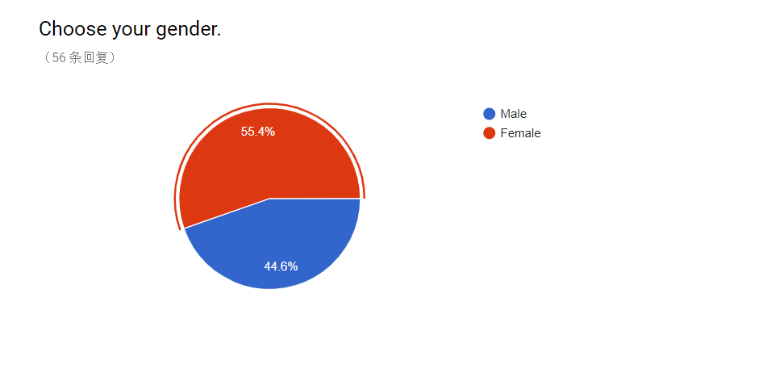

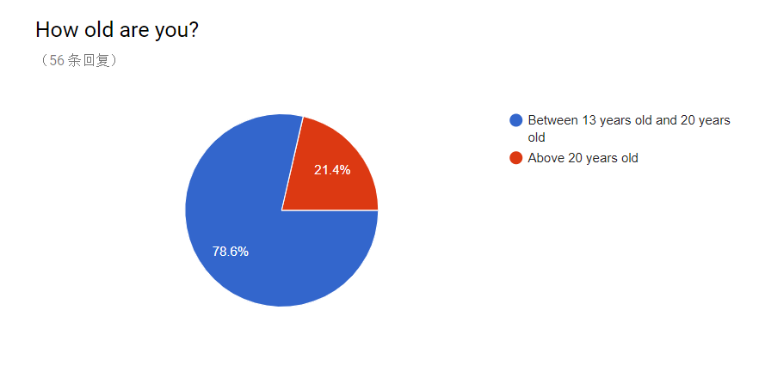

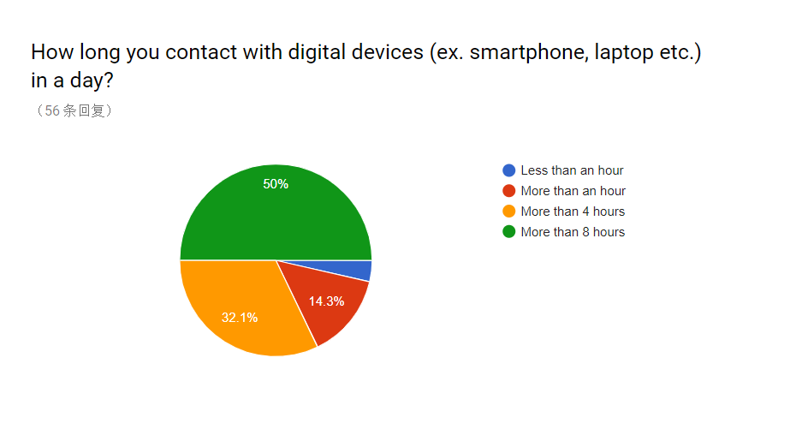

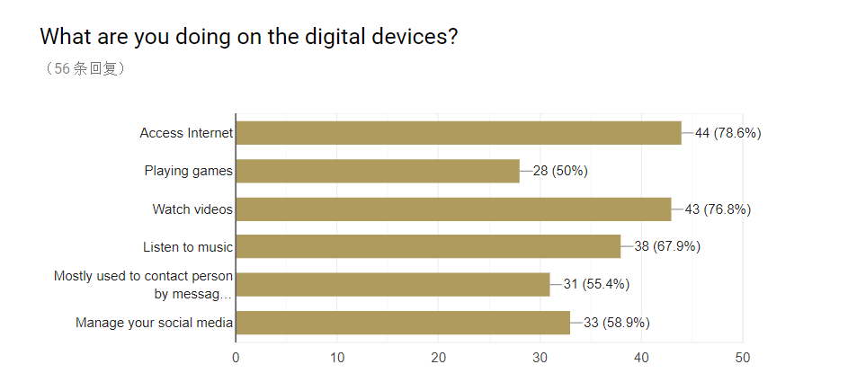

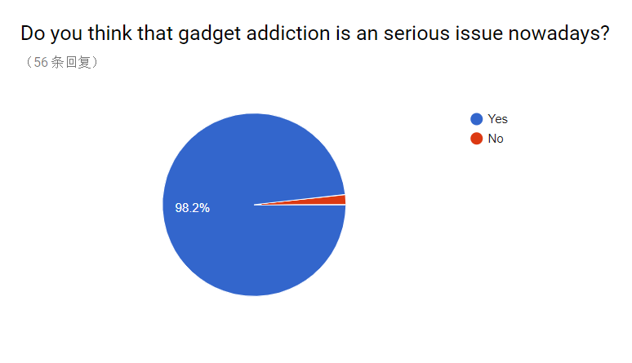

The responders of my survey are mostly from teenagers or students who are between 13 years old and 20 years old, which occupied 78.6% among 56 responders. The responders are mostly female which are 55.4% from 56 responders. There are half of 56 responders contact with digital devices more than 8 hours in a day, followed by 32.1% of 56 responders who are contact with digital devices more than 4 hours. It proves that the gadget addiction is really an issue nowadays and happen in teenager’s life. They spent more than 4 – 8 hours in a day with gadgets. In my opinion, if they spend the time on the other things, I think that they will gain something which are advance to their life such as participate in physical activities to gain life experiences. Most of them are using digital devices to access internet which are 78.6%, followed by watching videos which are 76.8% from 56 responders. Lastly, the result show that 98.2% of 56 responders are think that the gadget addiction is a serious issue nowadays.

**References**

1. Report: Kids Who Use Gadgets with Bad Posture Are Practically Placing 27kg On Their Necks; Published on 22th March 2018; last surveyed on 5th November 2018; <https://www.worldofbuzz.com/report-kids-who-use-gadgets-with-bad-posture-are-practically-placing-27kg-on-their-necks/>
2. The Star - A growing addiction; Published on 5th December 2016; last surveyed on 13th November 2018; <https://www.thestar.com.my/news/nation/2016/12/18/a-growing-addiction-as-internet-addiction-tightens-its-grip-on-asia-sunday-star-speaks-to-experts-ab/#Upe0qcKER9OsYlWv.99>
3. Internet Addiction: A Handbook and Guide to Evaluation and Treatment; Edited by Kimberly S. Young, Cristiano Nabuco de Abreu; Published on September 2010; Published by John Wiley & Sons, Inc.; last surveyed on 5th November 2018;<https://books.google.com.my/books?id=C_omSZQyfYcC&printsec=frontcover&dq=gadget+addiction&hl=en&sa=X&ved=0ahUKEwjkjNG4x9HeAhXvYt8KHelHCN8Q6AEITzAH#v=onepage&q=gadget%20addiction&f=false>
4. Glow Kids: How Screen Addiction Is Hijacking Our Kids - and How to Break the trance; By Nicholas Kardaras; Published on August 2016; Published by St. Martin’s Press New York; last surveyed on 7th November 2018; <https://books.google.com.my/books?id=Ka5nCwAAQBAJ&printsec=frontcover&dq=gadget+addiction&hl=en&sa=X&ved=0ahUKEwjM_qnBx9HeAhVtT98KHdfkDPA4ChDoAQgnMAA#v=onepage&q&f=false>
5. The New Straits Times - Gadget addiction can lead to pornography; Published on April 2018; last surveyed on 7th November 2018; <https://www.nst.com.my/opinion/letters/2018/04/355036/gadget-addiction-can-lead-pornography>
6. The New Straits Times - Give attention not gadgets; Published on January 2017; last surveyed on 7th November 2018; <https://www.nst.com.my/news/2017/01/208476/give-attention-not-gadgets>
7. Borneo Post Online - Gadget-addicted children could contract pseudo-autism – specialist; Published on March 2018; last surveyed on 7th November 2018; <http://www.theborneopost.com/2018/03/23/gadget-addicted-children-could-contract-pseudo-autism-specialist/>
8. AppliedBehaviorAnalysisEdu.org - How Do You Identify Signs of Autism in Young Children?; last surveyed on 7th November 2018; <https://www.appliedbehavioranalysisedu.org/how-do-you-identify-signs-of-autism-in-young-children/>
9. Phubber; Published on April 2015; Published by Ray Du English; last surveyed on 13th November 2018; <http://rayduenglish.com/phubber/>
10. Vulcan Post - Malaysian Youngsters Are More Affected By Internet Addiction Than You Think; Published on 2014; last surveyed on 13th November 2018; <https://vulcanpost.com/26961/internet-addiction-harming-youngsters-malaysia/>
11. The Malaysia Times - Internet addiction making youths weak; Published on 11th August 2014; last surveyed 13th November 2018; <http://www.themalaysiantimes.com.my/internet-addiction-making-youths-weak/>
12. ResearchGate - Relationship between Smartphone Addiction with Anxiety and Depression among Undergraduate Students in Malaysia (Research Article); Published on January 2018; Author: Norbaidurah Ithnain, Shazli Ezzat Ghazali, Norrafizah Jaafar; International Journal of Health Sciences & Research Issue: 1; last surveyed on 13th November 2018; <https://www.researchgate.net/publication/323118342_Relationship_between_Smartphone_Addiction_with_Anxiety_and_Depression_among_Undergraduate_Students_in_Malaysia>