

**Course Technology and Information System**

**( SECP 1513 )**

|  |  |
| --- | --- |
| Assignment type | Group 5 |
| Semester/Year | Semester 1 2020/2021 |
| Title Design Thinking | Tracker Alarm ( I - ONE ) |
| Title Chapter | Chapter 6 : Input and Output |
| Prepared for | Dr. Zuraini binti Ali Shah |
| Section | 08 |
| Submission Date | 15.11.2020 |
| Prepared by | 1) Ahmad Nazran Bin Yusri ( A20EC0179 )  2) Ethan Leong Yi Thian ( A20EC0033 )  3) Nur Afikah Binti Mohd Hayazi ( A20EC0220 )  4) Megat Irfan Zackry Bin Ismail ( A20EC0205 ) |

|  |  |  |
| --- | --- | --- |
| No. | Title | Page |
| 1. | INTRODUCTION | 3 |
| 2. | DETAIL STEPS AND DESCRIPTIONS | 4 |
| 3. | DETAILED DESCRIPTION | 5 |
| 4. | DESIGN THINKING EVIDENCE | 6 |
| 5. | REFLECTION | 15 |
| 6. | TASK ASSIGNMENT | 16 |

TABLE OF CONTENT

**Tracker Alarm ( I - ONE )**

**1.0 Introduction:**

Design thinking is a skill to create a new thing by modifying the existing application. This skill requires the inventors to have critical thinking and analysis to fulfill the user's requirement and provide the solution to solve the problems.

Based on the topic Input and Output, this report is mainly about creating a device related to input device and output device to secure any personal belongings in our daily life.

**Input and Output**

Input devices convert what we understand into what that system unit can process. Output devices convert what the system unit has processed into a form that we can understand. In this project, we have created a device which function to secure people belongings. In the device, a fingerprint scanner is used in the interface app as an input device and a buzzer is added into the alarm as an output device.

**2.0 Detail Step and Descriptions**

**Empathy**

Empathy is the stage where we should understand the problems faced by our respondent. Recently, we have reached out to the community by using Instagram’s question poll to collect our data about difficulties faced by the community. Due to the Movement Control order (MCO) of the pandemic, we have conducted our survey and interview via phone calling and social media platform.

**Define**

Define is the stage for us to identify the problems faced by the respondent. After having survey from the social media, we have pointed out the most critical reason for a theft crime. In this phase, we have conduct group meeting to discuss about problem face by the responder and prepared list of solution to reduce or trying to eliminate the theft crime happen.

**Ideate**

Ideate is the stage for us to brainstorm so that we can generate all possible solutions based on the problem defined. After having discussion, we came out with many solutions. Lastly, we have chosen the most effective solution based on 3 categories which are rational, intermediate and radical to be written in the report.

**Prototype**

Prototype is the stage for us to select the most suitable idea from the possible ideas and turn the idea into a virtual product. Our prototype is a set of devices with two component that alike with pentagon shape. The first component is a tracker and the second component is an alarm The material and application we used to build the prototype is paperboard, spray paint and colour pencil.

**Test**

Test is stage where our product tested by our user and their feedback help us to identify the limitation of the product. In this test phase, we explained and demonstrated the features of I-One. Moreover, we have made a feedback form with our product’s description and collect feedback from community.

**3.0 Detailed description**

**Problem**

After surveying and interviewing the responder, we have concluded that most of them are facing insecurity in the public because of theft crime. Physically, theft is the major reason which causes insecurity to the community.

**Solution**

After having group discussion, we have suggested some solution. We think that maybe theft crime can be reduced by technology, and thus, we have worked out with a portable UI tracker alarm. The interface for users has 3 options which are manually activate the buzzer alarm, set the minimum distance the user wants to make the alarm ring and track exact location and map of the tracker.

**Team Working**

The group member is being assigned with different task. Ahmad Nazran Bin Yusri is mainly focus on making prototype; Ethan Leong Yi Thian is mainly focus on the report; Nur Afikah Binti Mohd Hayazi is mainly on the designation of prototype; Megat Irfan Zackry Bin Ismail is mainly on collecting data from the community. Production of video is made by every member.

During the process, we face a lot of difficulties such as no time for conducting face meeting. The most brutal difficulty is different idea for prototype from each member. Lastly, we managed to combine out idea to make a more perfect product.

**4.0 Design Thinking Evidence**

**4.a Sample Work**

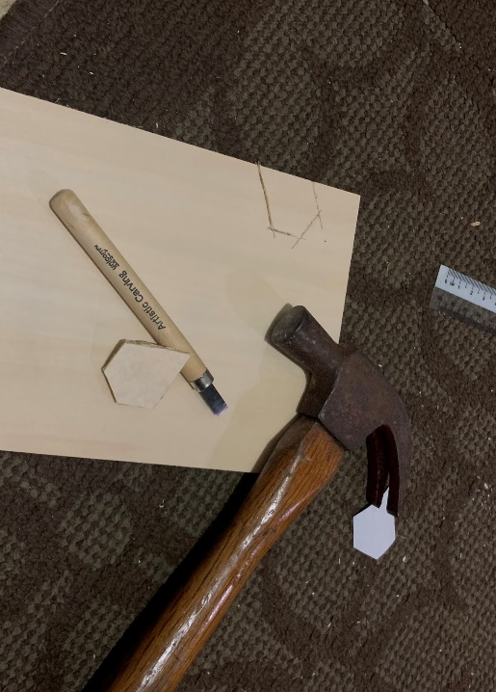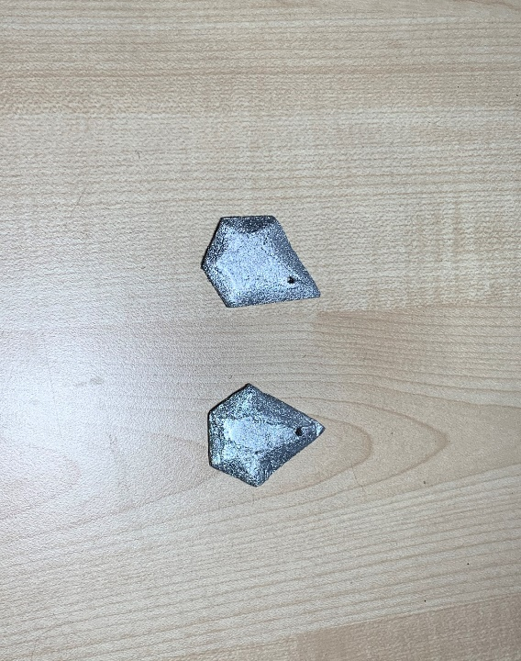

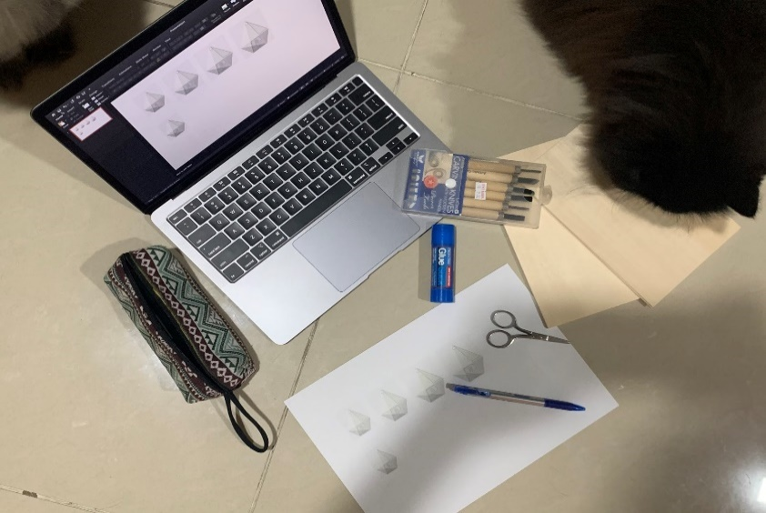

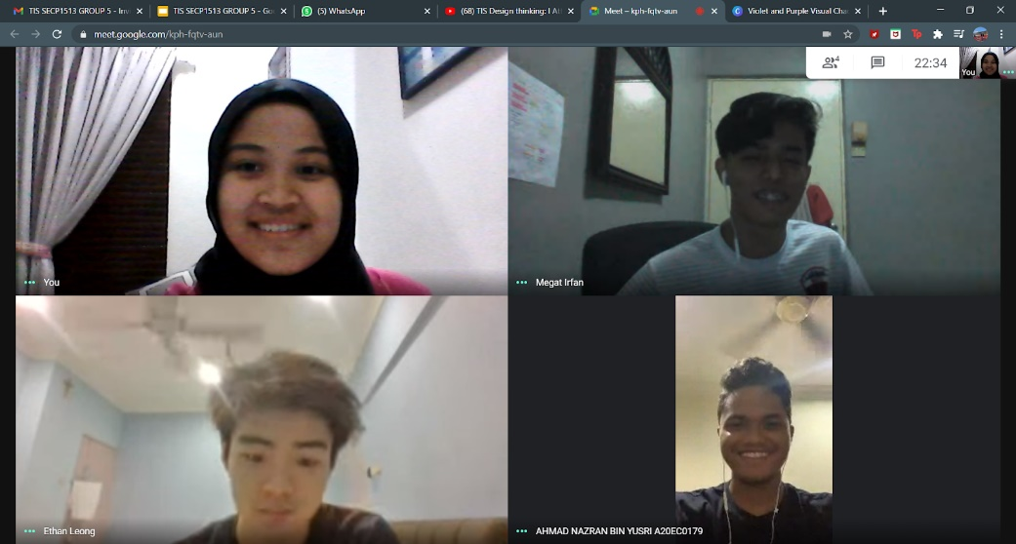

**3.b Record for each face**

Empathy:

Tables below show question and answer from interview:

|  |  |
| --- | --- |
| Introduction to subject | Yee Ze Hong  19 years old  A software engineering student in Xiamen University Malaysia |
| Targeted subject | Himself |
| Question 1: What do you often worry at public places? | I feel insecure when I am in a public crowd. I meant that I am worried someone will steal my belongings without my concerns, and I believe that many people will also feel worried about this problem. |
| Question 2: Do you own a lot of personal belongings when you go out? | Not much, usually is my wallet, phone and keys. I will carry a bag if I have to bring a lot of stuff to go out. But basically, I only take my wallet, phone and keys to shopping. |
| Question 3: How would you describe yourselves when you carry along many personal belongings outside? | I will describe myself as a careless person as my things always go missing no matter is in my house or going out. Besides, I feel that every person is like me which is a lack of awareness because thinking that we will not be the target by theft. |
| Question 4: Do you have experience with being a victim of theft crime? Do you mind sharing your experience? | Yes, of course I will. This happened to me last year when I went to a shopping mall. I was being rest assured to scroll my phone sitting on a bench. I put my wallet in the pocket as usual. Without my concern when I decided to leave, I noticed my pocket is not full enough, I can't feel my wallet. At that moment, I realized that somebody had got to my wallet. But it is too late for me to find it. So, I need to make a simple report at the police station for my identification. Besides losing some cash, I need to terminate all my credit and debit cards, making me so much in trouble. |
| Question 5: In your opinion, what can be done to solve theft crime? | I think the most important things to do is always be alert no matter where you go. Playing phones outside is really not a good habit. We need to pay responsibility to our own belongings. Besides, I think that shopping malls should have 100% coverage of CCTV views so that if anything happened, the replay might be a help to the police department. |

**Table 1**

|  |  |
| --- | --- |
| Introduction to subject | Aiman Hakimy  19 years old  A software engineering student in Universiti Teknologi Mara |
| Targeted subject | Aiman Hakimy’s mother  56 years old |
| Question 1: What do you often worry at public places? | I am afraid of thieves especially pick- pockets although it didn't happen to me before. I am a very cautious person to secure my belongings well. However, this sometimes makes me tense because I need to always be prepared if something happens. |
| Question 2: Do you have experience with being a victim of theft crime? Do you mind sharing your experience? | For me no, but my mother did experience it right before MCO happened. At that time, I was still staying at my hostel in the university. I feel so angry that those snatchers even targeted an old lady. That day, my mother is heading to the market to fill in some groceries as lockdown is happening soon. She goes by herself as nobody is in the house. Just when she is near the market, not yet entering the crowd, two men on a motorbike snatched her purse and just ran away. However, other people did not notice as they were busy in their hands. |
| Question 3: Does your mother own a lot of personal belongings when she goes out? | Actually no, but she always brings a lot of cash when she goes out as she does not own any e-wallet. I think this is the main reason why she is targeted by the snatchers. |
| Question 4: In your opinion, what can be done to solve theft crime? | Firstly, we need to eliminate any catalyst that triggered the snatcher's desire to commit theft crime, I think elderly must have their own e-wallet so that they no need to bring so much cash whenever they go out. Secondly, people should be more giving attention to the surroundings. Otherwise, the authorities such as community centers can send some people to petrol. |

**Table 2**

Evidence photo of conducting survey and interview as below:

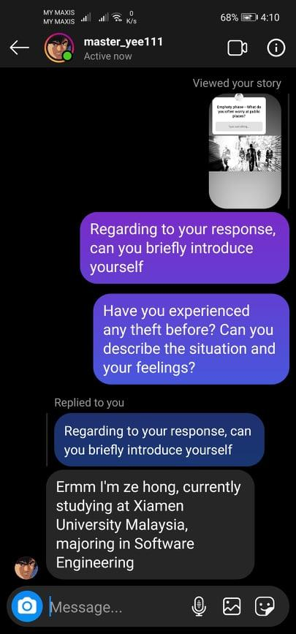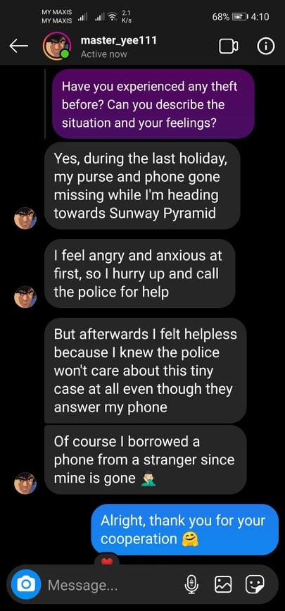

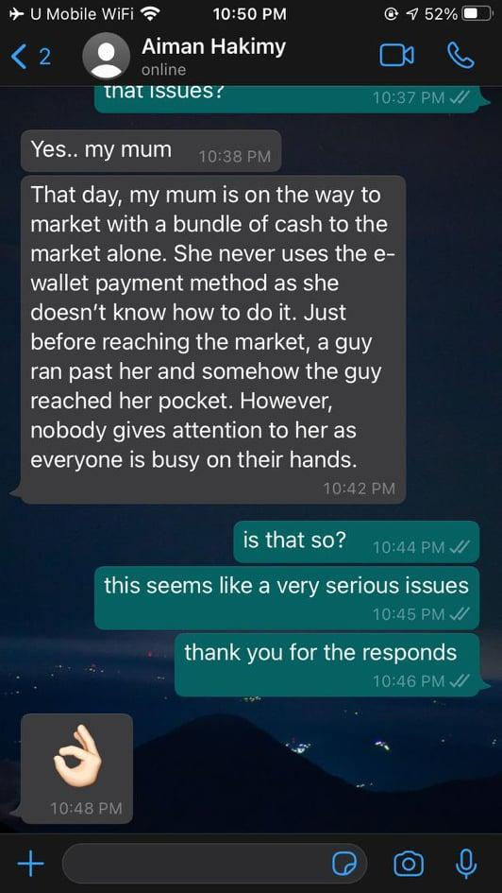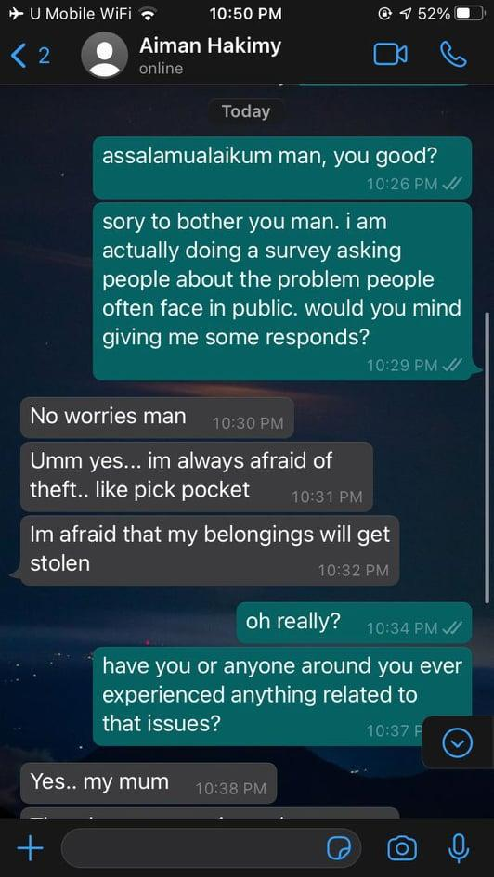

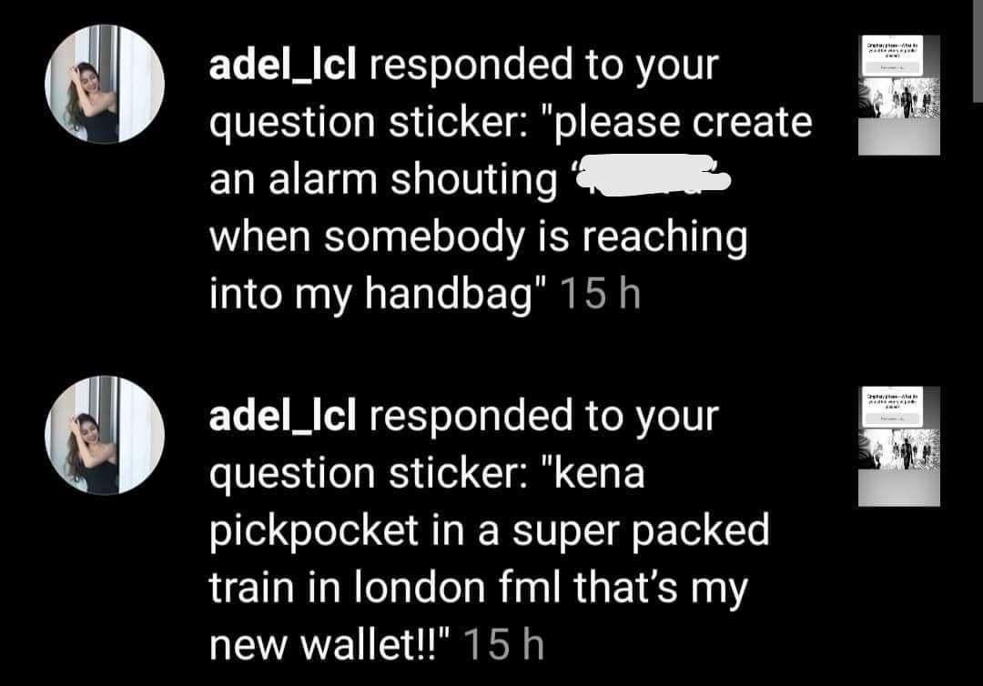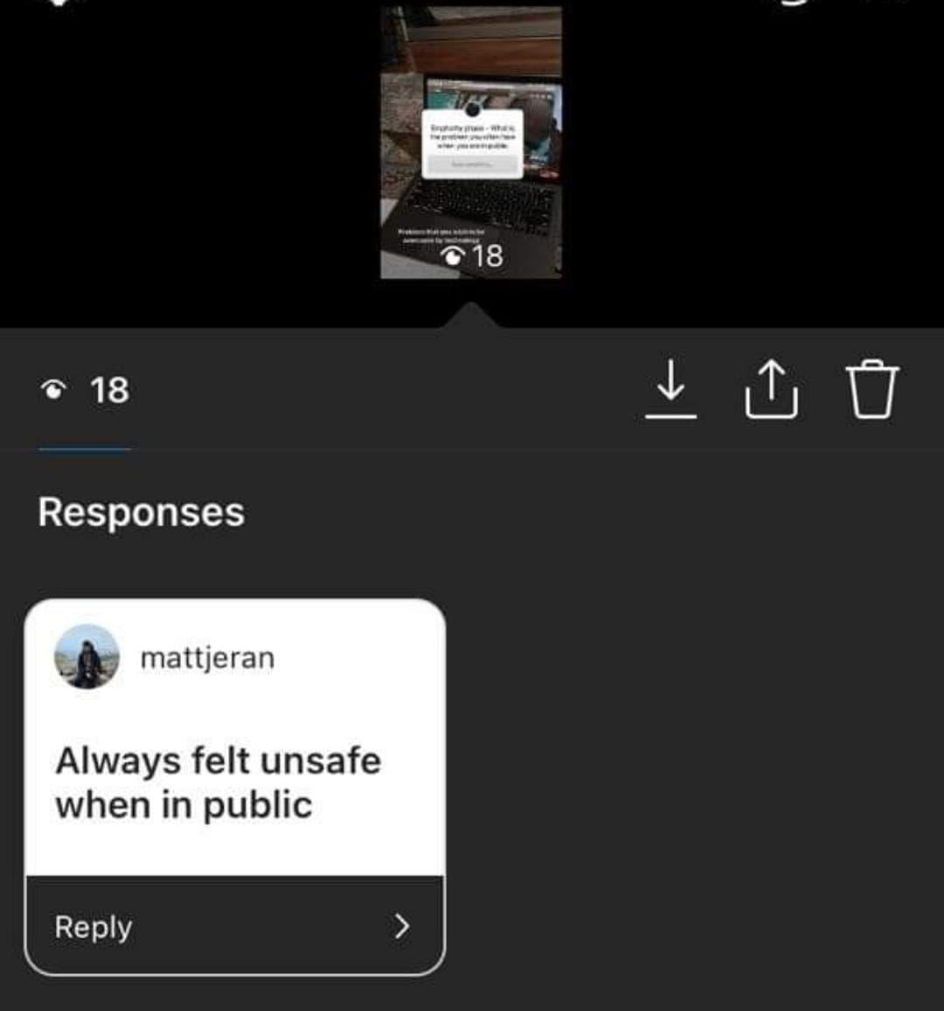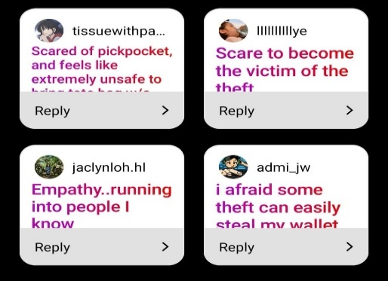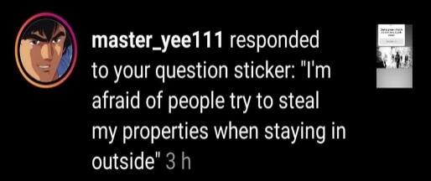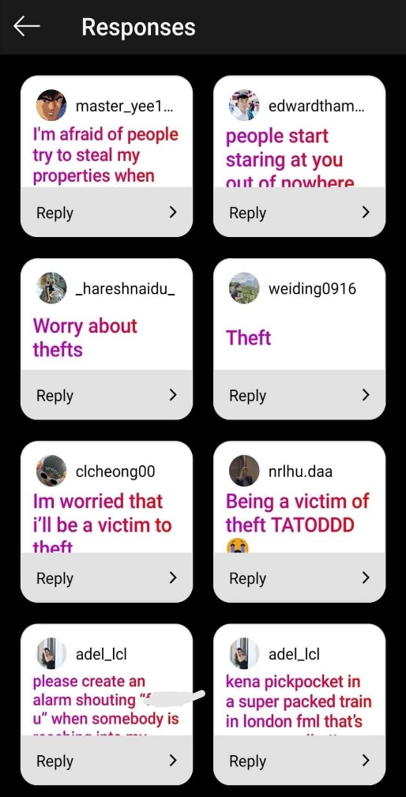

Define:

Possible problem that cause crime theft is shown as table below :

|  |  |
| --- | --- |
| Problem | Description |
| People lack of awareness | When people are focusing on playing phone, this provide an opportunity for theft to commit the crime. Some people even notice their belongings is being stolen when they reach their home. |
| Elderly people are lack of knowledge | They have to carry a pile of cash in their wallet which probably may give rise to desire in theft crime |
| Pedestrian or passerby are too selfish | They are busy focusing with their own task until neglect people at their surrounding needed help |
| Deserted place such as alley, construction area and others | People always take advantage in deserted site as a shortcut. However, this is the perfect location for committing whatever crime as there are less witnesses or even don’t have |

**Table 3**

Ideate:

Possible solution after brainstorming is shown as table below :

|  |  |  |
| --- | --- | --- |
| Rational | Intermediate | Radicle |
| * well educated with awareness and always advise to be alert * free classes such as learning how to use e-wallet conduct by community centers | * deserted roads or site needed to be closed to prohibit people entering or passing * Enforcement of law such that increase penalty for minor crime * Road patrol | * creating a device which has a safety input and a lofty tone of output when your belongings are too far from you. |

**Table 4**

Prototype:

After the group discussion, we have decided to use the radicle solution which is creating our product I-One. Table below is description, specification and functionality of our product:

|  |  |
| --- | --- |
| Name | I-One |
| Component | 2 components in a set. One is a tracker and the other is an alarm. Application is available to downloaded as interface with the tracker and alarm. |
| Product overview | The tracker and alarm are combined to build a pentagon shape (which is in deactivated form). The tracker is connected via Bluetooth and Global Positioning System with smartphones. Users can use the interface application to set the maximum distance between tracker and alarm. Once the tracker is brought away from the distance, the alarm will ring.  **Interface applications provide three function: -**   1. activate and deactivate the buzzer alarm 2. setting the maximum distance for tracker and alarm 3. track exact location and map of the tracker.     **A Fresh Design with Keychain Port**    Keychain Port is available for buckling at anything  **Intelligent Touch, Absolute Comfort**    Hold your phone comfortably with one hand, while a more advanced fingerprint access to unlock the application |
| Specifications | Tracker & Alarm:  Item Weight : Approximate 60g  Bluetooth : Yes  GPS : Yes  Alarm : 80dB |

**Table 5**

Test:

After finishing the prototype, we have made some demonstrating option to users about how to use the tracker and alarm. User have multiple option to choose such as picture below, feedback is then recorded from the community. :

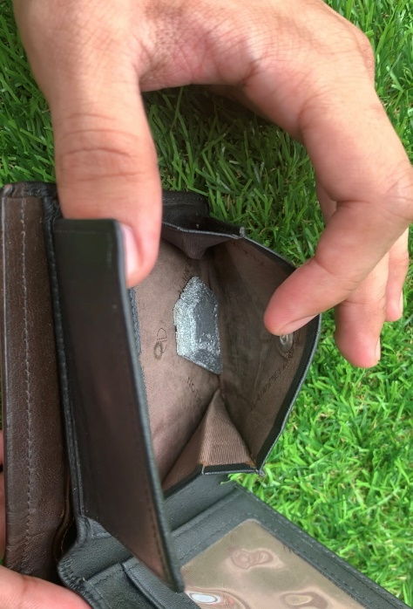

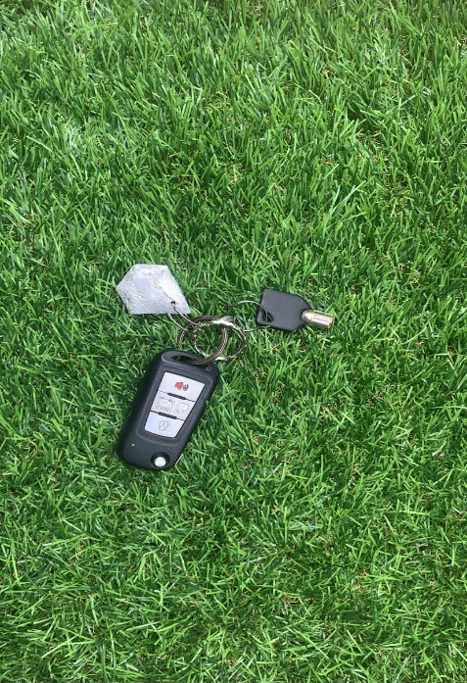

**5.0 Reflection**

Regarding to my study course, my goal is to graduate my study course with flying colours and I hope to be a person who can contribute to the community in the future. I

**6.0 Task Assignment**

|  |  |
| --- | --- |
| Members | Task Assigned |
| 1. A person standing on a beach     Description automatically generatedAhmad Nazran | - Making and testing prototype - Testing the prototype  - Writing report  - Video design thinking |
| 1. A person standing in a room     Description automatically generatedEthan Leong | - Conducting survey from community  - Interview to respondents  - Writing and compiling report  - Video design thinking |
| 1. A person smiling for the camera     Description automatically generatedNur Afikah | - Design prototype  - Design app interface  - Writing report  - Video design thinking |
| 1. Megat Irfan Zackry    | - Conducting survey from community  - Interview to respondents  - Writing report  - Video design thinking |