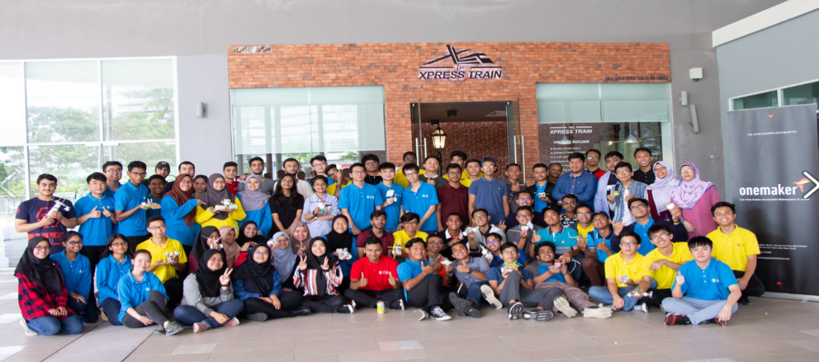

Issue

***OneMaker***

*WHO IS ONEMAKER ?*

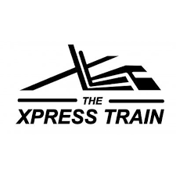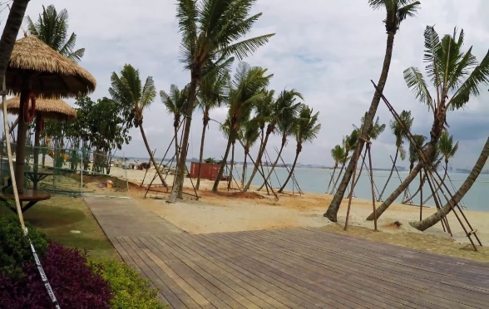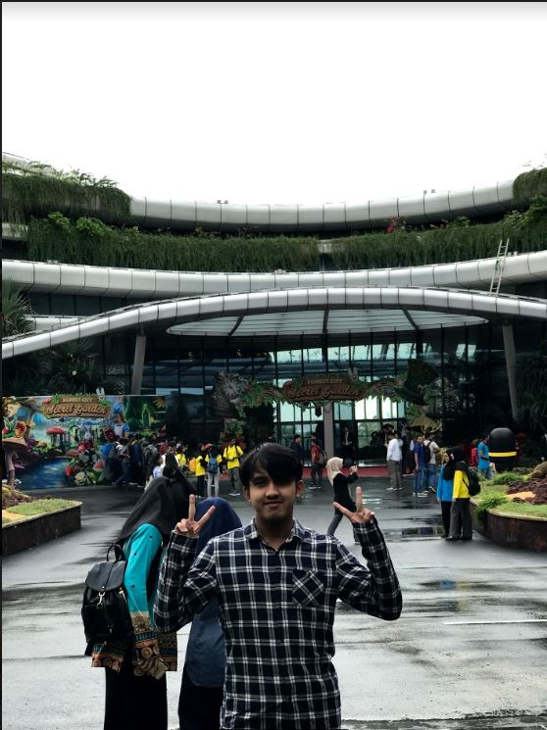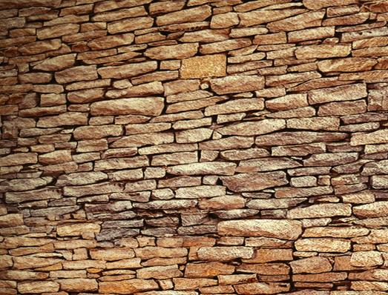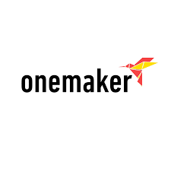

We arrived at Medini Mall 10 a.m. student were separated into two big group which are Group A and Group B. in the morning session, there was two activity. The first activity was conducted by VRgini, second activity was conducted by The Xpress Train. The activity was run simultanouesly, so from 10 a.m-12 a.m. , group A was having activity with VRgini, while group B with The Xpress Train. For the second session, the activity were running vise versa.

On 24th November 2018, the student who is taking Software Engineering under School of Computing from Universiti Teknologi Malaysia (UTM) had to visit Medini Mall to attend the industrial talk conducted by OneMaker group. We student gathered in front of CICT before went to Medini Mall. Total student and lectures were about 150 due to some student did not attend because of health problem. We departed at 8.00 a.m., we stopped at Forest City before arrived at Medini Mall. Forest City is made up of four man-made Islands spanning 3,425 acres off the Iskandar, Johor Bahru in Malaysia. It is also very near to Singapore, just a forty minute drive so you can access it from there too.

OneMaker Group Pte Ltd (OMG) is a leading Maker-centric service provider in the region. OneMaker business was including Maker education, digital prototyping services and corporate professional development.

For more information:

info@onemakergroup.com

**A REPORT ON INDUSTRIAL VISIT**

*VENUE : MEDINI MALL*

*SUPPORTED BY : ONE MAKER*

*DATE : 24TH NOVEMBER*

Lastly the speaker talked about mixed reality. Mixed reality like its name, it is basically the combination of virtual reality and augment reality. Also known as the result of combining physical world and digital world. Mixed reality is the result of human, environment and computer interaction and evolution, that makes everything possible.

***ACTIVITY 1***

***ACTIVITY 2***

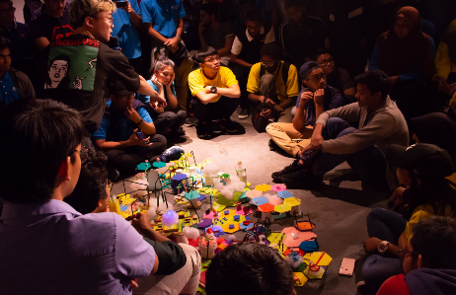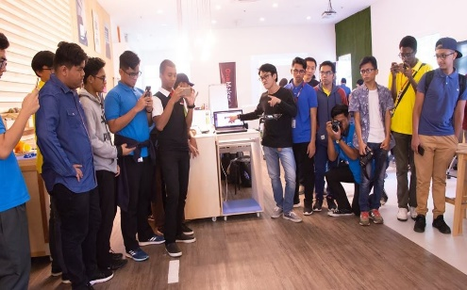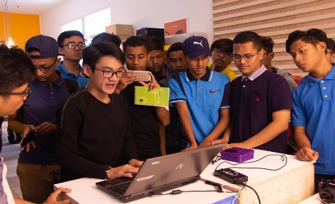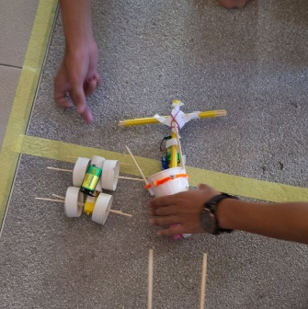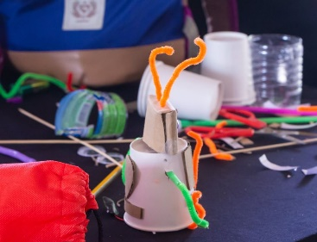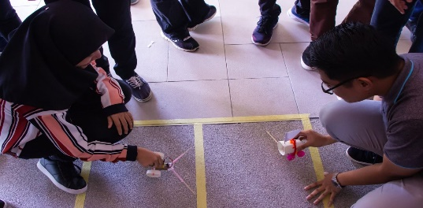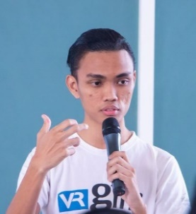

**FUTURE SCHOOL**

To wrap up, all of the activities held by OneMaker taught us a lot new things that we never realized its existence. It is a great program to improvise our knowledge and confidence when talking to large audience. We are really happy and satisfied will all the utility and service provided by them-_and also FOOD! We expected to have another field trip like this or maybe even better in the near future.

For the third workshop arranged by OneMaker, we were needed to build any section that we like for our future school via our own imagination and functionality. We created the section by using tools provided by OneMaker such as cotton, wool, cardboard and polymorph. This workshop started on 5 p.m. and ended after 2 hours. After we completed building the school section, we are required to explain the section we made and the purposes.

What the user needs to make sure is the computer and the drone is being connected to the same wifi network. The fourth workshop required students to use their own computer to open some software called SketchUp and design something according to the crew instructions. The last workshop is the 3D Printing workshop. During this workshop, the crew briefly explain how the 3D printing is mainly being used in the industry. Student also can try to do some 3D printing with the provided machine during this workshop.

Next, the second workshop is the mini robot that moving around according to the colour code that has being programmed in the robot. Student can make their own path for the robot using the provided colour pen based on the colour code given by the crew. The third workshop is involving drones flying using an instruction or code that can be writes using some certain software in the computer without using any controller to move around the drones.

The second session started around 2 p.m. until 4 p.m. During this session, there are five different workshops that the One Maker’s crew prepared for students. This session started with some talk from the crew on what the students will do during this session. The first workshop is an artificial intelligence workshop. In this workshop, the crew briefly explain how the AI is being used and students also can try to use the AI that the crew have prepared for them.

Augmented reality is the combination of digital information with the environment in real time, augmented reality uses the existing environment and overlays the new information on top of it. For example, snapchat and snow which is both of them are mobile application that is popular among users because they provide cute filter.

The first speaker of the day is Syukri Radzi. He is responsible to a gave a talk about Virtual Reality (VR), Augment Reality (AR) and Mixed Reality (MR). Virtual reality is basically is the use of computer technology to create a new simulated environment. Instead of viewing the screen in front, virtual reality will make the users immerse and be able to interact with the 3-Dimension world. The only limit for virtual reality are the availability and the content of the computing power. Next, augmented reality.

*QUIRKYBOT COMPETITON*

***ask the experts >>>***

Option congue nihil imperdiet doming id quod mazim placerat facer minim veni am ut wisi enim ad minimeniam, quis erat nostr uexerci tation ullamcorper nostru exerci tation ullam corper et iusto odio dig nissim qui blandit praesent lupta. Tummer delenit augue duis dolore magna erat aliquam erat volutpat. Nam liber tempor cum soluta nobis sed.

*Option congue nihil imperdiet doming id quod mazim placerat facer minim veni am ut wisi eni ad minimeniam, quis erat nostr uexerci tation llam corper nostru exerci tation ullam.*