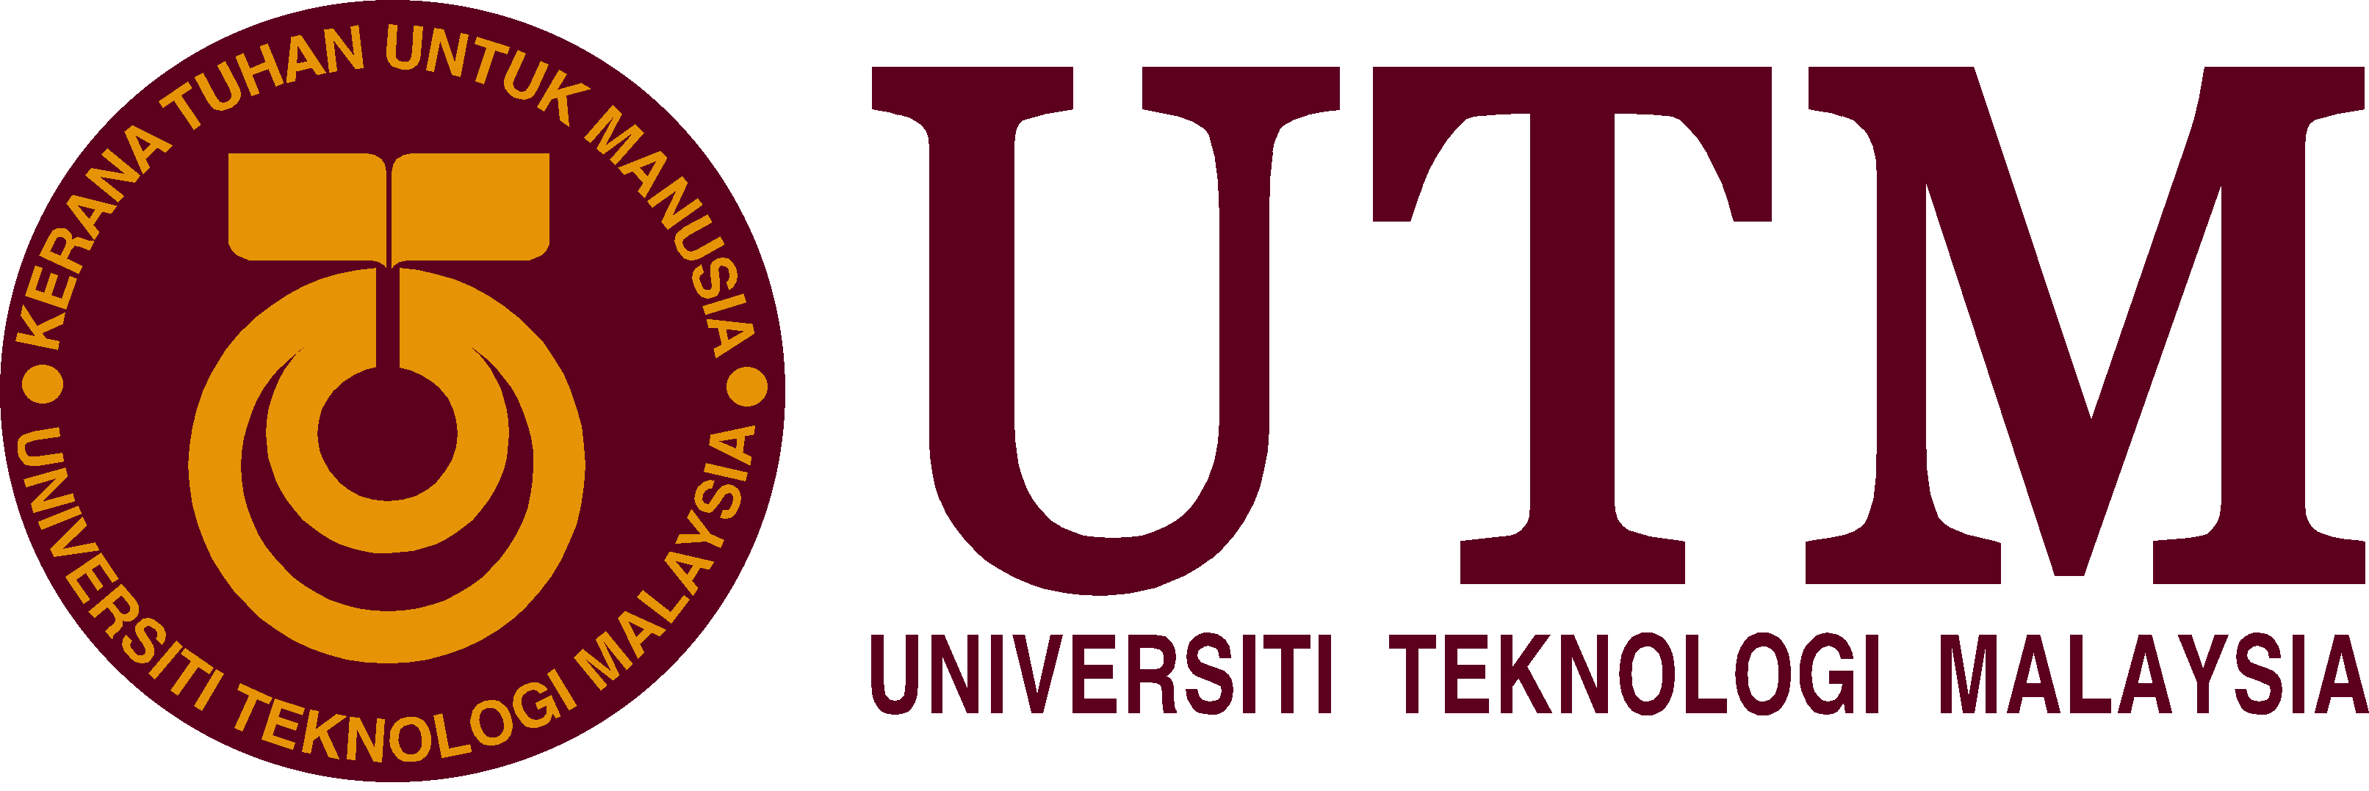

**SCHOOL OF COMPUTING**

**FACULTY OF ENGINEERING**

**SECP1513-08 TECHNOLOGY AND INFORMATION SYSTEM**

GROUP ASSIGNMENT

INDUSTRY VISIT: CICT

**_________________________________________**

COURSE : COMPUTER NETWORK AND

SECURITY

COURSE CODE : 1SECR

SECTION : O8

GROUP : 8

TEAM MEMBERS :

|  |  |  |
| --- | --- | --- |
| NO | NAME | MATRIC CARD |
| 1. | NUR MINHALINA BINTI ABDUL RAZAK | A19EC0135 |
| 2. | ATIFAH QOTHUNNADA SUPIANTO | A19EC0226 |
| 3. | MUHAMMAD HAZIQ BIN SULAIMAN | A19EC0196 |

LECTURER’ NAME : DR HASWADI HASAN

DATE OF SUBMISSION : MONDAY, 11TH NOVEMBER 2019

**INTRODUCTION**

Sunday, 20 October 2019 at 3.15PM, We are School of Computing’s student from subject Technology and Information System went to Perpustakaan Sultan Zanariah to do industry visit at Gallerium UTM which is at level 2. The purpose of this industry visit is to give student more knowledge about the history and development of computer hardware. The first thing we do when we arrived was waiting in front of Gallerium because there was another section who also doing their industry visit at the Gallerium too.

When we entered the Gallerium, it is divided into 3 types of Gallery, which are Information Technology Gallery, Audio Visual Gallery, and Microfilm Gallery. We were gathered at Information Technology Gallery while listening to the speaker who was explaining about the Gallerium.

UTM is one of the universities in Malaysia that have many older generation of computer hardware such as mainframes, supercomputer, back-up system, printer, hard disk, CPU and many more. The reason why the hardware was in a big size but small capacity is because in the past people tend to use small data and it does not have any colour for computer which consist only black and white.

From this visit, we had learned many information about the development of computer hardware and how human used technology in the past.

There were many technologies that had been used in Universiti Teknologi Malaysia (UTM) in the last century.

One of the early technologies used in UTM is the Mainframe Tape Subsystem IBM 9309. This rack enclosure with industry-standard dimensions that makes it suitable as a mounting enclosure and power distributor for hardwares. The purpose of this device is to serve as a backup for the mainframe system and staffs’ and students’ information and also other University’s information system. This device was used from the year 1987 to 1995.

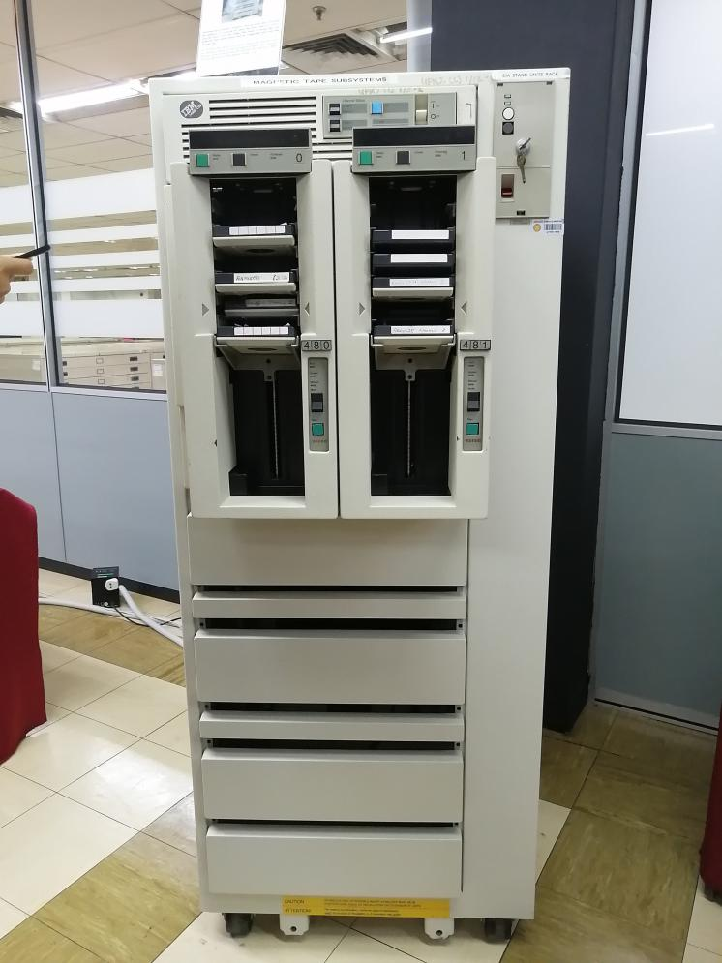

Mainframe Tape Subsystem IBM 9309

Another device that was used is the IBM POWERserver 550. The IBM POWERserver was considerably one of the fastest processing devices for its time. It was an effective system for medium-sized database at the time and was seen as a starting point of the information technology evolution and was of significance in UTM Library’s history.

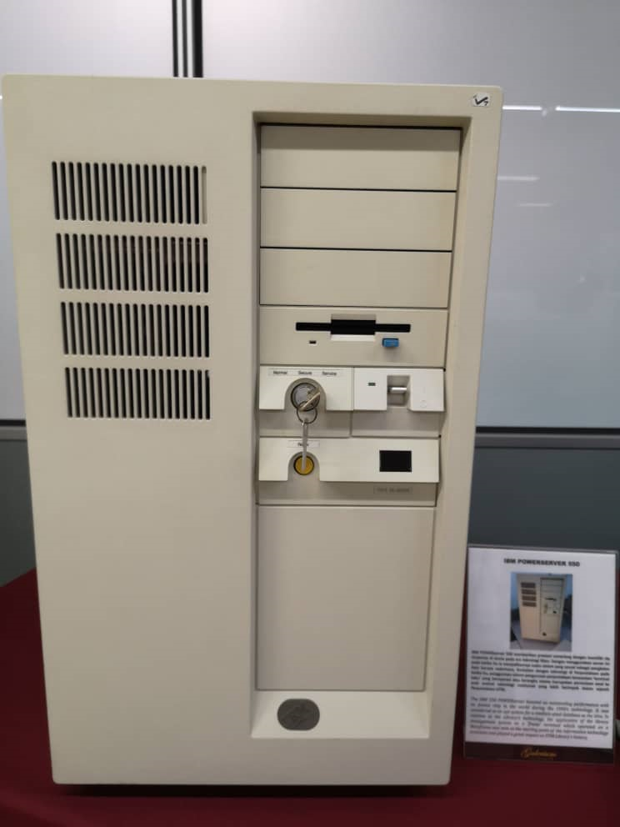

IBM POWERserver 550

The computer that was used in UTM is the IBM Personal System/2 Model 70 386. This personal computer is not as small as a laptop and is considered as a portable computer. The computer has 4 MB of RAM, 60 MB hard disk and runs IBM DOS 5.0 and Windows 3.0. Its processor runs at 20 MHz which is quite fast for its time. It has a high-density memory technology and many features integrated into it. The computer and its system greatly helped the library in performance improvement for desktop operations.

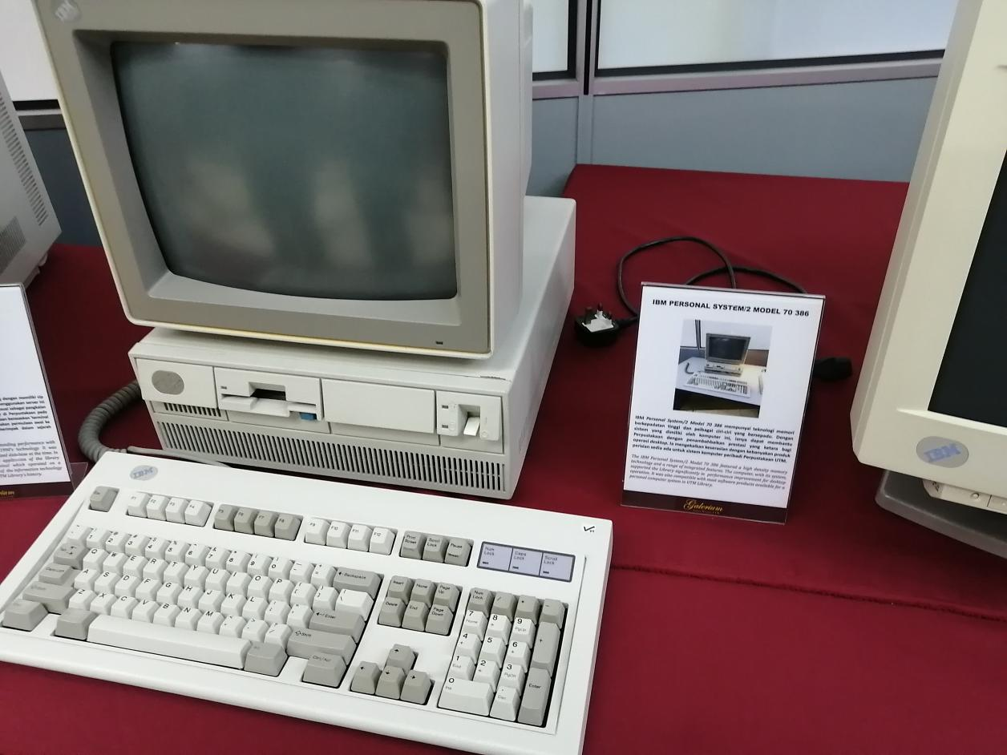

IBM Personal System/2 Model 70 386

Another type of computer that was used in UTM was the IBM Personal Computer 300GL. Due to its high affordability, UTM library are able to buy this computer. This computer was very helpful in increasing the library’s productivity and shows the system transformation and evolution that is constantly taking place in UTM library.

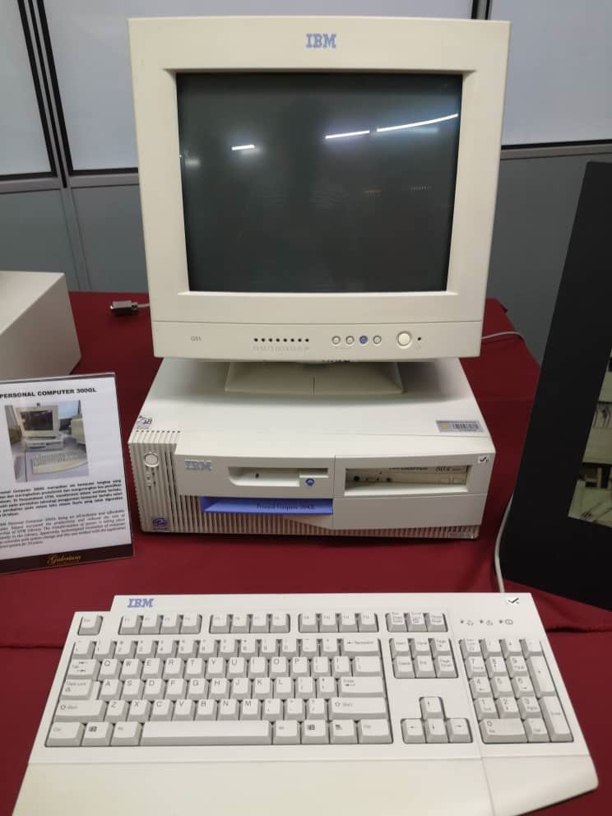

IBM Personal Computer 300GL

The Impact Printer IBM (4245) or also called the Dot Matrix is a printing machine used during the 1990s till 2011. This printer serves the purpose of printing the data information of students and staffs to meet the University’s requirements. It is also able to print many copies non-stop for 48 hours. This printer can print with speeds between 1,200 to 2,000 lines per minute using 48-charcter interchangeable print band.

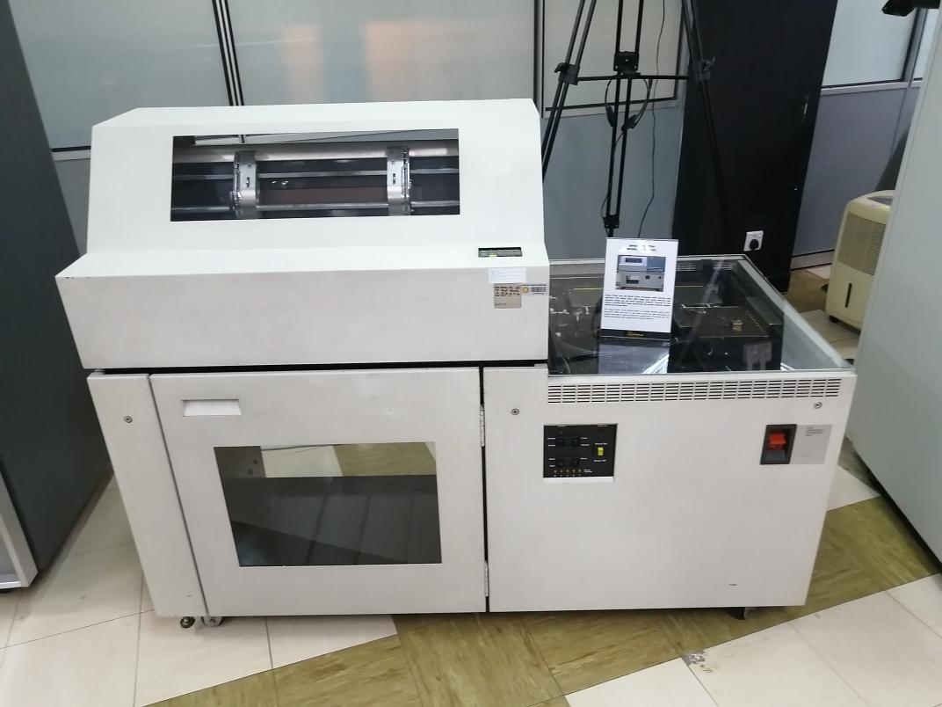

Impact Printer IBM (4245)

A wide variety of computer mice were used in the UTM library from the year 1980 until today. These mice are very easy to operate and are very affordable. These helps students to navigate the computer with ease and help them to find information and do their assignments.

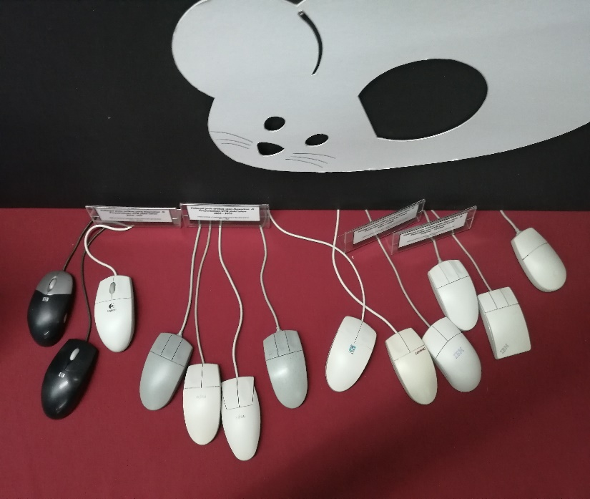

Wide variety of mice used by the UTM library

Process Camera was a gift from the Department of Survey and Mapping Malaysia (JUPEM) to help facilitate students in understanding the concept, steps and process of photography production. The camera is a horizontal process camera and was used by students who are in the Cartography Department, Faculty of Surveying from the early 1980s until late 1990s.

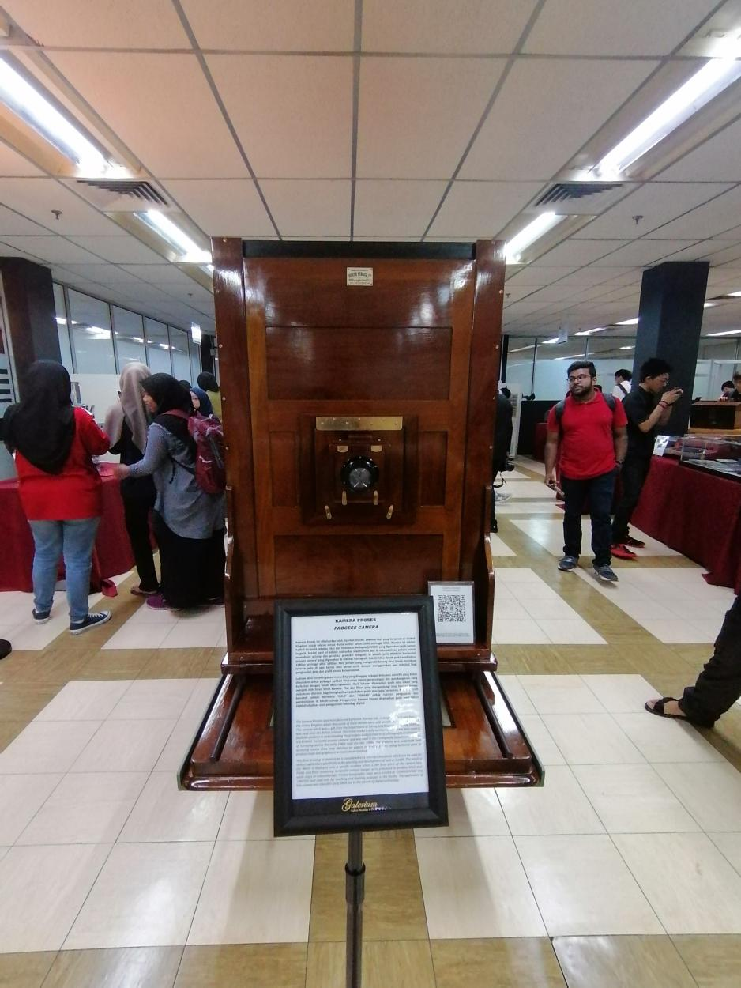

Process Camera

Another teaching tool that was used is the Radial Plotter. It was used by students who partake courses in the Department of Photogrammetry, Faculty of Surveying during the 1960s to 1990s to produce topographic maps. Students were taught about mapping basics and topographic mapping using photographs as the main data source.

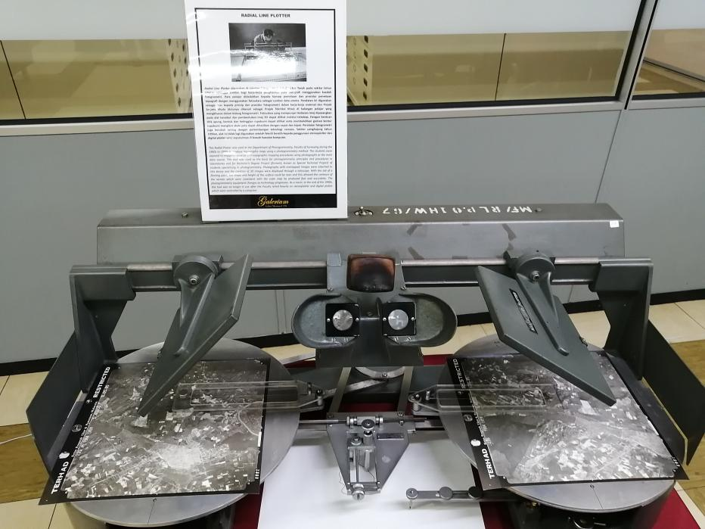

The Radial Plotter

The Microfilm Machine ‘Recordak Model’ or the Recordak ‘Micro-File’ is a machine that was used in UTM from around early 1980s until around 2007. This machine was used to capture small images found in UTM theses. The images are then recorded in to a small microfilm.

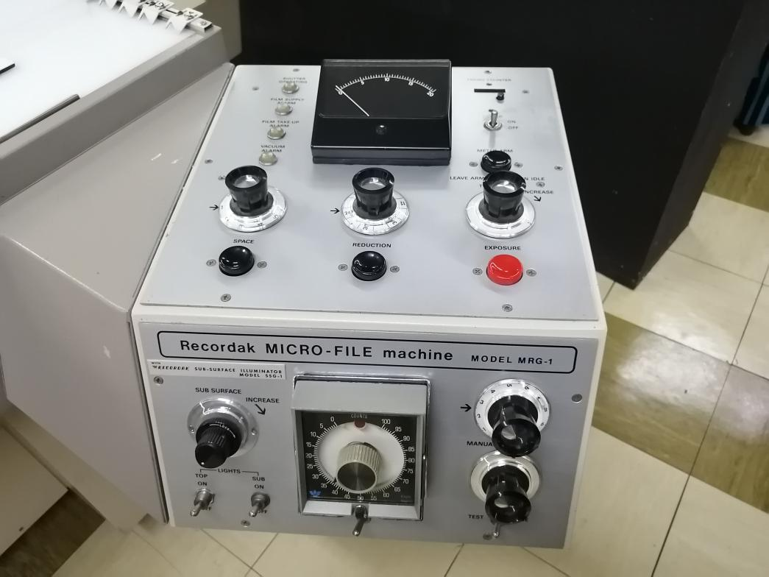

Microfilm Machine ‘Recordak Model’

Microfilms were used as a learning and reference medium in UTM during the 1980s until early 2000s. Microfilms are stored in boxes for easy storage. There are about 15,000 titles of microfilms in the library which includes theses, international journals, acts, newspapers and many more. These old microfilms are stored in an environmentally controlled storage at Media Materials Room, UTM library to preserve it.

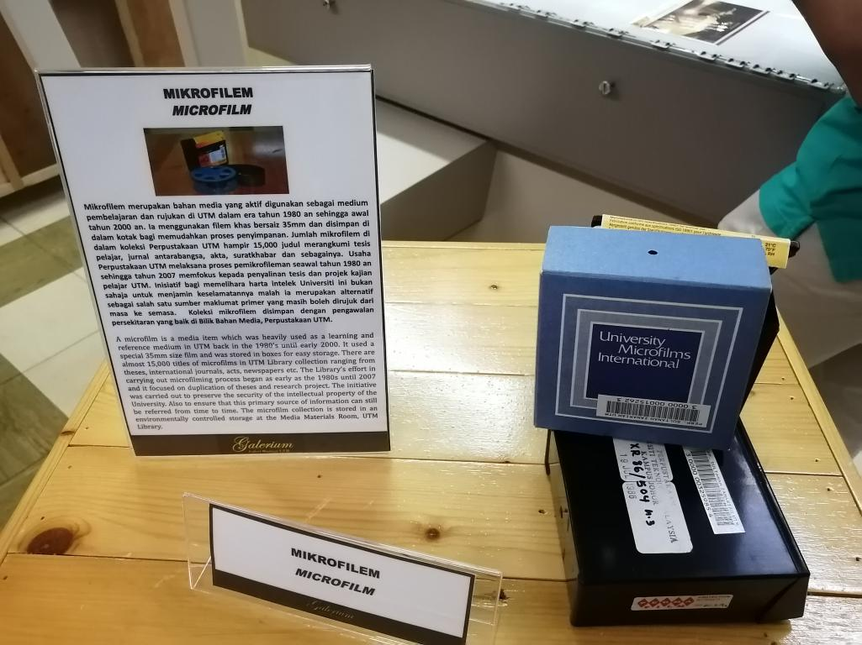

Microfilms

Hot stamping block was used in UTM back in 1978 featuring UTM logo and its previous motto ‘Untuk Tuhan dan Manusia’. This hot stamping logo which is gold in colour was used on official documents and publications and can be seen clearly against the buckram which is a type of cloth commonly used as book covers. The motto is then changed to ‘Kerana Tuhan Untuk Manusia’.

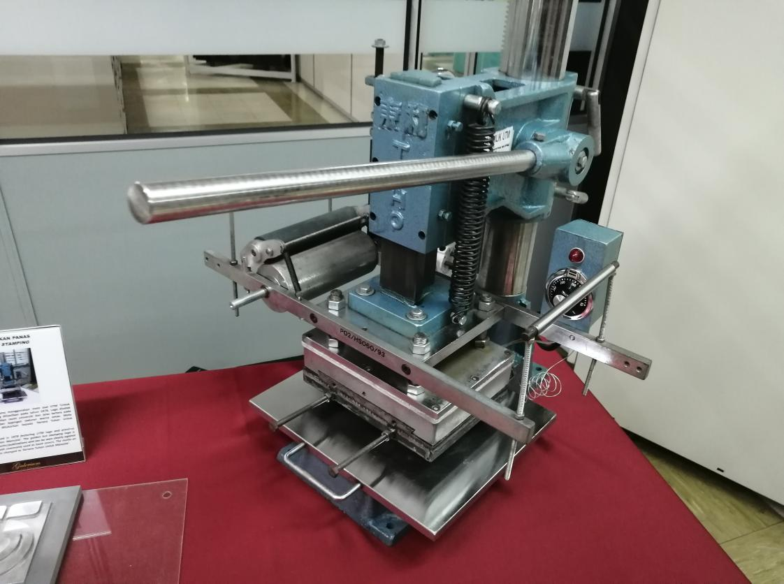

Hot Stamping Block

**Reflections**

The main goal for us as network and computer security students is to gain a lot of knowledge and practice more skills during our studies to prepare ourselves from the challenges we will face ahead in the future. The rapid growth of technologies can lead to many crimes such as modification, misuse and unauthorized access of personal information that involved users all around the world. Therefore, it is our goal to provide more security and help to protect their identity in the networks.

This visit showed us how technology has been developed over the years. It amazed us how people in the past can provide solutions to make the technologies more effective and user-friendly. From huge devices to smaller devices, from low storage to unlimited storage and many more. As the devices are getting smaller and smarter nowadays, there will be more possibilities of crime to happen among users. Therefore, this visit has an impact on our goals by making us aware of the challenges we will face in the future to maintain computer security.

The industries nowadays are searching for workers that are passionate and committed to their works. To improve our potential in the industry, we need to think creatively (outside of the box), being innovative, improve communication skills, work smart and able to provide a solution to every problem. Therefore, by having these potentials, we will able to create new technologies that can help secure the data and bring peace and justice in the digital era.