

**SCHOOL OF COMPUTING**

**SCSP1513-08 TECHNOLOGY AND INFORMATION SYSTEM**

**SECTION-09**

**REPORT ON INTERNET OF THINGS (IOT) OPEN DAY 2018**

**LECTURER : DR. AZURAH BINTI A SAMAH**

BADRUL FITRI BIN SHAIFULL NAIM A18CS0042

**Report on IOT Open Day 2018**

During the 18th of November, all of the Computer Science students were tasked to attend an industrial talk at the IoT Open Day 2018 that was held at the school of Electrical Engineering(SKE), PO3-221. The industrial talk started at 11am and ended at 1pm. The objective of the talk was to expose students to Internet of Things (IoT) to Universiti Teknologi Malaysia (UTM). It is also to encourage UTM students, especially the undergraduate final year students to further their studies in IoT related fields at School of Electrical Engineering(SKE) and School of Computing(SC). Vendors can promote their IoT based products, research findings, final year projects and related capstone labs projects. This program can provide opportunities of research collaborations between industries and researchers with Advanced Telecommunication Technology (ATT) and division of Communication Engineering(COMM) as well as SKE and SC. The first main talk was a talk given by Mr. Syahrul Haridz Suid who is an Enterprise Consultant from Hewlett Packard Enterprise. He talked about predictive maintenance and how it is transforming industries and machines that were previously out of reach.

Other than the talk, they also have posters exhibition where they display different types of projects that were made by UTM students. I will talk about some of the project posters that were displayed on that day. One of the projects is called Office Monitoring and Control System by Mohd Adib Sarijari. Office Monitoring and Control System is one of the many IoT applications. Since the introduction of IoT as a new technology, it has received a lot of attention in the recent years. The technology allowed interconnection between smart devices over the Internet network. The system will monitor the access to the office and control the electrical devices in the office. The system has the ability to provide secure access method by using Near Field Communication (NFC) technology in which NFC has a higher security level system as compared to RFID. Raspberry Pi 3 module is used as the gateway and the main controller of the system, while Raspberry Pi Zero W is used to implement the control system. The cloud will be set up to enable user to access the database and the server from a web-based software, through the gateway device. Next, the Graphical User Interface (GUI) is implemented to provide a user-friendly interaction environment. The problem on how to detect the connection between the client and the server has been found by using the IoT method called Heartbeat which can notify the user about the connectivity status between server and client. The work produces the system that can monitor the person enter and exit the building and can control the lighting lamp in the building through loT platform. The problem statements for this project are, limited human ability to monitor and control office access and electrical devices 24 hours a day, prevent unauthorised access to the office and the connection between the server and client is either online or offline.

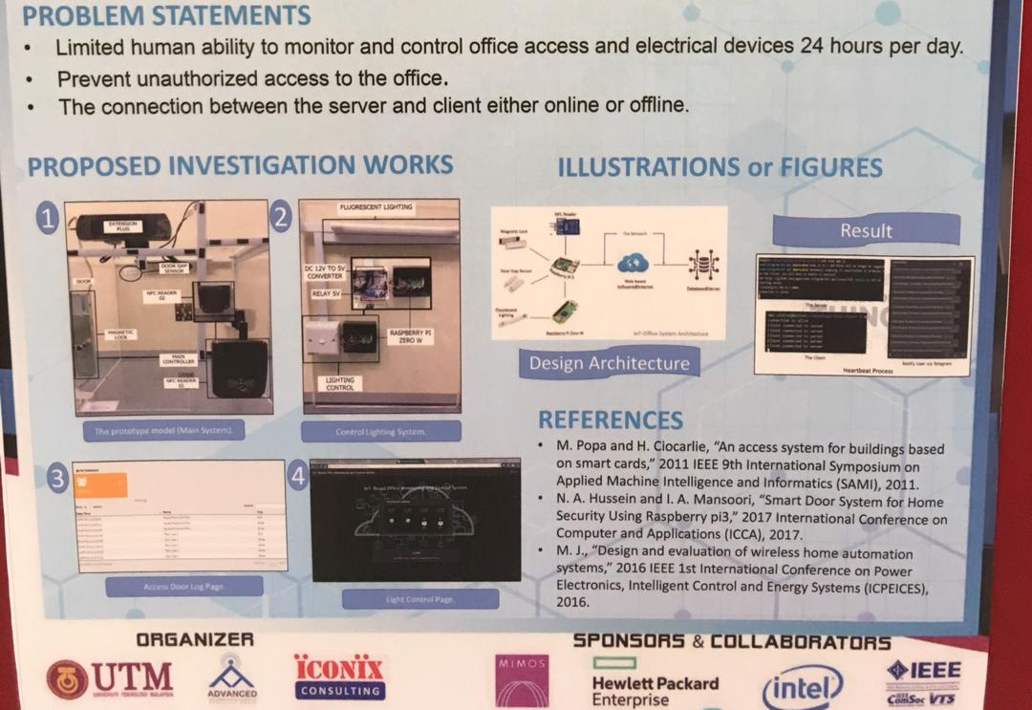

Next, we will discuss about IoT-based Smart Irrigation Management and Monitoring System using Arduino by Firdaus bin Kmaruddin, Nik Noordini Nik Abd Malik and Nurul Mu’azzah Abdul Latiff. In order for plants to growth healthy, they need water, light and nutrition from the soil in order to effect cleaning air naturally and produce oxygen to the world. Therefore, a technology that manage to brilliantly control plants watering rate according to its soil moisture and user requirement was proposed in this paper. The developed system included an Internet of Things (IoT) in Wireless Sensor Network (WSN) environment where it manages to manage and monitor the irrigation system either manually or automatically, depending on the user requirement. This proposed system applied Arduino technology and NRF24L01 as the microprocessor and transceiver for the communication channel, respectively. Smart agriculture and smart lifestyle can be developed by implementing this technology for the future work. It will save the budget for hiring employees and prevent from water wastage in daily necessities. This work has successfully implemented water irrigation system that meet the objective water-saving purpose since it is equipped with self-intelligent capability.The system manage to save the usage water and prevent the plants from being flooded. The system also successfully implemented several methods like sensor nodes, wireless communication between sensor nodes, base station and android application for controlling system in an unlimited range and Wi-Fi routine checker to overcome the disconnection of an Internet.

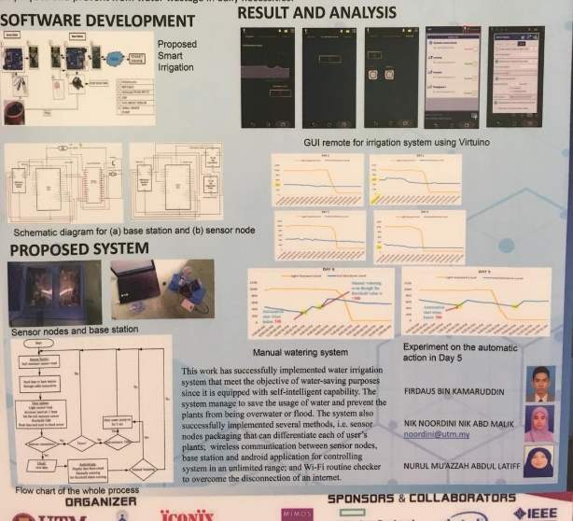

The last project is about IoT-based Temperature Control for Smart Mosques by Muhammad Nur Adib Yuraselan and Siti Zaleha Abdul Hamid. The goal of the project is to create a position that would enable the implementation of the temperature control task. The design of this project is using IoT to reduce the power consumption of mosque by controlling the fan and air conditioner. The objectives of this project is to study the working mechanism of temperature sensor in close space. To design and construct a circuit for the temperature sensor based on IoT using Raspberry Pi 3. Lastly, to implement a model temperature control into a mosque. The benefits of the product include saving money and energy usage, bring comfort and convenience to visitor and most importantly reduce mosque power consumption. The sensors can be read by sensor accurately. Fan and air conditioner can be turn ON and OFF according to the temperature reading. Air conditioner can be remotely control by web or smart phone.

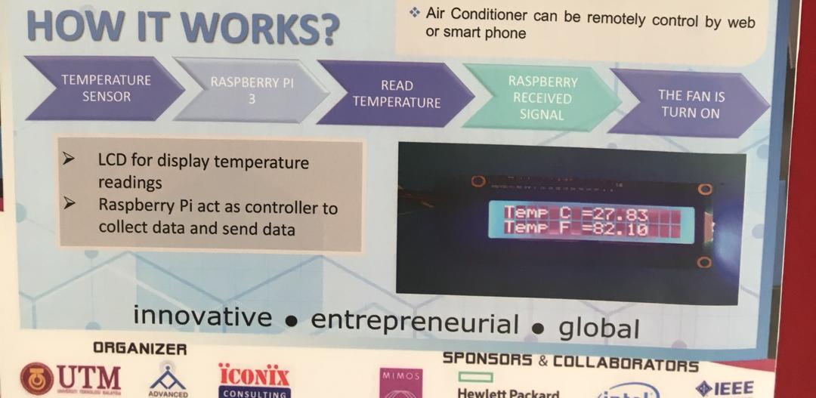

In conclusion, I think I have gain a lot of knowledge from attending this IoT Open Day. Even if I’m still a first-year student, I already have an idea on what to do during my final year project in the future. I understood everything the speaker said and captured every bit of info. I learned that It is an important part of our everyday life from household work to industrial work. On the other note, I can properly plan my career path. I feel that my course in networking and security can help me in achieving an excellent job.