

**SCHOOL OF COMPUTING**

**FACULTY OF ENGINEERING**

**SECP1513-08 TECHNOLOGY AND INFORMATION SYSTEM**

GROUP ASSIGNMENT 2

DESIGN THINKING: DATABASE

**_____________________________________________**

COURSE : COMPUTER NETWORK AND

SECURITY

COURSE CODE : 1SECR

SECTION : O8

GROUP : 8

TEAM MEMBERS :

|  |  |  |
| --- | --- | --- |
| NO | NAME | MATRIC CARD |
| 1. | NUR MINHALINA BINTI ABDUL RAZAK | A19EC0135 |
| 2. | ATIFAH QOTHUNNADA SUPIANTO | A19EC0226 |
| 3. | MUHAMMAD HAZIQ BIN SULAIMAN | A19EC0196 |

LECTURER’ NAME : DR HASWADI HASAN

DATE OF SUBMISSION : SUNDAY, 20TH OCTOBER 2019

**INTRODUCTION**

Design thinking is the main process of creating innovation that can help to solve many problems. Design thinking requires teamwork, critical thinking and innovative thinking. It is a must to create useful inventions and to advance in technologies. Design thinking consists of five different phases. Those phases are : Empathy, Define, Ideate, Prototype and finally Test.

Empathy is the phase where designers understand the problems, motivation, and the need of the users. The empathy phase is very important for gathering information related to the problem that the designer are trying to solve. This phase can help designer create the perfect tool to solve the users’ problems.

The define phase is where designers analyse the problems and information that had been gathered during the empathy phase. This is to refine the problems to create a single problem statement that covers all the problems listed during the empathy phase. The define phase helps designers in creating features and functions that can solve the problem of the users.

During the ideate phase, designers generate ideas to identify a new solution to the problems that the users face. The most common technique in the ideate phase is to brainstorm with the designers team. Other techniques can also be used during this phase in order to find the solution to the problem.

The fourth stage is the prototype. During this phase, designers will start creating a small and inexpensive version of the product with the same functionality as the original. The solution found from the ideate phase is implemented on the product and tested among the designers and some features can be added or rejected to produce the best invention.

Test is the final phase of design thinking. During this stage, the prototype of the final product is tested by the users. The users will then give feedback to the designers for room of improvement on the product. Some features will be added or removed from the product based on the feedback from the users. The prototype is perfected during this process and the real product can be created.

**EMPATHY**

We decided to conduct a short interview with a few people around Universiti Teknologi Malaysia (UTM).The first user was Amirul Syafiq from Faculty of Engineering. The problem that he had was his order was not taken by the waiter when he went to the restaurant. This situation was unfair for him because there were customers whose orders taken by the waiter as soon as they enter the restaurant. Meanwhile, he needs to go to the counter and order for himself.

The second user was Shafia Carina from Faculty of Science. According to her problem, sometimes she got the wrong food after she had ordered at the restaurant. This shows that there was a miscommunication between the waiter and the customer.

Some restaurants never care about the "First Come First Serve" basis. This is what happened to the last user we interviewed, Norefa Atika from Faculty of Engineering. She complained about how terrible the service provided for their customers at some restaurants. She felt discriminate and angry as the chef made the food for those who ordered later than her.

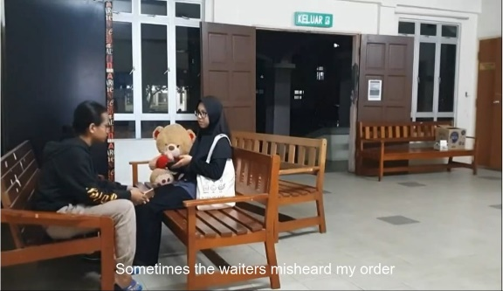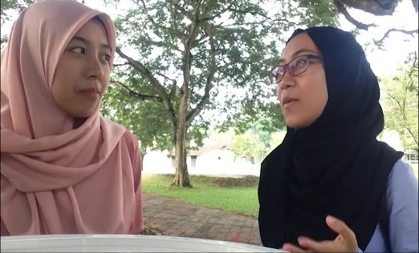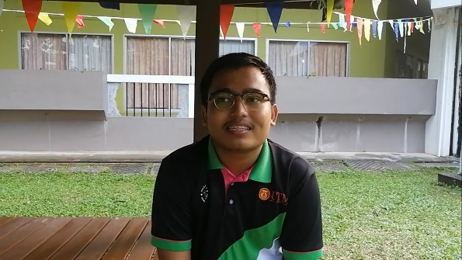  
 *First user;Amirul Syafiq Second user;Shafia Carina Third user;Norefa Atika*

**DEFINE**

|  |  |  |
| --- | --- | --- |
|  | **Problems** | **Explanation** |
| 1. | Order not taken when the customer arrived. | This probably happened because the waiters were too busy and cannot handle the restaurant.Despite that,the waiters have to do their work properly and to treat their customers better. |
| 2 | Miscommunication when ordering food at restaurants. | This problem usually occurred when the customer speaks too slow and the waiter misheard the order.A good waiter would repeat the order again to the customer so that it is correct and to reduce the restaurant’s cost. |
| 3. | Not first come first serve service. | The service at the restaurants was not as systematic as they do not have order numbers when taking the order.Most of the time they make food that easy and quick to cook first compare to the difficult one. |

**IDEATE**

In the discussion, there were many ideas provided by the team members to solve the problems. The first idea was to create a kiosk at the side of the restaurant for the user to place their order. But the idea was rejected because it required high cost and did not user-friendly. The second idea was to make voice recognition where the user can input their order through a voice recognition device. This idea was rejected as the process is not very accurate as they are some error during the process. Last but not least, the idea that we were using was to make a device that can input orders from users at each table at a particular restaurant. The advantages are it is more efficient, user-friendly and saving more time.

**PROTOTYPE**

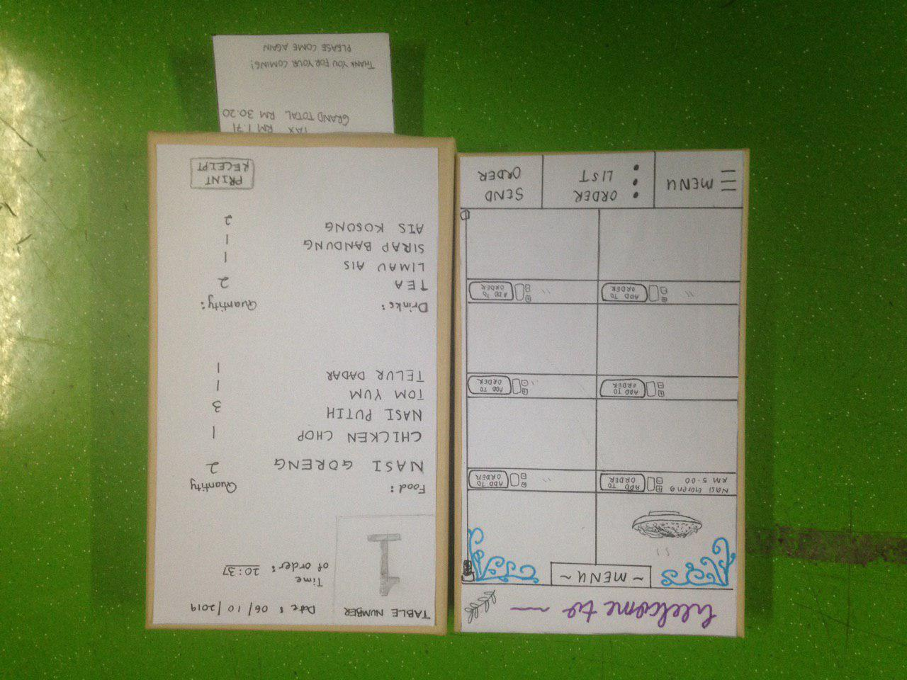

The prototype that we were creating is called iOrder. This prototype is a device that will allow users to select a variety of food from the menu provided in the system before placing their order. This prototype is attachable on the table and users can easily access the prototype without having any difficulties.

We decided to use boxes to build our prototype as it represents a tablet. One of us takes the role to cut the box into a specific shape while the other makes the interface of the system using paper. *Prototype; iOrder*

How does this prototype work? First, users can place their orders by selecting the restaurant's menu. The orders then will be delivered to the chef without any mistakes. The chef will read the order on the chef's monitor provided in the kitchen area and then start making the food. After the food is done, the chef will print a receipt from the chef's monitor and the waiter will give the user along with the food ordered.

All the problems stated in the define step can be solved by using this new technology.

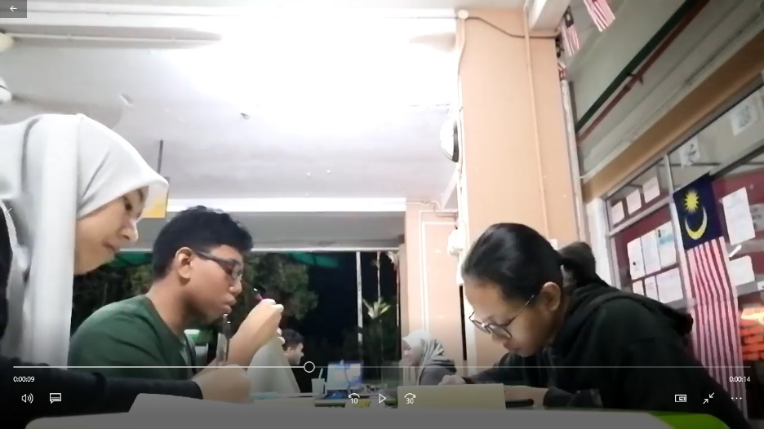

*Making prototype*

**TEST**

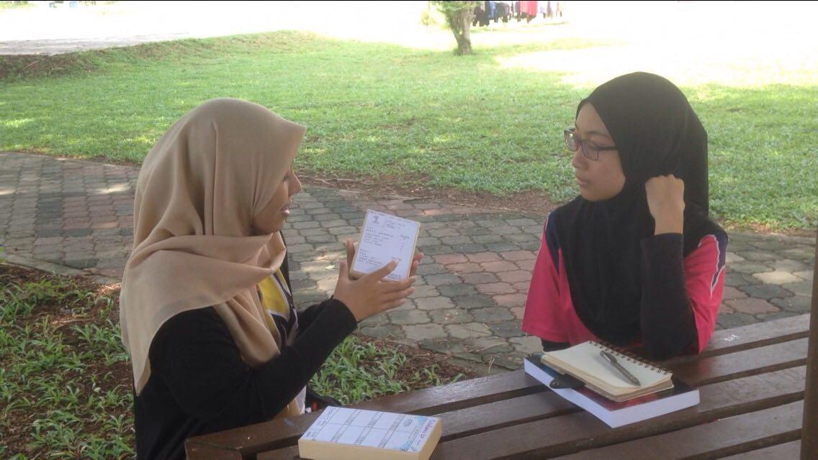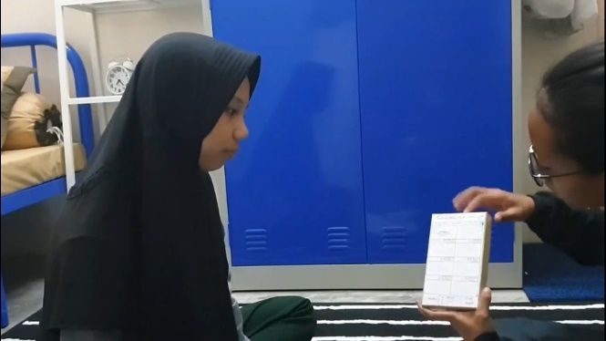

*Explaining to users*

After finishing our prototype, we went to interview the user from the empathy step to give their opinions. A user suggested that we should add one more feature, for example, a notification. Users will be informed by the notification whenever the food is ready or being delivered. Other than that, all the users give positive feedback.

**REFLECTIONS**

1. What is your goals/dream with regard to your course/program?

Goals that we want to achieve regard to this program is we want to be able to face any kind of problem in the future of our life, improving our studies, skills, and insight, get better future, and better career, get experience as much as we can, expand our network and friendship, get good score, make our parent proud of us, use our knowledge to help anyone, useful in any kind of environment, since we are in network & security area we also want to help people protect their identity in this digital era.

1. How does this design thinking impact on your goals/dream with regard to your program?

This project required us to think in the critical way to solve some kind of problem, so from this project we learn to make solution from people’s problem in some cases, so this make us used to useful in any kind of situation that we will face in the future, we learn to how to work as a team and accept any kind of suggestion, we learn something new that will improving our skills, we learn how to helping each other as a teamwork. These impact will build us to have better skills when we will enter corporate world.

1. What is the action/improvement/plan necessary for you to improve your potential in the industry?

Action that necessary to improve is need to be more creative, innovative, having a better communication skills, work as hard as we can, trying to fit in any condition even the hardest condition and can solve any kind problem. These improvements are needed because in the future those skills will be considering as a requirement to getting a job.