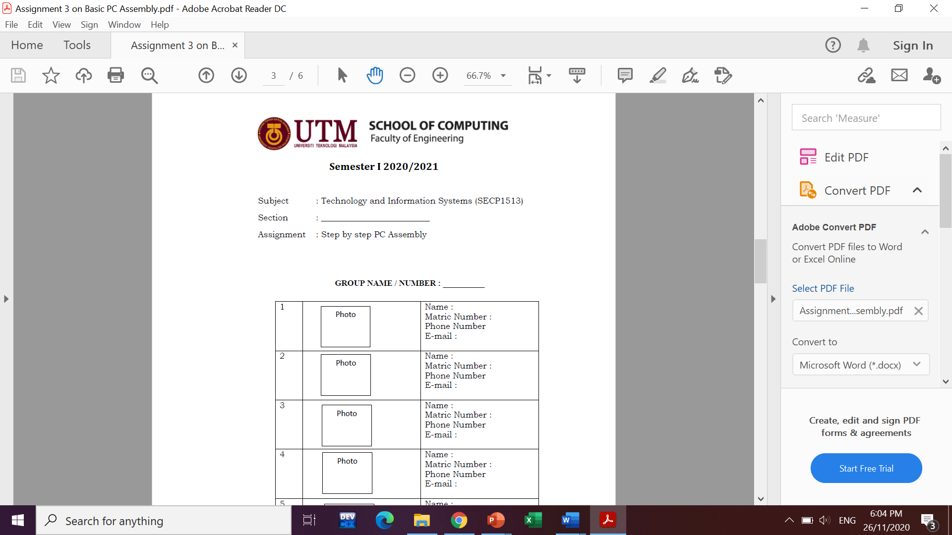

Subject : Technology and Information Systems (SECP1513)
Section : 01
Assignment : Step by step PC Assembly

GROUP NAME / NUMBER: 05
1. |  | Name: Mek Zhi Qing  Matric Number: A20EC0077  Phone Number: 0167812448  E-mail: mekqing@graduate.utm.my
2. |  | Name: Rohaizaazira binti Mohd Zawawi  Matric Number: A20EC0138  Phone Number: 0179573753  E-mail: rohaizaazira@graduate.utm.my
3. |  | Name: Zereen Teo Huey Huey  Matric Number: A20EC0173  Phone Number: 0167293878  E-mail: zereen@graduate.utm.my

Part A - Tools required in assemble PC

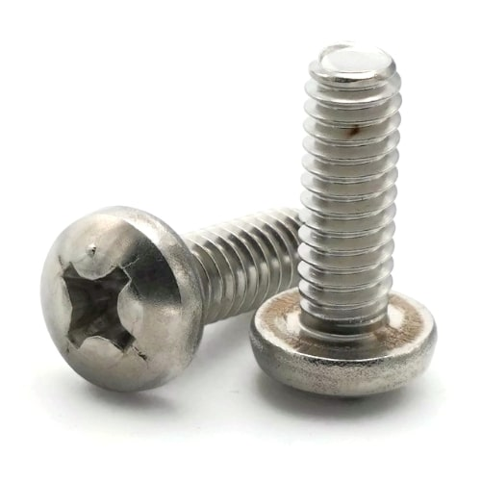
- Screw
The screw is used to hold two materials together tightly and efficiently. Basically, the screw used in assembly PC is 6-32 screw, a type of Phillips screw. By using screw, the components can fix at their right position.

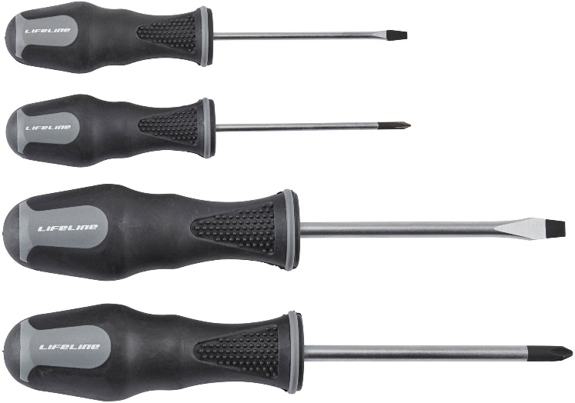
- Screwdriver

The screwdriver is a tool for tighten and loosen screw from their original position. The type of screwdriver used is based on the type of screw used when assembly PC. Only by using the screwdriver, the screw is able to install and fix the components in the PC.

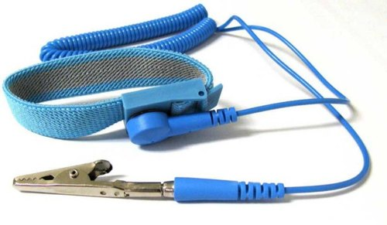
- Anti-static equipment
The anti-static equipment is used to reduces or inhibits electrostatic discharge when assembly the electronic device. By using the anti-static equipment, it will protect us from being discharge when assembly PC.

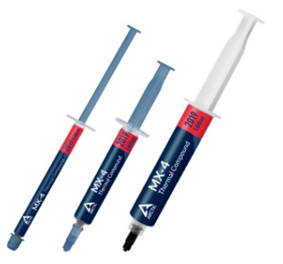
- Thermal paste
The thermal paste is a high heat conductive paste which apply between CPU and heat sink. Basically, it is used for better heat conduction between CPU and heat sink. By using thermal paste, the heat sink can function better since more efficient heat transfer from CPU to heat sink.

PART B – Sketch of a mother board layout
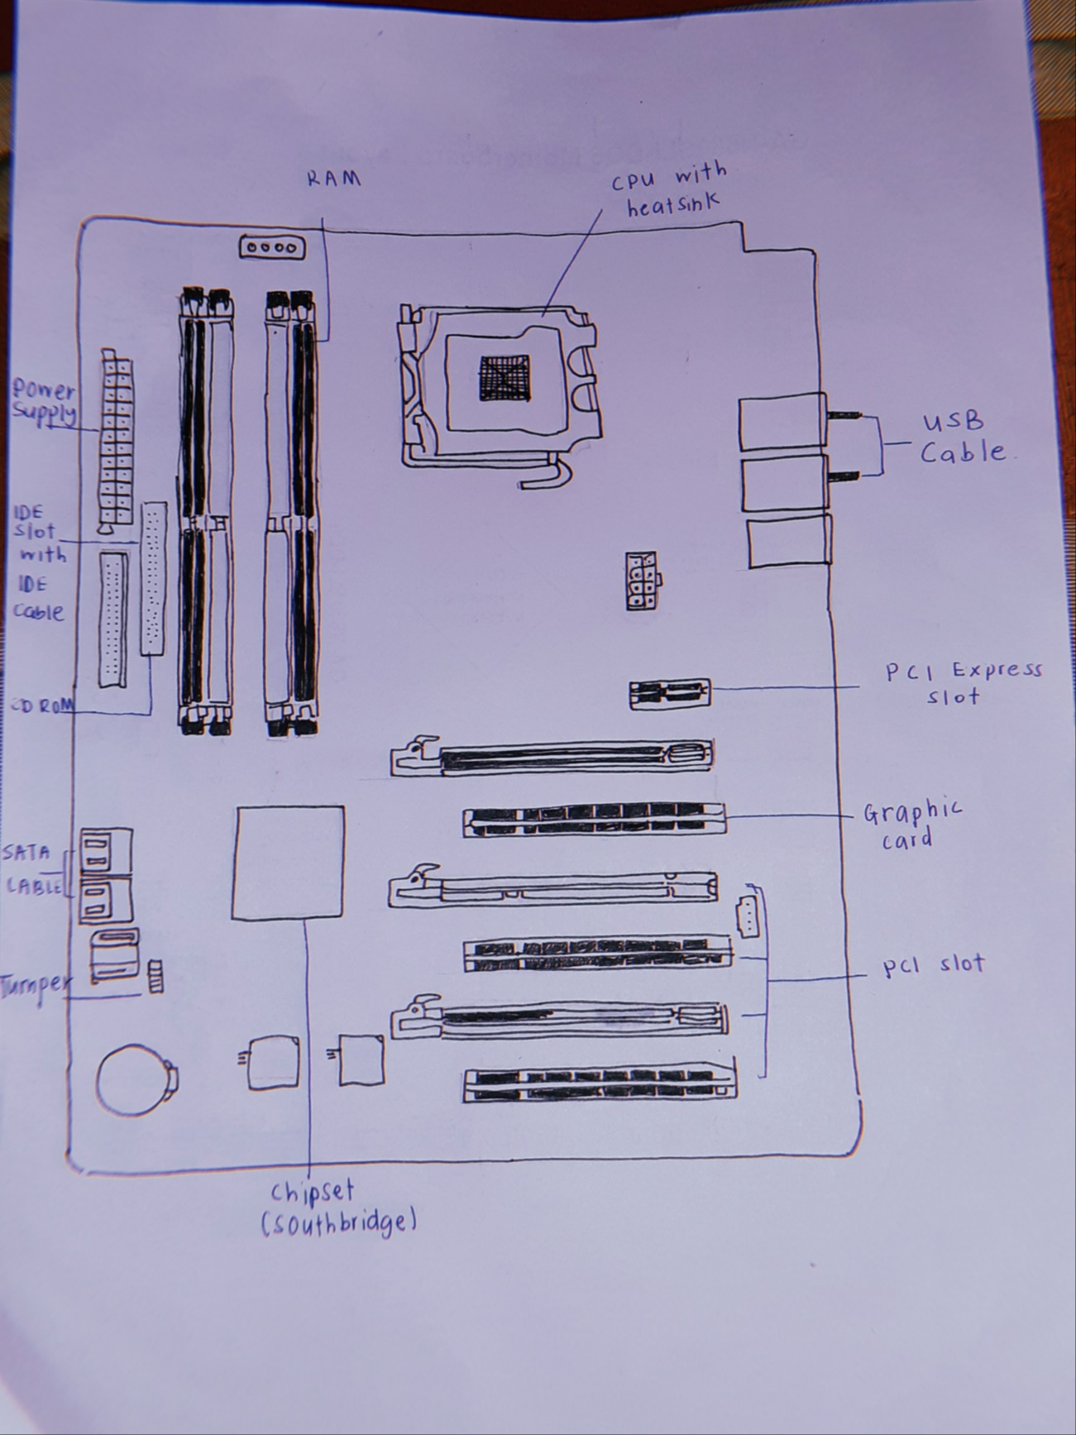
Figure 1a – A sketch of motherboard layout
Name | Function | Example of Model
Graphic Card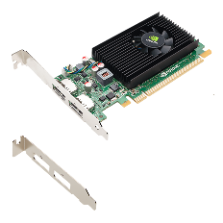 | Allow computers to produce graphics and images more quickly. | -NVIDIA TITAN X Graphics Card Video.  -AMD Ryzen Threadripper Graphics Card Video.
Compact Disc-Read-Only Memory  (CD – ROM)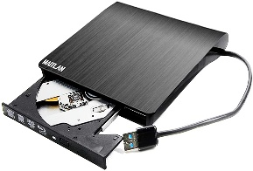 | -A compact disc that stores computer data of graphics, text, and audio  -Can only read information on disk | -CD-Rom Samsung SN-124  -Samsung SH-C522C 52x
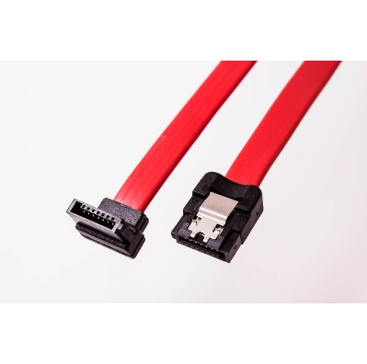  SATA Cable | A computer bus interface used to connect host bus adapters with mass storage devices like optical drives and hard drives. | -Micro SATA  -e-SATA  -SATA Bracket  -SATA Power
CPU/Processor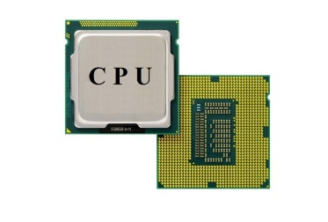 | CPU is considered as the brain of the computer.  -CPU performs all types of data processing operations.  - It stores data, intermediate results, and instructions (program).  -It controls the operation of all parts of the computer. | -Intel Core i3  -Intel Core i5 vPro  -Intel Core i7  -Pentium III Xeon
USB Cable  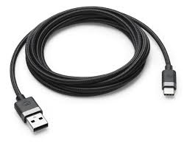 | -USB cables carry power as well as signals. This allows for "USB powered" gadgets as well as recharging batteries in cameras and other USB peripherals  - | -USB A-Type.  -USB B-Type.  -USB C-Type.  -Micro-USB A.  -Micro-USB B.  -USB Mini-b (5-pin)  -USB Mini-b (4-pin)  -USB 3.0 A-Type.
IDE Cable  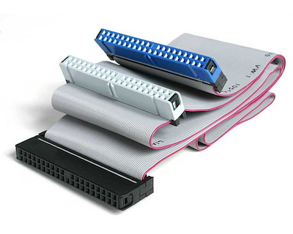 | Used to connect storage device to the motherboard | - 34-pin IDE cable  - 40-pin IDE cable

Hard disk (Jumper)  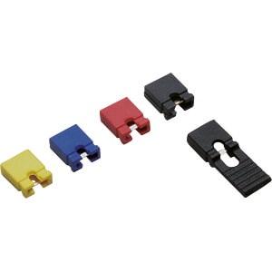 | Allow the computer to close an electrical circuit, allowing the electricity to flow on a circuit board and perform a function | -Jumper Master Setting  -Jumper Slave Setting
Random access memory (RAM)  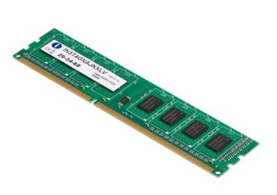 | Temporary storage that goes away when the power turns off | -Dynamic RAM (DRAM)  -Static RAM (SRAM)
Heat Sink  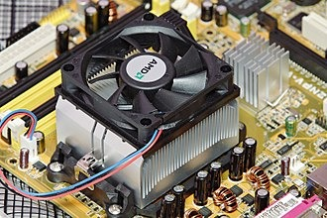 | Thermal conductive metal device designed to absorb and disperse heat away from a high temperature object such as a computer processor. | -Active Heat Sink  -Passive Heat Sink
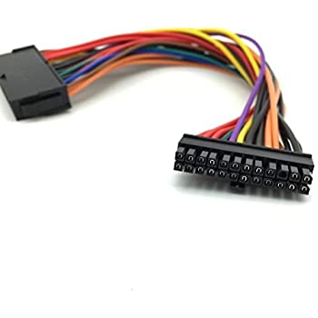  Power Supply | -Convert AC to DC  -Provide DC voltage to the motherboard, adapters, and peripheral devices  -Provide cooling and facilitate air flow through the case | -Original IBM PC Power Supply  -XT Power Supply  -AT standard Power Supply
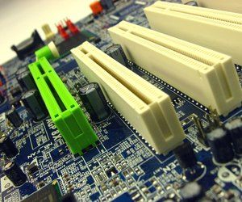  Slot | Used to add an adapter to the motherboard | -PCI Slot  -PCI Express Slot  -IDE Slot  -AGP Slot  -CNR Slot

Part C – Step by Step PC Assembly
Step 1 – Attach CPU on motherboard
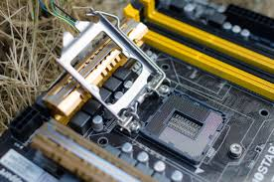
1.1: Release the tension lever and open the CPU socket.

1.2: Attach the CPU on motherboard.

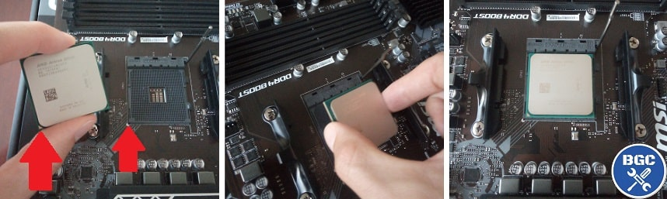

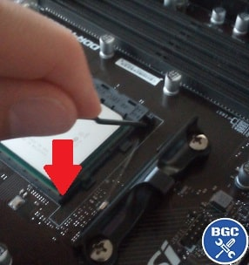
1.3: Lock the CPU socket by press the tension lever down.

Precautions:
When handling the CPU, only touch the side of CPU, do not touch the bottom and top of CPU.
Make sure the arrow on the top of the CPU is same direction with the arrow on the CPU socket.
Make sure you use anti-static equipment to prevent electronic discharge.

Step 2 – Mount Heat Sink on Motherboard
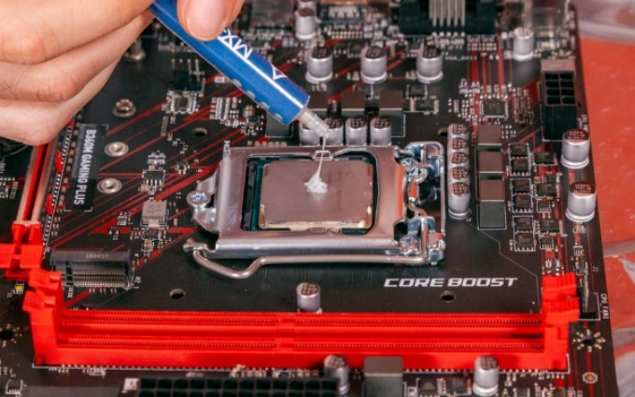
2.1: Some of the heat sink have pre-applied paste on it, if it does not have apply a small amount of thermal paste on the centre of CPU.

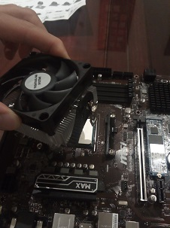
2.2: Lower the heat sink onto the top of CPU.

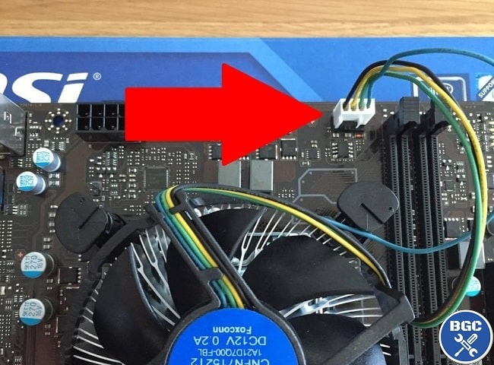

2.3: Plug the power cable of heat sink into the motherboard connector.

Precaution:
Do not squeeze too much thermal paste on top of CPU, it may cause leaking to other parts.

Step 3: Install RAM
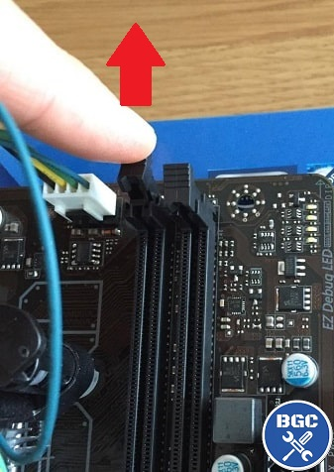
3.1: Unlock the small clip at the side of DIMM slot before insert the RAM.

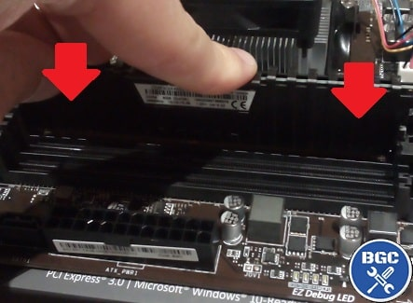
3.2: Place the RAM stick into the slot by pushing it. Make sure the clip at the side of DIMM slot is closed.

Precaution:
Hold the edge of the RAM, do not touch the exposed circuitry.
Tips:
When installing a single RAM, it should be insert into DIMM slot 0/1.

Step 4: Install Power supply
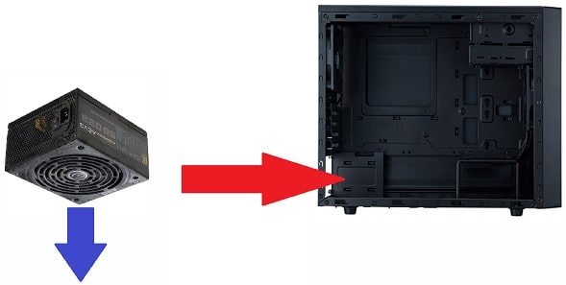
4.1: Install the power supply at the bottom of the cover.

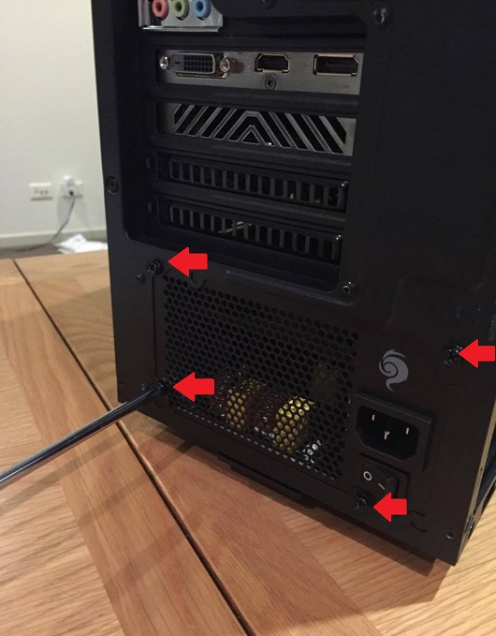

4.2: Screw each corner of the power supply to tighten it.

Step 5: Put Motherboard into the Computer Case
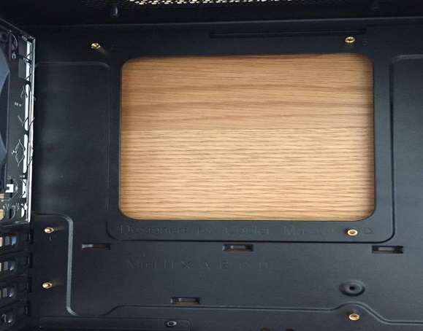
5.1: Screw standoffs at the part of case where the motherboard will be landed.

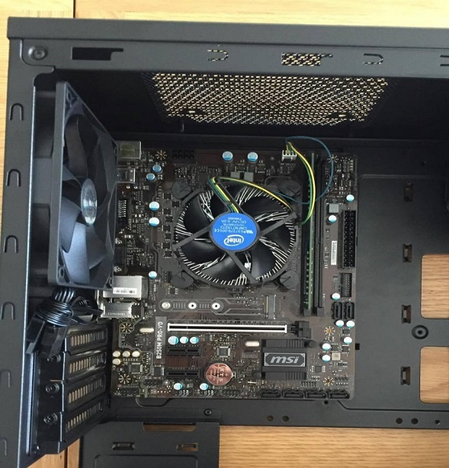

5.2: Put the motherboard into the case, ensure that each standoff fit the hole of motherboard and screw the motherboard.

Step 6: Install Graphic Card
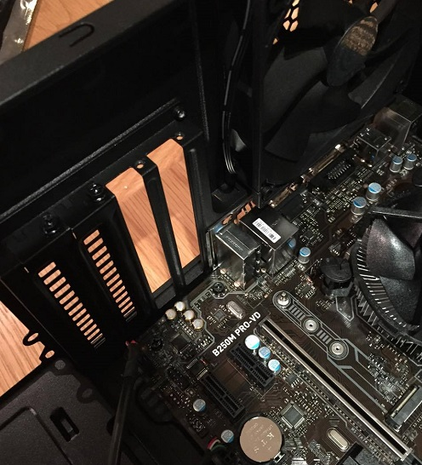
6.1: Remove the slot covers on the back of the case by unscrewing them.

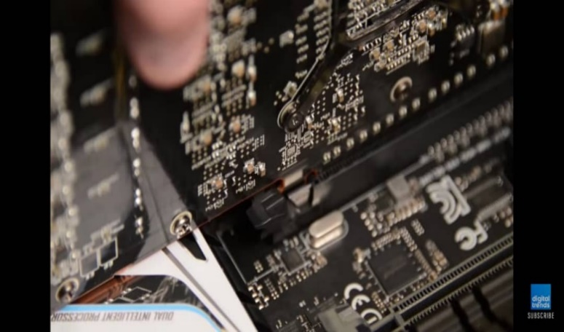
6.2: Unlock the PCI expansion slot on the motherboard before install the graphic card.

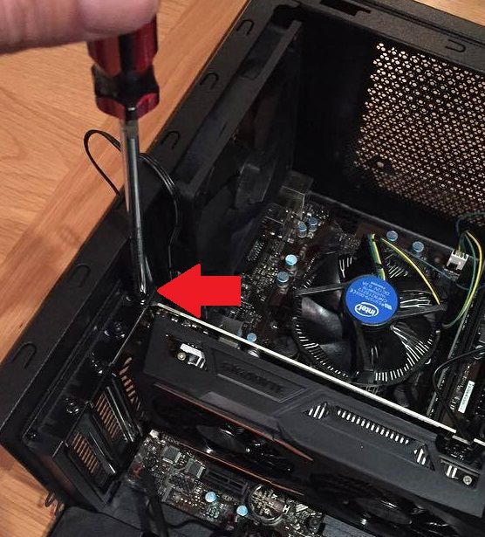

6.3: Install the graphic card into the PCI expansion slot of the motherboard and screw back the slot cover to tighten the graphic card.

Step 7: Install Hard Disk Drive
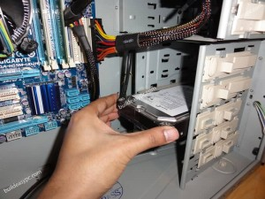

7.1: Mount the hard disk drive into the case drive bays.

7.2(a): If you are installing IDE hard disk drive, connect the hard disk drive to IDE slot on motherboard by IDE cable.
7.2(b): If you are installing SATA hard disk drive, connect the hard disk drive to SATA slot on motherboard by SATA cable.
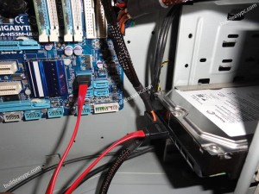
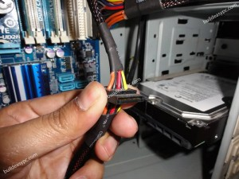
7.3: Plug in power supply cable to the hard disk drive.

Tips:
If you are installing more than one IDE hard disk drive, you need to set up jumper. The main drive will be set as master and second drive will be set as drive.
For SATA hard disk drive do not need to set as master or slave.

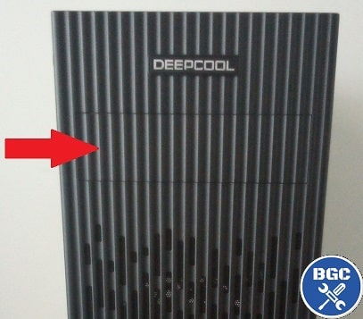
Step 8: Install CD ROM Drive

8.1: Remove the front panels form the computer case.

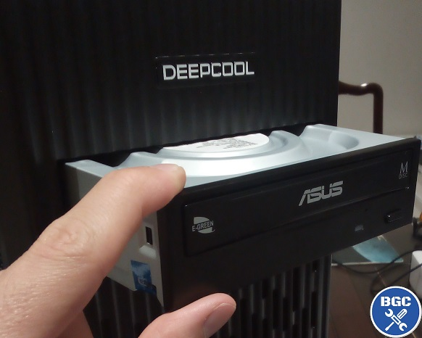
8.2: Install the CD ROM drive by slide in from the front of the computer case into the slide bay.

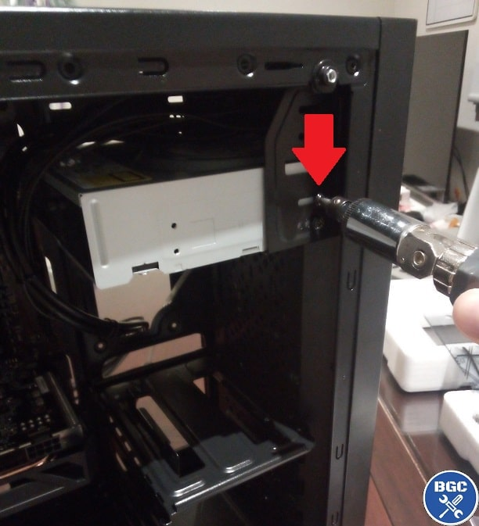

8.3: Match up the holes at the side of CD ROM with the computer case and screw it.

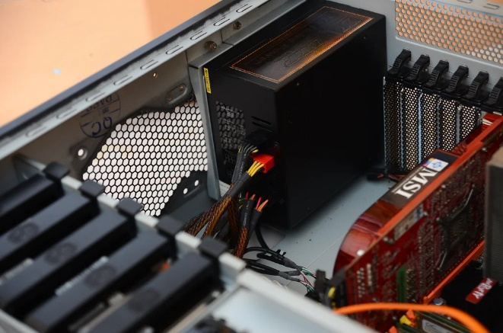
8.4: Connect the CD ROM drive to the IDE slot on motherboard by using IDE cable or SATA cable to the SATA slot. Connect power cables from the power supply to the CD ROM drive.

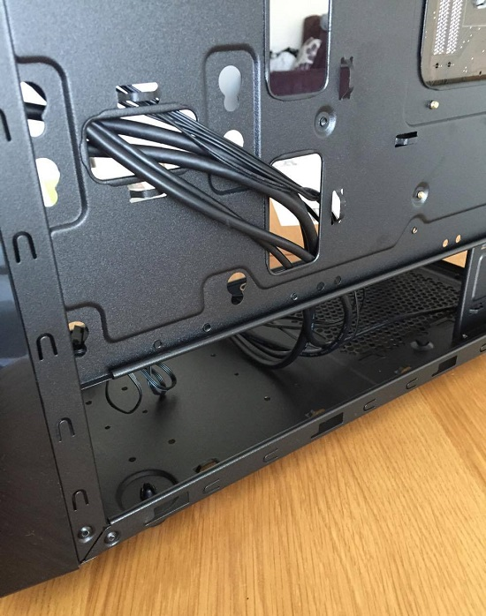
Step 9: Connect Front Panel Cables to Motherboard

9.1: Route the cables through the back of the computer case.
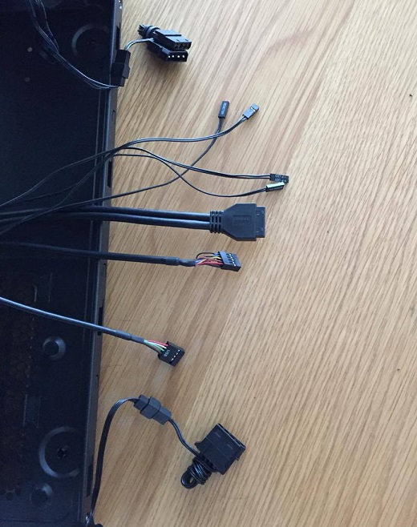

9.2: Connect front panel cables to the motherboard include:
a) Power switch cable
b) Reset switch cable
c) Power light cable
d) Hard drive light cable
e) USB cable
f) Audio cable

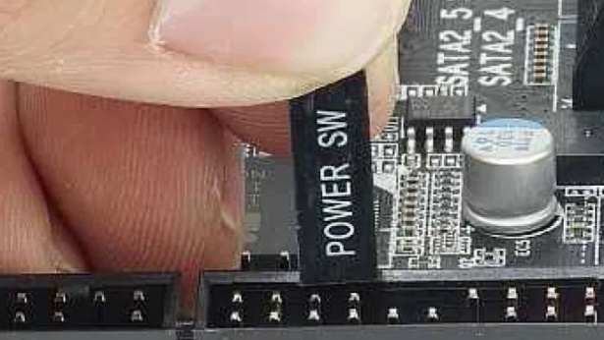

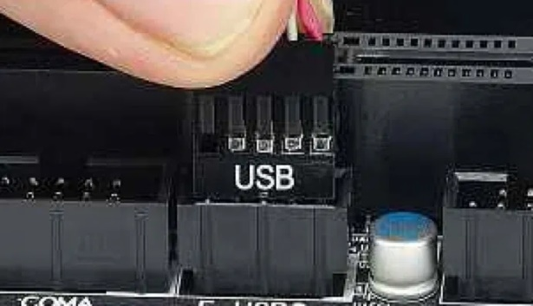

Step 10: Closing the Case and Connecting the Peripherals
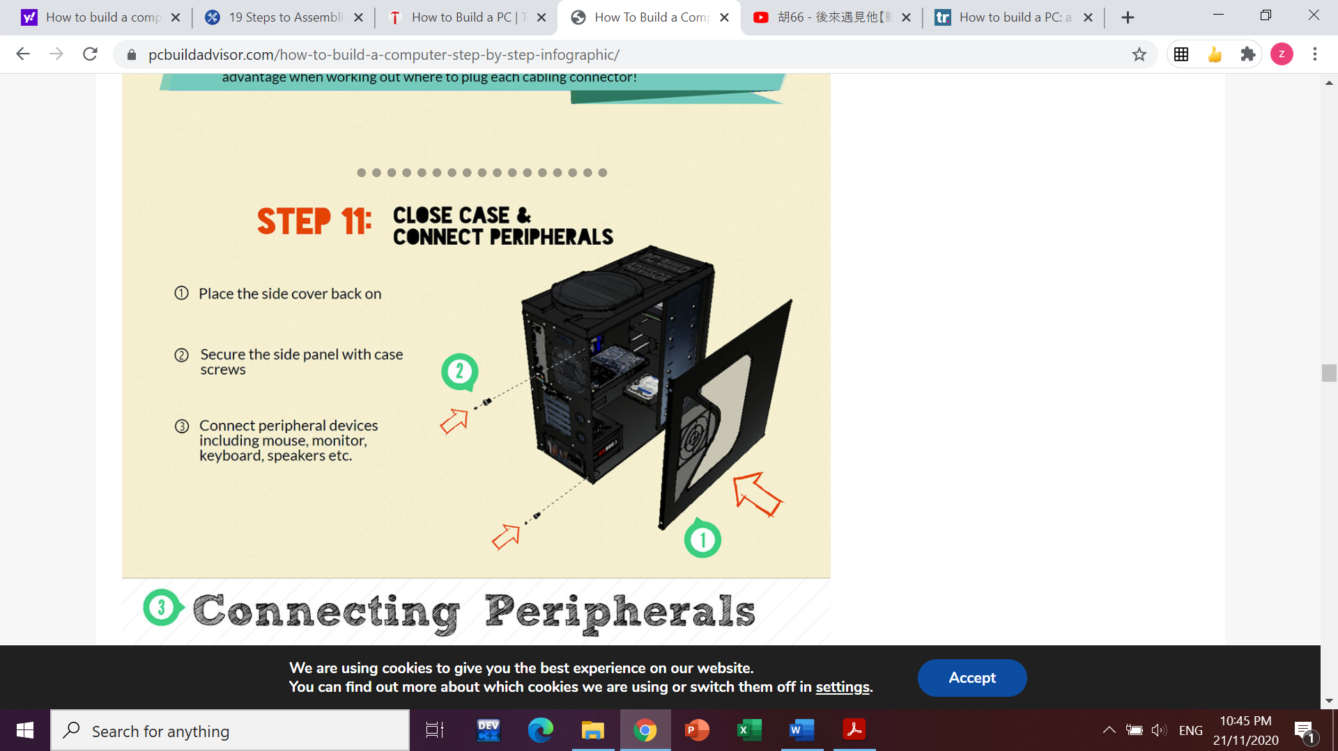
10.1: Place the side cover back on and secure the side panels with case screws.

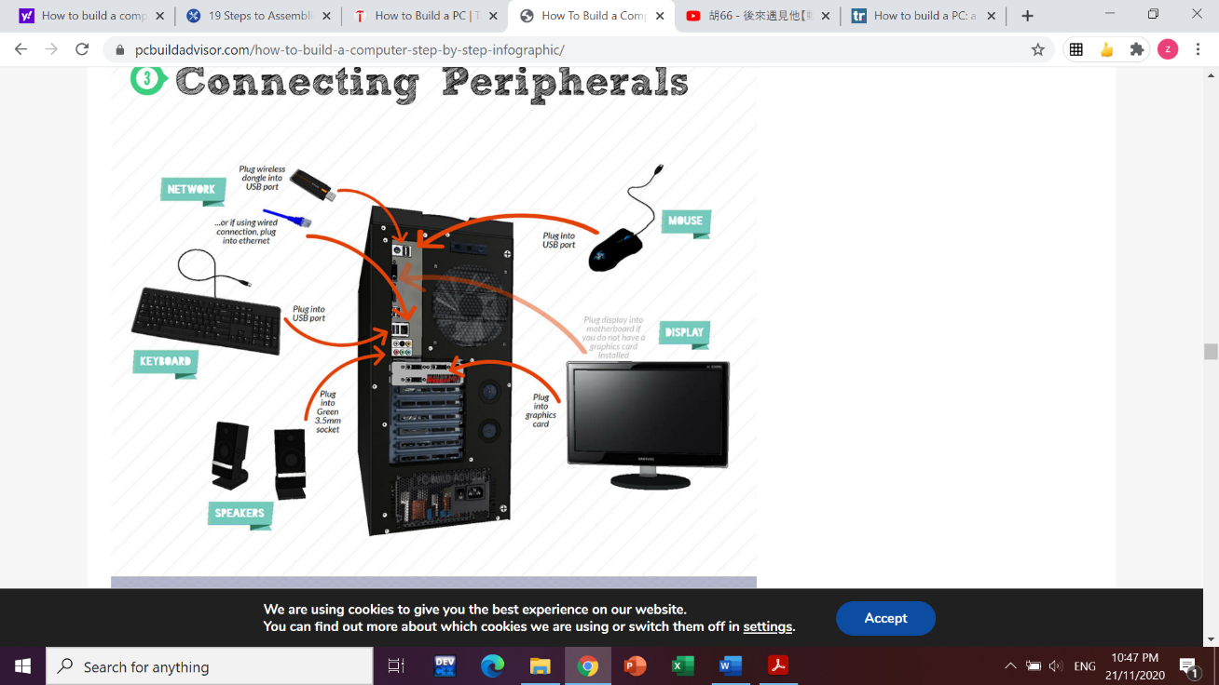
10.2: Connect peripheral devices which include keyboard, mouse, wireless network dongle, printer, and webcam with your CPU by plugging into USB port.

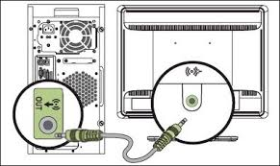
10.3: Then, connect speakers and microphone into 2.5mm sockets.

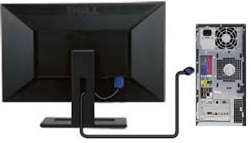
10.4: Finally, connect the CPU to monitor by plugging into display ports.

References
Part A
1. Lathan, P. (2016). 5 Tools You Need to Build A PC. Retrieved 23 November 2020, from https://blog.nzxt.com/tools-need-build-pc/
2. Bbenn D. (2006). Thermal Paste and How to Use It. Retrieved 23 November 2020, from https://www.techpowerup.com/articles/overclocking/134

Part B
1. Beecroft, D. (2020). Computer Hardware. Retrieved 29 November 2020, from https://quizlet.com/513045242/computer-hardware-flash-cards/
2. Tutorialspoint. (2020). Retrieved 29 November 2020, from https://www.tutorialspoint.com/computer_fundamentals/computer_cpu.htm
3. Anon, (2020). What is a USB cable. Retrieved 29 November 2020, from https://www.l-com.com/frequently-asked-questions/what-is-a-usb-cable
4. Components, I. (2020). USB FAQ - Frequently asked Questions. Retrieved 29 November 2020, from https://itm-components.co.uk/pages/usb-products-faq
5. Roger R. (2020). A heat sink is a thermal conductive metal device designed to absorb and disperse heat away from a high temperature object such as a computer processor. Retrieved 29 November 2020, from
https://www.scribd.com/presentation/432286922/Networking

Part C
1. Andrew E. Freedman. (2020). How to Build a PC. Retrieved from 29 November 2020, from https://www.tomshardware.com/reviews/how-to-build-a-pc,5867.html
2. Julien. (2020). How to Assemble a PC. Retrieved 29 November 2020, from https://www.build-gaming-computers.com/how-to-assemble-a-pc.html

