

**SECP1513-06**

**Technology and Information System**

**DESIGN THINKING REPORT**

**Lecturer: Dr. Aryati binti Bakri**

**Group members:**

1. **Nursyahidatul Asyiqin binti Yusof**
2. **Qudri Ameer bin Mohd Safiee**
3. **Sharmarke Hussien Ibrahim**
4. **Nurul Aqilah binti Ahmad**

Contents

**INTRODUCTION 3**

**DESIGN THINKING EVIDENCE 4**

**REFLECTIONS 8**

**TASKS 9**

**DESIGN THINKING VIDEO 10**

**INTRODUCTION**

To start off, this report is about how we solve problems that are faced by users regarding ‘Information System’ topic by using design thinking method which has empathize, define, ideate and prototype process.

The purpose of this report is to divulge our progress and activity in using design thinking method. It is also to show and provide the benefit of using design thinking process to solve difficulties.

Apart from that, the aim for this project is to find a solution to the problems by using the design thinking method. In addition, it is to understand and interpret user’s issue and then provide fine solution. Also, it is to train other to think creatively and create invention in purpose to ease the burden of the user.

A brief about ‘Information System’ topic - the definition of the Information System is a collection of people, procedures, software, hardware and data.

This project is held after our curiosity about the benefits in developing a new system and creating an update to the system. Besides, we are aware of the difficulties of using manual method in recording students’ activities.

**DESIGN THINKING EVIDENCE**

1. ***Empathize***

The lecturers are facing difficulties in observing students’ activity. Since there are lots of students to monitor and record their activities, the lecturers found it hard to handle all of them at once because they need to write one by one all of the students’ activities. We held an interview with some people regarding this problem.

*(Interview with the developer)*

Question 1: “Tell me about yourself/ background.”

Answer: “I am Helmee bin Yaakob, officer of CICT. I am in one of the team that is in charge of developing Human Resource.

Question 2: “What do you know about Information System?”

Answer: “TPS is a basic system for data collection and improvement. Example of TPS that is used now is UTM ACAD. The lecturer that you did interview with is one of the TPS user. In UTM ACAD, there are application, process and verification that will become a data. After collecting a number of data, it will become MIS. MIS can be managed to do speculation by creating graphs and stimuli. For example, if we want to calculate the percentage of attendance of UTM students. We can also observe the last year’s attendance and interpret the pattern by using DSS system. The graphs will be used by the top management which is the ESS user.”

*(Interview with the user)*

Question 1: “Tell me about yourself / background.”

Answer: “My name is Dr. Suhaila binti Mohamad Yusuf. I am the senior lecturer in School of Computing. I have been in academic lines since 2006. Now, I am acting as a coordinator of Student Development.”

Question 2: “What kind of information system that you have been used?”

Answer: “The thing that I am using now is UTM ACAD system. UTM ACAD system is a system that we can register any students’ activities and record all of the attendance of the students.”

Question 3: “What are the problems that you have been facing in managing the students’ activities?”

Answer: “For the access, the only thing that I can do is recording the attendance but download all the attendance at once. I cannot have the access to all the activities conducted by School of computing.

Question 4: “What do you think the differences between the old and new system?”

Answer: “Back then, we did manually by providing the name, matric number and then the students need to sign. But, nowadays, the lecturer can bring their laptop and the students just need to key in their matric number. It is a very good system because we can do statistics later.”

Question 5: What kind of update that you wish for?

Answer: “If CICT people can build a feature for the person in charge in School of Computing to download all the attendance at once.”

What do we get from the interview?

The first interview which is from Encik Helmee bin Yaakob, we understand more about management levels. He explains to us about the managements level and what kind of person in charge on each level. We also understand the detail of computer-Based Information System which are TPS, MIS, DSS and ESS. For the second interviewee Dr. Suhaila binti Mohd Yusof, we learn that every system must be upgraded from time to time to make sure it will be functioned as user’s requirements.

1. ***Define***

We discuss the information that are gained from the interview and understand all the problems. We then find all the possible outcomes problems and trying to figure out on how to solve it. The problems are stated below:

* An organization is not well-managed because of data problems related to reliability and accuracy.
* User’s requirements are increasing from time to time so there will be problem in remaining the performance level.

1. ***Ideate***

This phase is the most important phase because we can find out the solution from the the ideas that are brainstormed by each of us. Since our opinions and suggestions are distinct and variety, we have further discussion to obtain final decision.

For the first problem, the solution is to build an information system in purpose to collect, process, store and deliver information accurately.

For the second problem, an upgrade is needed in order to improve the system and enhance the performance level.

1. ***Prototype***

Regarding this phase, we create 4 types of interface which each of the interface stands for each Computer-Based Information System. Figure 1 shows the user interface for Transaction Processing System (TPS). It will only show the preview of the thing that user searched. Next for figure 2, which is Management Information Systems (MIS) it will show more details for the information as our example, figure 1 show the picture of food only and figure 2 show the ingredients and process of making the food. In figure 3, which is Decision Support System (DSS) we want to show how the system compile all the information gains from previous system. For example, from the recent search it will analyse data and interpret the pattern by using simple graph. For figure 4, which is Executive Support System (ESS) it will summarize the simple graph and make it readable and easy to understand for the company usage.

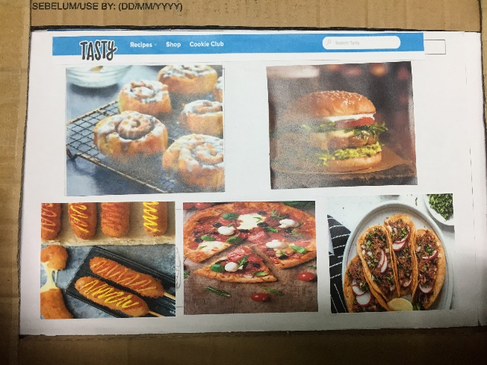 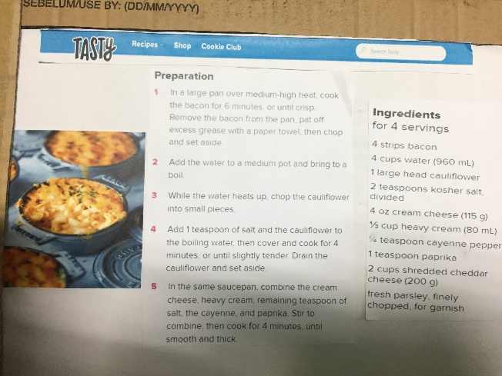

Figure Figure

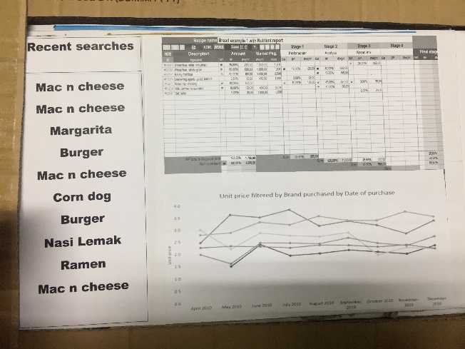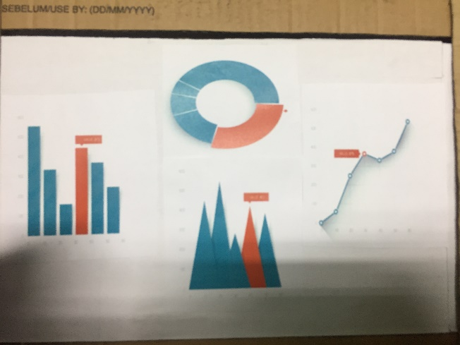

Figure Figure

**REFLECTIONS**

*Nursyahidatul Asyiqin binti Yusof*:

My goals are to graduate with flying colours and be a person who can fulfil the criteria of a company that I will serve. I realized that using design thinking method helps me in training ourselves to interpret and understand more about a problem after my group members had few discussions and observation, which one of the process in design thinking. In order to improve my potential in industry, it is necessary for me to be active in class. For example, I would not stay silent and try my best to participate when given a question.

*Nurul Aqilah binti Ahmad:*

Regarding to ‘Technology and Information System’ subject, my goal is to be a person that can develop new invention to help and ease people in the future. I noticed that the design thinking method helps me a lot in solving problem. It is also impact in honing creativity as it requires a lot of thinking and ideas in order to find solution of the issues. I think, in purpose to improve my potential in industry, I need to always find out the different solution of a problem. I believe by doing that, I will be open to any kind of solution and I can improve my creativity.

*Qudri Ameer bin Mohd Safiee:*

Regarding to the given topic which is ‘Information System’, my goal is to improve myself in the way I learn and manage things. By learning how design thinking works, it taught me about organizing and managing the way of solving the problems. I realized that some industry has many chances of job in each level. For a higher chance to succeed in the future, I need to have the skill and knowledge about all the different level to perform well in the industry.

*Sharmarke Hussien Ibrahim:*

Towards this project, my goal is to improve my thinking skill. I hope in future, I can use my knowledge about design thinking in real life for example when do any project. I realize by mastering those skills, it will impact me in a way on how I see the problems and find a solution to solve it. Therefore, in order to enhance my thinking skill, I need to think out of the box and suggesting variety of ideas.

**TASKS**:

|  |  |
| --- | --- |
| 1. Nurul Aqilah binti Ahmad | * Interview * Report * Reflection |
| 1. Nursyahidatul Asyiqin binti Yusof | * Interview * Report * Reflection |
| 1. Qudri Ameer bin Mohd Safiee | * Interview * Video * Reflection |
| 1. Sharmarke Hussien Ibrahim | * Interview * Slides * Reflection |

**DESIGN THINKING VIDEO**:

<https://www.youtube.com/watch?v=0L7yiNkF0e0>