

**SECP1513 – TECHNOLOGY AND INFORMATION SYSTEM**

**ASSIGNMENT:**

**DESIGN THINKING**

SECTION : 03 – 1 SECRH

COURSE NAME : BACHELOR OF COMPUTER SCIENCE –

NETWORK AND SYSTEM SECURITY

|  |  |  |
| --- | --- | --- |
| NO. | NAME | STUDENT ID |
| 1 | ILAMUHIL A/L KATHIRAVAN | A20EC0047 |
| 2 | MUHAMMAD IZWAN SAZMIN | A20EC0092 |
| 3 | RAJA MUHAMMAD HAFIZ BIN RAJA ALAUDIN SHAH | A20EC0223 |
| 4 | MOHAMAD HADIF NAZHAN BIN HALMEY | A20EC0206 |
| 5 | MUHAMMAD SHAUQIE DANISH BIN ABAS | A20EC0098 |

LECTURER’S NAME : DR. JOHANNA

Table of Contents

|  |  |
| --- | --- |
| Content | Page |
| Introduction | 2-3 |
| Log journal | 4 |
| Problem  Solution  Team working | 5-7 |
| Design Challenge | 7 |
| Empathy | 8,9 |
| Define | 10-11 |
| Ideate | 12 |
| Prototype | 13 |
| Test | 14-15 |
| Reflection | 16 |
| Task Assignment | 17 |
| Bibliography | 18 |

**Introduction**

Design thinking is a process for creative problem solving. In other words, it is a guideline for people to use critical thinking in order to provide a solution for an existing problem .Moreover, design thinking is essential for organizations to focus on the buyers and consumers they're creating for, which leads to better technology, services, and internal processes .For instance, anyone can come out with solutions for problems and mind blowing ideas, but at the end it goes back to the question ,what’s in it for the people? In a nutshell, design thinking is the main ideology for any kind of innovation. The [**idea behind design thinking**](https://www.interaction-design.org/literature/article/design-thinking-get-a-quick-overview-of-the-history)states that, in order to come up with revolutionary solutions, one should approach the problem from the user’s perspective .At the same time, design thinking is more focussed on getting hands on; the aim is to turn your ideas into reality; testable technology or service. Design thinking plays a pivotal role of the question “how to turn my idea into reality”. Having said that, basically, design thinking is all about coming out with creative solutions for problem, making it a reality by implementing it and creating it. In total, the process can listed down as below:-

* Empathy
* Define
* Ideate
* Prototyping
* Testing

**Privacy and security**

Today, the massive growth of technology is influencing almost every aspect of human life. Although technology has provided undeniable advantages across multiple sectors, it also has its dark side. According to a report by Risk Based Security it has been revealed that a shocking 7.9 billion records have been exposed by data breaches in the first nine months of 2019 alone. This number is tremendously more than double (112%) the number of records exposed in the same period in 2018.Are we safe in the cyber world? This rapid paced evolution of global cyber threat with a rising number of breaches would not bother some people because they are simply not aware of the risk of privacy threats. For instance, anyone can easily impersonate anyone in this modern world just with our identity cards or even withdraw our money without our authority. The risk of self-victimization is very high because of the unstoppable growth of cyber world. Privacy and security should be the main concern of everyone in this vast cyber world. We can’t really escape from this because everything that revolve around us has something to do with technology. We can say that today’s technology has the power to destroy someone or uplift anyone. Thus, every individual should be responsible and concerned about cyber security and data privacy as the saying goes” with a great power comes a great responsibility”.

**Log journal**

|  |  |
| --- | --- |
| Date | Description |
| 1 November 2020 | * Discussion about design thinking that related to Chapter 9(Privacy and security) * Assignment of task to all the group members |
| 2 November 2020 | * Prepared the interview questions * Mini meeting session with members |
| 3 November 2020 | * Interview session in Cisco Webex :   session 4, Mr. Mohd Farid and PM Dr. Murtadha  (Open interview on Information Security) |
| 4 November 2020 | * List all the related problems and solutions * Sorted out and selected the main problem |
| 5 November 2020 | * Conducted a survey on payWave system using Google Form * Shared the Google form to Whatsapp groups and gained feedbacks |
| 6 November 2020 | * Discussion about the responds from the survey * Brainstorming all the solutions to the problems faced by respondents * All the members chose the best solution |
| 7- 8 November 2020 | * Making of prototype |
| 9 November 2020 | * Updated the progress of the prototype to Dr Johanna |
| 10 November 2020 | * Conducted a test survey using Google Form to gain feedback on our project |
| 11 – 12 November 2020 | * Report and video |
| 16 November 2020 | * Ready to be submit |

**Problem**

When it comes to privacy and security, there are thousands of problems faced by our community in a daily basis. But one common thing we noticed especially during this Covid-19 pandemic is the rapid growth of usage of cashless payment system, in our case the payWave technology. This is mainly due to the social distancing practice of the new norm. Although there are claims that payWave technology is extremely safe and convenient due to the high usage of payWave technology, the vulnerabilities in the payWave system is increasing day by day as the digital thieves and culprits are coming out with various types of techniques to break into the system. On top of that, worst case scenario is when the card gets stolen. Although the there is a limit for the transaction, a pickpocket or a thief can easily misuse the card by simply tapping it against contactless-enabled terminal. The situation gets even worst when the owner did not realize the theft. Nowadays, most Malaysians tend to be negligent about the vulnerabilities in payWave system and less aware of credit card safety.

Moreover, another major issue in the payWave system is the money limit. As the world is moving towards cashless payment methods, it will be more convenient if the payWave system does not have money limit except when we set it. But due to this limitation of payWave, majority of people still prefer transactions and payment with cash.

Apart from that, this payWave system is limited to pay in stores only. Especially, during this pandemic time, most of the people are staying and purchasing things at their respective homes.

**Solution**

Our project’s main goal is to improve the security and reliability of the payWave system which allows everyone to use it daily. Thus, our first solution is to create a very simple authentication app to secure the purchases using the payWave technology. This app will have a lot of features such as biometrics authorisation, card pairing feature and card management system. Basically, the biometrics system includes fingerprint access and also supports iris scanner technology. In this way, the chances of a thief to misuse the card will be extremely low because the payWave system could only be used if the owner of the card scans his fingerprint using the biometric verification. Next, the login password to the app will be encrypted with multiple layers of encryption. This allows the user to use a normal password without having the fear of hackers cracking the password.

On top of that, this app requires the user to pair his debit card to the card management system. This will allow the user to easily configure the preferences of services and to manage the payWave system settings. Moreover, the app will be using a peer-to-peer architecture to communicate with the card. This adds a layer of security to the system and allows the user to use it efficiently. In addition, the only thing that differs the traditional usage and the upgraded version of payWave system is the verification of authority using a biometric system and the peer to peer network between the card and the system of application. To sum it up, the card will only give out NFC(Near-Field-Communication) signals to the card terminal after the user scans his fingerprint in their smartphone. We came out with this idea because almost everyone nowadays owns a smartphone. Besides, the card management system is to increase the efficiency. This new payWave system upgrade will be handy for user who have multiple debit cards and for the users who focus on the securing their money.

Having said that, the addition of a new security layer will allow the user to purchase anything using the payWave system as we have noticed the limitations of payWave which only lets the user to use certain amount of money at a time. This upgrade will allow a user to use the payWave technology as their default payment method.

Furthermore, we have also planned to enable the user to use the card for online transactions.Having said that, the user simply have to login into the app,enter a OTP(One Time Password ) in the online payments section and finally tap the card on the smartphone to complete a purchase. In this way, the users can enjoy a fast and secure online payment method.

**Team Working**

As we were going through the five steps of design thinking, all the members contributed by giving creative ideas to solve the problems and designing the app with a lot of features.

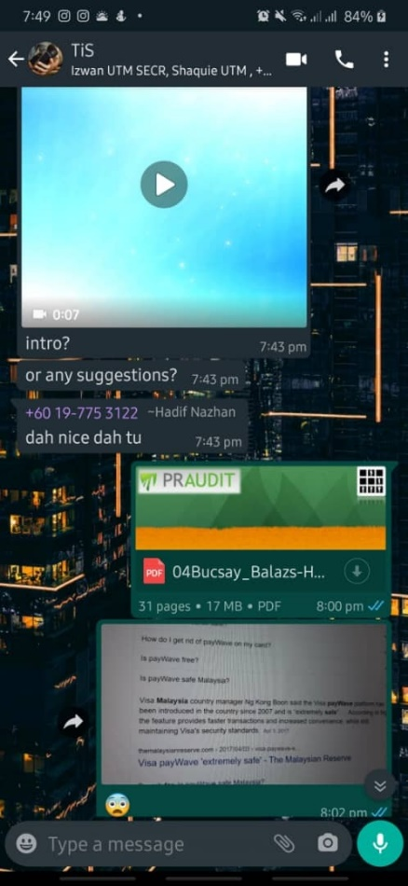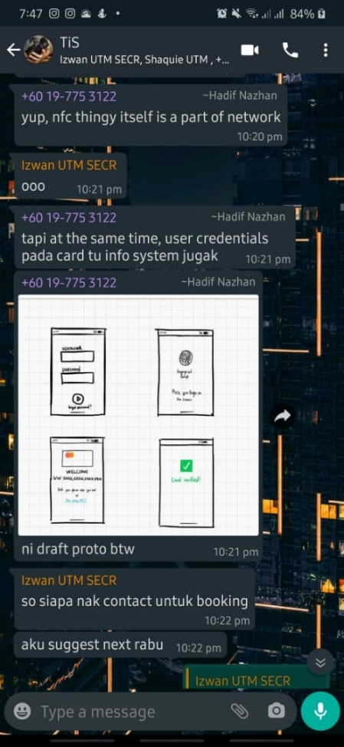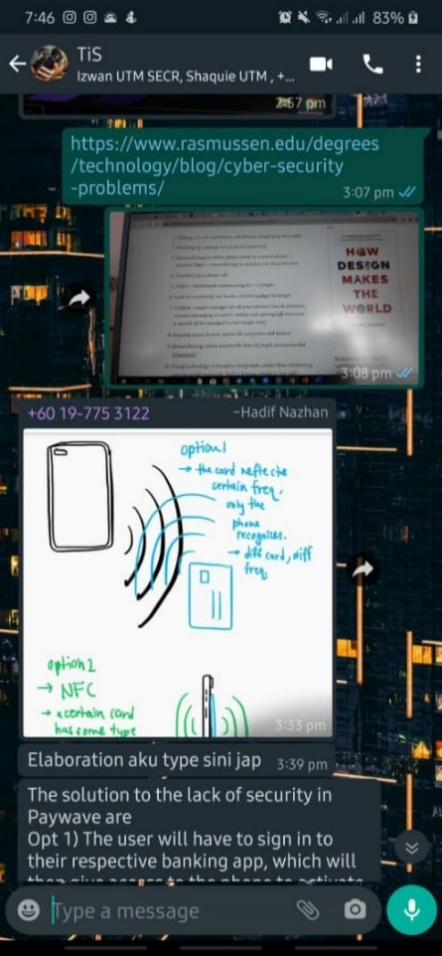

**Design challenge**

We went through all the five steps of design thinking in order to make our idea into reality.

First, we figured out the problems and empathised it by interviewing PM .Dr Murthada and En.Mohd Farid in an open interview session. We figured out some problems which are related to our topic. Next, we defined and chose a particular problem which is the payment method issue. As we dived into research, we figured out that the payWave system can be further improved by making it more secured. Next,we came out with the plan to design an app to configure and manage the authorisation. As for the prototype, we drafted some ideas and chose the suitable and simple interface for the users. We made a video to demonstrate the interface and functionality of the app and conducted surveys to improve our ideas.

**Steps and description**

1. **Empathy**

On 3rd of November at 9 p.m., all the members of the group had an interview session with Mr. Mohd Farid and Prof. Madya Dr. Murtadha. We asked about his opinion on the current payWave system.

*Question*: What is your opinion on the current payWave system? Is it secure enough?

*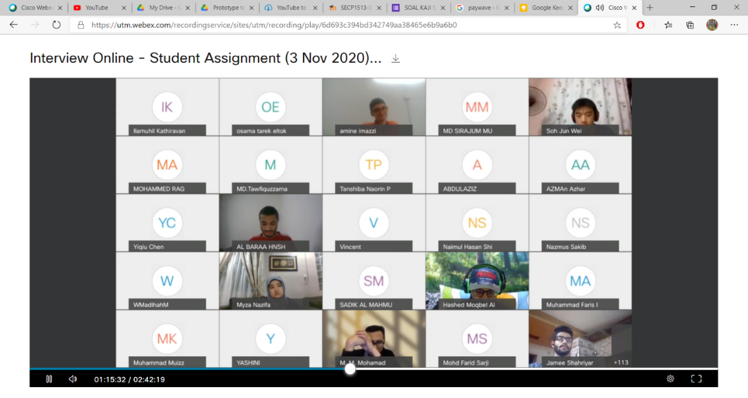Answer*: Actually, the system is secure enough. But there are some sources saying that the system can be hacked or misused. PayWave is secure so those claims are probably just to warn users to use payWave accordingly and wisely. It goes down to the user himself. For one, set the limit of the maximum amount per transaction. Secondly, do not transfer your whole savings into your bank account so that you would not have to worry about misspending by using your debit card.

Link: <https://utm.webex.com/recordingservice/sites/utm/recording/playback/6d693c394bd342749aa38465e6b9a6b0>

Password: Pd2KnRjt

After the interview session, we tried to identify the weaknesses of the current payWave system. We decided to conduct a survey regarding the security level of the current payWave system and the respondent’s suggestion to improve the payWave system. Therefore, our targeted respondents consisted of the public, since there is a widespread use of the payWave system in our country and it is growing from time to time. Shortly after listing out the weaknesses, we created a form for the survey by using Google Forms and distributed them through online platforms such as Telegram and WhatsApp.

*Chart:* Suggestions to improve payWave system

*Chart*: Response towards whether the payWave is on safe levels of security

Link to the form: <https://forms.gle/XKb3edbvtFhL8ndV8>

1. **Define**

We have done a survey regarding the payWave system in Malaysia. Diagram 1.1 and 1.2 and 1.3 are the visual representation of the survey.

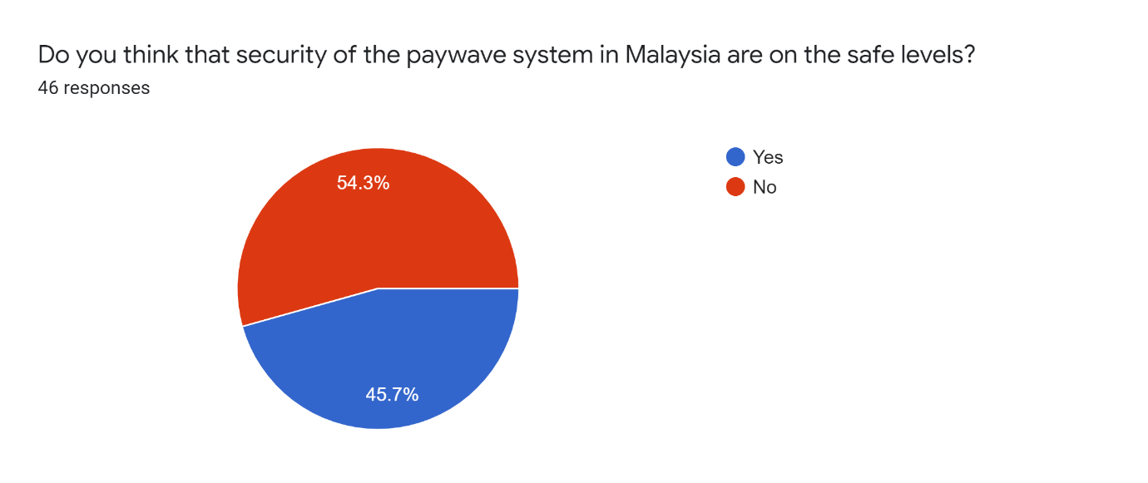

*Diagram 1.1*

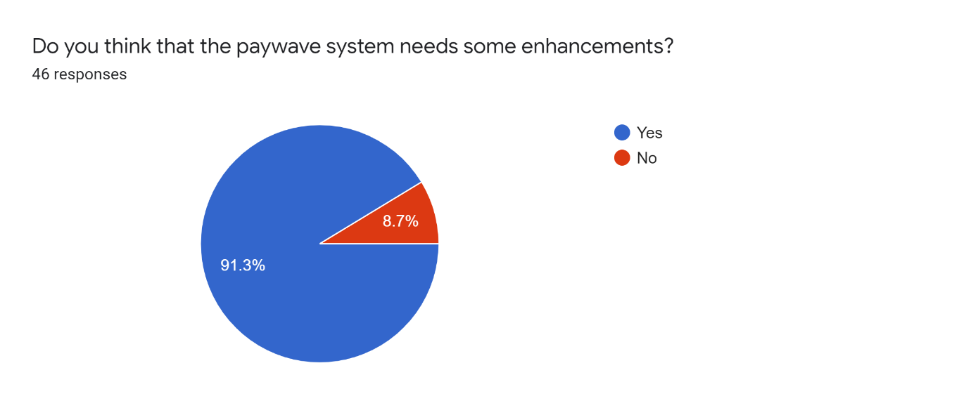

*Diagram 1.2*

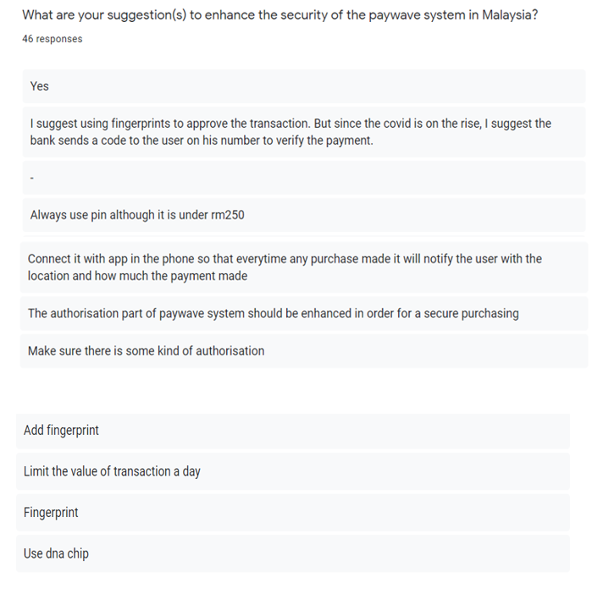

*Diagram 1.3*

The main problem- Among the 46 responder that took the survey 53.3% of them state that the payWave system in Malaysia are not at the safe and 91.3% of them wanted the system to be improved. One of their main concerns regarding this issue was that one can use our debit card easily because there is no measures to verify the authorization of the owner of the debit/credit card if they use the payWave system. A thief can easily act like a legitimate customer and purchase goods if the owner is unaware that his card was stolen

Solution- Based on the survey, most of them suggest adding biometric authentication to our app as most of the smartphones nowadays comes with his feature in our app. So, we added this feature in our prototype of mobile application that pairs our card with our handphone.

Problem- This type of authentication process will slowdown the smoothness of the purchase as we have to verify every time, we purchase something.

Solution- The app’s security features will be updated time to time and the bugs will be solved in a short period of time. A proper customer support will be given for the convenience of the buyer.

1. **Ideate**

At this stage, we had a virtual conversation in our Whatsapp group on the functionality of the app. Furthermore, we also discussed on the cryptographic technology and the security features as it was our main concern in this project. We emphasised on the feedbacks of the survey and came out with various ideas to design our prototype.

One of the ideas of a member was to add multiple layers of encryption to the master password that one use to login the app. Moreover, one of the members suggested a futuristic idea to include an AI support to the app so that the app is secure. Subsequently, Hadif and Hafiz who were the committee of prototype sketched and designed the interface of the application.

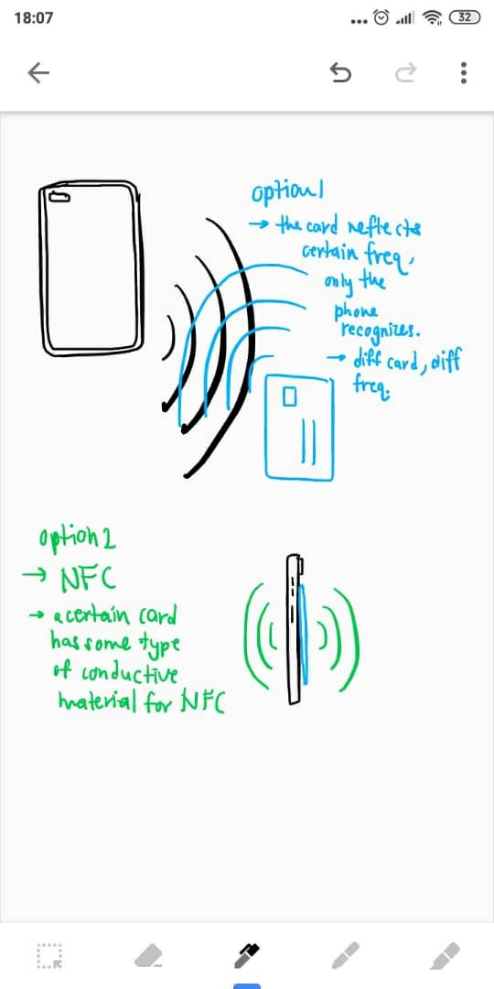

**Prototyping**

Based on our idea about the solution of the problem, a prototype application was developed by Hadif which is created by using google Keep and a phone. The prototype of the app is created with Google Keep using a drawing feature and the demonstration was done by using a phone to make the demonstration of the prototype more easy to perceive.This sketch of app include two major part of the interface which is log in page and the payment processing interface.

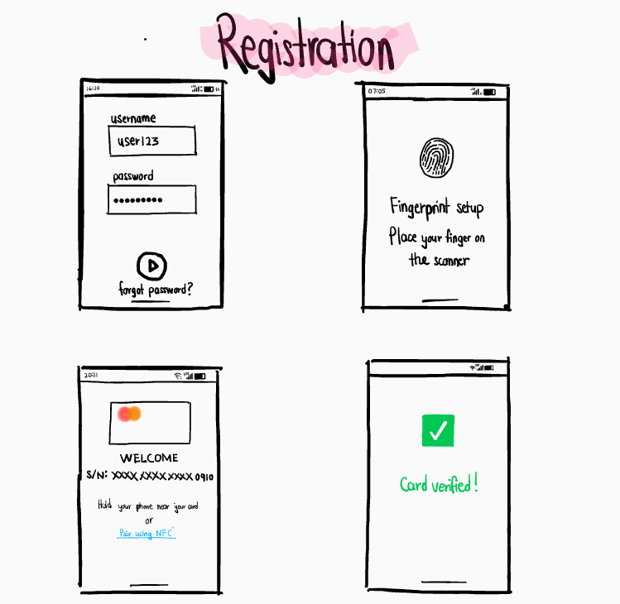

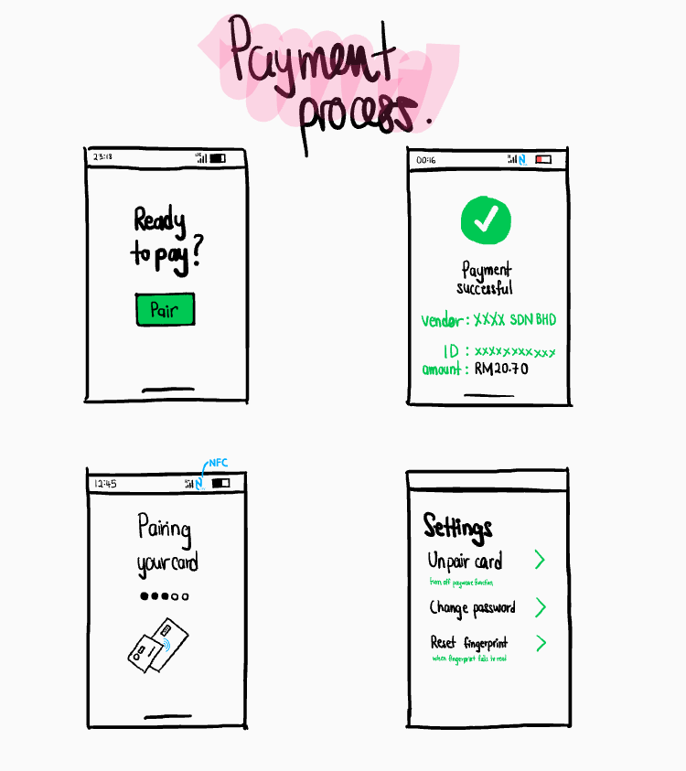

1. **Testing**

After finishing the prototype, we made a short video demonstration on the app and the new improved payWave system. In order to get some review on our prototype, we made a google form and shared it in WhatsApp groups to conduct a virtual survey. We also attached the video of the prototype testing to get a better view of the prototype. The respondents gave mostly good reviews about the app and the demonstration. Most of them gave some minor suggestion to improve the quality of the app. The positive feedbacks were indeed overwhelming .The diagrams 2 , 3 and 4 shows the details of the survey on testing.

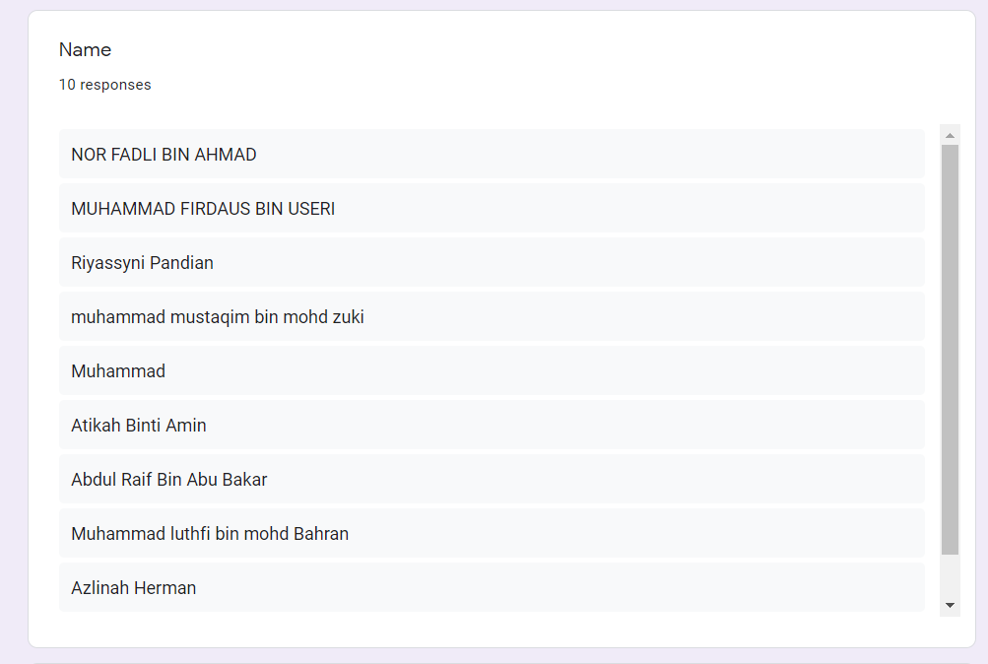

*Diagram 2* :List of respondents

*Diagram 3* : Pie chart of the feedbacks

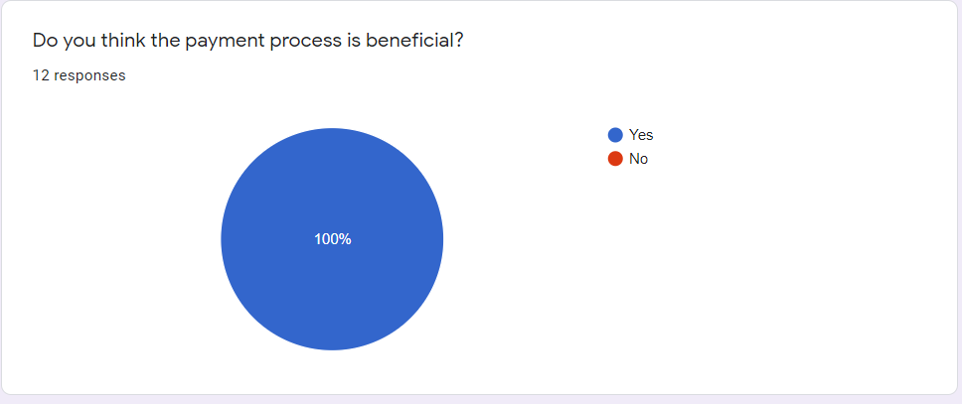

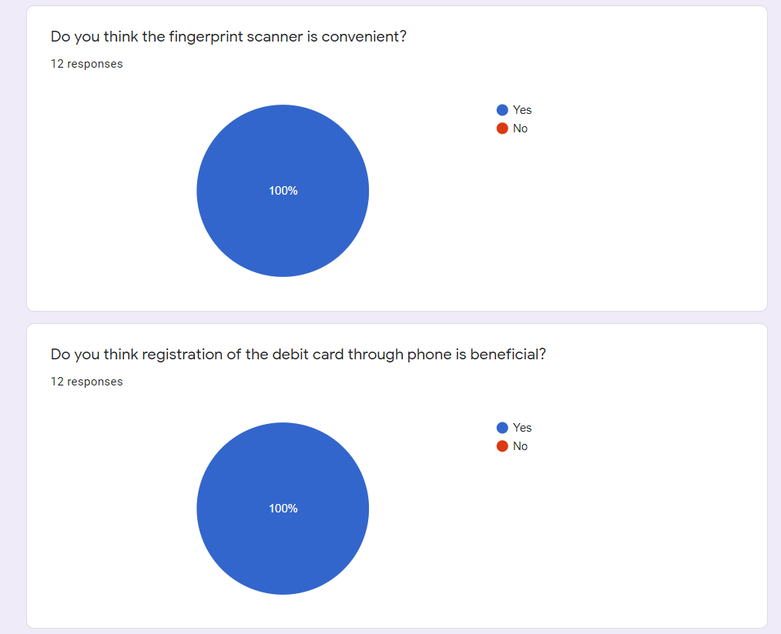

*Diagram 4* : Suggestions given by the respondents

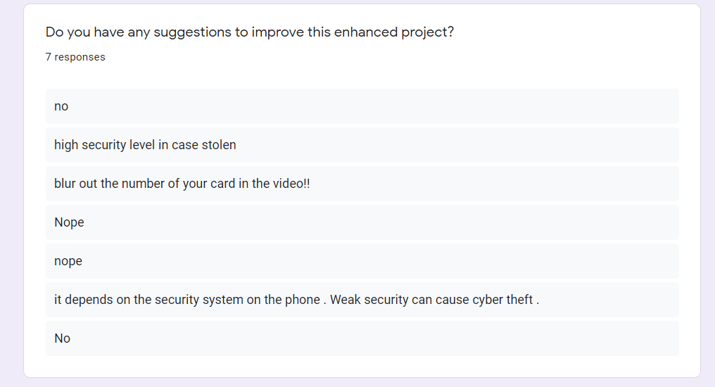

**Reflection**

My dreams with regard to my course are to involve myself in technology and get a better understanding of what is behind all the possibilities technology can offer. Apart from that, I would love to be able to contribute to the communtiy with the use of my knowledge in technology even by little means, as long as they can make people’s lives easier, safer and more efficient.

This design thinking project can actually help me in better planning in future tasks such as time management, task division among group members and work efficiency. This helps me in facing further assignments and task, as well as cope up with the workload in future jobs, while still being creative and innovative.

In my journey of improving my potential in the industry, I am going to deepen my knowledge regarding technology such as programming languages, digital logic, statistics and the information system. Furthermore, I will participate in more group-based tasks or assignments to improve my management and leadership skills. I also plan to get myself into challenges like hacking competitions or developing a program that can enhance my knowledge and skills regarding technology which can be useful in today’s fast-growing industry.

**Task Assignment**

|  |  |  |
| --- | --- | --- |
| **No** | **Name of Member** | **Task** |
| 1 | ILAMUHIL A/L KATHIRAVAN  (A20EC0047) | * Idea generation * Report writing * Chapter Presentation(C9-Ethics) * Interview session with expert * Improvisation |
| 2 | MUHAMMAD IZWAN  (A20EC0092) | * Idea generation * Report writing * Video Editing * Interview session with expert * Collect interview question |
| 3 | MOHAMAD HADIF NAZHAN BIN HALMEY  (A20EC0206) | * Idea generation * Prototype design(sketch) * Survey * Interview session with expert * Video Presentation |
| 4 | MUHAMMAD SHAUQIE DANISH BIN ABAS  ( A20EC0098) | * Idea generation * Report writing * Prototype Video * Interview session with expert * Video recording |
| 5 | RAJA MUHAMMAD HAFIZ BIN RAJA ALAUDIN SHAH  ( A20EC0223) | * Idea generation * Slides * Prototype design * Video Presentation |

**Bibliography**

1. Stevens, E., 2020. *The Design Thinking Process | What It Is, How To Use It, And What's Next*. [online] Invisionapp.com. Available at: <https://www.invisionapp.com/inside-design/what-is-design-thinking/> [Accessed 17 November 2020]
2. Gilchriest, B., 2020. *Design Thinking And Intelligent Technologies*. [online] Digitalistmag.com. Available at: <https://www.digitalistmag.com/iot/2018/09/14/design-thinking-intelligent-technologies-06186379/> [Accessed 17 November 2020].
3. RBS. 2020. *Number Of Records Exposed Up 112% In Q3*. [online] Available at: <https://www.riskbasedsecurity.com/2019/11/12/number-of-records-exposed-up-112/> [Accessed 17 November 2020].
4. Medium. 2020. *How Money Can Be Stolen From Contactless RFID And NFC Cards*. [online] Available at: <https://medium.com/@Vasco_bags/how-money-can-be-stolen-from-contactless-rfid-and-nfc-cards-cd74fea192a6#:~:text=A%20new%20method%20of%20stealing,%E2%80%9D%20using%20hand%2Dmade%20readers.&text=Fraudulent%20schemes%20are%20meant%20to%20intercept%20NFC%20signals%20using%20illegal%20reader%20devices.> [Accessed 17 November 2020].