

TECHNOLOGY INFORMATION SYSTEM

|  |  |
| --- | --- |
| **Name** | Jeawan Naayagar  A/L Kanakasabai |
| **Talk Title** | E-Rezeki |
| **Speaker Name** | Ms Nor Ashikin  bt Halil |

**TABLE OF CONTENTS**

|  |  |
| --- | --- |
| **CONTENTS** | **PAGE**  **NUMBER** |
| SUMMARY | 1 |
| INTRODUCTION | 2-3 |
| ADVANTAGES OF PARTICIPATING THIS PROGRAM | 4-5 |
| WHY SHOULD TRY FREELANCING ? | 6 |
| SUCCESS STORIES FROM PARTICIPATING THIS PROGRAM | | 7-8 |
| HOW TO PARTICIPATE IN THIS PROGRAM ? | | 9 |
| CONCLUSION | | 10 |

Global Online Workforce

**SUMMARY**

**GLOW**(Global online workforce) is a program

to coach, mentor and nurture full time crowd workers

that are able to consistently earn a stable digital

income.

The program aims to generate fixed and stable digital

income for Malaysians via crowdsourcing.

Crowdsourcing is the future as it enables digital

works to be offered and delivered online.

This program helps someone to cultivate their talents.

In addition, the talent is able to generate income.

This program is one of the digital initiatives that

connects the lower income earners with digital

revenue channels where the individual will do digital

work.

Participants who join program will be trained,

qualified and matched with appropriate or working

tasks.

The program is based on the crowdsourcing concept - with a special focus on public service-based models.

**INTRODUCTION**

This program was organized by Malaysia Digital Economy Corporation (**MDEC**)

This program is a unique partnership with Public-Private Partnerships funded by the Malaysian government to develop the world's first 'Private Talent Cloud'. The

program is a special focus on service-based models.

The program aims to benefit mainly to low-income households, opening up opportunities and enabling them to generate income opportunities through digital methods.

Through this program, participants will be trained, qualified and matched to the appropriate assignment. Additionally, participants can also learn new skills, as well as increase income by working for leading companies around the world and locally. The program is open to anyone aged 18 years and above with a monthly income of RM4,000 and below whether students, housewives, retirees or senior citizens.

Some of this program centers have been set up in strategic locations such as Johor, Perak, Kedah, Sabah, Sarawak, Selangor, Pahang, Terengganu and Kuala Lumpur.

The center of this program is a physical center, providing the necessary infrastructure and assistance for you to participate in the program.

This program has four section that is known as :

* **Micro-Digital Work**
* Fill in data into online form.
* Review and delete repetitive data.
* Download and test applications.
* **Digital Work**
* Develop a website.
* Develop a smartphone app.
* Create a logo and design graphs.
* **Non-Digital Work**
* Conduct home-to-home censuses for survey purposes.
* Reviewing the prices of goods and services.
* Running part-time jobs like being event crews and programs.
* **Passive Digital Work**
* Offer the work of your creations, such as photography or graphic vectors.
* Become a dropship agent, or help promote products and services.

**ADVANTAGES OF PARTICIPATING THIS PROGRAM**

* **Flexible Hours:**

The first advantage of becoming a freelancer is that you can work whenever you want. You get to choose your own hours. If you want to sleep in until noon, you can do that. If you want to take the weekend off so you can explore the city, by all means, go for it. As a freelancer, you can actually work during your most productive hours, and those hours don’t have to fall in during regular business hours.

* **Control over Jobs and Clients** :

When you work for someone else, you don’t get a choice of who you work with. You can become stuck with unprofessional or rude clients. But, when you’re a freelancer, you can choose with whom you work. If you don’t mesh well with a client’s personality or business or payment philosophies, you can pass on the opportunity and wish them the best. It’s as easy as that.

* **Work Wherever You Want**

Whether you prefer consistency or shaking things up when it comes to your work environment, you can choose to work wherever you want, whether you choose to work in a local coffee shop or while you’re on vacation in Europe. You are no longer stuck in an office or even in your home. Find a place in which you work best.

* **You’re the Boss :**

You no longer have to answer to anyone but your clients and yourself. No one is hanging over you or micromanaging you. You are free to do as you please, when you please. Making all the tough decisions just became your responsibility; you have all the control.

* **You Keep All the Profits**

No longer do you have to work for a flat rate, no matter how large the projects are that you complete. Now, you get to allocate or keep all the profits from your large and small projects and clients. This gives you the freedom to then use that money to improve yourself and expand your business.

**WHY SHOULD TRY FREELANCING ?**

* **You're unemployed:**

Here's a reframe for you: You're not unemployed. You're self-employed. You just gave yourself a job. Now start chasing revenue. That's what employers do.

* **You're young:**

Young people living low-cost lifestyles (no mortgage, no kids, no spouse) are particularly good candidates for independent contracting. Plus, it's a way to get experience without convincing someone to give you a chance to prove yourself. Besides, you're internet ninjas, and that's what matters nowadays.

* **Your job is expensive:**

Maybe your job requires that you live in a big, expensive city, own a car, and commute daily. Sit down and calculate what your job is costing you. For many freelancers, the office is wherever they put their laptop.

**SUCCESS STORIES FROM PARTICIPATING THIS PROGRAM**

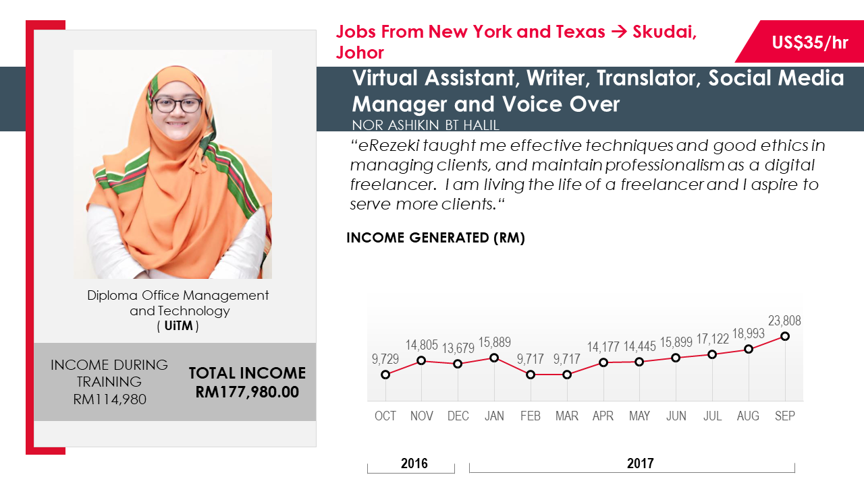

Earning Rate: US$ 35/hour

**Nor Ashikin bt Halil**

Shehad done her Diploma in Office Management and Technology at UniversitI Teknologi MARA (UiTM). She sarted to doing part time jobs in this program for 3 years before she start her full time service.Now, she working as a Virtual Assistant, Writer, Translator, Social Media Mnager and Voice Over. Normally jobs offered from New York and Texas to Johor.

*This program taught me affective techniques and good ethics in managing clients and maintain professinalism as a digital freelancer. I am living the live of a freelancer and I aspire to serve more clients* – Ashikin.

Income during training : RM 114, 980.00

Total income now : RM 177, 980.00

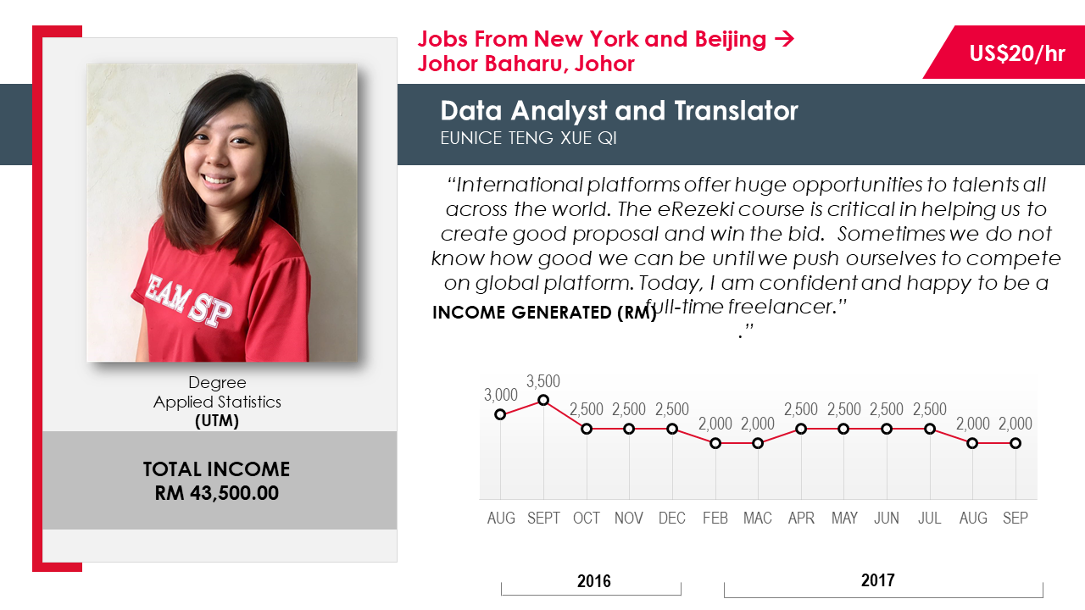

**Eunice Teng Xue Qi**

Earning Rate: US$ 20/hour

She finished her Degree in Applied Statistics at *University of Technology Malaysia* (UTM). She’s work as Data Analyst and Translator in this program. She also been offered job from New York, Beijing and Johor Baharu.

*International platform offer huge opportunities to talents all across the world. The program course is critical in helping us to create good proposal and win the bid. Sometimes we do not know how good we can be until we push ourselves to compete on global platform. Today, I am confident and happy to be a full-time freelancer.* – Eunice

Total income now : RM 43,500.00

**HOW TO PARTICIPATE IN THIS PROGRAM ?**

* Online E-form

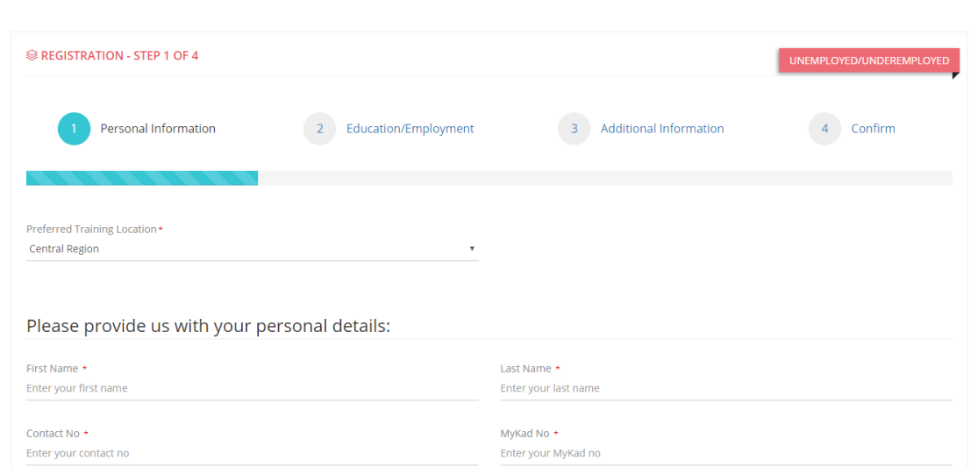

* Through Industry Talk

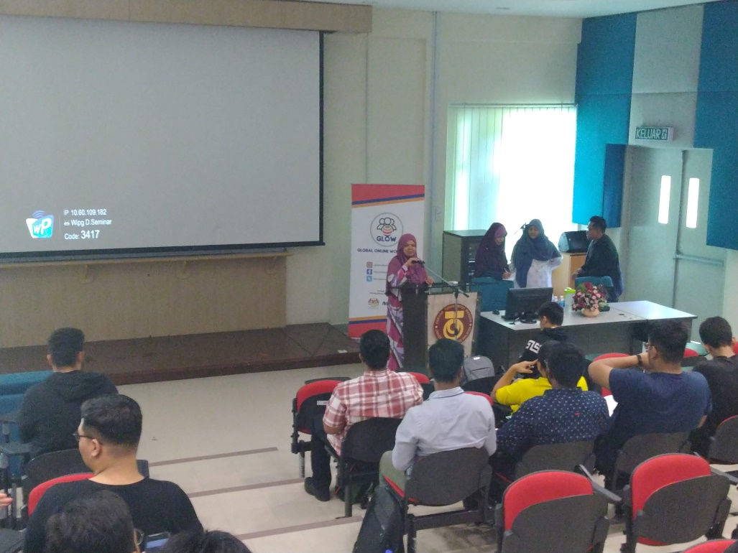

\

**CONCLUSION**

In conclusion, this program is very helpful to students, housewives, retirees and senior citizens. All who have joined the program have earned lucrative income with only home-based work using a laptop or smartphone. Finally, the program also reduces the unemployment rate in Malaysia.