

TECHNOLOGY AND INFORMATION SYSTEM (SCSP1513)

PREPARED FOR:

DR. ARYATI BINTI BAKRI

PREPARED BY:

KHAIREENNUR KHALIESHA BINTI MOHAMAD JAIS

(A19EC0300)

LOKESH A/L PATHMANATAN

(A19EC0077)

MUHAMMAD HALIM BIN JOHAR

( A19EC0097)

Contents

INTRODUCTION 3

DETAILS OF THE VISIT 4

MAINFRAME & SUPER COMPUTERS 6

APPLE MACINTOSH CLASSIC COMPUTER 8

IBM Personal System/2 Model 70 386 8

IBM Personal Computer 300GL 9

IBM P70 Model 6554-673 9

MOUSE 10

TYPE WRITER AND KEYBOARD 11

REFLECTION 13

# INTRODUCTION

CICT is a support unit that offers and delivers ICT services for the university (staffs and students) especially in ICT infrastructure, system development and academic / administrative activities. CICT was also known as the Computer Centre back in 1975, and then it became the Institute of Computer Science in 1984. The name was then changed to Computer Centre UTM (PKUTM) in the year 1991. And finally the name CICT was given in the year 2004 which has remained till the present day.

CICT is responsible for planning and provision of central ICT services in UTM and also facilitating the delivery of ICT services across the University’s campus. CICT supports the use of ICT in the academic and administrative functions of the university. All of the services and skills provided by CICT not only benefits the students, but also the staffs in UTM. CICT offers hosting services such as web hosting, server hosting and also colocation server hosting not only to the UTM community, but also for any external customers at a very affordable price. CICT also developed and now maintains the campus communication network system.

# DETAILS OF THE VISIT

On the 20th October 2019, students from SECP1513 – Section 06 had the opportunity the visit the CICT Gallerium located in the lower floor of the Sultanah Zanariah Library (PSZ), UTM. Our visit was roughly at 3.30 p.m. We were greeted by Encik Zahari bin Zainal Abidin, Assistant Chief of Information

Technology. He gave a short briefing about the history of CICT, and then functions and facilities that

are provided by CICT. He was very detailed about all of his explanations and was also patiently explaining about how the trends have evolved in the past few decades, eventhough it was hard for most students to actually understand.

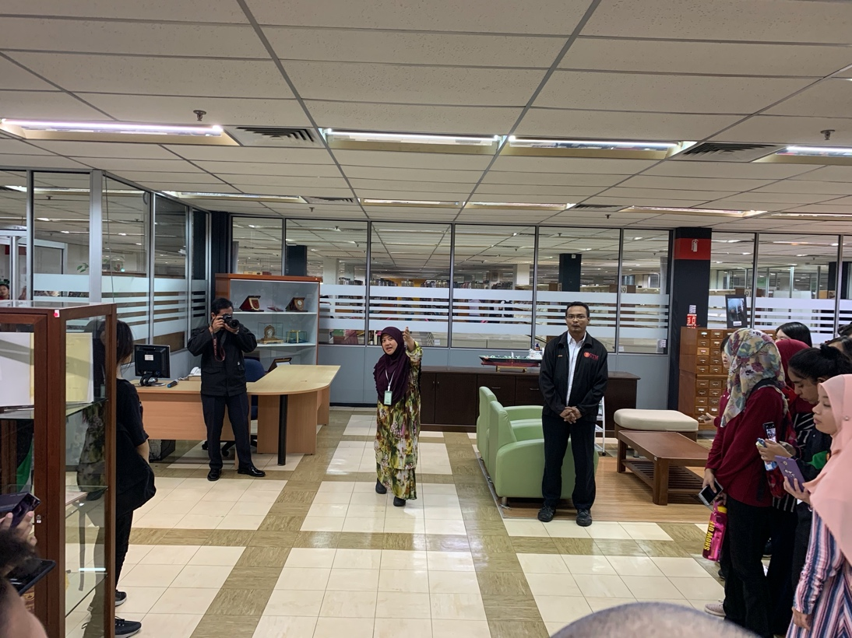

Picture 1 : Short briefing session

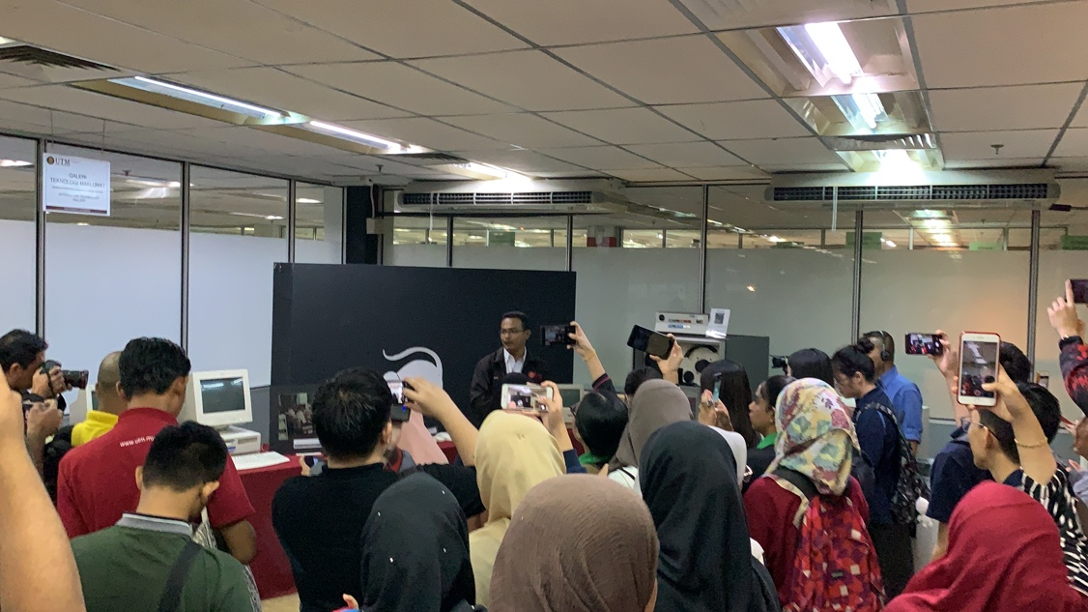

Picture 2 : Explanation on the evolution of technology

# MAINFRAME & SUPER COMPUTERS

Mainframe computers or mainframes (colloquially referred to as "big iron") are computers used primarily by large organizations for critical applications; bulk data processing, such as census, industry and consumer statistics, enterprise resource planning; and transaction processing. They are larger and have more processing power than some other classes of computers: minicomputers, servers, workstations, and personal computers. Some examples are such as IBM, Hitachi and also Amdahl.

The term originally referred to the large cabinets called "main frames" that housed the central processing unit and main memory of early computers. Later, the term was used to distinguish high-end commercial machines from less powerful units. Most large-scale computer system architectures were established in the 1960s, but continue to evolve. Mainframe computers are often used as servers.

The biggest and most obvious distinction between mainframes and supercomputers is the type of problems they tackle. Each of these large-scale computers is specially designed and optimized to perform a specific type of task. Supercomputer and mainframes can do tasks more efficiently than other types of computers and also do things that no other regular computers can do.

|  |  |
| --- | --- |
| Mainframe | Supercomputer |
| * Able to run multiple programs concurrently. * One big system that perform huge amounts of external data. * Flexible enough to run many kinds of applications and tasks. | * Processing power used to only execute few programs, but as quickly as possible. * A cluster or grid of smaller computers working together . * Specific purposes (usually research). |

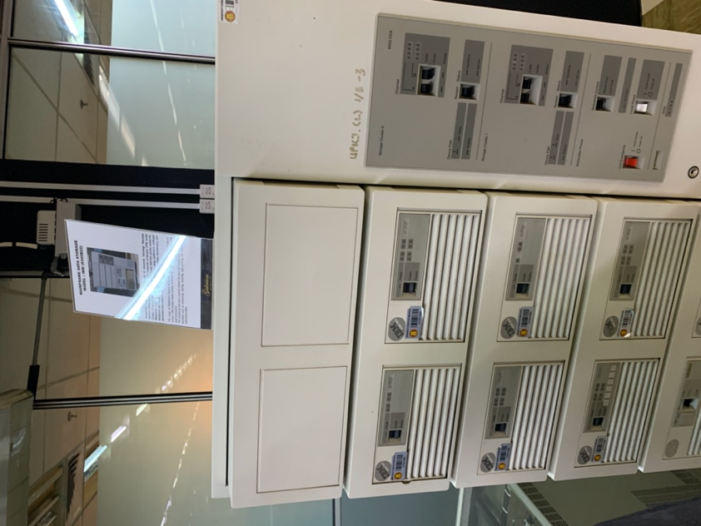

Picture 3 : Mainframe Data Storage

# APPLE MACINTOSH CLASSIC COMPUTER

The Macintosh Classic was introduced in early January 1984 and has been used in UTM Library in early 1990. It was equipped with a software memory of 1MB of RAM and 2MB to 40MB of hard disk. With its large capacity at that time, the computer was used in the Library along the Lotus 123 and Word Star Applications for work and simple calculation

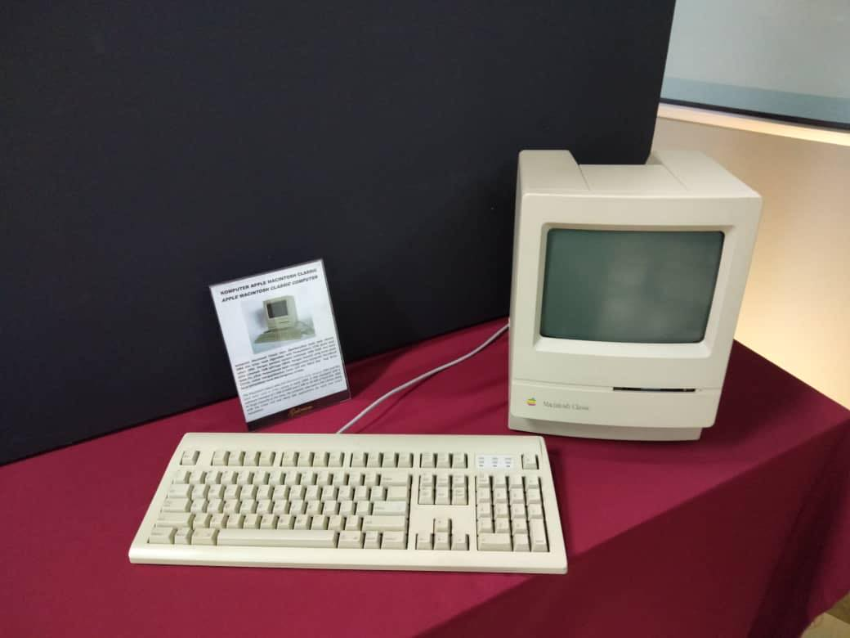

# IBM Personal System/2 Model 70 386

The IBM Personal System/2 Model 70 386 featured a high density memory technology and a range of integrated features. The computer, with its system, supported the Library significantly in performance improvement for desktop operation. It was also compatible with most software products available for a personal computer system in UTM Library.

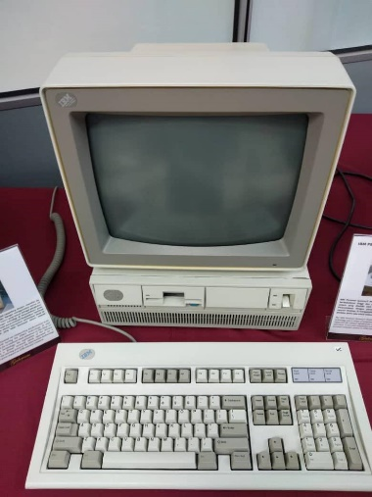

# IBM Personal Computer 300GL

IBM Personal Computer 300GL being an all inclusive and affordable computer, helped increased the productivity and reduced the cost of ownership of UTM Library. The transformation of system is taking place constantly in the library. Apparently, technological revolution of computer usage coincides with system change and this was evident with the application of Dynix system for 10 years.

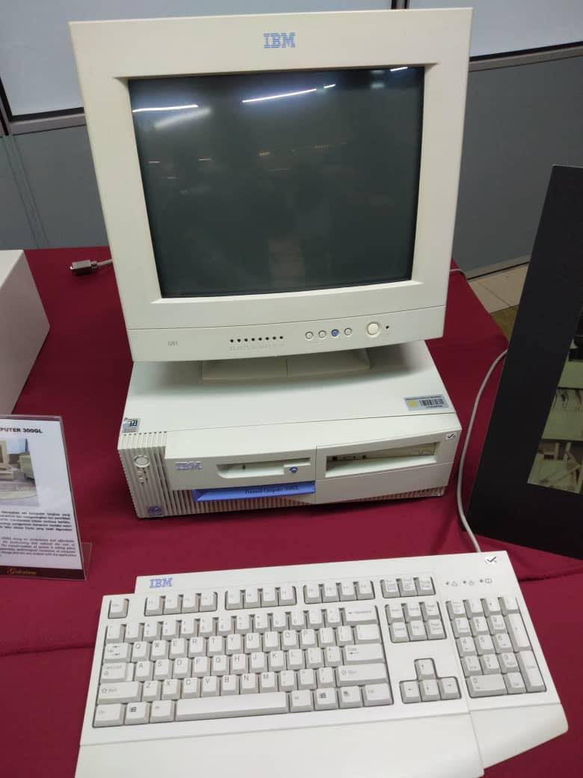

# IBM P70 Model 6554-673

The IBM P70 Model 6554-673 was used in library in early 1998 for contributing to the work performance. As such, library was liable of all modules, databases, software operations and data accessibility. The computer system provided a performance improvement on desktop operation with its ability in supporting up to 16MB on disk storage**.**

# MOUSE

A mouse is a hand-held pointing device that detects two-dimensional motive relative to any surface. This motion is then translated into the motion of a pointer, which is then displayed on the screen. The first official public demonstration of a computer controlled system by a mouse was on the year 1968. The first ever mouse prototype however was built in 1964 by Bill English. The Xerox Alto was one of the first computers that was designed to utilize a mouse in 1973. And by the year 1982 the third version of the xerox mouse, the Xerox 8010 Star was probably the best-known computer with a mouse. Now most modern mices are wireless and have higher tracking precision for much more advanced tasks.

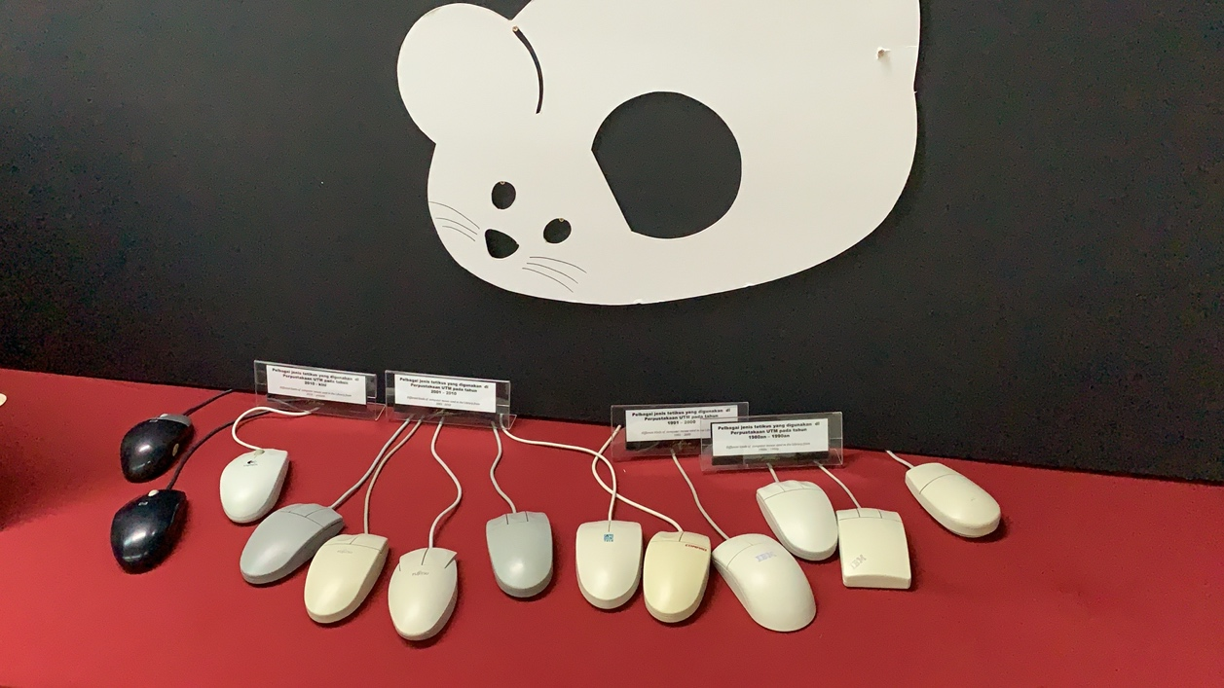

Picture 4 : Evolution of mouse

# TYPE WRITER AND KEYBOARD

The type writer keyboard was developed and patented in 1868 by Christopher Sholes and is considered to be the first typewriter but it only become famouse usage in office until mid-1880s.

The type writer keyboard is a mechanical or electromechanical machine for writing similar character. It has an array of keys and each of it can causes different type of single character which can be produced onto the paper.Also, the Type-Writer introduced the QWERTY layout, which is still used on almost all US keyboards today.

The typewriter which present in the library were used in the library during the early 1976s until early 1980s. Before the application of computers in1985, these application were used in administration tasks such as printing letters.

With the development of technology, the keyboards began to resemble what we use today and were heavy mechanical keyboards or converted electric typewriters by IBM company. But the qwerty keyboard continues to be the standard used in computers too. In 1986, IBM released the Model M keyboard that resembles what most keyboards look like today with the function keys across the top of the keyboard. The Model M is still a highly regarded keyboard even today, as it introduced the 101-key standard US layout that is used today for full sized keyboards. It has also been adapted to the 104-key layout for Windows keyboards with the Windows keys and Menu keys. As time goes on, the keyboard also has been in changes which changes is moving from a mechanical switch to a membrane. A membrane makes it much easier and cheaper to manufacturer computer keyboards. A membrane keyboard also makes the keyboard quieter, lighter, and thinner than the first mechanical keyboards.

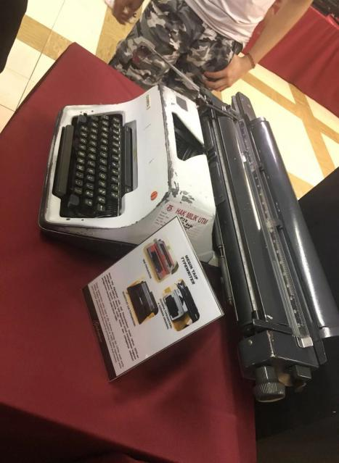

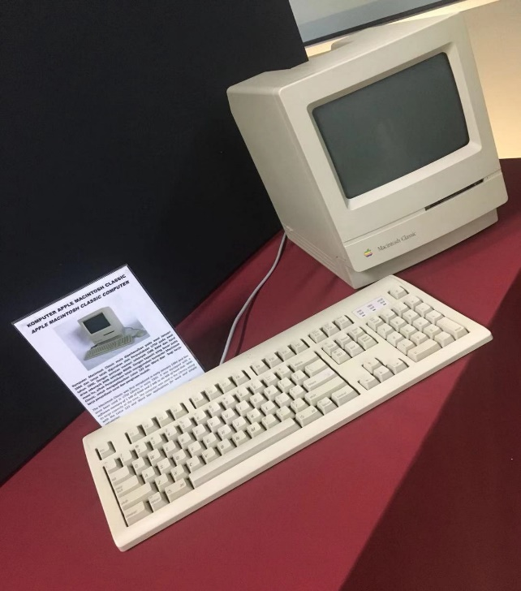

# REFLECTION

Our visit to CICT taught us a lot of stuffs about general life and how technology has really played a key role in shaping who we all are as humans today. It helped us focus more on our goals and future dreams and use technology to our advantage and achieve whatever we want. This was a golden opportunity for all of us to broaden out horizon on how technology was actually used in the past few decades and also how it has come so far ahead till this point of time. And as I mentioned earlier, the staffs at the CICT Galeria and especially, Encik Zahari was very kind and took a lot of time to giving us as detailed of an explanation as he possibly can. It helped us create an image of how things started just as an idea and has now made life so much simpler and hassle free.

The visit also taught us the without any of this advancements, we can never reach where we are today. We should know that, now we hold the responsibilities and burden of advancing the currently existing technologies and also developing all new ideas into future products. We need to do so to keep making the life of future generations as simple and straightforward as possible. We also need to find new ways for self-betterment in the midst of the developing technology, for a better us and a better community. We always need to give our very best at all times to ensure we also always get the very best results out of it.