Industrial Talk: The Importance and Trending of IT Project Management

Ieskandar Zulqarnain Bin Ghazali1, Aiman Na’im Bin Ariffin2, Syaza Syaurah Binti Mohd Yusran3, Lai Kin Yong4, and Hibban Kamil Hizbuttahrir5.

1,2,3,4,5School of Computing, Faculty of Engineering, Universiti Teknologi Malaysia (UTM),

Skudai, Johor, Malaysia

***Abstract***—**This is a summary of the information given during the industrial talk which discusses project management in the IT industries. Project management is the application of knowledge and skills in conducting a project to deliver the maximum price-performance ratio of the project. Due to the development in the IT field, a new trend of project management has emerged in the IT field, known as IT project management. The IT companies are seeking the qualities of a good project manager among their employees. Therefore, the employees should harness the IT project management skills for their employability and the prosperity of their companies.**

***Keywords***—***Industrial Talk, Importance, Trending, IT Management***

I. INTRODUCTION

The industrial talk titled “The Importance and Trending of IT Project Management” is organized by the Technology and Information Systems Department, School of Computing, UTM from 10 A.M. to 11 A.M. on 1st December 2020. Mr. Mohd Khairul Reeza Ruslan, the head of Project Management Office from the Commerce Dot Com Sdn. Bhd. is invited as the speaker to this talk.

II. IT PROJECT MANAGEMENT

*A. The Definition of Project*

A project is a specific and finite series of tasks for providing a product or service to generate the desired result within a framework defined by a reasonable time, cost, and quality[1][1]. In the industries, there will always be multiple projects that serve a greater goal which is planned in a program, while the program itself also serves for an even greater target proposed by a portfolio.

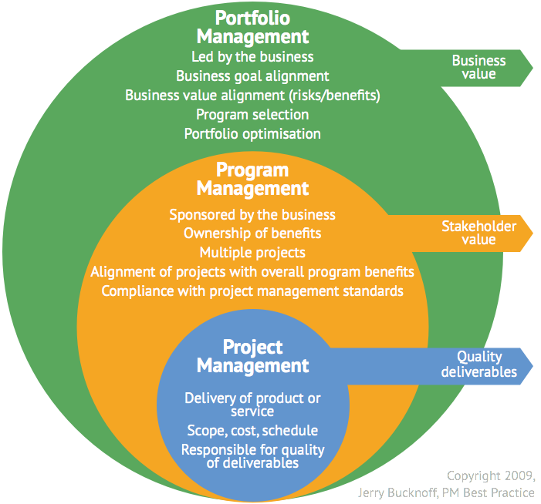

Figure 1. The relation between portfolio, program, and project.

*B. The Importance of IT Project Management*

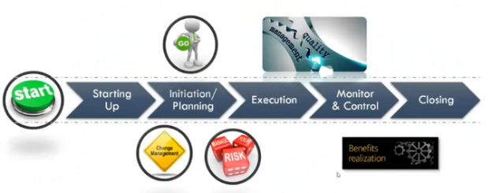

Figure 2 Process of project management

With proper project management, an individual could efficiently utilize his knowledge, skills, tools, and techniques to conduct a project. Project management and helps a person to clarify the problem statement in a project and plan the solution based on the person’s capability. In other words, it allows a person to evaluate the cost, time, and energy needed for the project. In this way, he could decide whether he requires extra resources to secure the benefit from the project, or tailoring the process by achieving the minimum project requirement without disregarding the project quality so the project is always cost-effective. Project management proposes the individual to keep track of the progress in the project so measures could be taken at once if any problem occurs. Eventually, it is encouraged to write documentation as the closing of the project for review and storage purposes.

*C. Trending of IT Project Management*

|  |  |
| --- | --- |
| **Trends** | **Explanation** |
| Gig Economy | Economic system defined by the increasing demands for short-term contracts or freelance work rather than permanent jobs[2]. |
| Big Data | Enormous data analytics to understand customer needs and detail risks for generating insight into a development project. |
| Artificial Intelligence | AI-powered automation is capable of performing certain tasks at maximum efficiency and accuracy. |
| Change Management | Flexibility in managing the project which promotes the adaptability to change. |
| Method Melding | The practice of the combination of multiple project management methodologies. |
| Tools & Solutions | The utilization of advanced project management devices in planning, executing, and monitoring the project. |
| Emotional Intelligence | Ability to control emotions and associate with others’ emotions. |

Table 1

III. RELEVANT IT CAREERS

Since the IT industry is developing rapidly and many workers commit themselves to the IT industries, the industries have emphasized project management skills as the primary qualification that they expect from the employees rather than programming skills. The list below includes some careers from the IT industries. The following careers are also the careers in which project management skills are highly valued by employers.

* Software/Application Developer
* Cloud Computing Engineers
* Computer Network Specialists
* Database Administrator
* Data Analysts
* Internet Advertisement Manager
* Information Security Specialist
* E-Commerce Sales Manager

IV. REFLECTIONS

* Ieskandar Zulqarnain

My dream is to become a software developer after I graduate with this degree. This industrial talk makes me clearer to become a software developer because project management is related to being a software developer. Therefore, I will improve my to manage my project to make a better quality of my client needs.

* Aiman Na’im

My goal is to become an innovator in the IT field after graduating from this course. This talk would be a catalyst for me to ensure I could become a better innovator in the future. Hence, I will learn and apply more about handling project management better to improve my current quality in the industry.

* Hibban Kamil Hizbuttahrir

My Target after graduating is to become a Chief Information Officer (CIO). This Industrial talk, talk about Management in IT Project. In these jobs, I just realize how important management is. I love working in teams. I look forward to forming and organizing a team for the advancement of the company.

* Lai Kin Yong

The industrial talk has enlightened me with the knowledge about project management which I never know it is such significant for successful project development and employment. Therefore, I would start practicing project management in every project, as a way to develop my project management skills so I could become an outstanding candidate in the competition.

* Syaza Syaurah

I’m aiming to be one of the successful people that always do the best in every of her work. This talk has encouraged me and opens my eyes wider to always be diligent and manage my work well. My knowledge about project management has increase and I will practice it in my real life in doing any project/work to give all my best in advancing the industry.

ACKNOWLEDGMENT

I sincerely acknowledge and heartily thank Dr. Zuraini Binti Ali Shah, Department School of Computing, Faculty Engineering, the University of Technology Malaysia for spending his leisure time just to explain this kind of assignment by giving all the details that I need.

REFERENCES

[1] MSG Management  Study  Guide. (n.d.). Retrieved December 22, 2020, from https://www.managementstudyguide.com/what-is-project.htm

[2] Contributors, T. (2020, October 26). What is the gig economy? Definition from WhatIs.com. Retrieved December 22, 2020, from https://whatis.techtarget.com/definition/gig-economy