# UTM-LOGO-brand-

# 

# 

INDUSTRIAL TALK 1- MALAYSIAN DIGITAL ECONOMY CORPORATION (MDEC):

e-REZKI AND GLOW PROGRAMME

|  |  |
| --- | --- |
| NAME | HABIB HADMY BIN ZULKAFFLI |
| MATRIC CARD | A18CS0067 |
| SUBJECT | SCSP1513 SECTION 11 |
| LECTURER | DR ARYATI BAKRI |

**Table of Contents**

#### 1.0 INTRODUCTION 3

#### 2.0 CONTENT 3

#### 2.1 SPEAKER’S BACKGROUND 3

#### 2.2 E-REZKI PROGRAMME 4

#### 2.3 BENEFITS OF MDEC PROGRAMME 4

#### 2.4 MDEC PROMOTE 5

#### 2.5 THE IMPACT TO MALAYSIA 5

#### 2.6 PERSONAL NOTES ON FURTHER INTEREST 6

#### 2.7 REFLECTION FROM THE INDUSTRIAL TALK 6

#### 3.0 SUMMARY 6

#### 4.0 BIBLIOGRAPHY 7

**Table of Figures**

#### Figure 1: Mr. Mohd Ihsanuddin Jamhari 3

#### Figure 2: MDEC and e-Rezki logo programme 4

#### Figure 3: MDEC GLOW wepsite 5

#### Figure 4: Figure 5 Dr.Aryati Bakri give thanksgiving to the speaker,Mr. Mohd Ihsanuddin Jamhari 6

# 1.0 INTRODUCTION

Malaysia Digital Economy Corporation (MDEC) was held an industrial talk about their programme such as E-Rezki, e-Usahawan and Global Online Workforce (GLOW) on 24th September 2018 at Seminar Hall where is located in N28A. All student of School of Computing was required to attend and make the report about that. Actually, the focus of the program is to attract community especially the students and youths to full utilize the usage of Internet to generate additional income.

# 2.0 CONTENT

This part will show the content of the talk and also about the background of the speaker, the brief explanation on the programme, the impact of the program, the way to participant the programme also some personal notes on the further interest and the reflection on the Industrial Talk.

## 2.1 SPEAKER’S BACKGROUND

He is a full-time freelancer in photography, major in graphic design, project director, ICT service and consultant, also an educator. He is a fulltime freelancer at XSUN GRAPHYX and a professional that had 6 years of experiences in the creative industry. Along with his brand, XSun Graphyx, he become a professional in freelancing world especially in graphic design that create creative and amazing logos for his clients and got many projects in Upwork and Behance. Previously in 2010, he received his Bachelor’s Degree in Electrical and Electronics Engineering from Universiti Teknikal Malaysia, Melaka. Then in 2012 he pursued his education in Universiti Teknologi Malaysia by doing Master’s Degree in Technical, Vocational Education and Training until 2015. His name is Mohd Ihsanuddin Jamhari, who is a Global Online Workfoce Master Trainer from MDEC was gave his talk and explanation about the programme. As graphic designer, he shares about his journey by involves in e-Rezki with his expertise is particularly in using some softwares such as Adobe Illustrator, Adobe Photoshop, and some Microsoft applications.

Figure 1: Mr. Mohd Ihsanuddin Jamhari

## 2.2 E-REZKI PROGRAMME

E-Rezki is a programme that focus on the online service task such as graphic design, videography, photography, ads-sharing and more. It targets to help any individual who has the skills but doesn’t have a fixed or permanent job as known as a freelancer to rise their income by immerse to a digital world. E-Rezki also the medium to client who needs freelancer to do their specific task because they would accept the job with lowest cost than hires a company. Hence, MDEC has come out with some initiatives to empower Malaysians to fully utilize Internet as a platform for online jobs then gain digital income through “crowdsourcing” system. Crowdsourcing is a system where the e-Rezki’s freelancer can find some online jobs offered and delivered through digital global platform.

Figure 2: MDEC and e-Rezki logo programme

## 2.3 BENEFITS OF MDEC PROGRAMME

This program brings a lot of benefits for the Malaysian especially students and youths. Many students and youths have zero knowledge about entrepreneur and experience. Then, this is MDEC’s responsibility to play their role to advice and guide the participants to improve their skills. It also can be a starter kit to them to face the job’s world. Also, as experience in making contact with some clients through online workplaces. With these benefits, many companies will hire them easily since they need a fresh employee with experiences to rise their productivity, client’s trust and to fulfill client’s high demand. For those who provide their skill service, this programme will provide the medium to them to find the trusted client. MDEC will give all the information about the client also the client also will get the information about them. Hence, both of them no need to fear being the scammed. through the programme need a good medium where they can serve client without fear of being scammed. The biggest benefit of this programme is the flexibility to do the jobs online as long as users have access to Internet and for who are unlucky to continue their study into higher education also can join this program through micro task job to gain some income and get the benefit from it.

## 2.4 MDEC PROMOTE

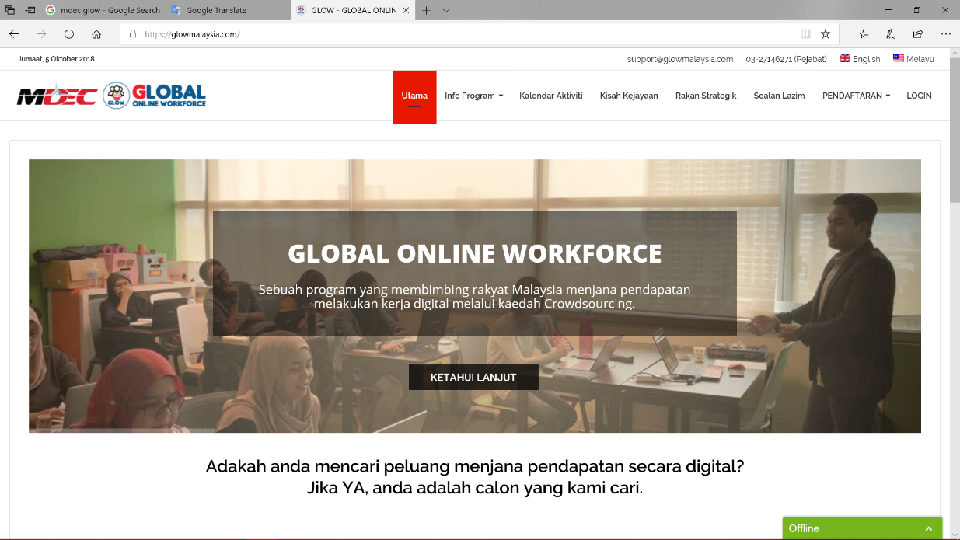By attending some university and held an industrial talk, MDEC consistence to promote their programme each institute in Malaysia especially university. Their hope is to attract more student who has hidden digital skills to join their programme then will generate more digital income and also as preparation themselves before they face the job’s world. Plus, MDEC can reduces the unemployment rate among the fresh graduated students with e-Rezki programme. Hence, the news about unemployed graduated student can be reduces the unemployment rate. MDEC also promotes this programme through the Internet with social media and website (www.glowmalaysia.com) to ensure all the Malaysian notice about it. So, all age-level of Malaysian can join this programme.

Figure 3: MDEC GLOW wepsite

## 2.5 THE IMPACT TO MALAYSIA

All of the MDEC programme is a high impact digital program which it able to empower Malaysians to utilize the usage of Internet to the next level that can help to improve the quality of the entrepreneurship and economy of the country by the amazing achievement of some individual who already being successful in the world. Besides, we could see a generation of entrepreneurs in the future which most of them are the youths and being students at the same time. MDEC also promotes the talent from Malaysia into the global stage. As a proof, Tanty Marlena who is a professional shoe designer was represented Malaysia in the International Footwear Competition in China on May 2018. She said by joining MDEC helps her to propel the business into global market as the assigned coach helps her streamline the business and give new strategy to increase sales. MDEC biggest impact on Malaysia is provides a door of new working sector which is freelancing, thus can decrease the unemployment rate among the society.

## 2.6 PERSONAL NOTES ON FURTHER INTEREST

On the personal note, I am interested to participate in the programmes especially e-rezeki programme that can help me to be a successful entrepreneur being a freelancer since is a branch of working where fresh graduates can take opportunity. I also can gain some experience during join the programme to prepare myself in job interview since nowadays every company needs the experienced employee. I think I can get some extra money by being a freelancer, with them I will pay my education loan such as PTPTN faster then just hoping my fixed salary. Lastly, I hope this program will be one of the main parts of the national education syllabus in the future and without any doubt, I will surely join MDEC in the future.

## 2.7 REFLECTION FROM THE INDUSTRIAL TALK

Some reflection from the industrial talk are the speaker positively can deliver the talk objectives and the messages about the programme since the speaker using two-ways communication during the talk. Next, I think MDEC also successfully provides the pathway for society especially to student to involve the programme and get the better future. I can conclude that soft skills and technical skills are vital in freelance community. It might be the vast experiences of the speaker itself since he needs more focus on the work than the talk itself. Lastly, I want take this opportunity to thanks to all Technology and Information Systems lecturers to take me involve in this industrial talk by MDEC.

# 3.0 SUMMARY

MDEC programmes like e-Rezki and GLOW are truly giving the significant benefit to the university students and youths. MDEC creates this programme is to guide the employee society to be more professional and being a talented freelancer. Next, to show that freelancing is a alternative job for Malaysian to gain more income through the global medium digital. Lastly, to promote Malaysian’s service and talent to global market. Hence, its are exist to follow the global trend, as it is the one of the national aspirations to create a community of digital makers and digital employers by 2050.

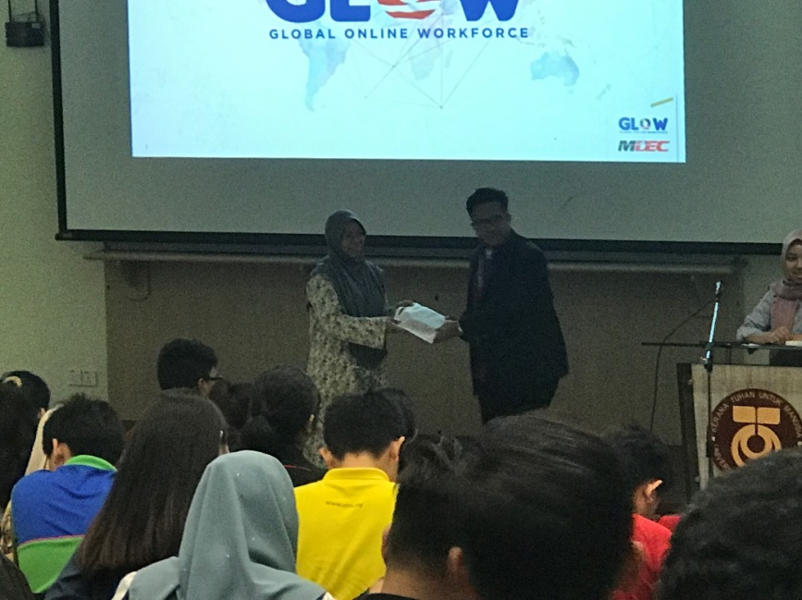

Figure 4: Figure 5 Dr.Aryati Bakri give thanksgiving to the speaker,Mr. Mohd Ihsanuddin Jamhari

# 4.0 BIBLIOGRAPHY

Jamhari, I. (2016, September 1). *About Me*. Retrieved from Behance: https://www.behance.net/ihsanjdesign

Success Stories 2018 | The Apprentice Shoe Designer Program. (May 2018):

http://www.shrdc.org.my/success-stories-2018/

MDEC Corporation. (2018). *Info Program*. Retrieved from Glow Malaysia. : https://glowmalaysia.com/apa-itu-eglobal-freelancer/

MDEC Corporation. (2018). :

https://www.mdec.my/