
Unit 2: Capacitors and Inductors in DC Circuits

Print this page
Recall from your earlier courses that resistance is opposition to the flow of current. Capacitance, which we'll study in this unit, is an entirely different electrical property. It's the ability to store a charge. Capacitors are components that are manufactured to have this ability.
Inductance, which we'll also study in this unit, is another completely different electrical property. Inductance is opposition to change in current, and inductors are components that are manufactured to oppose changes in current. Suppose that a circuit with an inductor has a certain current flowing through it. If you try to increase or decrease that current, then the inductor will fight against you, and will try to keep the current at its initial value. Eventually the inductor will lose this fight, and the current will change, but this will take some time to happen. This is different from what happens in a circuit with no inductor: if there's no inductor, then the amount of current can increase or decrease immediately. If there is an inductor, changes in current take a while to happen.
First, you should read the following sections of Thomas Floyd's Principles of Electric Circuits (8th edition):
- The Basic Capacitor (Section 12-1)
- Types of Capacitors (Section 12-2)
- Series Capacitors (Section 12-3)
- Parallel Capacitors (Section 12-4)
- Capacitors in DC Circuits (Section 12-5)
- The Basic Inductor (Section 13-1)
- Types of Inductors (Section 13-2)
- Series and Parallel Inductors (Section 13-3)
- Inductors in DC Circuits (Section 13-4)
Then work through the e-Lesson below.
After you finish the e-Lesson, you'll be ready to take Quiz #2, perform Lab #2, and do Homework #2.

Unit 1 Review
- This unit will build on material that you studied in Unit 1. So let's begin by taking this self-test to review what you learned in that unit.
- 

Capacitance & Capacitors (Floyd, pp. 467-468)
- Capacitance is a measure of a component's ability to store charge.
- A capacitor is a device specially designed to have a certain amount of capacitance.
- This ability to store charge means that capacitors can be dangerous. Some common electronic devices, such as televisions, contain large capacitors that can hold a deadly charge long after the device has been turned off and unplugged. Just as you should always assume that a firearm is loaded, you should always assume that a capacitor is charged.
Capacitor Application: A Camera Flash
- A simple, everyday use of capacitors is in the flash unit for a camera. You need a large charge in a very short time to light up the camera's flash bulb. The camera's battery cannot provide such a large charge in such a short time. So the charge from the battery is gradually stored in a capacitor, and when the capacitor is fully charged, the camera lets you know that it's ready to take a flash picture.
Schematic Symbol, and Appearance
- Here's the schematic symbol for a standard capacitor: 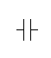
Often, one of the lines in this symbol is drawn slightly curved, so that people won't confuse it with the symbol for a voltage source.
- While most resistors look more or less the same, capacitors come in many different types of package. Here are a few examples of what they may look like.
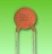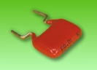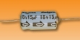
Parallel-Plate Capacitor
- Most capacitors are parallel-plate capacitors, which means that they consist of two parallel pieces of conducting material separated by an insulator.
- The insulator between the plates is called the dielectric.
Charging a Capacitor (Floyd, pp. 467-468)
- When a capacitor is connected across a voltage source, charge flows between the source and the capacitor's plates until the voltage across the capacitor is equal to the source voltage.
- In this process, the plate connected to the voltage source's negative terminal becomes negatively charged, and the other plate becomes positively charged.
- 

Unit of Capacitance (Floyd, p. 468)
- Capacitance is abbreviated C.
- The unit of capacitance is the farad, abbreviated F.
- Typical capacitors found in electronic equipment are in the microfarad (μF) or picofarad (pF) range. Recall that micro- means 10⁻⁶ and that pico- means 10⁻¹².
- You'll also remember that nano- means 10⁻⁹. But for some reason, the nanofarad has traditionally not been used, even in cases where that might make the most sense.
  - For example, if a capacitance is equal to 1×10⁻⁹ F (or 0.000000001 farads), you might think that you'd write that as 1 nF. But in fact, most people would write this as either 1000 pF or 0.001 μF. This is strange and confusing, but you just have to get used to it.
- In recent years, however, it's becoming more common to see nanofarads (nF) used.
  - For instance, the capacitance meters that the EET department bought 10 or 15 years ago displayed all capacitance values in either μF or pF. But the capacitance meters that we've bought in the past 5 years display capacitance values in μF, nF, or pF.
Energy Stored by a Capacitor (Floyd, p. 470)
- Recall from EET 150 that when current flows through a resistance, energy is dissipated as heat.
- But capacitance does not behave like resistance. A capacitance does not dissipate energy; rather it stores energy, which can later be used to do something useful (such as light up a camera flash) or returned to the circuit.
- The energy W stored by a capacitance C is given by
W = ½ CV ²
where V is the voltage across the capacitor. Here energy (W) is in joules (J), capacitance (C) is in farads (F), and voltage (V) is in volts (V).

Capacitor Ratings (Floyd, p. 471)
- Commercially available capacitors have several important specifications:
  - nominal value and tolerance
  - temperature coefficient
  - DC working voltage
  - leakage resistance
- Read on for discussion of these specifications.
Nominal Value & Tolerance
- Capacitors are available in a wide range of nominal values, from 1 picofarad to several farads.
- A specific capacitor's actual value is subject to the manufacturer's tolerance specification. Typical capacitor tolerances range from ±5% to ±20%.
Capacitor Identification Game
- In lab you'll learn to read the codes on capacitors. You'll need to become an expert at reading these capacitor codes. To work on this skill, play the Capacitor Identification Game. This game has a Study mode that reviews the relevant theory, a Practice mode that lets you practice with no time pressure, and a Challenge mode that tests your skill while the clock is running.
Temperature Coefficient (Floyd, p. 471)
- Ideally, a capacitor's capacitance would be the same at all temperatures. But in reality, capacitance changes as the capacitor gets warmer or cooler. In many cases, you can ignore this change in capacitance, but if you need a very precise capacitance value, or if you're dealing with very large temperature swings, you may not be able to ignore it.
- A capacitor's temperature coefficient tells you how the capacitance changes with temperature.
  - A positive temperature coefficient means that as the capacitor's temperature increases, its capacitance also increases. (And vice versa--as the capacitor's temperature decreases, its capacitance also decreases.)
  - A negative temperature coefficient means that as the capacitor's temperature increases, its capacitance decreases. (And vice versa--as the capacitor's temperature decreases, its capacitance increases.)
- In addition to telling which way the capacitance changes (increase or decrease), the temperature coefficient also quantifies the amount of change. Usually it does this by saying how many parts per million (ppm) the capacitance changes for each °C change in the temperature.
  - For example, a temperature coefficient of 200 ppm/°C means that for each °C change in the temperature, the capacitance changes by 0.02%. (That's because 200 ÷ 1,000,000 = 0.0002, which is the same as 0.02%.)
DC Working Voltage (Floyd, p. 471)
- The DC working voltage (also called the breakdown voltage) is the maximum voltage at which a capacitor is designed to operate continuously.
- Usually, the higher the capacitance value, the lower the DC working voltage.
- Typical values of DC working voltage are a few volts for very large capacitors to several thousand volts for small capacitors.
Leakage Resistance (Floyd, p. 471)
- An ideal capacitor would have infinite resistance, with absolutely no current flowing between the plates.
- In reality, a capacitor's resistance is finite, resulting in a small leakage current between the plates.
- Typical values of leakage resistance are 1 MΩ to 100,000 MΩ or more. This is large enough that, from a practical standpoint, we can often pretend that the resistance is infinite.

Capacitor Types (Floyd, pp. 474-477)
- Capacitors are often classified by the materials used for the dielectric (the insulator between the capacitor's plates).
- Some types are air, paper, plastic film, mica, ceramic, electrolyte, and tantalum.
- Each type has its own advantages and disadvantages; see pages 474-478 of the textbook for discussion of the various types.
- Often you can tell a capacitor's type by the appearance of the package. For example, ceramic capacitors typically look like this:
Here's a typical plastic-film capacitor:
Here's how electrolytic capacitors usually look:
Electrolytic Capacitors (Floyd, p. 477)
- Of the different types of capacitors just mentioned, one in particular deserves special discussion: electrolytic capacitors, which are available in very large values, up to 100,000 μF and above.
- Unlike most capacitors, they are polarized: one side must remain positive with respect to the other. Therefore you must insert them in the proper direction. Inserting them backwards can result in injury to you or in damage to equipment.
- In this photo of an electrolytic cap, notice that it has little arrows with negative signs pointing to one end:
The lead that the arrows are pointing to is the negative lead.
- Also, the schematic symbol for an electrolytic cap has a positive sign to tell you which way to hook up the capacitor: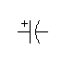
Variable Capacitors (Floyd, p. 477)
- Variable capacitors are also available. These contain a knob or screw that lets you adjust the capacitor's capacitance.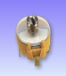
- The schematic symbol has an arrow to show that the component's value can be adjusted:
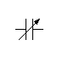

Stray Capacitance
- Stray capacitance exists between any two conductors that are separated by an insulator, such as two wires separated by air. This means that a circuit may contain some capacitance even if there's no capacitor in the circuit.
- Stray capacitance is usually small (a few pF), and you can usually ignore it, but it can have undesirable effects in high-frequency AC circuits.

Capacitors in Series (Floyd, pp. 480-481)
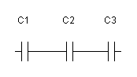
- Suppose you have two or more capacitors connected in series, as in the picture above. To find their total capacitance, use the reciprocal formula:
C_{T} = 1 ÷ (1÷C₁ + 1÷C₂ + ... + 1÷C_{n})
- This equation has the same form as the equation you've learned for finding the total resistance of resistors connected in parallel. So we see that capacitors in series combine like resistors in parallel.
- Want more pratice finding total capacitance of capacitors in series? Here are some more practice problems:
Shortcut Rules for Capacitors in Series (Floyd, p. 481)
- In EET 150 you learned two shortcut rules that you can use for special cases of parallel resistors.
- The first shortcut rule said that if you have just two resistors in parallel, you can find their total resistance using the product-over-sum rule: R_{T} = (R₁ × R₂) ÷ (R₁ + R₂). Similarly, if you have just two capacitors in series, you can find their total capacitance using the use the product-over-sum rule:
C_{T} = (C₁ × C₂) ÷ (C₁ + C₂)
- The second shortcut rule applied to several parallel resistors that all have the resistance. This rule said that if you have n parallel resistors, each with resistance R, the total resistance is given by R_{T} = R ÷ n. Similarly, if you have n series capacitors, each with capacitance C, the total capacitance is given by:
C_{T} = C ÷ n
- Of course, the reciprocal formula given earlier applies to all cases of capacitors in series, so it will give the same answer that the shortcut rules give for these special cases.

Capacitors in Parallel (Floyd, pp. 484-485)
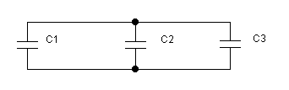
- Suppose you have two or more capacitors connected in parallel, as in the picture above. To find their total capacitance, simply add the individual capacitances:
C_{T} = C₁ + C₂ + ... + C_{n}
- So we see that capacitors in parallel combine like resistors in series.
- Want more pratice finding total capacitance of capacitors in parallel? Here you go:

Series-Parallel Capacitors
- For series-parallel capacitor circuits, the strategy is very similar to the strategy that you learned in EET 150 for series-parallel resistor circuits: Combine series capacitors and parallel capacitors to obtain progressively simpler equivalent circuits, until you've combined all of the capacitors into a single total capacitance, C_{T}.
- Plenty more practice problems right here:

Don't Connect Capacitors Directly Across a Voltage Source
- In general you should not connect a capacitor (or combination of capacitors) directly across a voltage source, since the resulting surge of current could damage the capacitor or the voltage source:
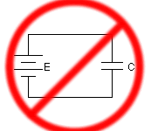
- Instead, you should always have a resistance in series with the capacitor(s), to limit the amount of current that flows.
Series RC Network
- A resistor and capacitor connected in series are called a series RC network.
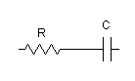
- Series RC networks have many practical uses. They are often used in timing circuits to control events that must happen repeatedly at a fixed time interval.
  - One example is a circuit that causes an LED to blink on and off once every second. There are several ways to design a circuit to do this, but one of the most common ways uses a series RC circuit. By adjusting the value of the resistor or the capacitor, the designer can cause the LED to blink faster or slower.
DC RC Circuit
- An RC circuit is any circuit containing, in addition to a power supply, just resistors and capacitors.
- For now we'll restrict our attention to RC circuits containing DC voltage sources. We'll refer to such circuits as DC RC circuits.
- Examples: A very simple DC RC circuit just has a resistor, a capacitor, and a voltage source in series: 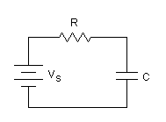
- Here's a more complicated DC RC circuit, with several resistors and capacitors: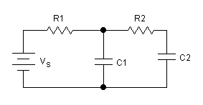
Behavior of Capacitors in DC Circuits
- The currents and voltages in a DC RC circuit depend on whether the capacitors are fully discharged, partially charged, or fully charged.
- Here's an important rule of thumb that you must memorize:
A fully discharged capacitor is equivalent to a short circuit.
- So to find currents and voltages in a DC RC circuit whose capacitors are fully discharged, replace all capacitors with short circuits (in other words, with wires). Then you'll be left with a circuit containing just a power supply and resistors, which you can analyze using the skills you learned in EET 150.
- Here's another important rule of thumb:
A fully charged capacitor is equivalent to an open circuit.
- So to find currents and voltages in a DC RC circuit whose capacitors are fully charged, replace all capacitors with open circuits. Then you'll be left with a circuit containing just a power supply and resistors, which you can analyze using the skills you learned in EET 150.

Initial, Transient, Steady-State
- In most practical DC RC circuits, the values of current and voltage change with time as capacitors are charged or discharged. Typically such circuits contain a switch that is initially open, and you're interested in the circuit's behavior after the switch has been closed.
- To remind ourselves of this fact, we often include an open switch in schematic drawings of DC RC circuits, as in the following picture:
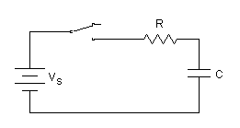
- We distinguish three time periods in the analysis of such DC RC circuits:
  - the initial period, when the switch is first closed.
  - the transient period, while the capacitors are being charged or discharged.
  - the steady-state period, after the capacitors have been fully charged or fully discharged.
- As we'll see now, we use different rules to figure out voltages and currents during these three different time periods.
Initial Currents and Voltages
- The currents and voltages in a circuit at the instant when a switch is first closed are called the initial currents and initial voltages.
- In most cases, at this initial instant the circuit's capacitors are either fully discharged or fully charged. Therefore, using the rules of thumb you learned above, you'll find the circuit's initial values of voltage and current by replacing the capacitors either with shorts (if the capacitors are fully discharged) or with opens (if the capacitors are fully charged).
Steady-State Currents & Voltages
- When the switch in a DC RC circuit has been closed for a long time, currents and voltages have reached their steady-state values.
- In most cases, in the steady state the circuit's capacitors are either fully discharged or fully charged. Therefore, using the rules of thumb you learned above, you'll find the circuit's steady-state values of voltage and current by replacing the capacitors either with shorts (if the capacitors have been fully discharged) or by opens (if the capacitors have been fully charged.)
Transient Currents and Voltages (Floyd, p. 489)
- We've just seen how to figure out the initial currents and voltages in a DC RC circuit and the steady-state currents and voltages in a DC RC circuit. That covers the instant when the switch is first closed, and it also covers times a long time later, after the capacitors have been fully charged or fully discharged. But what about the in-between times, after the switch has been closed but before the capacitors are fully charged or discharged?
- While a capacitor is being charged (or discharged), currents and voltages change gradually from their initial values to their steady-state values. We call this the transient period of a DC RC circuit.
- For instance, consider the simple series RC circuit shown below:
Here's a graph showing the how current in this circuit changes with time after the switch is closed. The graph shows current on the vertical axis and time on the horizontal axis.
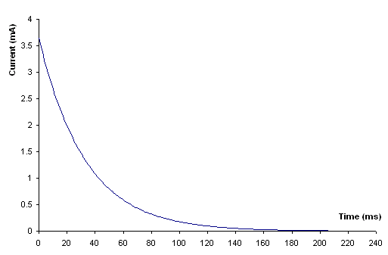
- For now, don't worry about the numbers on the axes. Just look at the shape of the curve. The numbers will be different if you change the values of V_{S}, R, or C, but the curve will always have this shape.
- Notice that the current starts out at its highest value and then decreases as time passes. But it does not decrease in a straight line. Instead, the current decreases very quickly at first, and then decreases more slowly.
- In mathematics, a curve with this shape is called an exponential curve. So, since the current is decreasing (or decaying) along a curve of this shape, we call this exponential decay.
- And the graph below shows how the capacitor's voltage changes with time. Note that this voltage starts at 0 V and gradually increases until it reaches a maximum when the capacitor is fully charged. Notice that this curve has basically the same shape as the other curve, but flipped upside down. We see again that the voltage changes quickly at first, and then gradually approaches a final value.
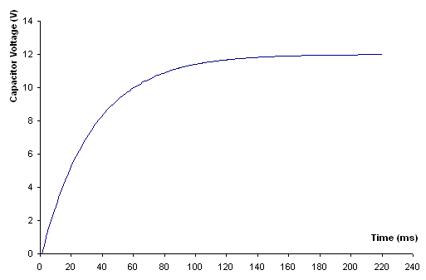
Time Constant (Floyd, p. 489)
- For any series RC circuit, the quantity R×C is called the circuit's time constant. It is represented by the Greek letter τ, and its units are seconds:
τ = R×C
- The time constant τ is an indicator of how long the capacitor takes to charge. The larger τ is, the longer the charge time.
- By the way, the name of Greek letter τ is "tau," which rhymes with "cow."
How Long to Charge?
- Here is a useful rule of thumb:
For most practical purposes, we may assume that all quantities in a DC RC circuit have reached their steady-state values after five time constants.
- So, for example, if we're charging a capacitor in a DC RC circuit, and if that circuit has a time constant of 1 second, then it will take about 5 seconds to charge up the capacitor.
- Since one time constant is equal to R×C, we can write this rule of thumb as an equation:
Time to reach steady state ≈ 5×R×C
- Notice that in this equation I used a "squiggly equals sign" ≈ to indicate that this is an approximation. Actually, after five time constants the capacitor will be about 99.3% charged, not completely charged. For most practical purposes, that's close enough.
- This completes our introduction to capacitors. Now let's turn to inductors.

Review of Electromagnetism
- Recall that in Unit 1 we briefly considered two related phenomena, electromagnetism and electromagnetic induction. These two principles are key to understanding how an inductor operates, so let's do a quick review.
- In 1820, Hans Oersted discovered that electrical current creates a magnetic field. This phenomenon is called electromagnetism. Oersted also realized that the you can increase the strength of the magnetic field surrounding a current-carrying wire by winding the wire into a series of closely spaced loops. A wire that is looped in this way is called a coil.
- A few years later, Faraday discovered that a voltage is induced in a wire whenever there's a change in the size of the magnetic field surrounding the wire. This phenomenon is called electromagnetic induction. Also, the induced voltage will be greater if you use a coil of wire rather than a straight piece of wire.
Self-Inductance (Floyd, p. 527)
- Now here comes the part that we're really interested in. Suppose you've got some current running through a coil of wire. According to the principle of electromagnetism, this current creates a magnetic field around the coil. What will happen if you change the size of the current? Well, that will change the strength of the magnetic field. But according to the principle of electromagnetic induction, when the magnetic field surrounding a wire changes, a voltage will be induced across that wire.
- And it turns out that this voltage will always oppose the change you're making to the current. In other words, if you increase the current, then a voltage will be induced that will try to decrease the current. On the other hand, if you decrease the current, then a voltage will be induced that will try to increase the current.
- The bottom line is: Whenever the current in a coil increases or decreases, a voltage is induced in the coil, and this induced voltage opposes the change in current.
- This is called self-inductance; as we've seen, it's the result of electromagnetism and electromagnetic induction working at the same time.
Inductance of a Coil (Floyd, p. 527)
- The size of the voltage induced in a coil depends on a property of the coil called its self-inductance (or simply inductance).
- The symbol for a coil's inductance is L.
- The unit of inductance is the henry, abbreviated H.
Inductors (Floyd, p. 527)
- An inductor is a device designed to have a certain amount of inductance.
- Here's the schematic symbol for an inductor: 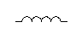
- Most of the inductors in our labs look similar to this: 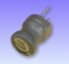
- Typical inductors found in electronic equipment are in the microhenry (μH) or millihenry (mH) range. Recall that micro- means 10⁻⁶ and milli- means 10⁻³.
Winding Resistance (Floyd, p. 529)
- Usually we treat wire as having zero resistance, but in reality wire does have some resistance. And the longer and thinner a piece of wire is, the greater its resistance.
- An inductor is simply a coiled piece of very long, very thin wire. Therefore an inductor will have some resistance, which we call the inductor's winding resistance.
- The symbol for winding resistance is R_{W}, and it is measured in ohms.
- You can measure an inductor's winding resistance simply by connecting an ohmmeter to its two leads, just as you would measure a resistor's resistance.
- This winding resistance can be fairly large--for example, it's not unusual to have an inductor whose resistance is 50 Ω or more. But 50 Ω is still not huge, and we might be able to ignore it if the inductor is in a circuit whose resistors are much larger.
  - For example, suppose you've got an inductor whose winding resistance is 50 Ω, and suppose this inductor is in a series circuit whose total resistance is 2 kΩ. Then the inductor's winding resistance is only 2.5% of the circuit's total resistance, small enough that you can probably ignore it when you're calculating the circuit's current and voltage drops.
  - As a general rule of thumb, if an inductor's winding resistance is less than about 5% of the resistance that it's in series with, then you can ignore it.
- An ideal inductor has no winding resistance. In other words, R_{W} = 0 Ω for an ideal inductor. In most of the following discussion we'll assume that inductors are ideal, but in a few places we'll mention the effect of a real inductor's winding resistance.
Inductor Types (Floyd, p. 532)
- Inductors are classified by the materials used for their cores.
- Common core materials are air, iron, and ferrites.
- Variable inductors are also available. The schematic symbol has an arrow to show that the component's value can be adjusted: 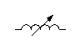
Chokes and Coils
- Inductors used in high-frequency AC circuits are often called chokes, or simply coils.

Energy Stored in an Inductor (Floyd, p. 527)
- Recall that resistors dissipate energy as heat, but that capacitors store energy.
- Like a capacitor, an inductor stores energy, which can later be returned to the circuit.
  - An ideal inductor (with zero winding resistance) doesn't dissipate any energy as heat.
  - Since R_{W} ≠ 0 Ω for a real inductor, a real inductor does dissipate some energy as heat, but generally it's small enough to ignore. We'll return to this point later when we discuss power in an inductor.
- A capacitor stores energy in the electric field that exists between the positive and negative charges stored on its opposite plates. But an inductor stores energy in the magnetic field that is created by the current flowing through the inductor.
- The energy W stored by an inductance L is given by
W = ½ LI ²
where I is the current through the inductor.

Inductors in Series (Floyd, p. 533)
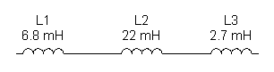
- Suppose you have two or more inductors connected in series, as in the picture above. The total inductance is equal to the sum of the individual inductances:
L_{T} = L₁ + L₂ + ... + L_{n}
- So inductors in series combine like resistors in series.
- Want more pratice finding total inductance of inductors in series? Here are some more practice problems:
Inductors in Parallel (Floyd, p. 534)
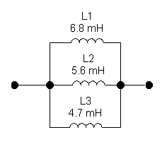
- Suppose you have two or more inductors connected in parallel, as in the picture above. To find the total inductance, use the reciprocal formula:
L_{T} = 1 ÷ (1÷L₁ + 1÷L₂ + ... + 1÷L_{n})
- So inductors in parallel combine like resistors in parallel.
- Want more pratice finding total inductance of inductors in parallel? Here you go:
Shortcut Rules for Inductors in Parallel
- In EET 150 you learned two shortcut rules that you can use for special cases of parallel resistors. The same basic rules apply to inductors in parallel.
- The first shortcut rule said that if you have just two resistors in parallel, you can find their total resistance using the product-over-sum rule: R_{T} = (R₁ × R₂) ÷ (R₁ + R₂). Similarly, if you have just two inductors in parallel, you can find their total inductance using the use the product-over-sum rule:
L_{T} = (L₁ × L₂) ÷ (L₁ + L₂)
- The second shortcut rule applied to several parallel resistors that all have the resistance. This rule said that if you have n parallel resistors, each with resistance R, the total resistance is given by R_{T} = R ÷ n. Similarly, if you have n parallel inductors, each with inductance L, the total inductance is given by:
L_{T} = L÷ n
- Of course, the reciprocal formula given earlier applies to all cases of inductors in parallel, so it will give the same answer that the shortcut rules give for these special cases.
Series-Parallel Inductors
- As you can probably guess, when you have series-parallel combinations of inductors, you find the total equivalent inductance by combining the rule for inductors in series with the rule for inductors in parallel.
- How about some more pratice problems? (Some of these are a little tricky, so be sure to try them all.) Remember, practice makes perfect!

Series RL Network
- A resistor and inductor connected in series are called a series RL network. 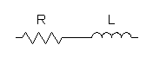
DC RL Circuit
- An RL circuit is any circuit containing, in addition to a power supply, just resistors and inductors.
- For now we'll restrict our attention to RL circuits containing DC voltage sources. We'll refer to such circuits as DC RL circuits.
- Examples: A very simple DC RL circuit just has a resistor, an inductor, and a voltage source in series:
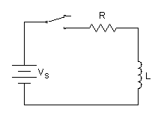
- Here's a more complicated DC RL circuit:
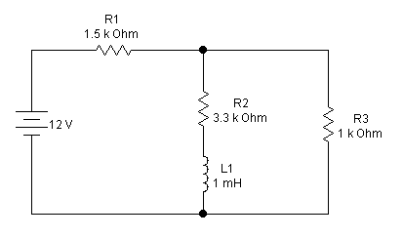
Behavior of Inductors in DC Circuits
- Just as we have rules of thumb that let us analyze the behavior of capacitors when they're fully charged or fully discharged, we have similar rules for inductors.
- Here's an important rule of thumb that you must memorize:
When an inductor with no current flowing through it is first switched into a circuit, it behaves like an open circuit.
- So to find currents and voltages in a DC RL circuit whose inductors have just been switched into the circuit, replace all inductors with open circuits. Then you'll be left with a circuit containing just a power supply and resistors, which you can analyze using the skills you learned in EET 150.
- Here's another important rule of thumb:
When a constant, unchanging current is flowing through an ideal inductor, the inductor behaves like a short circuit.
- So to find currents and voltages in a DC RL circuit whose inductors are carrying a constant, unchanging current, replace all inductors with short circuits (in other words, with wires). Then you'll be left with a circuit containing just a power supply and resistors, which you can analyze using the skills you learned in EET 150.
- Notice that this second rule of thumb applies to ideal inductors (with zero winding resistance). On the other hand, when a constant, unchanging current is flowing through a real inductor (with R_{W} ≠ 0 Ω), the inductor behaves like a resistor whose resistance is equal to R_{W}. But as we've seen, this R_{W} is often small enough that we can ignore it and treat the inductor as a short.
Initial, Transient, Steady-State
- In most practical DC RL circuits, the values of current and voltage change with time as the current through each inductor changes. Typically such circuits contain a switch that is initially open, and you're interested in finding the values of voltage and current after the switch has been closed.
- To remind ourselves of this fact, we often include an open switch in schematic drawings of DC RL circuits, as in the following picture:
- Just as with DC RC circuits, we distinguish three time periods in the behavior of any DC RL circuit:
  - the initial period
  - the transient period
  - the steady-state period
- During the transient period, the circuit's currents and voltages are changing from their initial values to their final (steady-state) values.
Initial Currents and Voltages
- The currents and voltages in a circuit at the instant when a switch is first closed are called the initial currents and initial voltages.
- In most cases, at this initial instant the circuit's inductors have no current flowing through them. Therefore, using the first rule of thumb you learned above, you'll find the circuit's initial values of voltage and current by replacing the inductors with opens.
- This is the opposite of capacitors, which initially behave like short circuits (assuming that they start out being fully discharged, which is normally the case).
Steady-State Currents & Voltages
- When the switch in a DC RL circuit has been closed for a long time, currents and voltages have reached their steady-state values.
- According to the second rule of thumb you learned above, an ideal inductor (with zero winding resistance) behaves like a short circuit in the steady state. So you find steady-state currents and voltages in an RL circuit by replacing all ideal inductors with short circuits.
  - Usually we treat inductors as being ideal. But if you want to take a real inductor's winding resistance into account, then to find steady-state values you should replace the inductor with a resistor whose resistance is equal to R_{W}, instead of replacing the inductor with a short.
- Again, this is the opposite of capacitors, which behave like open circuits in the steady state.
Transient Currents & Voltages
- When a switch is first closed (or opened) in a DC RL circuit, currents and voltages change for a short time from their initial values to their steady-state values. This is very similar to what happens in a DC RC circuit.
- In the circuit shown below, if we close the switch at time t = 0, the current will gradually increase from its initial value (zero) to its steady-state value (which is equal to V_{S}÷R).
More Exponential Curves
- The graphs below show how the current and inductor voltage change with time in a DC RL circuit after the switch is closed.
  - In the plots below, the values on the horizontal and vertical axes will change depending on the values of resistance, inductance, and source voltage in a particular circuit, but the shape of the curves will be the same for all series DC RL circuits.
- The current in a DC RL circuit starts at 0 and rises to its final value:
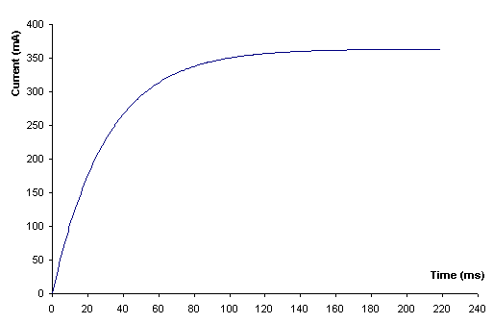
- On the other hand, the inductor's voltage starts at its maximum value and then decreases to 0:
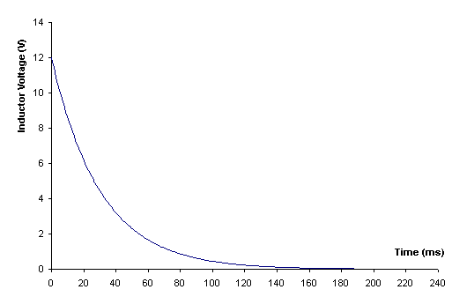
- Notice again that, in each of these graphs, the values change quickly at first, and then gradually approach a final value.
Time Constant (Floyd, p. 536)
- For any series RL circuit, the quantity L ÷ R is called the circuit's time constant. The time constant is represented by the Greek letter τ, and it is measured in seconds (s):
τ = L ÷ R
How Long to Reach Steady State? (Floyd, p. 536)
- The time constant τ is an indicator of how long i takes to increase from zero to its steady-state value.
- Here is a useful rule of thumb:
For most practical purposes, we may assume that all quantities in a DC RL circuit have reached their steady-state values after five time constants.
- So if a circuit has a time constant of 1 millisecond, then it will take about 5 milliseconds for the circuit's currents and voltages to reach their steady-state values.
- Since one time constant is equal to L÷R, we can write this rule of thumb as an equation:
Time to reach steady state ≈ 5×L÷R
- Notice that in this equation I used a "squiggly equals sign" ≈ to indicate that this is an approximation. Actually, after five time constants the current will have risen to about 99.3% of its steady-state value. For most practical purposes, that's close enough.
De-Energizing an Inductor
- Up to now we've been talking about energizing an inductor. Similar comments, but in reverse, apply to the case of discharging a capacitor. In this case we get what's called an inductive kick, which has some interesting practical applications , as you'll read about in this animation:

Unit 2 Review
- This e-Lesson has covered several important topics, including:
  - capacitance
  - capacitor specifications
  - types of capacitors
  - capacitors in series, in paralle, and in series-parallel
  - time constant of a DC RC circuit
  - inductance
  - types of inductors
  - energy stored in an inductor
  - inductors in series, in parallel, and in series-parallel
  - time constant of a DC RL circuit.
- To finish the e-Lesson, take this self-test to check your understanding of these topics.

Congratulations! You've completed the e-Lesson for this unit. What's next?
- Take Quiz #2.
- Perform Lab #2 and turn in a typed short lab report. (You may wish to review my instructions on writing short reports.)
- Do Homework #2.
- Keep practicing your skills by playing the games on the Games page.
- Prepare for Unit 3 by reading Chapter 11 of Thomas Floyd's Principles of Electric Circuits (8th edition).
Then you'll be ready to go on to Unit 3.

Nick Reeder | Electronics Engineering Technology | Sinclair Community College
Send comments to nick.reeder@sinclair.edu

