**Alumni Sharing Session**

On the 29th of December 2020, UTM’s School of Computing (specifically the Technology and Information System course) held a sharing session with three alumni. The topic of the sharing session was about inspiring work experience and COVID 19 pandemic challenge, which is a very interesting topic because during this pandemic, most jobs have changed from offline to online, meaning employees mostly work from home and it is challenging because not every job is suitable with this method of work. With all the alumni having different jobs, we can get a good coverage of what is it like to work in the tech sector and dealing with the challenges faced during this pandemic. The moderator of the talk was Dr Johanna Ahmad which, senior lecturer for School of Computing at UTM. The speakers were Tan Yong Keong who has been working as a data science engineer for one and a half year at Micron Semiconductor Asia Operations, Mohamad Zamarul Akmal bin Mohd Hussin, a data engineer at PPG Coatings and Batrisyia binti Azman Shah who has been working as a social media data analyst for a year at TM One.

As a data science engineer, Tan Yong Keong (YK) tell us that he got the job by getting many achievements through joining many competitions throughout his university life. With many experiences gathered during his university life, he polished his soft skill and the company would easily accept him into the company because of his experiences and achievements. Not just that, he also got an excellent CGPA as well, so he could answer the obligational theory test that the company offered to their future employees. While CGPA matters for being accepted in a company, YK said that soft skill and experience matters the most in applying to the company.

Mohamad Zamarul Akmal graduated with a bachelor’s degree in Data Engineering. Zamarul was absorbed as a permanent stuff in his internship company. Zamarul attributes his proactive trait for this achievement. He has always been involved with the company by providing ideas. During his internship, Zamarul proposed a monitoring dashboard which could monitor all jobs at once because PPG Coatings was still using Talend to monitor big data manually. Later, this proposal became his final year project and caught the attention of his supervisor. Although the company ordered retrenchment and all new employment was halted, Zamarul’s supervisor still tried to get Zamarul absorbed as a permanent staff. Zamarul believes there are two things that students can do to increase employability. Firstly, students should learn new technical skills by taking up online courses and joining training camps. Secondly, students should enhance their soft skills. Communication and teamwork are important skills in the working world. Zamarul gained his confidence by joining programs during his university years. He also said it is important to ask questions to prevent making more mistakes.

Batrisyia binti Azman Shah is same as Zamarul which she also absorbed as a permanent stuff in her internship company. During her internship, she put a lot of efforts to do a real-life social media project for the TM One. The data were collected from the social media of the clients and interpret the data into dashboard to aids improve the branding on the marketing site. Her manager wanted her to stay in the company as well after the internship end so that she can further proceed with the project. She suggested the students to be good in the technical skills of the data engineering by using Microsoft Excel, Python and so on but the most importantly is to be proactive in the job. She also suggested the students not to limit yourself and always open to learn the new things. Batrisyia gained her confidence through the events and programs or projects during her university life and advised the new students not to be shy and speak up more to gain confidence.

During the queastion and answer session, we learned that CGPA is less important when applying for a job in private company compared to government sector. However, Zamarul did mention it is best to keep your CGPA above 3.0. Non-academic achievements are equally important. It does not matter if you lose in a competition because the most important thing is your effort and experience gained. During the pandemic, passion, mindset and excitement is what keep Batrisyia, Zamarul and Yong Keong motivated to keep working. Lastly, you can always request for higher pay if you feel underpaid and report to your supervisor when you are overworked.

In conclusion, the tech sector is a sustainable sector during the pandemic as shown by the 3 alumni who are still employed and unaffected by retrenchment. We also learned that soft skills such as communication and teamwork are very important in determining our employability and these are what separate us from other candidates. It is also important to join competitions to gain experience and build self-confidence.

**Team 3**

Muhammad Zaki Mufthi A20EC0325

Lai Yee Jen A20EC0061

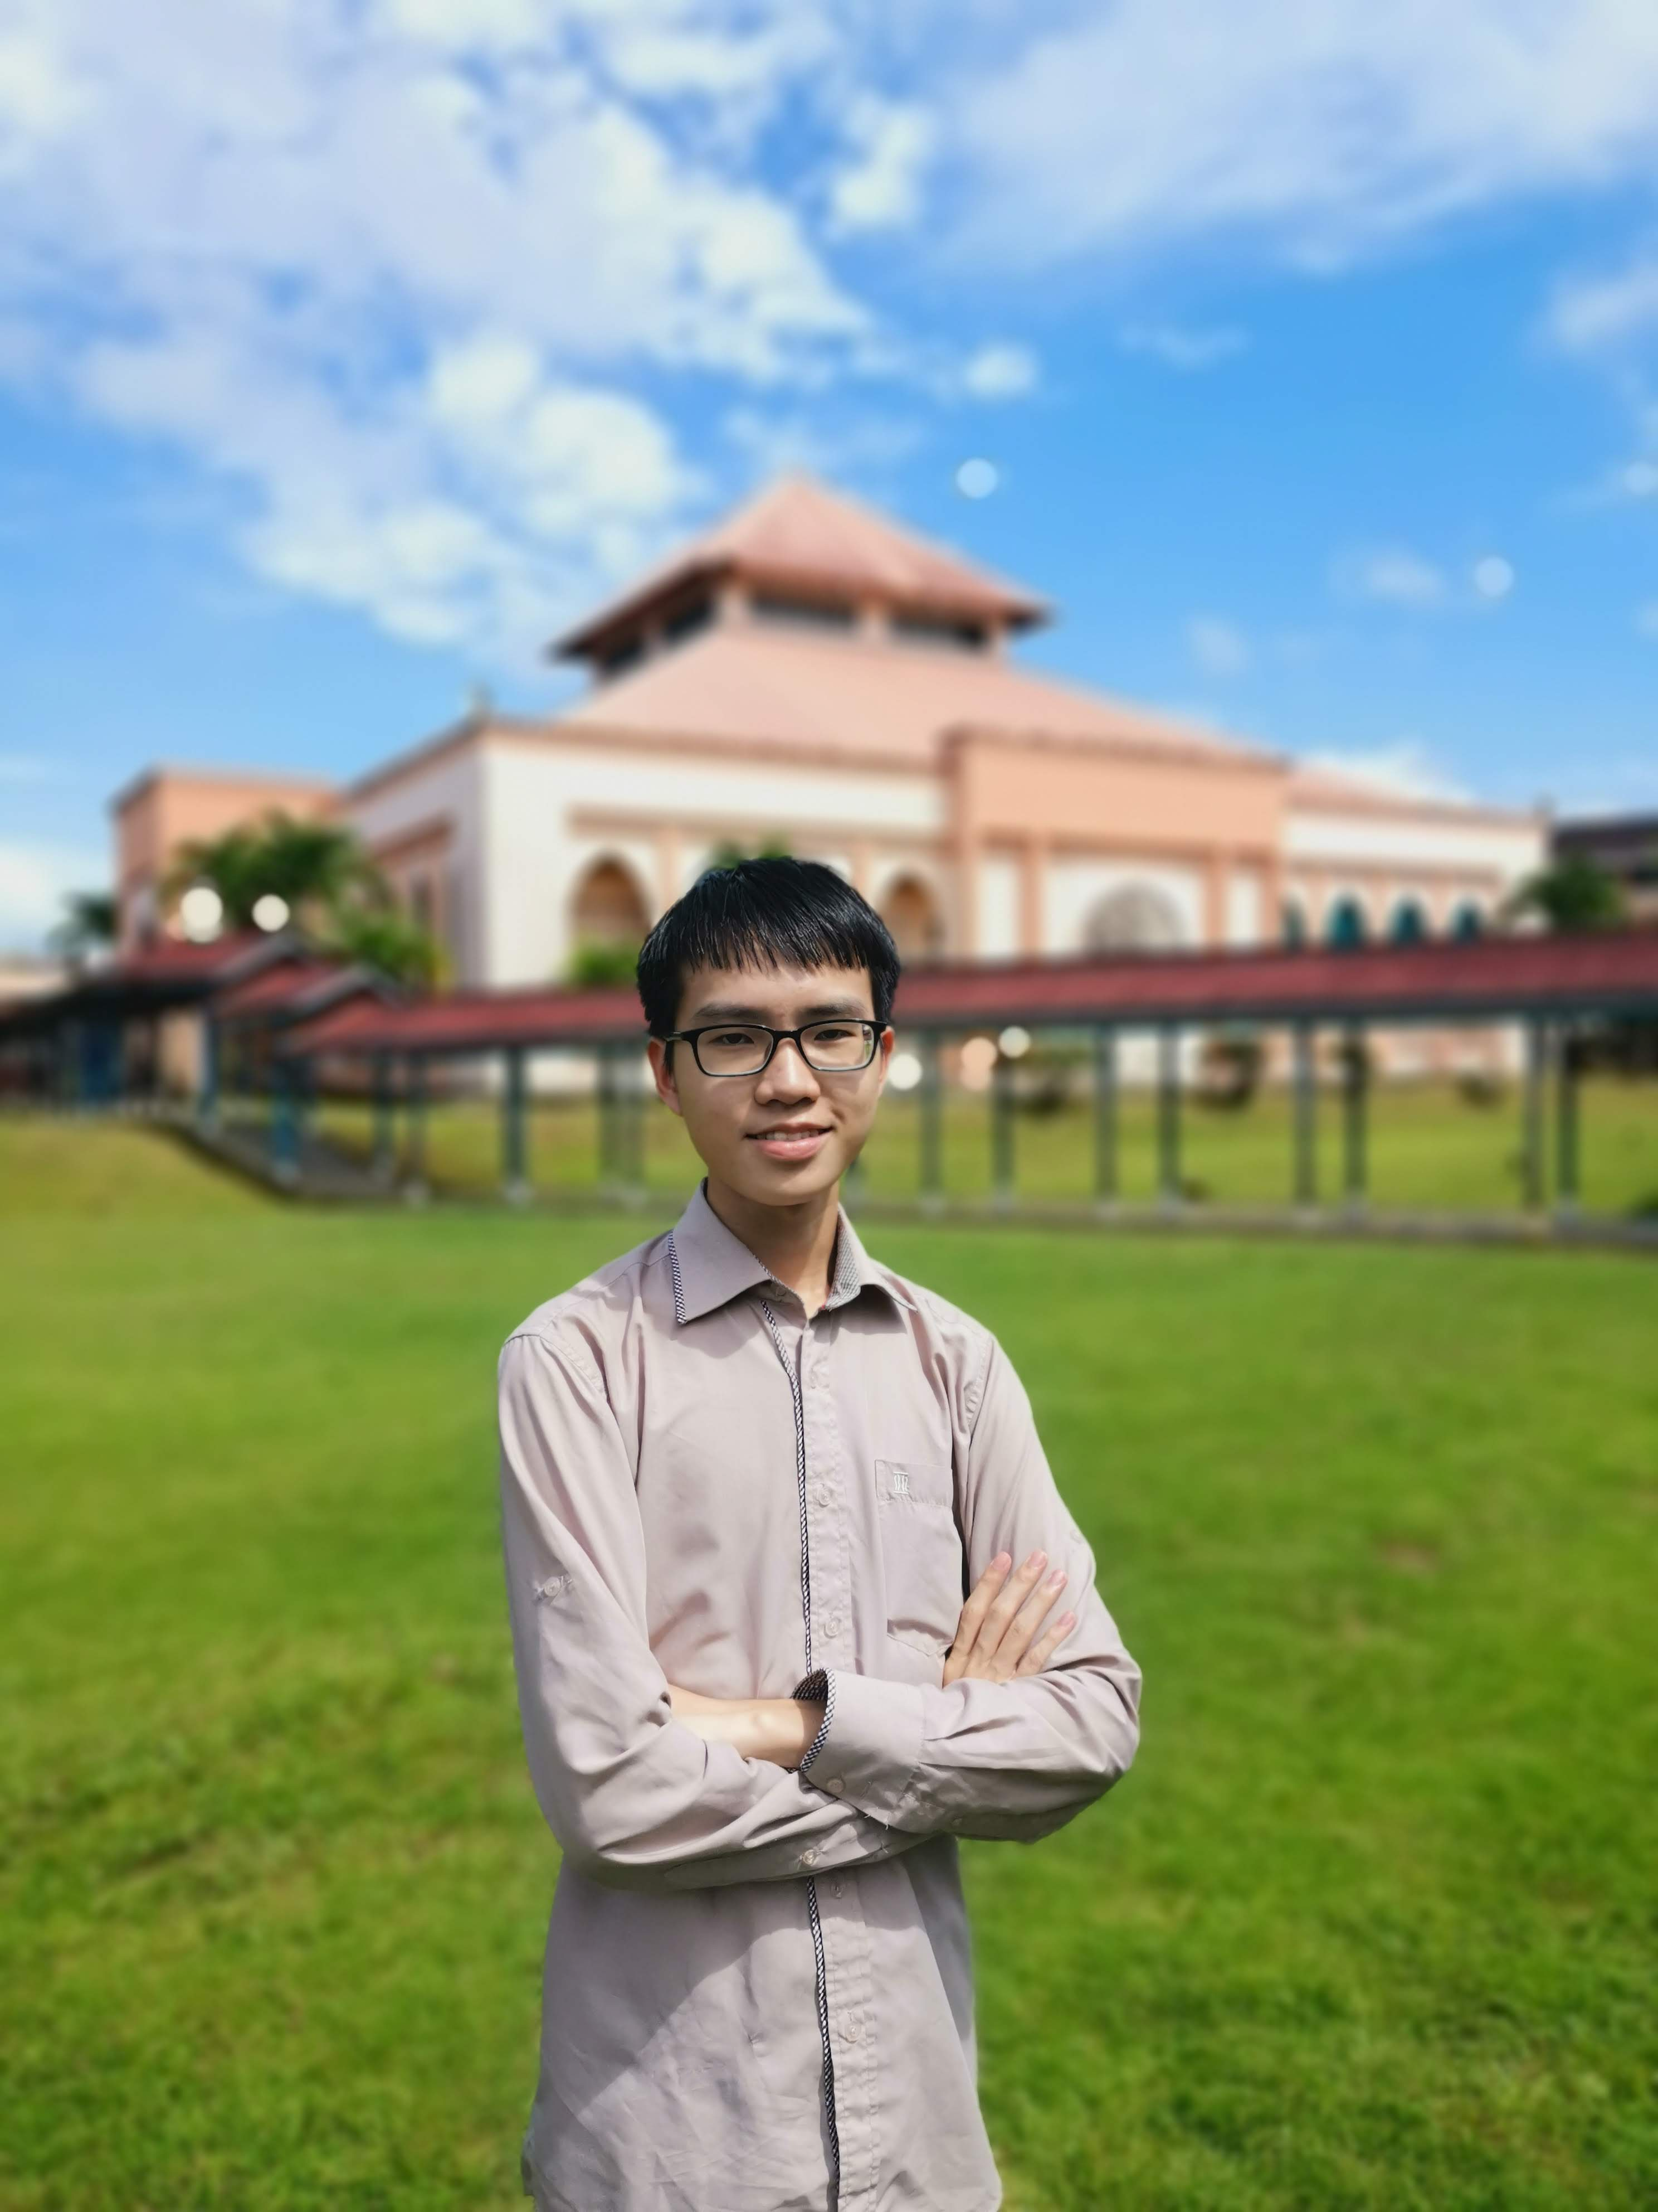Tham Chuan Yew A20EC0166