29 December 2020

# School of Computing

**Alumni Sharing Session: Inspiring Work Experience and COVID-19 Pandemic Challenge**

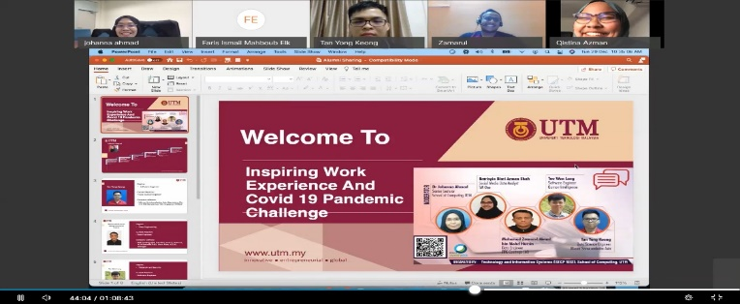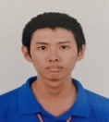

We had joined the Alumni Sharing Session via Webex platform organized by School of Computing form 10 a.m. to 11 a.m. on 29 December 2020. Firstly, the moderator asked questions from the three speakers which were, how they secure their job during in this COVID-19 pandemic, what is the questions being asked in the interview session, may you share some experiences when handling a project, what is the current project handled, how to learn new languages in programming, what is the tips to increase job opportunities, how to improve programming skills, how to gain confidence, what is the differences between study life and career life. We learnt very useful skills and experiences from the speakers.

Besides that, we also have the chances to ask questions from the speakers. These included, is CGPA is important when finding a job, will we be mistreated by our lecturer or university if we lose in a competition, how to stay motivated in the daily basis, how to join a competition, what is the technology used in social media data analysis, will we get only minimum wage during our internship, what is the speaker’s hobby, is it possible to get a job that is not related with our studies, what is your first-year university life experiences.

At the end of session, the moderator and speakers gave advices to us to enjoy the study life, make new friends during university life, be proactive and stay safe.

### Chronological Order

Introduction 1

Chronological Order 1

Summary 2

Conclusion 2

**December 29, 2020:** COVID-19 Pandemic has been a prime issue in the whole world due to the difficulties faced by human during this period. A sharing session with UTM’s alumni played an important part on sharing their working experience during the pandemic. Dr Johanna Ahmad is a senior lecturer in School of Computing, who was the moderator of this talk. The speaker lineup for the talk were Tan Yong Keong, a data science engineer at Micron Semiconductor Asia, Batrisyia Qistina, a social media data analyst at TM One and Mohamad Zamarul Akmal, a data engineer at PPG Coatings(M).

The purpose of the talk is to share their experiences on their working life and they gave us knowledge on requirements that need to be fulfilled in order to get hired by a company. Lastly, they also talked about some tips and experiences on life in university and they also gave advices to the juniors regarding the online learning due to the pandemic.

## Introduction

Inside this issue:

ERICA DESIRAE MAURITIUS

From the sharing of the speakers, we knew that our academic results are only the minimum requirement and ruler for the company to filter out talented person with others. To get a better job opportunity, we have to equip ourselves with more soft skills, such as communication skill.

University life is a precious period for us to expose ourselves in gaining experience and learning new things. We will have a lot of chances involve in many competitions. The most important element in a competition is neither win nor lose, it is the experiences we gain from the mistakes. We learn to communicate and cooperate with our team members to achieve the same goal. We also train our confidence in presenting our ideas to others. We also learn skills and knowledges that are out of our syllabus when participate in a competition. For example, we tend to learn a new language and view things in different dimensions to get more ideas and information in a competition.

Besides, we have to be proactive, keep motivate and love the things we are doing to keep ourselves improving. We need to have the right attitude and willingness to make contribution to our surroundings people. Responsibility is important in every human, as we grown up, there are more things we need to take consideration and responsibility. As a student, we need to be responsible to our academic performance, but in a company, our performance indicates the company’s performance, we should learn to avoid serious mistake as it may bring serious repercussion to us and our surroundings people. When facing a problem, we should be proactive in solving it and not wait for others to help us.

To sum up, a company is looking for a talented person who has the right attitude and responsibility, proactive and confident, willing to make contribution and good in soft skills, to be the worker to them.

LUE GUO MING

MOHD FIRDAUS BIN ZAMRI

FELICIA CHIN HUI FEN

Authors

“ The most important element in a competition is neither win nor lose, it is the experiences we gain from the mistakes.”

To conclude, the talk went well but there were strengths and weaknesses in this talk. The pros of the talk were the talkers gave so much inspiration to the students. Moreover, this talk has gave us many tips on how to get a permanent job and taught us that we need to explore more as the world now is full of technology. Besides that, the talk made us realize that grades are not everything when it comes in applying a job but instead the most crucial part is having skills. On the other hand, the cons of this talk were insufficient time as the talk was a bit rushing due to the time passing by so quickly. Also, it would have been better if the talk was held longer because we would like to know more on how to get a secure job.

Besides that, this talk has motivated us to be more active by joining variety of competitions as this will enhance our experience and if we are lucky, we will even get a job interview.

Furthermore, the insight that we got from this talk is we need to be independent. For instance, we cannot rely on people to teach us about a particular work. This talk has also taught us tips on how to get hired as well as to gain self-confidence. We hope that this kind of talk will be held again in the future.

## Conclusion

## Summary

Page 2

Alumni Sharing Session: Inspiring Work Experience and COVID-19 Pandemic Challenge