

# Semester I 2020/2021

Subject : Technology and Information Systems (SECP1513)

Section : __________________________

Assignment : Step by step PC Assembly

**GROUP NAME / NUMBER : __2________**

|  |  |  |  |
| --- | --- | --- | --- |
| 1 | |  | | --- | |  | | Name : mohand alaa abouzeid mohamed  Matric Number : A20EC4042  Phone Number :01139714465  E-mail : ABOUZEID@GRADUATE.UTM.MY |
| 2 | |  | | --- | | Photo | | Name : muhammad ammar bin adnan  Matric Number : A19EC0192  Phone Number  E-mail : |
| 3 | |  | | --- | | Photo | | Name :  Matric Number :  Phone Number  E-mail : |
| 4 | |  | | --- | | Photo | | Name :  Matric Number :  Phone Number  E-mail : |

PART: A

Tools used :

1- ANTI-STATIC EQUIPMENT.

2-LIGHT SOURCE.

3-ZIP OR TWIST TIES.

4-EXTRA SCREWS.

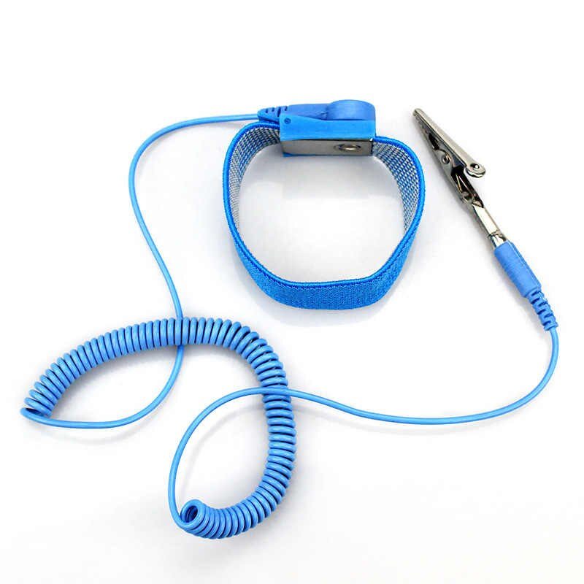

1. ANTI-STATIC EQUIPMENT :

ANTI-STATIC EQUIPMENT is a wire connected to the a surface and the same wire is connected to the person who use it .the person part in ANTI-STATIC EQUIPMENT absorb the static electricity in the body .the other part get rid of the static electricity . ANTI-STATIC EQUIPMENT maintain the pc sensitive parts that damage by the static electricity like hard drivers and motherboard and GPU .its help people to save the part from very deep damage.

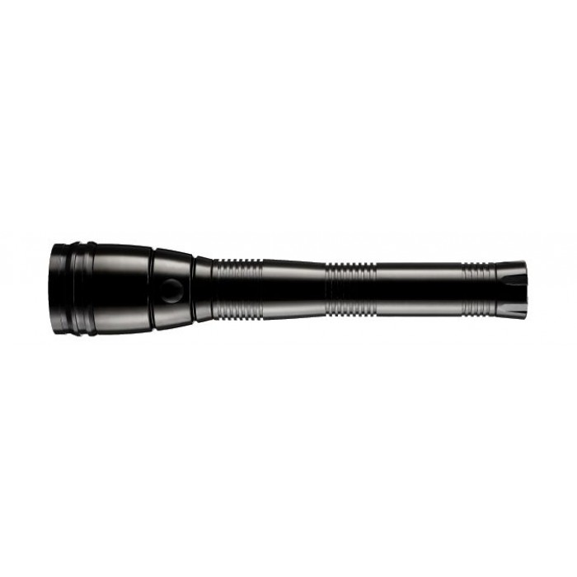

2- LIGHT SOURCE.

LIGHT SOURCE is the part that give the user opportunity to see small details in the parts like motherboard and CPU .some operation in the pc assemble demand good light to do it like attaching parts and connecting of cables in power supply, motherboard and the sata cables .

3-ZIP OR TWIST TIES.

The ZIP is a tiding tool .it contains a rap that you can assemble the cables with and a ZIP to tide cables.it tides things together like a group of cables .the main job of ZIP Is organizing cables and make organized cable management. The organized helps users to repair or upgrade the pc without damage.

4-EXTRA SCREWS.

EXTRA SCREWS is optional tools. Usually the screws that the users need come with the main parts like motherboard ,cooler, power supply and the GPU.the extra screw is important in case you missed or damaged your screws.

5- screwdrivers

Screwdrivers is a essential tool to tide the screws in the pc build .without this tool you will not be able to do anything at all .

PART: b

Sketch

PART: C

Step 1:- Installing the CPU (Central Processing Unit).

Place the motherboard on the anti-static mat. Open up the latch. Align the CPU with the CPU socket on the motherboard. Gently drop the CPU into the CPU socket. Close the latch.

Step 2:- Installing the CPU heat sink.

Apply a small amount (pea sized) of thermal paste onto the IHS (integrated heat spreader). Align the heat sink with the CPU and the screw holes on the motherboard. Install the screws for the heat sink. Plug in the fan cable into the fan header on the motherboard.

Step 3:- Installing the RAM.

Align the RAM with the RAM socket before installing. Push the RAM into the RAM slot until you hear a clicking sound.

Step 4:- Installing hard disk.

Install the IO shield into the case. Screw in the standoff into the casing for the motherboard. Align the motherboard with standoff the screw the motherboard securely onto the casing. Install the hard disk into the hard disk slot. Screw the hard disk into it’s mount.

Step 5:- Installing the PSU (Power Supply Unit).

Install the PSU on the bottom part of the casing. Make sure the fan is facing downwards. Align the screw holes on the PSU with the screw holes on the back part of the casing. Install the screws.

Step 6:- Installing the SATA cable, IDE cable and PSU power cable.

Connect the PSU power cable into the CPU power connector, motherboard power connector, hard disk power connector and other places where needed. Plug in the SATA cable into the hard disk and into the IDE ports on the motherboard.

Step 7:- Installing the USB cable.

Look at the labels on the casing cables. Plug it into it’s respective connectors on the motherboard to allow the usage of external pc case buttons and ports.

Step 8:- Installing the GPU (Graphics Processing Unit)

Remove the metal plates behind the pc case. The amount of plates removed depends on the number of slot the GPU takes up. Align the GPU into the PCIe slot. Push the GPU into the slot until you hear a click. Screw the backside of the GPU onto the case. Take the PSU power cable and plug it into the GPU power connector.

Step 9:- Installing the CD ROM

Remove the front panels from the computer case. Mount the CD ROM in the front panel slot and screw it in place. Connect the CD ROM to the motherboard using a SATA cable. Plug in power cabling from the PSU to the CD ROM.

Last Step:- Closing the case and connecting the peripherals.

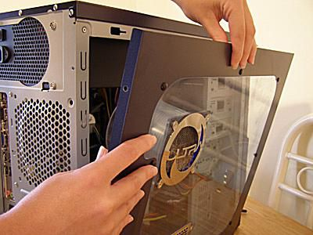

Place the side cover back on and secure the side panels with case screws.

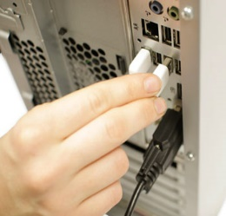

Connect peripheral devices which include keyboard, mouse, wireless network dongle, printer and webcams with your CPU by plugging into USB port.

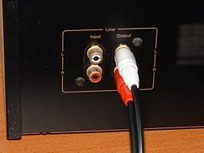

Then, connect speakers and microphone into 2.5 mm sockets.

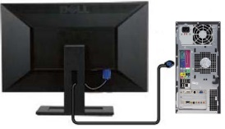

Finally connect the CPU with monitor by plugging into display port