

SECJ2154 – 02
OBJECT ORIENTED PROGRAMMING

EXERCISES AND LAB TASK

INTERFACE

Name | MADINA SURAYA BINTI ZHARIN
Matric No. | A20EC0203
Section | 02

- Implement the classes. Assuming that Food is an abstract class and Convertible is an interface.

- The Convertible interface converts the following:
- Weight in pound to gram
- US currency to Malaysia Ringgit

- The food class contains abstract method (named displayInfo()) whose purpose is to display brief information about a food, such as:
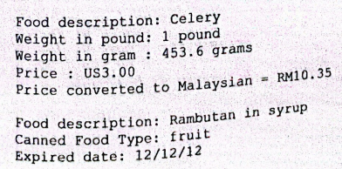


- Write the application program to test the classes named FoodApp. The program must apply a polymorphism concept and the sample output of the application is as shown above.
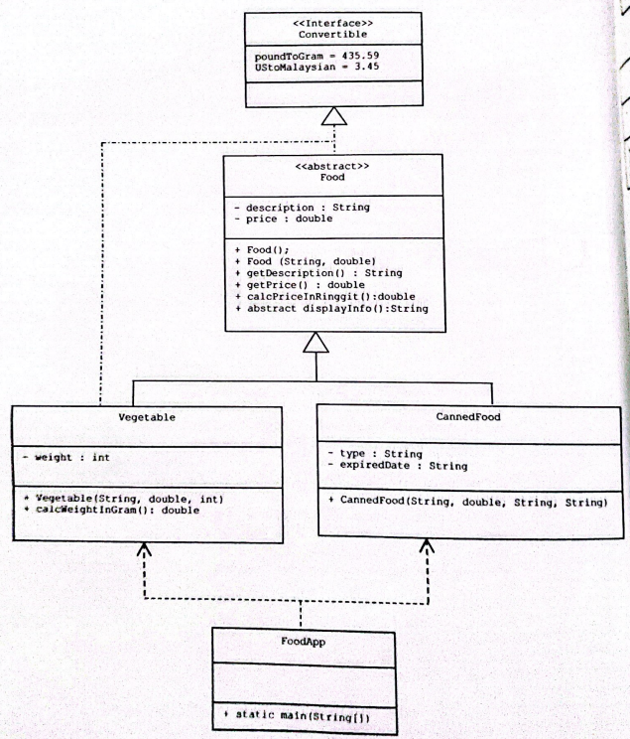
interface Convertible {
final double poundToGram = 435.59;
final double UStoMalaysian = 3.45;
}

abstract class Food implements Convertible {
private String description;
private double price;

public Food(){
this.description = "";
this.price = 0.0;
}
public Food(String description, double price){
this.description = description;
this.price = price;
}
public String getDescription(){
return this.description;
}
public double getPrice(){
return this.price;
}
public double calcPriceInRinggit(){
return price * UStoMalaysian;
}

public abstract String displayInfo();
}

class Vegetable extends Food{
private final int weight;

public Vegetable(String description, double price, int weight){
super(description, price);
this.weight = weight;
}

public double calcWeightInGram(){
return weight * poundToGram;
}

public String displayInfo() {
String str;
str = "Food description: " + super.getDescription() + "\nWeight in pound: " +
weight+ " pound" + "\nWeight in grams: " + String.format("%.2f", calcWeightInGram()) + " grams" + "\nPrice : US" + String.format("%.2f", super.getPrice()) +
"\nPrice converted to Malaysian = RM" + String.format("%.2f", super.calcPriceInRinggit());
return str;
}
}

class CannedFood extends Food {
private String type;
private String expiredDate;

public CannedFood(String description, double price, String type, String expiredDate) {
super(description, price);
this.type = type;
this.expiredDate = expiredDate;
}

public String displayInfo(){
String str;
str = "\nFood descrption: " + super.getDescription() +
"\nCanned Food Type: " + type +
"\nExpired Date: " + expiredDate +
"\nPrice: US" + String.format("%.2f", super.getPrice()) +
"\nPrice converted to Malaysian = RM" + String.format("%.2f", super.calcPriceInRinggit());

return str;
}
}

public class FoodApp {
public static void main(String[] args) {
Vegetable v1 = new Vegetable("Celery", 3.00 , 1);
CannedFood c1 = new CannedFood("Rambutan in Syrup", 5.00, "fruit", "12/12/12");

System.out.println(v1.displayInfo());
System.out.println(c1.displayInfo());
}
}

