INDUSTRIAL VISIT REPORT – CICT

GROUP MEMBERS:
- LIM SIN JIE (A19EC0073)
- CHEONG CHIEN LI (A19EC0186)
- TAI WEN JUN (A19EC0207)
- CHAN YI LIN (A19EC0185)
- TAN CHIAW TORNG (A19EC0167)
- JARED RYAN SHEREMAN (A19EC5161)

LECTURER NAME: DR. HASWADI HASSAN

UNIVERSITY NAME: UNIVERSITI TEKNOLOGI MALAYSIA (UTM)

WORKSHOP NAME: ROBOKAR: ROBOT PROGRAMMING WORKSHOP

DATE OF VISIT: 9TH DECEMBER 2019

PLACE OF VISIT: ACTIVE LEARNING LAB (351-01), N28.

TECHNOLOGY AND INFORMATION SYSTEM: ROBOCAR WORKSHOP REPORT

INTRODUCTION

On the 9th of December 2019 (Monday), Section 03 of the Software Engineering Course (SECJ) attended a workshop on Robocar Programming organised by Dr Haswadi, which was hosted by the Faculty of Computing’s Robocar Club. The workshop was held inside the Active Learning Lab (351-01) located at the third floor of N28. There was a total of 5 staff members, and around 42 students, making a total of roughly 47 persons involved in this workshop.

DETAILS OF JOURNEY/ WORK PLAN

At around 2pm in the afternoon, the participants started to make their way into the Active Learning Lab after having their lunch. The attendance of all the participants were taken in the Lab before proceeding to start the workshop. Then, the workshop began with an opening speech by the head speaker, in which he introduced to the participants about the history of the autocar club. After the short introduction, the workshop was continued by having a programming session for the participants. During this session, the students were taught about some basics of robocar programming and was given a task to program their robocars together with their group members. Roughly an hour was given to every group to program their robocars respectively and then the participants were asked to head down to the second floor for a competition. At around 4pm the competition began and all the groups placed their robocars on the track one by one to determine which group finished the track in the shortest amount of time. The competition was carried out for around 30 minutes until the last group finished their lap. After that, the top three groups who finished the track in the shortest time were given some rewards in an award-giving ceremony before the workshop ended at roughly 5pm. Lastly, before the participants left, a group photo session was held and all the participants took some splendid pictures together. Everybody thanked Dr Haswadi after the photo session and parted ways after that.

DETAILED DESCRIPTIONS

During the introduction speech given by the head speaker, the participants were introduced to the history of the Robocar Club. According to the speaker, it all started in 2007 with a proposal of a collaborative project, followed by the emergence of the concept of educational robotics in 2008. However, the official year in which Robocar began was in the year 2012 with a vision to educate students on robocar programming via community service. Then, another branch of the robocar club; the robotar program started only a year later, in 2013. Moving on, the development of Internet of Things (IOT) began in 2017, which then led to the involvement of the industry in 2018. That was all for the history of the robocar club.
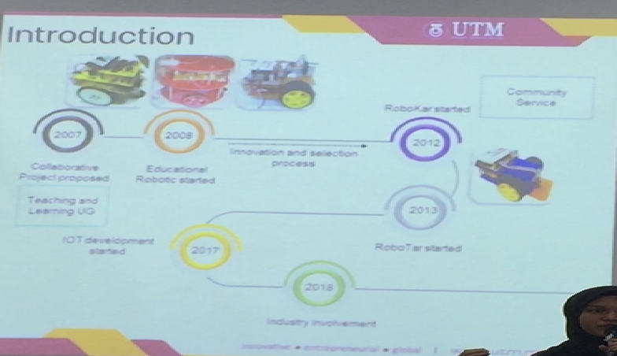
Next, the programme was continued by a teaching session from the speaker. During this session, the participants were taught about some basics of robocar programming. Some of the predefined functions were provided to the participants and each group was required to download an Arduino Integrated Development Environment (IDE) into their laptops in order to begin learning to program the robocars. Meanwhile, 6 robocars were brought into the lab and given to each group respectively in order to be programmed. Participants were taught about functions such as roboSetup (), roboHonk (), roboStop (), etc…. after around 30 minutes of teaching session, the participants were given an hour to start programming their robocars in order to successfully complete all 12 different tracks provided in the Lab.
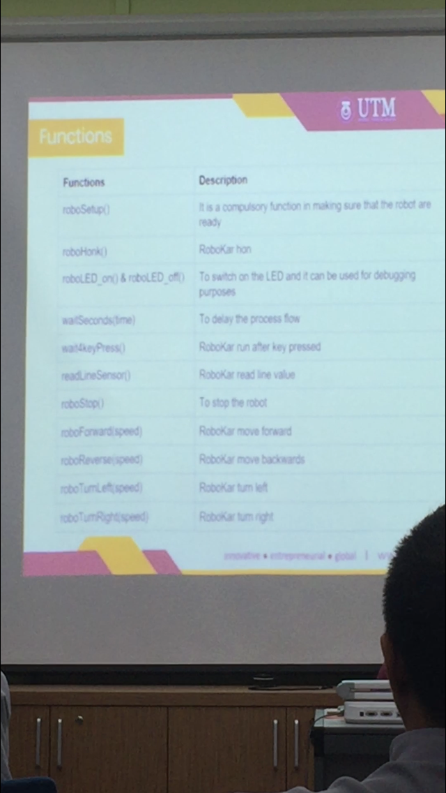
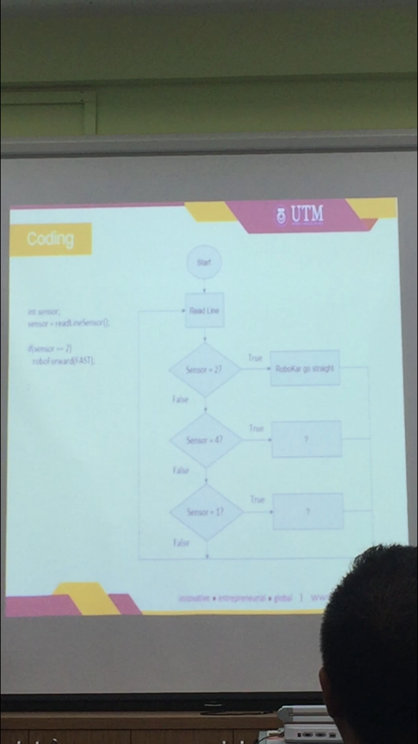
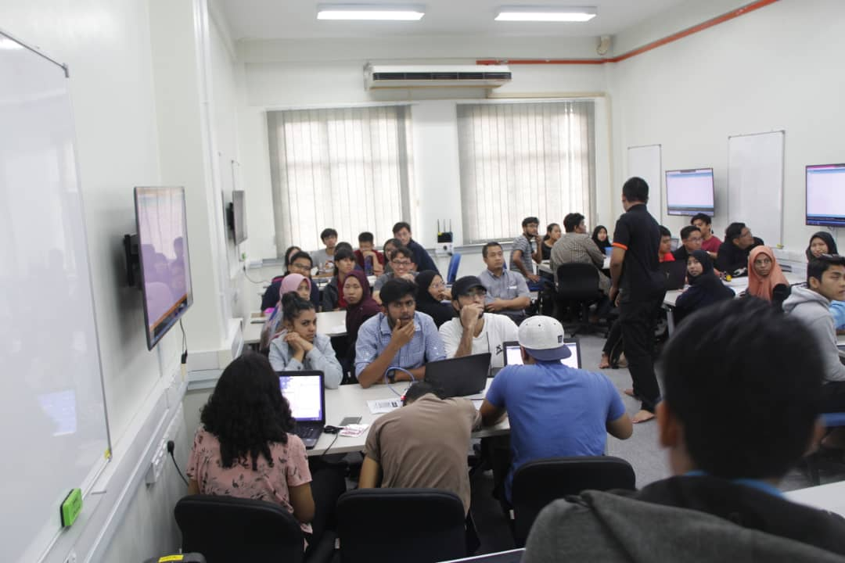
At around 4pm, the participants were asked to head down to the second floor to partake in a robocar competition with the robocars that they have programmed. The rules of the competition were simple; start when the judge said so, no touching the robocar when it is traversing the track, and a group will automatically lose if their robocar fails to complete the track within 3 minutes. The first group did an amazing job by setting a bar for the others to beat, by finishing the track in 1:23 minutes. Next, the second group was actually the fastest group to finish the track with a time of only 46 seconds. Then, the third group done decently by finishing the track in 1:34 minutes. Group 4 also did a great job by finishing the track in 1:19 minutes. Moving on, group 5 finished the track in 2:13 minutes, and last but not least, group 6 were unable to finish the track in time unfortunately due to some technical issues.
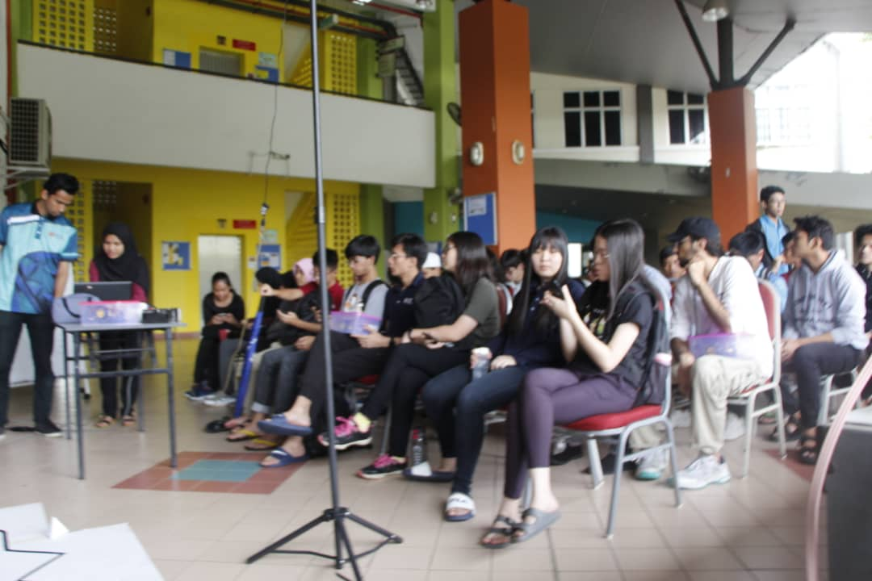
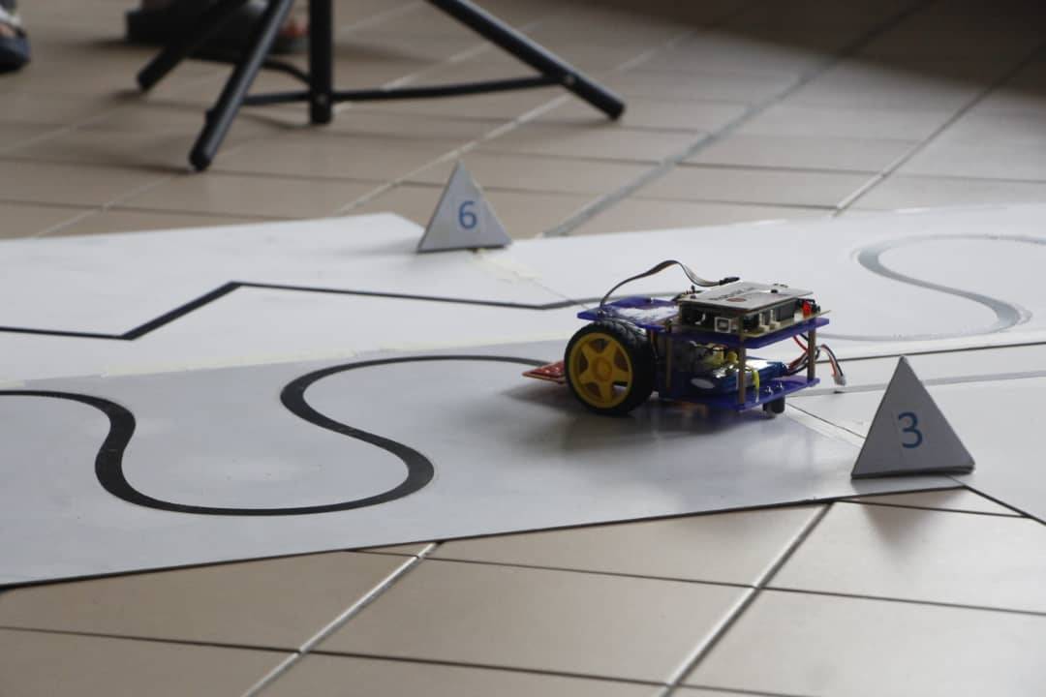

After the competition ended, the judge announced three of the fastest groups and then a speech was given by Dr Haswadi to congratulate the winners of the competition and also to share his reflection about the activity at hand. At around 4:50pm, a prize-giving ceremony was held to hand out the prizes (goody-bags) for the three winning groups. Lastly, a group photo session was help and the participants took some formal pictures and also some freestyle pictures, both of which captured wonderful memories.
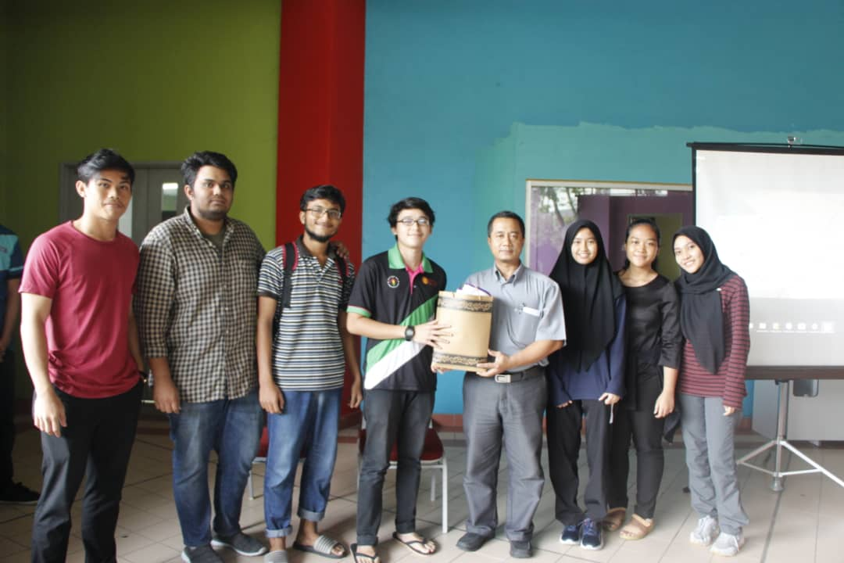
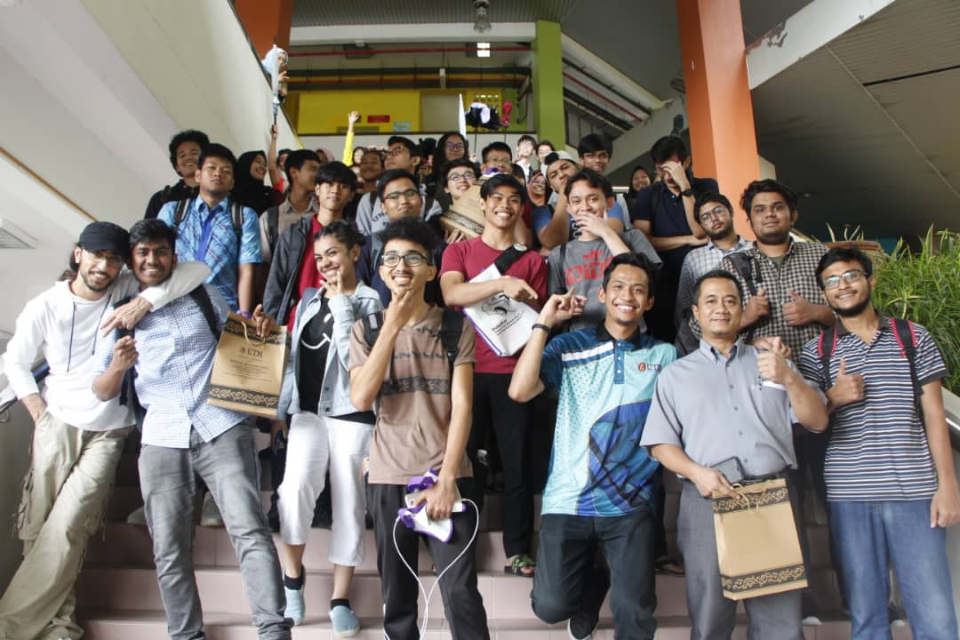
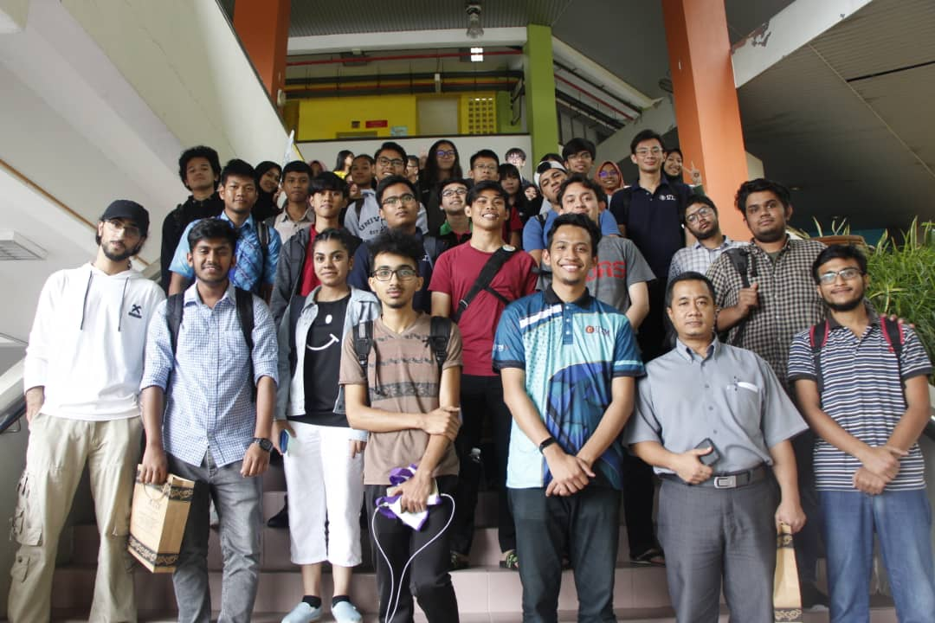
In conclusion, many things were learned by the participants in this workshop. Not only did the participants learned to program a robocar, they also learned about the importance of teamwork, critical thinking, and problem-solving skills. All these skills have to be used hand-in-hand in order for software engineering students to be effective in their field of work in the future. A big thank you to Dr Haswadi must be announced by the participants for his efforts to make this workshop as successful as it was in educating the participants about Robocar Programming. Apart from that, the Robocar Club should also be greatly appreciated for their great effort in trying to educate the participants patiently. They have achieved many great feats by doing this for the past few years such as successfully teaching high-school students to program robocars via many of their community service programs.

REFLECTIONS
- All of us in this group agrees that our main goal with our program of software engineering is to graduate and become successful software engineers in the future. On the other hand, our goal regarding this course (Technology and Information System) is learn the components of a computer thoroughly and to have a basic understanding of how computers function.
- This workshop has taught us to think critically and program robocars and also motivated us to study harder to pursue our goal of becoming software engineers, which is a great help for us.
- In order to improve our potential in the industry, we plan to improve not only our knowledge in computers but also our skills as leaders and problem solvers so as to become better software engineers in the future.

