

# INTRODUCTION:

we are now in the modern era. Nowadays, The Trend of Freelancing is increasing day by day. With the advancement of technology, freelancing is on the rise which turns freelancing jobs to their regular jobs and increases employment. Now everyone can become a self-employed or independent professional by their skills or talent and can generate a high income. The eRezeki program gives you chance to be a part of the freelancer in Malaysia.



# **Speaker of Talk:**

During this program, Nur Ashikin Halil was delivered a very effectual speech. Through the speech, she told her success story in freelancing. She also told some successful people in the world those have become famous in this platform. She motivates us about the importance of freelancing. And she also presents some online platform to the audience such as- Upwork, Freelancer, Fiverr, Elance, Guru etc.

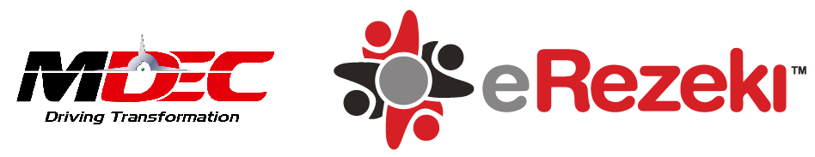

# **What is eRezeki?**

The eRezeki program enables citizens, especially low-income groups, generate additional income by doing digital assignments via online crowdsourcing platform. The eRezeki participants are matched with digital add line with their various skills. In 17 JUNE 2015 – Multimedia Development Corporation (MDEC), the lead agency for Digital Malaysia, introduced the National ‘eRezeki’ Programme, that provides a safe and trustworthy source of income for Malaysians. For joining in e-Rezeki you don't need to an expert in ICT, because there are all kinds of job in e-Rezeki like DIGITAL MICRO TASK, DIGITAL WORK, DIGITALLY-ENABLED TASK. With so many choices you can sure there is something for you and you can find a suitable job which gives you additional income.

***DIGITAL MICRO TASK:*** refers to some simple task involving data entry, processing images or actions that required the non-specific high level of skills to perform. Tasks can be performed and completed within a few minutes.

***DIGITAL WORKS***: where you need some specialized skills like the development of a website, mobile application development, creation of a logo, graphic design, software testing, document format conversion.

***DIGITALLY-ENABLED TASK:*** refers to some task that needs to complete offline and therefore does not required technical ICT skill. like delivering goods and picking up the passenger, conducting interviews and completing questionnaires and doing some part-time job like been part of event crew, electrician, cleaner and salesperson etc.

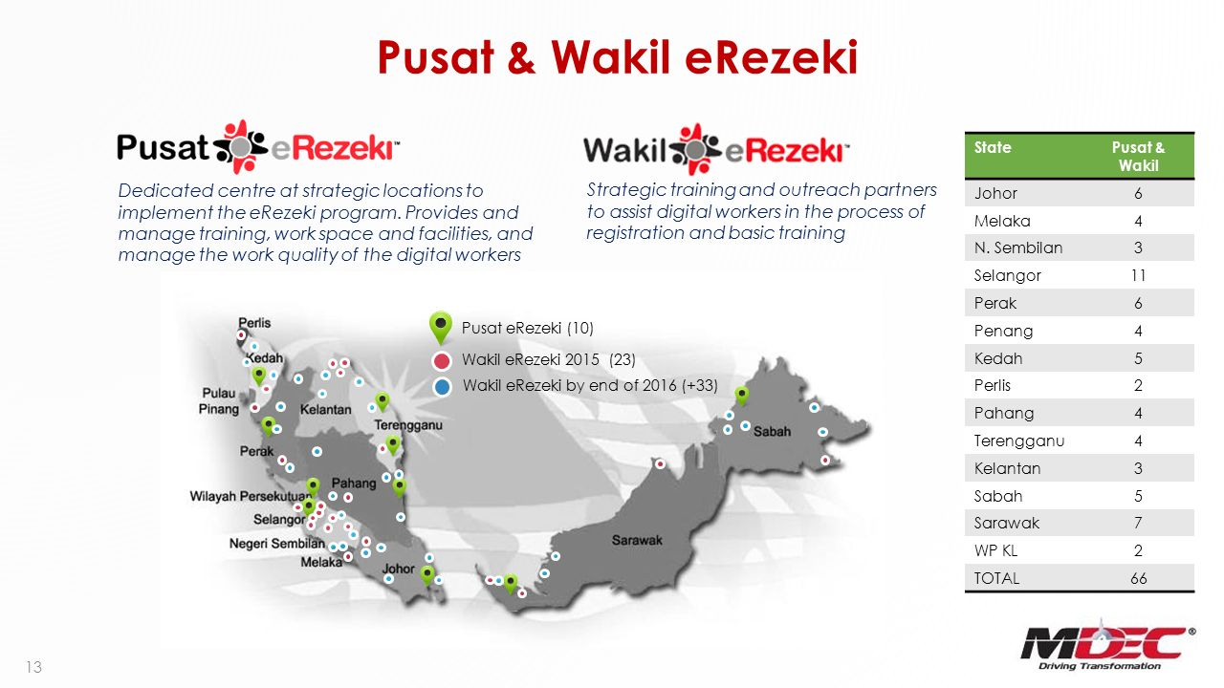

# **Who can join this program and how MDEC get people to join this program?**

All Malaysian citizens with the household income of below RM4,000 per month, that include students, housewives, retirees and senior citizens can register in eRezeki. In Malaysia more than 400 wakil eRezeki nationwide. they will help you to register and guide you to find a suitable job for you. And you can also register by own using the eRezeki online platform and perform simple digital-based tasks to generate additional income. The eRezeki centres or Pusat eRezeki along with Wakil eRezeki that provides facilities such as computers and connectivity for the participants. The centres are managed and guided by qualified trainers known as ‘Siberguru’ whose responsibilities include registration, task-specific training, and on-site facilitation of work delivery by the digital workers. The eRezeki portal and training services are free, for joining this service you are required to visit the nearest centre to register as participants.

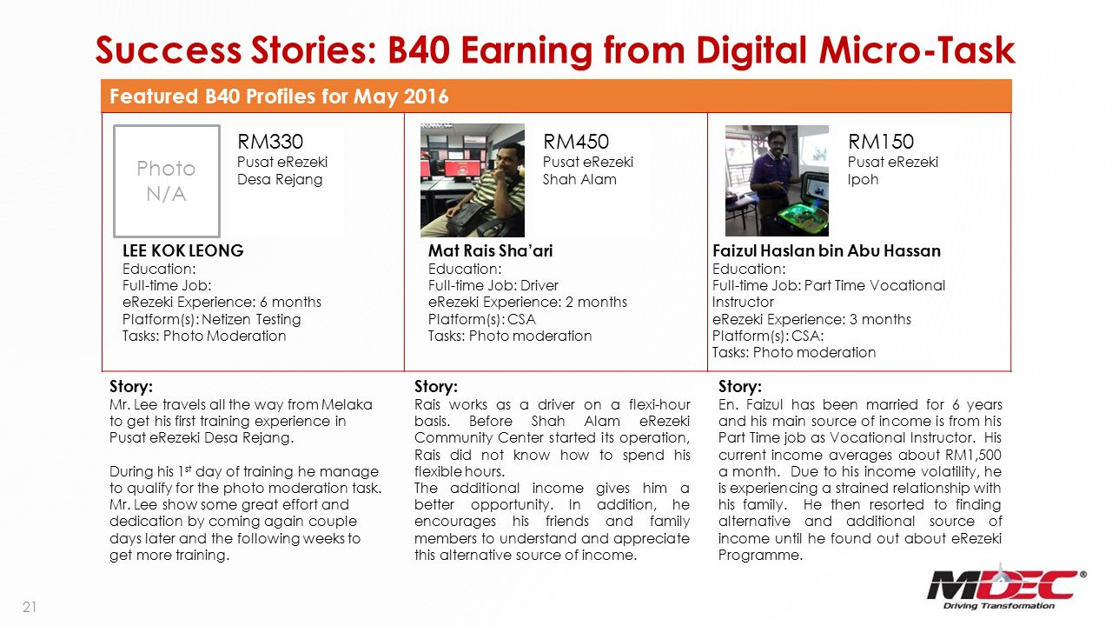

# **Impact of the eRezeki program to Malaysia:**

For Malaysia to build a vibrant digital economy, digital inclusivity is vital as the people are the key drivers to the larger economy. For this eRezeki provides opportunities for individuals and low-income households to generate income through digital methods and technologies. As digital technology has changed the way we work and live, individuals don’t have to go out and search for jobs in big cities anymore because the jobs follow them. It’s all about becoming a millionaire in your own kampung (village). In my opinion, the main benefits of eRezeki are all low-income groups people can do some simple task in eRezeki and can earn some extra money by this way their lifestyle will develop and they can lead a better life than before. And woman especially Muslim woman can also earn money by staying at home from there by doing some simple task on the internet. If Malaysia government can do proper apply of eRezeki then all the people of Malaysia can be self-reliant as a result Malaysia economy will increase rapidly because people are the key drivers to the larger economy.



# **My reflection for the eRezeki program:**

I think the eRezeki program is the most important step taken by the government in 2015. One of the project under the Digital Malaysia initiatives is eRezeki which is aimed at connecting Malaysians to digital income opportunities. Basically, this program is for low-income people in Malaysia. this program main goal is to generate additional income for low-income groups of people. We know that people are the main base of a country. if all the people of a country are self-reliant, if there are no unemployed people then the country can develop their economy. As an example, if we see in China they turn their population into manpower. Now they are dominance the world. If the Malaysian government turn their population to manpower by proper application of eRezeki then it will develop their economy rapidly. By this program, the student can also earn some money beside studying. Those who can't do hard physical work but can join the eRezeki program because of there a lot of work there where you don't need to do physical work. you can find suitable work which one you can do.