

SECP 1513 REPORT 1

Session 2019/2020-1

School of Computing

Faculty of Engineering

|  |  |
| --- | --- |
| **Lecturer** | : Dr Haswadi Bin Hasan |
| **Section** | : 03 |
| **Group No.** | : 9 |
| **Group Member** | : Rakesh A/L Kannapathy |
| : Lim Sin Jie |
| : Chan Yi Lin |
| : Anis Farzana Binti Ismail |

Table of Contents

Table of Contents2

Introduction3

Assessments Points4

Design Thinking ………………………………………………………………………………5

1. Empathize ………………………………………………………………………... 6
2. Define ……………………………………………………………………………. 7
3. Ideate …………………………………………………………………………….. 8
4. Prototype ………………………………………………………………………… 9
5. Test ………………………………………………………………………………..

Reflection ……………………………………………………………………………………12

Tasks Distribution …………………………………………………………………………..13

Conclusion …………………………………………………………………………………. 14

1. **INTRODUCTION**

Design thinking is a crucial process in which people seeks to understand the need of users, make assumption and define the problems faced by the users and thus create innovative solutions to make the prototype and test it. Also, design thinking is a process which consists of 5 phases- Empathize, Define, Ideate, Prototype and Test. It is part and parcel of our lives when we want to identify and tackle the problems in order to produce an effective solution. Since the design thinking process is known as a key which attribute to the success of organizations and companies, it has become increasingly popular over the last few decades. It urges people to think outside the box rather than follow the instructions given blindly. Design thinking is more than just a process, it provides a new path way to think and create a new solution with the new mindset.

In this chapter, System Analysis and Design, we have learned that there is a necessity for having system development life cycle before implementing some sorts of new systems. System analysis and design is a six-phase problem-solving steps for examining and improving an information system. The six phases include preliminary investigation, system analysis, system design, system development, system implementation and system maintenance. Hence, we integrate the concept of this chapter into our project, especially when we faced unpredictable challenges, so we are able to curb the problems efficiently.

Thus, after going through the design thinking process, we had decided to do a smart spectacle which is multifunctional that will help users to solve the problems when using navigation apps and systems.

1. **ASSESSMENT POINTS**

A vital part of design thinking is the process of reviewing and updating the plan from time to time. This is because we will be able to appreciate our own project success and the value of our work. Assessments are usually performed after each design thinking approach process to determine the capacity of the designs to meet program, functional and organizational requirements. Saving any of the phases would therefore have a major impact on the evaluation and design process of the system. Therefore, measurement point which are the phases of design thinking would help to identify whether or not the ultimate goal of a project to achieve the goals of the task is accomplished.

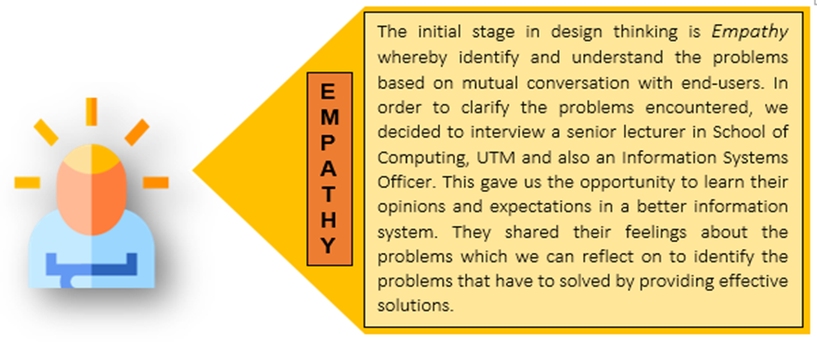

some students

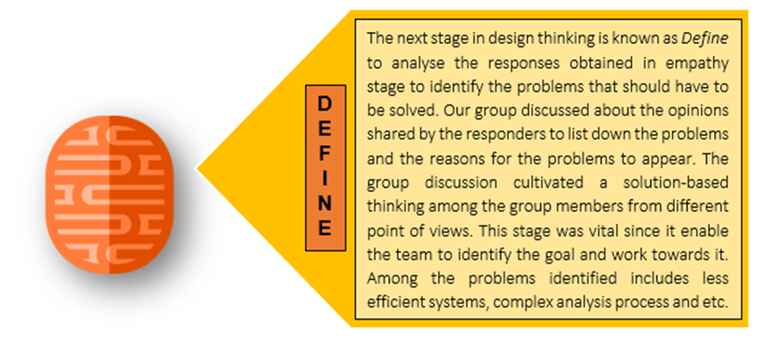

Figure shows details of assessment points at empathy and define.

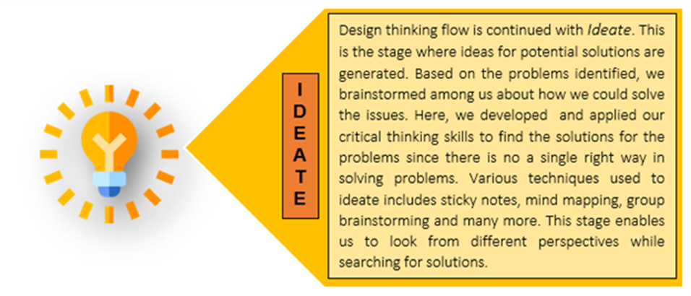

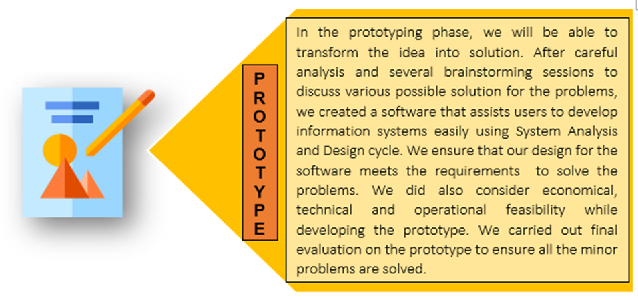

Figure shows details of assessment points at ideate and prototype.

1. 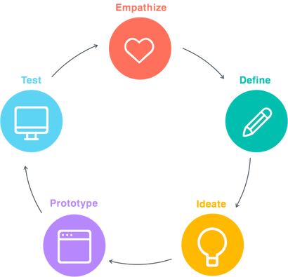**DESIGN THINKING**
   1. Emphathize

The first stage of design thinking allows us to have a deeper understanding to the users’ needs through our researches or investigations. Thus, we can have a real and various insight into the users’ needs instead of making our own assumptions, so that we can know the real problems and produce a way to solve it effectively. The approach that we have chosen is to conduct a face-to-face interview to let people share their experiences, in which we can know the other problems that may not be taken into our consideration.

1. Users are UTM students and at similar ages but use different types of transportation. Here are the questions and answers given during the interview.
2. Have you ever used any navigation systems before？

All : Yes, probably Google maps or Waze.

1. Do you find it is difficult to use navigation apps by mobile phones.

Drivers: Yes, it can distract me easily as it is hard to focus when driving. Also, I have no place to put my phone in my car.

Motorcyclists: It is dangerous to handle the mobile phones while driving and it will be difficult for me to change the lanes.

1. Have you ever experienced a situation where you nearly involved in an accident while navigating?

All: Yes.

1. Do you often get dazzled by high-beam headlights when heading to the destination especially during night time? Can you share your experience?

All: Yes. It is dangerous to drive at night.

* 1. Define

In this stage, we gather the information obtained during the interviewing sessions. Analysing and synthesizing the problems is important in order to define the core problems that have been identified by our team. Thus, a discussion was conducted to identify and recapitulate the problems faced by the users.

Throughout our discussion, we had found out that there are still many problems faced by people despite advanced technology. Throughout our observations, we have found out that one of the problems is that there are a few difficulties encountered by users when using navigation apps such as Waze and Google Maps. First, the drivers and motorcyclists can barely stay focused when driving as they are using navigation apps which can distract them easily. Although various types of mobile phone holders are specifically designed for car mount, but this cannot ensure their safety as some people cannot concentrate on multiple things at a time and they will be struggling with multitasking. Other than that, using navigation apps may put the drivers and motorcyclists in jeopardy especially during night time as it is easy for them to get dazzled by high beam headlights on oncoming vehicles, which in turn increase the risk of being involved in road accidents and become the cause of increasing car accidents. Thus, we must come up with the solution to can combat distracted driving to prevent the accidents from happening. Furthermore, there are some new routes that are not updated in the navigation apps which will consequently cause the drivers to be unsure about the ways to the destination and end up wasting their time finding the accurate routes. Hence, there is a need to create new inventions to combat the difficulties that the users meet when using navigation apps as safety should be always put on the top priority.

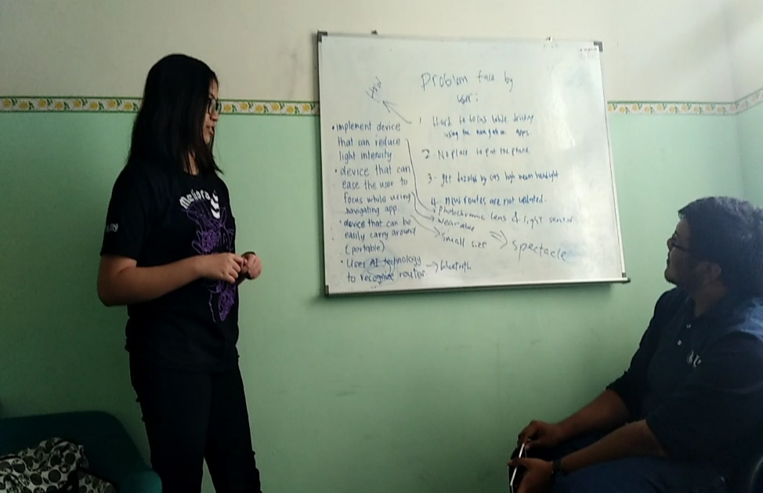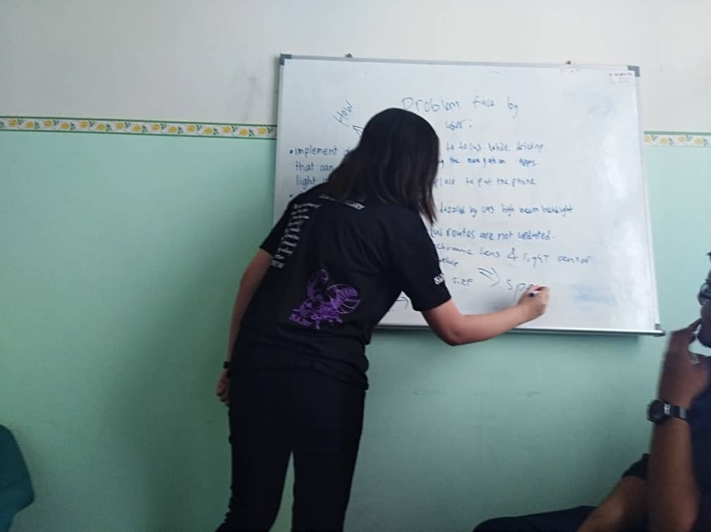

Our member, Chan Yi Lin was giving her opinions about the problems faced by the users.

* 1. Ideate

The third stage of design thinking is to generate ideas. It is time for us to brainstorm address to solve the problems and come up with a solution which meet users’ needs. Instead of identifying the problems conventionally, we will be looking for alternative ways to view the problems from another perspective and create innovative solutions to tackle the problems. Also, during this process, we prioritized the users’ needs when we evaluated the ideas that were collected from each member.

Here are some of the initial ideas from the members during the early stage of ideate.

1. A device that can reduce light intensity, such as with photochromic lens and light sensor.
2. A device that can ease the users to focus while using navigation apps, for example, the users can wear it during using navigation apps.
3. A device that can be carried easily wherever they are going, which is portable and small.
4. A device that will be implemented with new AI technology to recognize the routes. For instance, it can be connected to the Bluetooth devices and so on.

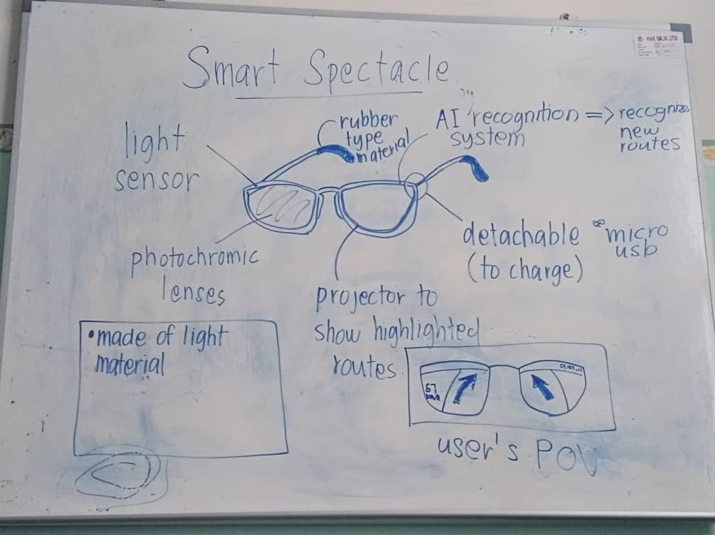 In the end of our discussion, we come up with an idea which is to make a smart spectacle as it meets all the requirements of users.

* A picture that shows that our final decision about the smart spectacle that is equipped with functions that meet users’ demands
  1. Prototype

This is an experimental stage in which we can create our product cost-effectively for the problems identified during the previous stages.

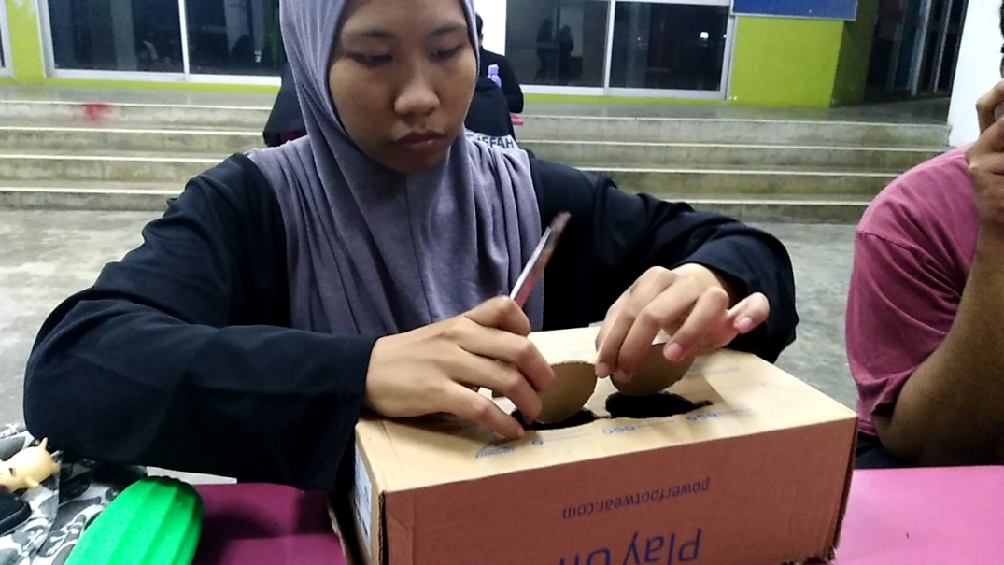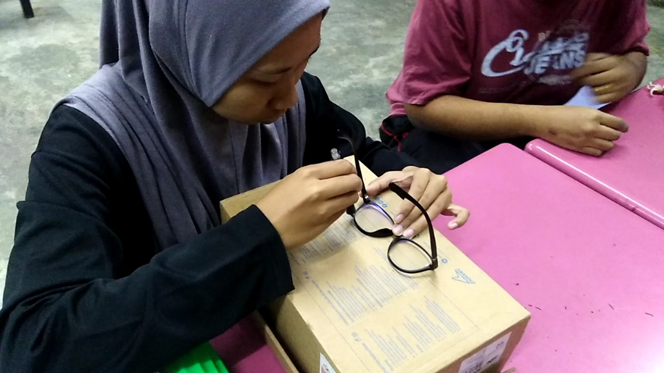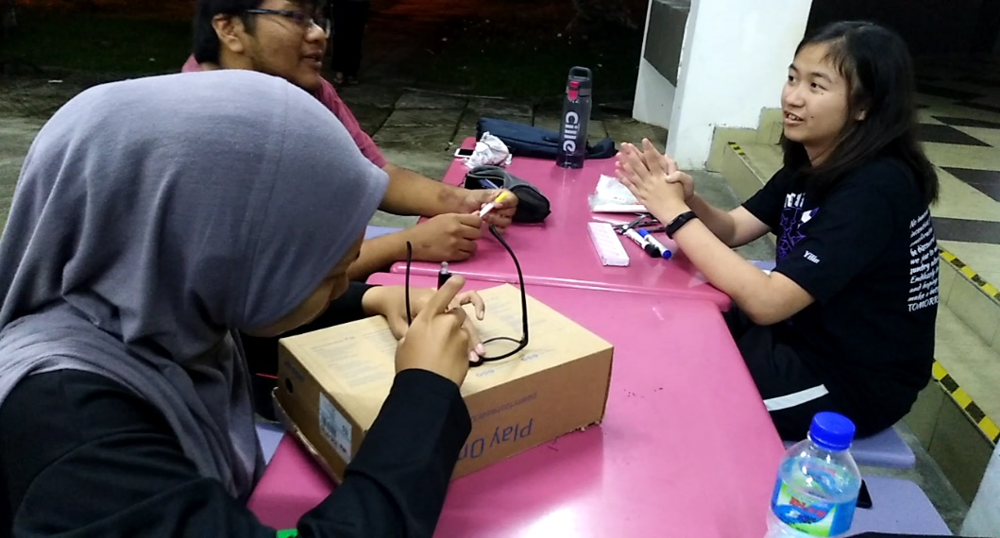

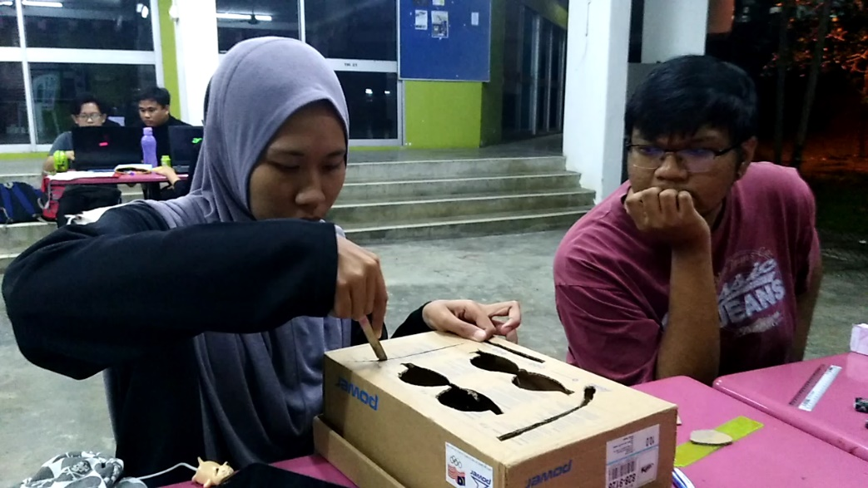

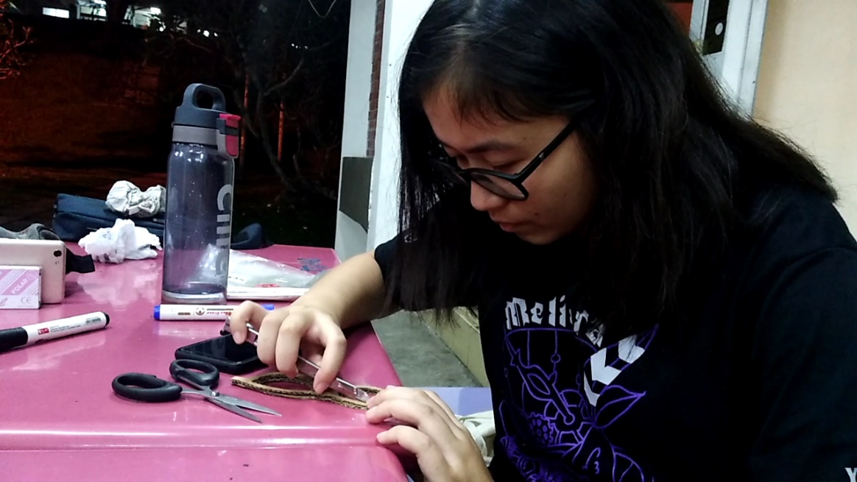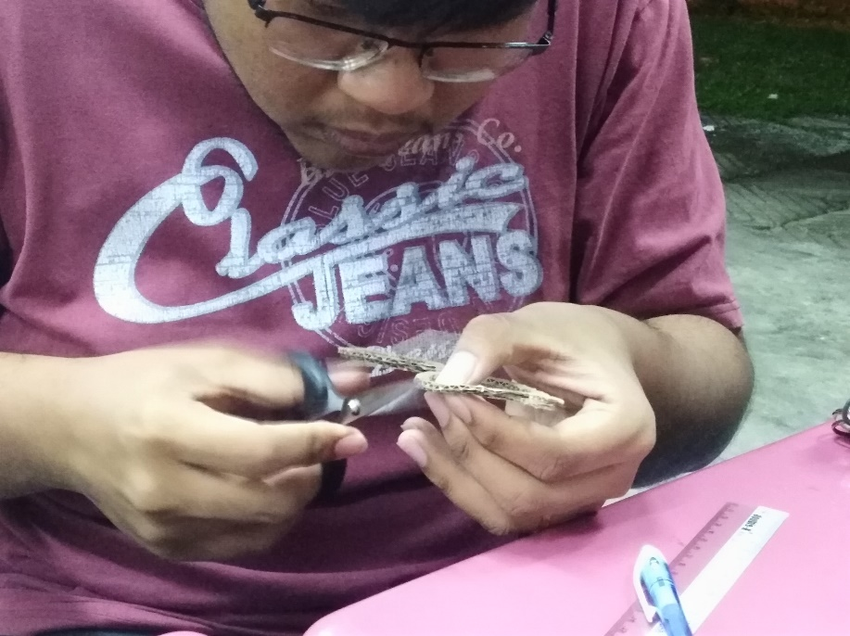

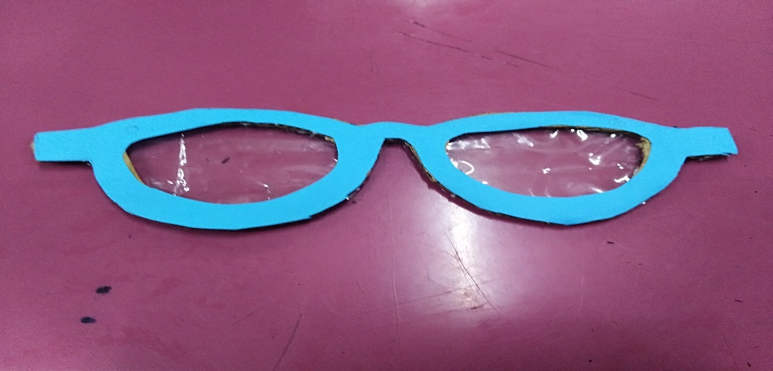

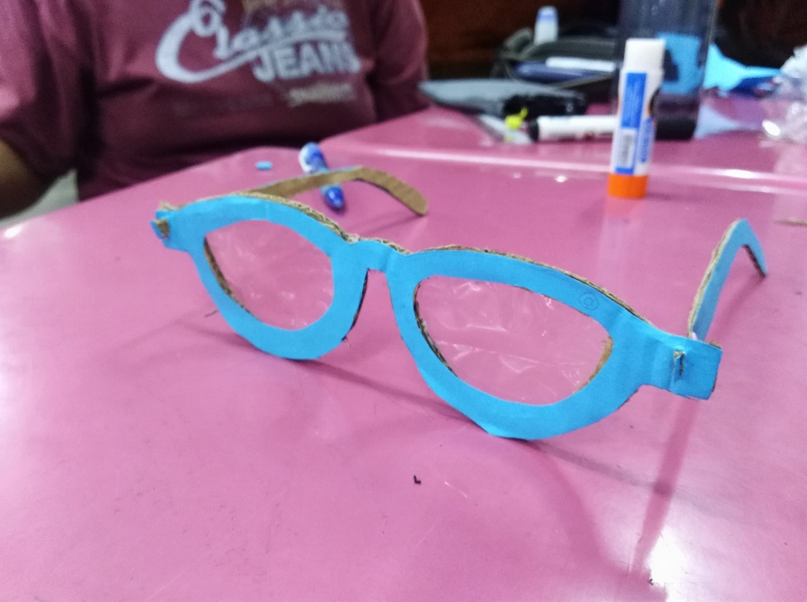

**3.0 REFLECTION**

a) What is your goal/dream with regard to your course/program?

1. We hope that the technological singularity is created by us.
2. We believe that AI technology will be the next technology singularity.
3. Software engineering course can help us much in this.
4. We wish to invent moe sophisticated equipment which can bring convenience to this world.

b) How does this design thinking impact on your goal/dream with regard to your program?

1. We think that the people now are too rely on mobile phone which caused new invention and this generation pay more attention to mobile phone.
2. We wish to invent something that can use the function from mobile phone without touching the phone.
3. Spectacles is a thing that had no other than to see clearly. This invention should not be just like that as it is ‘hand free’.
4. A ‘hand free’ AI technology will be a good idea for the next technology singularity.
5. It is good to be start from navigation system.

c) What is the action/improvement/plan necessary for you to improve your potential in the industry?

1. There are many possibilities in this infinite universe.
2. Our mind had restricted by what we knew and what we learnt.
3. Think for all possible for everthing we see and we learn, and the impact.
4. Always concern with the new invention.
5. Note down the problem in daily life so that we can think for the solution.

**4.0 TASKS DISTRIBUTION**

a) Lim Sin Jie

1. Filming
2. Find information for the report

b) Anis Farzana

1. Art (draw the model of the product)
2. Conclude the report

c) Chan Yi Lin

1. Interviewing
2. Gather information for report

d) Rakesh

1. Gather ideas of members
2. Video editing
3. **CONCLUSION**

From this activity, we learned that every innovation is not just only the creativity, but it also has to depend on the reality. Even we have a very good idea to invent something new, but if we can’t produce the thing out to benefit human, all of it is just our imagination. However, maybe it is impossible for us to do it for today, but we believe that as we keep improving ourselves we will be successful in the future. For example, the aeroplane which invented by Wright brothers. As long as they have the idea to make an aeroplane, they struggled to make the idea becomes real. Unfortunately, their first try to fly has failed. They keep on trying and make the corrections which made them fail and finally, the aeroplane successfully fly in the sky! Ergo, as we determine to do something, we should not give up easily and should always learn from mistakes. Nowadays, people starts focusing on their health, for sure, our innovated device will become so popular in the future and also it is so convenient for using. The limitation of our innovation is the price of the product is very expensive. As our product consists of high technological devices and also it is multifunction, therefore the price will be quite high which maybe cannot be supported by the poor families.