**SCSV 2113**

HUMAN COMPUTER INTERACTION

(Session 2020/2021 Semester 2)

School of Computing

Universiti Teknologi Malaysia

**P01 – IDEATION WORKSHEET**

[VISION +]

**LECTURER**

NOR ANITA FAIROS BINTI ISMAIL

(Section 01)

**GROUP NO 5 (Auspicious)**

*Prepared by*

MAIZATUL AFRINA SAFIAH BINTI SAIFUL AZWAN A20EC0204

MADINA SURAYA BINTI ZHARIN A20EC0203

NAYLI NABIHAH BINTI JASNI A20EC0105

MADIHAH BINTI CHE ZABRI A20EC0074

NURFARRAHIN BINTI CHE ALIAS A20EC0121

SAFIRA NURUL IZZA A18CS0323

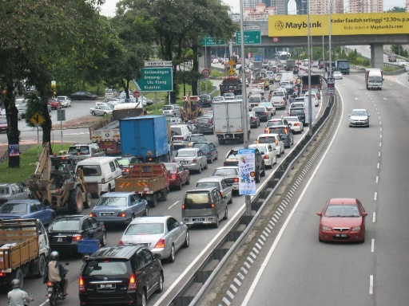

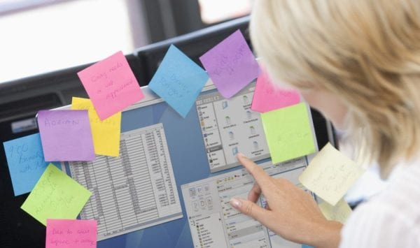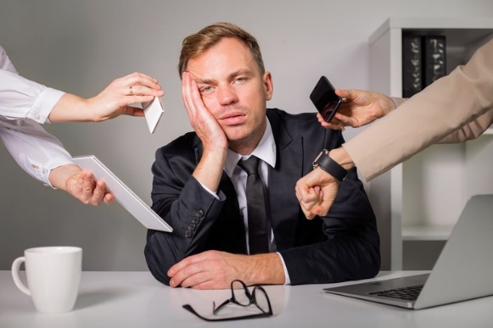



**OBSERVATION**

**Write down not only what you see, but also what you hear, smell, or feel.**

* What do I see?

1. Traffic congestion
2. Messy working environment
3. A lot of sticky notes used as a reminder.
4. Bad lighting

* What do I hear?

1. Car honking
2. A lot of people chit-chatting.

* What do I feel?

1. Stressed
2. Get not enough fresh air (poor ventilation)

* What do I smell?

1. Smoke emits by vehicle(exhaust)

**QUESTIONS FROM OBSERVATION**

1. **What surprised you the most about the community/workplace?**

How chaotic can one’s life be every day.

1. **Can you see any problems that are affecting the community/workplace? If so, who is it affecting and how?**

* A busy working person cannot keep up well with their daily activities that can be varied every day. This can be seen when someone is stuck in traffic jammed which interferes with their daily plans.
* Students especially during online class are distracted with poor study conditions such as poor room lighting, poor ventilation, noise, and chaos that come from someone else.

1. **What do you think this community/workplace needs to help solve that problem?**

* In a world where technologies conquered them all, society wants some sort of a tool, technology, gadget or a software that can help them sort things up and manages their schedule.
* People will not become fans of using sticky notes and stuff because using them will get messy, unorganized, use spaces, easy to tear up and most importantly not portable because usually sticky notes stay in one place.
* Therefore, they will need something that is up to today’s standard, does not take too much space, durable, and most importantly, portable, and efficient in sorting things.

1. **Who would be responsible for making that change and how?**

* Everyone is responsible for tidying up their stuff since, as children, we all have been taught how to clean up our mess; when our room is comfortable and tidy without clutter insight, we can feel less anxious and disturbed. So, start cleaning our surroundings also can help people to fix their messy life.
* Everyone should learn how to manage their time. Time management makes it easier to manage our projects and ensure that we have enough time to complete each project. When we are not rushing to finish something before a deadline, the quality of our work improves.

1. **How might the community/workplace needs be solved by technology?**

Technology has become advanced nowadays; developers' creativity helps us see things differently, better, and more manageable. Not all people can organize their daily activities by themself; some need help to do it. So, applications or tools that can remind them to do their activities can help them so much.

**PROBLEM STATEMENT**

1. **What is the problem you are trying to solve?**

Most people cannot manage their daily activities wisely. So, they need technologies to help them. Nowadays, people are lazy to make their own schedule manually and tend to use scheduled apps on mobile phones. However, people tend to disturb by their social media on the phone and waste their time.

1. **Who does the problem affect?**

The problems that we face are affected by all users regardless of age either students who are busy with their schoolwork and assignments, users who are busy with work such as meetings and projects and also other users that are busy with their daily routine.

1. **What do they need for the problem to be solved and why?**

The users who face this problem need an app or a software that can manage our daily routine and activities without having to open our mobile phone because not all users love to bring their phone everywhere, they go. The users also need something that is light and easy to bring and wear anytime and anywhere they go so that it will be a usable and effective thing to the user.

1. **What is the solution?**

Therefore, this group come out with a solution that will certainly fits the requirement of society nowadays. Introducing, the world’s first smart spectacles that is capable in editing your schedule, sorts and remind you about your upcoming events, anytime anywhere. Designed in a stylish matte colour, this product will captivate people especially the youths as they want to experience the power of AI while feeling luxurious. This product also has some additional capabilities by making people feel comfortable wearing it. The glass could change colour according to the environment and surely it is light that would make people feel less distracted.