

**REPORT:**

DESIGN THINKING

**SUBJECT:**

TECHNOLOGY AND INFORMATION SYSTEMS (SECP1513-02)

**GROUP/TOPIC:**

GROUP 9: SYSTEM ANALYSIS AND DESIGN

**LECTURER’S NAME:**

DR. ARYATI BAKRI

GROUP MEMBERS:

|  |  |  |
| --- | --- | --- |
| NO. | NAME | MATRIC NUMBER |
| 1. | VINCENT BOO EE KHAI | A20EC0231 |
| 2. | ONG HAN WAH | A20EC0129 |
| 3. | MADIHAH BINTI CHE ZABRI | A20EC0074 |
| 4. | QAISARA BINTI ROHZAN | A20EC0133 |
| 5. | RISHMA FATHIMA BINTI BASHER | A20EC0137 |

# **TABLE OF CONTENTS**

**TABLE OF CONTENTS** 2

**LIST OF FIGURES** 3

**INTRODUCTION** 4

**1.0 DETAILED STEPS** 5

1.1 Teamwork 7

**2.0 DETAILED DESCRIPTION** 8

2.1 Problem Statement 8

2.2 Solution 9

**3.0 DESIGN THINKING EVIDENCE** 11

Design Thinking Process 11

3.1 Empathy 11

3.2 Define 14

3.3 Ideate 15

3.4 Prototype 17

3.5 Test 18

**REFLECTION** 19

Vincent Boo 19

Madihah 19

Ong Han Wah 19

Qaisara 20

Rishma Fathima 20

**CONCLUSION** 20

**REFERENCE** 21

‌**TASK OF EACH MEMBER** 22

# 

# 

# **LIST OF FIGURES**

Figure 1: The phases in design thinking 6

Figure 2: The steps to solve a problem 10

Figure 3: Interview with Dr. Murtadha and Mr Farid 12

Figure 4: Interview with Mr Azlan Zainuddin 13

Figure 5: Discussion in Google Meeting 14

Figure 6: Discussion in Whatsapp 15

Figure 7: Process of ideating 16

Figure 8: Sample of prototyping 17

Figure 9: Testing the prototype 18

# **INTRODUCTION**

Design thinking is generally defined as an analytic and creative process to solve problems which is one of the most important skills nowadays. It is a structured and cyclical approach for generating and evolving ideas. In the design process, we must believe in ourselves to create an idea that gives positive impact to the targeted people. Thus, we get to develop an optimistic mindset when we use the design thinking approach for innovation. There are five phases in design thinking that help us navigate through the development process from identifying a design challenge to providing the solution and building it. These phases include empathizing users, defining the problem, ideating solutions to that problem, prototyping ideas and testing the model with users. A successful design process endeavor covers each of these phases thoroughly.

System analysis and design on the other hand is a structural approach used in solving a problem. This step-by-step procedure helps system analysts to configure a project systematically. The first phase in system analysis and design is preliminary investigation where the investigation is done from scratch to find out what problems the users are facing. Next phase is the system analysis where the data is collected about the current problem and analyzed for better requirements. Then, phase three which is system design which is one of the crucial stages in system analysis and design where an alternative system is designed. The following phase is system development where the new system is tested and this phase takes a long duration most of the time due to the evaluation process. Then, phase five which is system implementation where the old system is converted to a new system and there are few methods in converting the old system to a new system. Most of the time, the method depends on the economic feasibility of the system analyst. Last phase is system maintenance where it is to prevent errors while using the system and also to compare the original design with the new design specification. So, all these phases should be implemented in system analysis and design to prevent big mistakes from happening and also to save time.

# **1.0 DETAILED STEPS**

The five elements in design thinking which are used in this assignment are empathy, define, ideate, prototype and test to ensure the assignment is made perfectly. The first phase is empathizing which is to identify the problem based on the current situation. In order to identify the problem, we conducted an interview with experienced professionals. The first interview was with the CICT staff, Dr. Murtadha and Mr. Farid. Through this interview, we gained a lot of knowledge and information but the interview was joined by almost 150 people so we could not focus on our topic. Hence, we decided to conduct another interview. The interview was organized by Qaisara and she booked a slot with Mr. Azlan Zainuddin who is a chief technology officer of Global PCK Solutions Sdn Bhd with 16 years of experience. At the end of the interview, we gained a useful insight regarding the means of system analysis and design in the industry.

Next phase was to define, in this phase all of us had a discussion in Google Meet and Whatsapp to identify the problem statement. The discussions are also held to generate rough ideas regarding the next step that we all were going to do. In this phase, we all identified the problem based on the interview we had with Mr Azlan and Dr Murtadha. In most cases, the problem faced by the system analyst was to deal with unrealistic clients where the clients did not know how to explain what they needed to their designated team of system analysts and developers. Hence, this causes a lot of problems during the system implementation’s phase, in which the client is usually not satisfied with the outcome and expects more than the new system. To avoid any flaw sightings in System Analysis and Design (SAD), these problems have got to come to an end.

The next phase was to ideate which means all of our group mates had to think of a way to solve this problem by generating ideas. We had plenty of virtual discussion because we could not meet each other face to face due to the coronavirus disease pandemic. We brainstormed for ideas and evaluated each of the ideas according to its pros and cons. After conducting countless discussions on the Whatsapp application and Google Meeting, finally at the end of this phase, we came up with ideas and plenty of suggestions to solve the problem.

The next phase is to prototype where it is generally used to evaluate a new design to enhance precision by system analysts and users. In this phase, a virtual design is made in order to show the end product to the users and give them more understanding about our solution. The prototype we made was basically a platform for the users or clients to understand and take part while doing the system to ensure the system satisfies the client’s requirements. Hence, we tried a few times to find the best prototype. Finally, after putting in a lot of effort, we did one of the best prototypes which is Expedyte, a virtual centralized workspace.

The last phase is to test, where the prototype is tested and shown to the users in this phase. Besides, it is also a step to enhance our solution and make it a better system. The negative and positive feedback was gained from the users in order for us to improvise it.

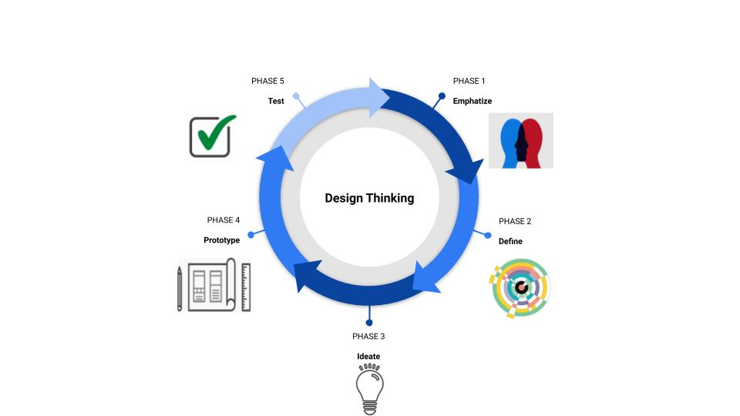

Figure 1: The phases in design thinking

Figure 1 shows the phases in design thinking. Hence, it shows the first phase is empathize, followed by define. Then, ideate. The next phase is prototype. Finally, the last phase is the test.

## **1.1 Teamwork**

Teamwork is a significant element needed in the makings of an assignment. It is never possible to do a huge amount of work alone. We all are very grateful to get such good teammates who helped all of us at any time of the day. First of all, we did not select a leader in our group because we felt like all of us have the equal rights to contribute ideas and do the work together. We did not let one person show their leadership quality instead we all showed our leadership qualities and tried our best to do the assignment. Firstly, Qaisara has helped us to book a slot with Mr. Azlan Zainuddin for an interview. She really struggled to book a slot with Mr. Azlan Zainuddin and the interview turned out to be very informative and we all gained a lot of knowledge through that. Then, Madihah who always helped us in texting Dr. Aryati and keeping all the groupmate updated all the time. Without Madihah, all the group mates would not get the information from Dr. Aryati. Then, Ong who always contributes extraordinary ideas in executing the assignment because ideas are very important in doing an assignment. Next, Vincent who always helped us in every part of the assignment, he never complained about work and always spent his time finishing up the work. Last but not least, Rishma who contributed ideas and made sure works are done on time. It is because punctuality is important in finishing up assignments to ensure it can be submitted in time.

Beyond their personal contribution, everyone contributes ideas and effort in finishing up this assignment. It was not at all difficult to do assignments with people we never met before because we all had good team work and understanding in finishing up our assignment. It was very great that all of us could have Google meetings and discussion on a fixed time and no one gave excuses to escape from the work. Besides, all of us could understand each and one of our problems. For example, if any of us did not have proper internet connection, we did not burden them to contribute work that needed internet connection, instead we gave work that can be done without internet connection. It is very satisfying to do assignments with people who actually helped each other and did not give up until the last minute. Teamwork is the key to success and definitely true for me and my teammates.

# **2.0 DETAILED DESCRIPTION**

After analysing the chapter our group was assigned to, our group decided to carry out an interview session with individuals that have experience in developing an information system. Both interviews with Dr. Murtadha and Mr. Azlan have brought us deeper understanding regarding the steps needed to configure a system and an insight on how the system analysis and design method is applied in the industry. Our group managed to identify some problems in respect of the challenges faced in System Analysis and Design (SAD).

## **2.1 Problem Statement**

1. **Unrealistic Clients**

One of the biggest fears of being a system’s analyst is to deal with unrealistic clients.

These individuals are usually not aware of the work they are involving themselves in,

some of them have unreasonable expectations while being on a tight budget whereas some others have no expectations at all, leaving the analysts to deal with their own preferences. In consequence of not knowing what the client’s need nor want, people working in the system analysis and design department are always having a hard time in satisfying their clients with the solutions they provide due to the lack of crucial information they retrieve.

1. **Misaligned interpretation between team members**

According to Mr Azlan, he himself had difficulty in searching for the right team of system’s analysts and developers. Sometimes in the makings of a project, lack of communication between team members can cause a twist in interpretation. In other cases, some individuals tend to be personal in having their work done instead of discussing it with their team members and getting consultation from their supervisors. By allowing this scenario to take place, misinterpretation of ideas is likely to happen. Therefore, the end product cannot be delivered realistically according to the client’s likings.

## **2.2 Solution**

The solution to all of the problems stated before came into our sight after having a deep and thorough discussion via Whatsapp application. Our group decided to create an online platform merely a functional software that runs as a centralized workspace specialized in system analysis and design (SAD). This user-friendly workspace named Expedyte, allows system analysts and other significant individuals to develop information systems without having to face major hustles like communication problems.

This website houses all of the key components in constructing an information system which is the six phases of the system's life cycle. This method is commonly used to help system analysts to solve problems and create solutions for their clients. Expedyte covers a wide range of work scope beginning with the investigation process, data analyzation, designing a system, developing the system, implementing it and lastly to maintain its performance and functionality. To curb the issue of dealing with unrealistic clients, Expedyte allows its clients to partially take part in designing their end product by allowing them to choose their desired layout and theme in the first phase which is preliminary investigation. This phase is above all, the most crucial phase in which clients have to give their utmost cooperation with their designated team of analysts.

Besides that, Expedyte also offers a solution to put a stop to misaligned interpretations between team members by having the chat box and comment feature. Unrelated coworkers can only view and comment on their colleagues' work or try out the chat box feature to stay in touch with their friends. On the other hand, analysts could also get real-time feedback from their clients by keeping in touch with them over the chat box feature. By this way, both team members and clients can work dually in peace and harmony.

Expedyte provides a coding environment with an integrated debugger, bug tracker and testing tools for developers to build and test the system. After the system is done, they can choose a method of implementation of the system and documentations can be generated from the software. Developers are also able to monitor and maintain the system through the software. They can set the maintenance schedule, get detailed reports on analysis of system and security controls to help maintain and improve the system performance.

Expedyte can truly bring a huge change in System Analysis and Design (SAD). Now that all work of each phase is centralized in a software, the chances of going through high stakes of problems will gradually decrease over time. Expedyte is developed to ease the process and the lives of those involved in the field.

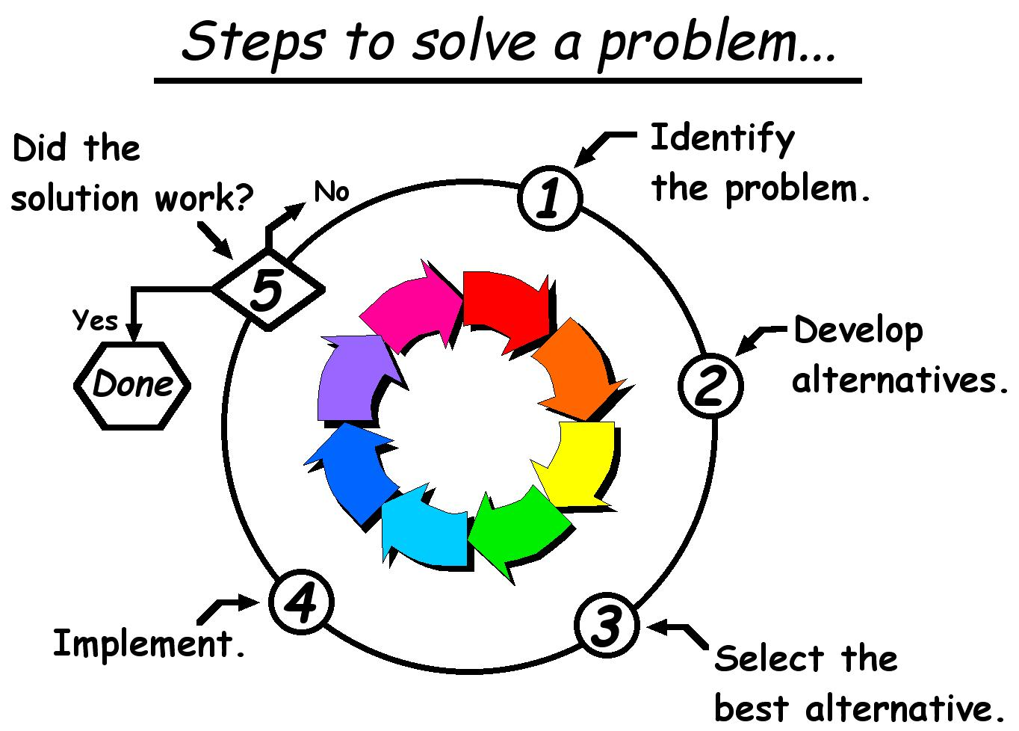

Figure 2: The steps to solve a problem

Figure 2 depicts the steps to solve a problem. This designated step is widely used in System Analysis and Design (SAD) to help project stakeholders, analysts and developers to solve a problem and to successfully create a system. This method is proved to be a good use in the industry.

# **3.0 DESIGN THINKING EVIDENCE**

## **Design Thinking Process**

### **3.1 Empathy**

In this phase, we conducted two interviews but the main one was with Mr. Azlan Zainuddin. Hence, a set of questions was prepared to be asked during the interview.

1. Please introduce yourself
2. How long have you been working in your department?
3. Can you briefly explain what is “System Analysis and Design” ?
4. How do we face difficulties in older days which are no more difficult these days?
5. Why do corporations go through basic phases of the system's life cycle?

The replies from Mr. Azlan Zainuddin:

1. I graduated in 2002 and started my career during final year. I was given the opportunity to do some freelancing and have the exposure on the business site. So, I set up my income immediately after graduation.
2. I have been working since 16 years ago.
3. System analysis and design from a business perspective is about responding to situations which require analysis of a particular business process and to respond in the form of solution.
4. Let’s say compared to now, the biggest differences will be in terms of resources. My generation requires us to be resourceful, not only in terms of knowledge but also in terms of resources. We are referring to hardware, software available.Those days, we had to make do with the limitations but the demand was different compared to now. In terms of resources, you had to go to the library. The Internet is a bit slow but after that we had broadband, so it is a little bit okay. But we are talking about sharing that broadband at the library or home because no phone and Internet but now everybody is connected. So those are the biggest differences because we know how to be resourceful. If we compared to now, everything is presented to you. So those are the difference things, we had to be resourceful, keep close relationships with your lecturer because they are your source of information as well. Besides that, I think that I realize that there is a lot of plagiarism nowadays and much information is overloaded nowadays. Sometimes, you feel that information comes from you, your own idea but the fact that it is a replication of what you’ve read online, so that's why the genuinity of the idea is hard to find now.
5. Development requires a structured approach in approaching a problem. If there is no structure, you might skip a few steps that lead you to overload in certain areas. For example, in order to respond to problem statements, data collection that you can get whether you go through the problem by yourself or engage with the user. Even though the system is a technology-based industry, for me, the most important thing is engagement. We don't want a developer to come out with his own solution in response to a problem yet you do not bounce that idea or proposal to the user. End up, it does not match with the user requirements. That's why the software development life cycle is a sequence of steps that allows you to go through structurally the problem and to make sure that whatever that translates into a solution is well-thought.

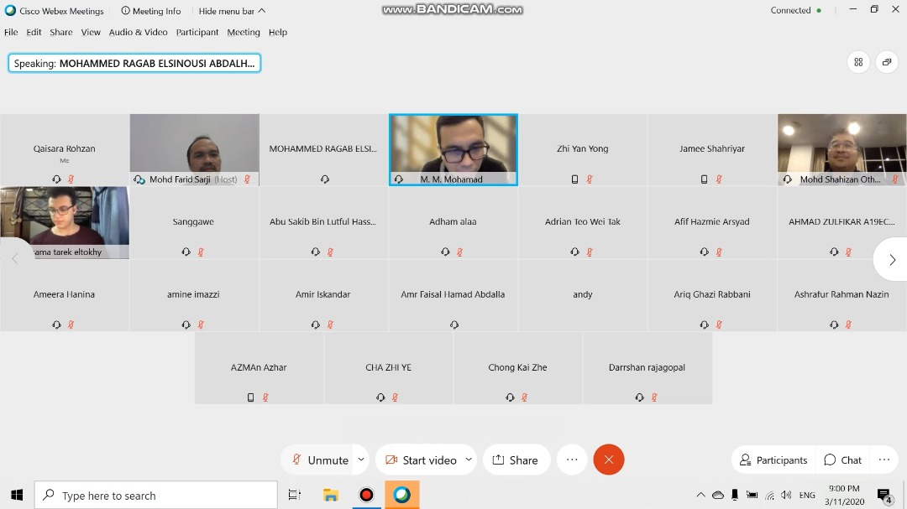

Figure 3: Interview with Dr. Murtadha and Mr Farid

Figure 3 depicts the interview session held by Dr. Murtadha and Mr Farid, who are in charge of the Information System department. The session was attended by more than a hundred students from Universiti Teknologi Malaysia (UTM). This interview was carried out for students who want to know more about the topic and ask the interviewees regarding their experience in the industrial sector.

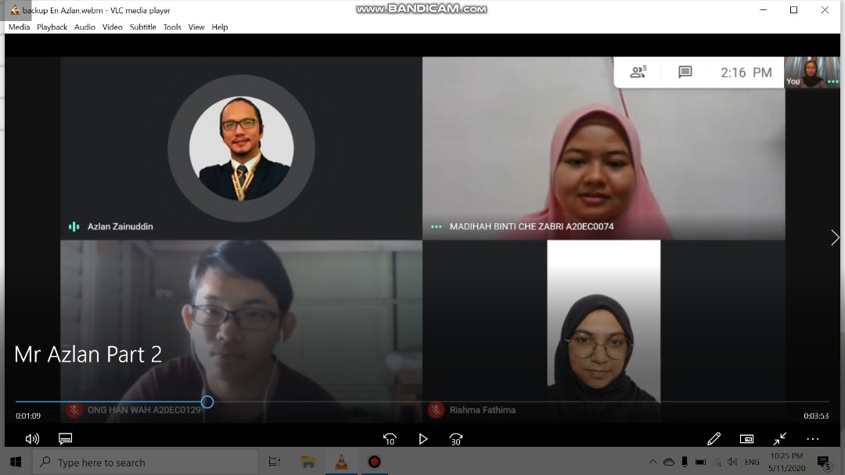

Figure 4: Interview with Mr Azlan Zainuddin

Figure 4 shows the interview session with Mr Azlan Zainuddin which our group attended. This interview was carried out to enhance our knowledge on the importance of System Analysis and Design in the Information System field. This phase is extremely crucial and is known as the empathy phase in design thinking. By carrying out this interview, our group gained deeper understanding regarding the system analysis and design methodology (SADM).

### **3.2 Define**

The define mode is when we organize our research, observe our users and synthesize our empathy findings. We have two goals which is to develop a deep understanding of our users and the design space and come up with a solution to the problem statement. In this phase, we did a lot of discussion to find out the problem faced by the users. The discussion is made by Google Meeting and WhatsApp. Hence, at the end of the discussion we found the right problem which was a problematic and unrealistic client who was not clearly demanding the requirements in creating a system. Meanwhile, they are complaining and expecting more after the system is done. Other than that, our group identified that there was no common platform that allows system analysts and other key individuals to collaborate while doing their work.

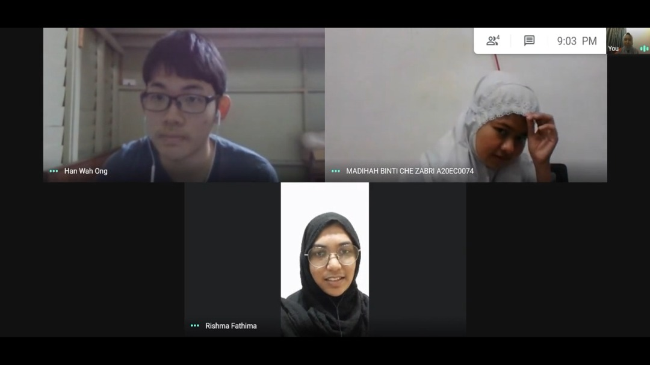

Figure 5: Discussion in Google Meeting

Figure 5 shows the meeting our group had in Google Meeting in order to discuss and find out the problem faced in system analysis and design after the interview session. During the discussion, our group reflected on the important points we received during the interview session.

### **3.3 Ideate**

Ideate is the phase during our design process in which we generate lots of ideas to overcome the problem. In order to come up with the best solutions, we must apply both divergent and convergent thinking. In this phase, all the group mates contribute the ideas and the discussion is made through Google Meeting and WhatsApp platforms. All of us sacrifice much time and energy in order to contribute ideas. A lot of ideas were shared among each other but the best one was selected.

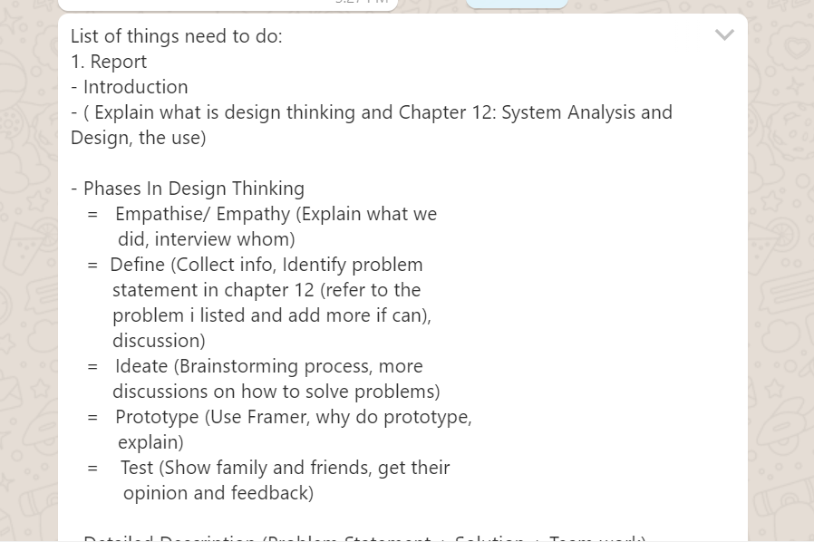

Figure 6: Discussion in Whatsapp

Figure 6 shows the discussion we had in Whatsapp. It is also the rough idea of a list of things that need to be done.

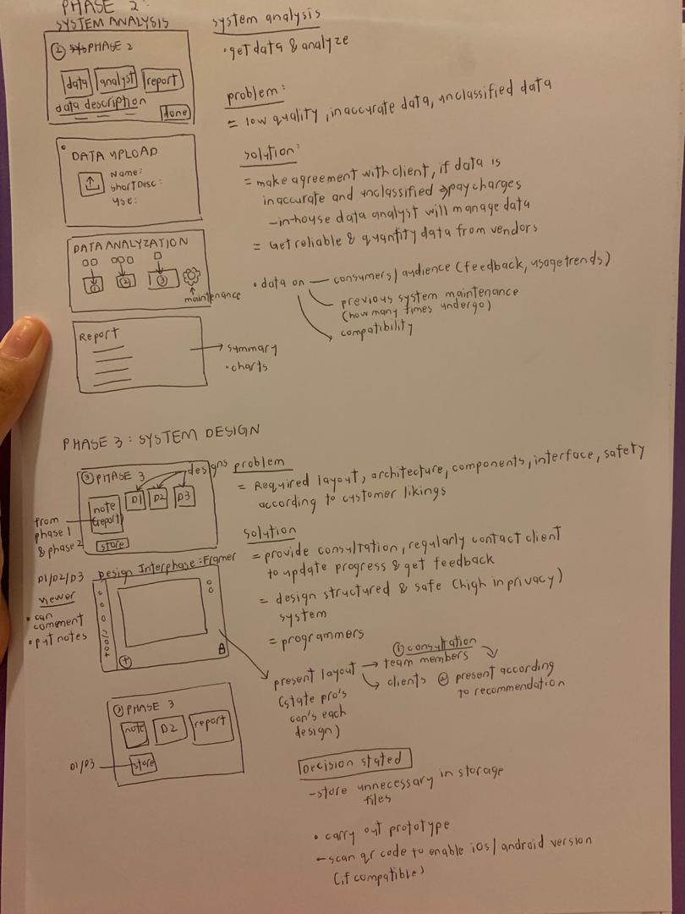

Figure 7: Process of ideating

Figure 7 shows a student’s sample work of ideating a solution. From the figure, we can see that the student is trying to depict the workflow of a system that can curb the problems faced by system analysts. The student carefully explains her idea using hand drawn layouts and the solution to each of the problems faced in respect of the different phases in the system's life cycle.

# 

### **3.4 Prototype**

Prototype is the phase where we get ideas from our mind and transform it into the physical world. It can be between our dream and reality but most of the time, the effective prototype is the simple one. In general, prototyping is important in solving a problem because it acts as the incomplete model of our designed solution which is Expedyte. In this phase we used a tool called Framer to do a virtual designing of the prototype. A lot of prototyping was made by all of us and the best one was selected. The Framer website helped us to visualize the flow of the software and also to create the interface design.

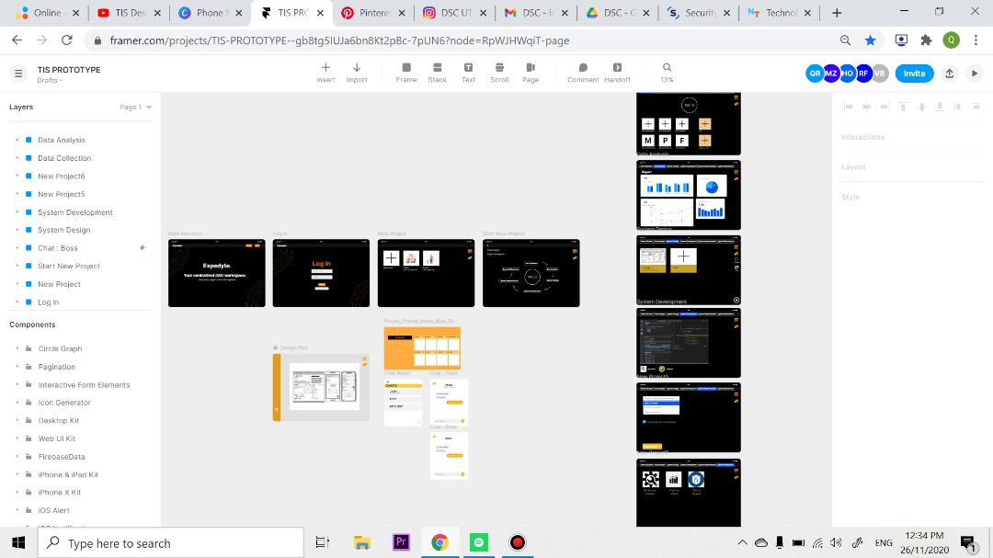

Figure 8: Sample of prototyping

Figure 8 shows the prototype that Group 9 has worked for the design thinking project. Our group used a free prototyping tool called Framer that allows all the team members to work simultaneously in order to finish the prototype. The figure depicts a fully done prototype did by our group, to know more do head to our YouTube video to experience more explanations regarding the prototype.

### **3.5 Test**

Finally, the last phase in design thinking is the test phase where the prototype is presented to the user. The prototype is explained to the users and all the doubts were cleared. The negative and positive feedback are gained from the users to make some improvement on our project. This phase is also very important because in this phase, improvement is made until the users are satisfied and it is user-friendly.

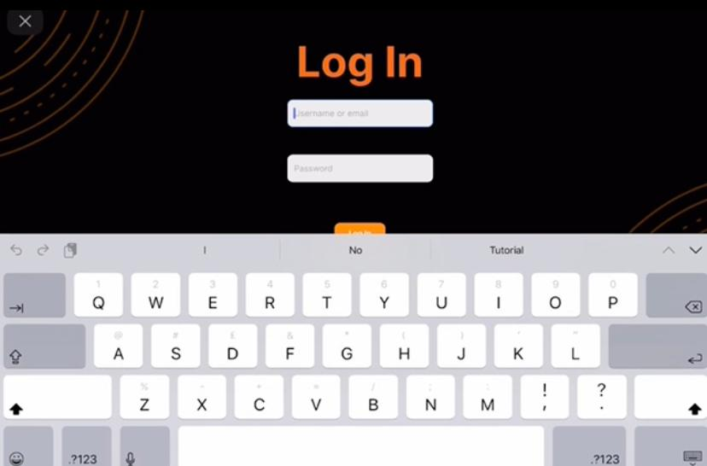

Figure 9: Testing the prototype

Figure 9 shows the prototype being tested to a user. This image was retrieved from Mr Akif Haiqal, who came forward as our group’s first user. He scanned the QR code from the prototyping website with his iPad and was allowed to see the preview of our group’s prototype functionality. Find out his feedback at the end of our design thinking video.

# **REFLECTION**

## Vincent Boo

In this course, which is data engineering until now, I have found that this is a very important course because it is very useful in our society and quite high in demand. And I understand that interest is very important and it can change a person because if lost interest will of course be lost of motivation. Just imagine if someone asked me to do something that I don’t like, I will not do it properly and sincerely. Furthermore, from the first day until now, I realize that I need to improve more in my responsiveness on group messages and team working, soft skill，leadership，initiative and speaking capability in order to graduate as a skillful student. In this case，I can easily blend into a new environment and workout with the environment with useful practical skills. These skills are also very important when it comes to doing our own business as we need socializing, productive and sincere to clients in order to become successful.

## Madihah

My goal regarding this course is I want to polish my soft skills as much as I can so that I can be a good employee and give benefits to other people around me. I am really thankful to my lecturer because she made me realize and always remind my friends and I that soft skills are really important in this course which really demands right now and needs a lot of practical skills. This design thinking had much impact on my goal as it taught me to communicate with my friends even though we never met before, be brave when making presentations, how to apply problem-solving skills, empathize and understand others' needs. All this time, I tried to give full commitment to this group and my dream is to be an expert in soft skills as it is the most important and necessary thing for me to improve my potential in the industry. Thus, I should improve myself to be a critical thinker and overcome my shyness.

## Ong Han Wah

Data might have become the most important thing in the era of modern technology. After pursuing the Data Engineering program, I hope that I will be able to analyse and extract information from the data efficiently. Through this design thinking, I have learnt that teamwork is crucial in completing a project in a group. As we cannot meet face to face with the group members and gather as usual, we also have to be adaptive and use alternatives to overcome the problem. After this assignment, I found that I have to possess strong communication skills, critical thinking and creative mind in order to deliver a good idea and be competent in the industry.

## Qaisara

After going through a few weeks in this course, all I can say is that I look forward to retrieving an excellent grade written in my academic transcript. This course is undeniably interesting and it definitely widens my knowledge in various fields. Design Thinking on the other hand has helped me understand the fundamentals of problem solving methods. I realize that I have to equip myself with plenty of skills so that I am prepared to meet the industry’s expectations. I have to polish on my communication and critical thinking skills at the very least to make myself competent for the future fueled with rivalry.

## Rishma Fathima

The dream regarding my course, which is data engineering, is to learn everything about current technology, data, programming and also everything about industries. In order with my design thinking assignment it is a step for me to fulfill my dream because in this assignment I gain a lot of knowledge in order to create and prototype a software. Moreover, I gain a lot of knowledge and experience throughout this assignment. Hence, I would like to improve my soft skill by gaining more confidence while speaking up and to take a brave action in a difficult situation in order to improve my potential in the industry.

# 

# **CONCLUSION**

In conclusion, we gained a lot of knowledge and experience throughout this assignment. Even though we could not meet our lecturers and group mates, virtual meetings and social media really helped us to finish up this assignment. Our sincere thanks to our lecturer for helping us and guiding us in finishing up the assignment. Without our lecturer we could not finish up this assignment. Because of this covid-19 pandemic, we found that all people tend to communicate through online platforms. As clients are always the first priority, their feelings are very important and it's our responsibility to take action to improvise our service. This app also gives other benefits too as chat can give a chance for project team mates to communicate on the same . Thus, it will reduce distractions and keep their concentration at the highest level. That’s why we hope that this app could contribute a lot of help to system developers and their clients. At the end of this assignment, we got to know deeper about System Analysis and Design and felt very happy to implement all of the knowledge in this assignment.

# 

# 

# **REFERENCE**

Baskerville, R., 1993. Information systems security design methods: implications for information systems development. *ACM Computing Surveys (CSUR)*, *25*(4), pp.375-414.

Gallo, C. (2020). *4 Design Thinking Principles To Craft A Great Story*. [online] Forbes. Available at: https://www.forbes.com/sites/carminegallo/2020/11/19/4-design-thinking-principles-to-craft-a-great-story/?sh=36e7496774c6 [Accessed 26 Nov. 2020].

Dam, R., & Siang, T. (2017). Stage 2 in the Design Thinking Process: Define the problem and interpret the results. *Interaction Design Foundation*.

Higgins, M. (2020). *Council Post: The Benefits Of Incorporating Design Thinking Into Business*. [online] Forbes. Available at: https://www.forbes.com/sites/forbestechcouncil/2020/11/05/the-benefits-of-incorporating-design-thinking-into-business/?sh=2b86a6bf55a8 [Accessed 26 Nov. 2020].

Kendall, K.E. and Kendall, J.E. (2019). *Systems analysis and design*. Hoboken, New Jersey: Pearson.

Plattner, H. (2016). *Design thinking research : making design thinking foundational*. Cham ; Heidelberg: Springer.

Razzouk, R. and Shute, V., (2012), *What Is Design Thinking and Why Is It Important? Review of Educational Research,* 82(3), pp.330–348‌

# ‌**TASK OF EACH MEMBER**

We have divided our group with a specific task at first but then we have changed our mind to do it together as this is a group work assignment and not an individual task. Besides, we can help each other in completing our assignment. We thought that we can get better results by being cooperative in this assignment and helping each other.

|  |  |
| --- | --- |
| Group Members | Task |
| QAISARA BINTI ROHZAN | Video Editor |
| MADIHAH BINTI CHE ZABRI | Presentation organizer |
| RISHMA FATHIMA BINTI BASHER | Report and data organizer |
| ONG HAN WAH | Prototype Designer |
| VINCENT BOO EE KHAI | Video editor |

This is the link to our Youtube video for this project:

<https://youtu.be/WC6PyoGUtIg>

This is the link to out Youtube video for Chapter 12 presentation:

<https://youtu.be/nV9VkloIQaQ>

|  |  |
| --- | --- |
|  |  |
|  |  |
|  |  |