

Lab Exercise 5
Name: BRENDAN DYLAN GAMPA ANAK JOSEPH DUSIT@DUSIT
Matric No: A20EC0021
Section: 08

QUESTION 1
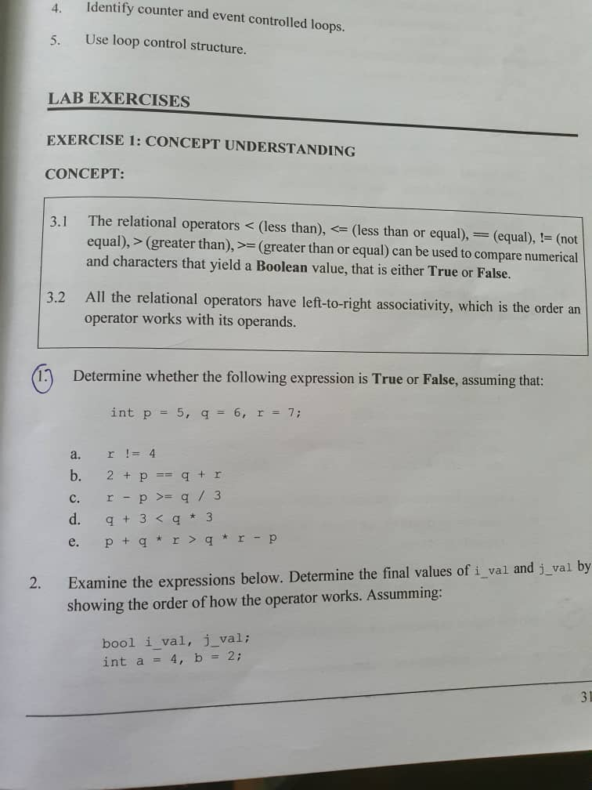
- TRUE
- FALSE
- TRUE
- TRUE
- TRUE

QUESTION 2
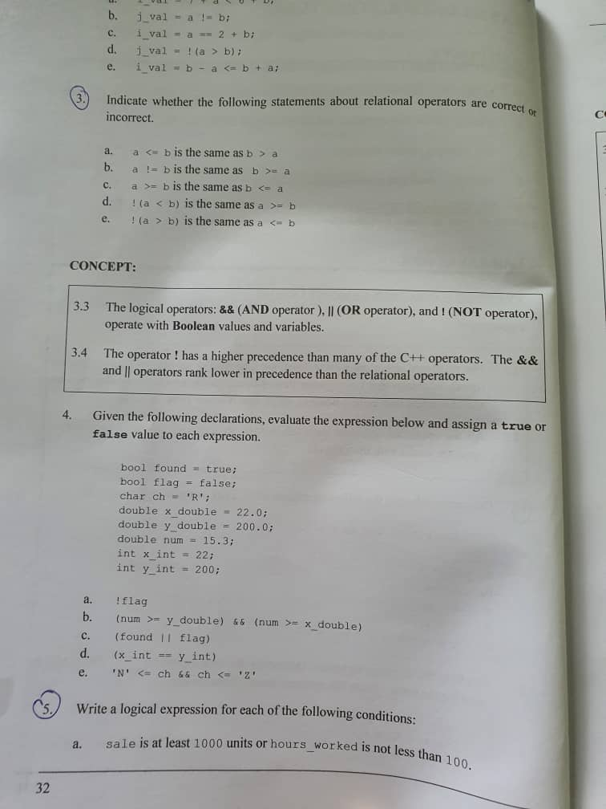

- INCORRECT
- INCORRECT
- CORRECT
- CORRECT
- CORRECT

QUESTION 3

$$sale >= 1000 || hours_worked >=100$$

QUESTION 4 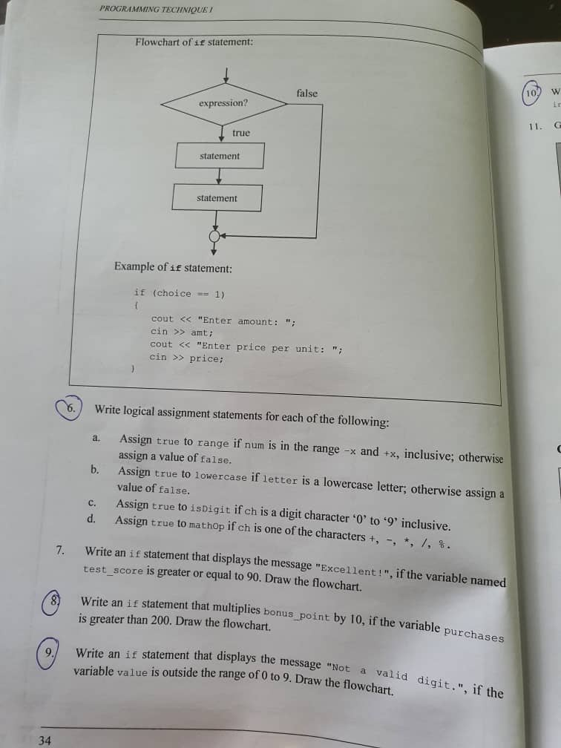

a.) int num;
bool range;
range = (num > -x && num < +x) ? true : false;

b.) char letter;
bool lowercase;
lowercase = ( letter == a) ? true : false;

c.) num ch;
bool isDigit;
isDigit = (ch >= 0 || ch <= 9) ? true : false;

d.) char ch;
bool mathOp;
mathOp = (ch == ‘+’ || ch == ‘-‘ || ch == ‘*’ || ch == ‘/’ || ch == ‘%’) ? true : false;

