 |  | Alumni Sharing Session | August 20XX  Issue #12
 |  | Inspiring Work Experience & Covid19 Pandemic Challenge
INSIDE  __  Engage in programs during covid-19  Be active in a lot of online activities and programs to enhance and develop skills and also to earn credit in cocurricular activities..  __  Tips to learn during Covid-19  Enhance programming skills, Learning new technical skills, learning soft skills  __ |  | 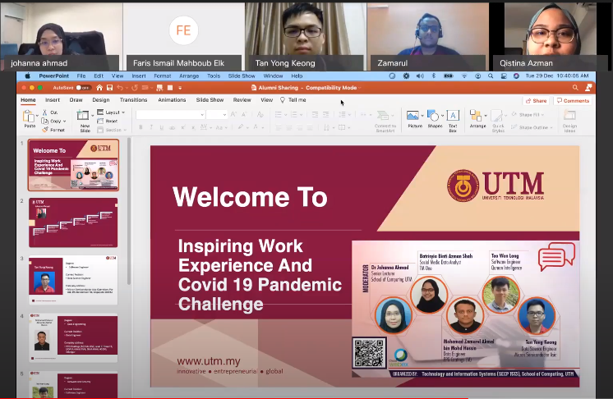  Work Experience during Covid-19  ‒ By Hafiz Surya Nugraha  The Alumni Sharing Session was a talk given by four of our UTM alumni that has successfully secured a career even under the global pandemic situation, COVID-19. The sharing session took place on 29th December 2020, Tuesday at 10:00 a.m. until 11:00 a.m via an online web conferencing, Cisco Webex. It was organized by UTM, Technology and Information System, School of Computing and moderated by Dr. Johanna Ahmad, a Senior Lecturer in School of Computing, UTM.  The sharing session is valuable knowledge for undergraduate students, as they can have a glimpse of insight of what the future might be after they graduate and obtain their degree. The main purpose of the talk is the sharing of ways that can help the chances to get a job and the work experience during a pandemic by the four alumni to the undergraduate students.

The Review
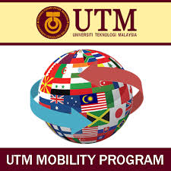  Tips to learn during Covid-19  ‒ By Natasya Nadhira Binti Ahmad Nazrain  There are 2 tips to learn during covid-19, which are to learn new technical skills and soft skills by learning through online. Programming skills can be enhanced by understanding the fundamental concept of programming, so it will be easier to master new languages. Additionally, by creating a program that can help others with real life problems and doing sample programming exercises from LeetCode can definitely improve our skills.  Learning new technical skills is important because it can boost our chances to get hired when the interviewer requires technical coding skills. We can gain new technical skills by doing freelancing, internship, entering competitions, taking online classes and joining training programs. Some online classes recommended by Mr. Zamarul is e-learning, CodeCamp and edX, which is a free online course provider, but needs to pay for the certificate.  Soft skills are skills that are developed naturally by speaking and involving team working. A good work management is adapted in our job to finish a project that was given by the company. Working environment need to give and share ideas confidently to collaborate a project. By being active in university, we can gain confidence as well as valuable experience and improving soft skills. Another way to improve our soft skill is by joining Toastmasters speaking skills.  Our Reflection  The Alumni Sharing Session is overall a very useful and valuable talk that will be useful after we graduated from university. The talk has a few strengths and weaknesses. The strength of the talk is the information shared by the four speakers is very insightful for us to prepare for a work life environment in the near future. Since the talk is recorded, we have the flexibility to rewatch the talk at any convenient time. From this session, we learn that 2 of the most sought out skills are technical skills and soft skills. Furthermore, being active in competition can definitely help our resume, skills and experience. |  | Join programs outside/organized by UTM during Covid-19  ‒By Amirul Shafiq Bin Amirrullah  Attending programs are great for adding something into resume qualifications and credits for co curricular activities. Programs can also provide us experience, a new way of how to train better, whether one is winning or not, does not really matter. It can also adapt to new environments as well as learn from the mistakes of the past.  During the covid-19 situation in our country, most of the events and programs are held online to respect the standard procedure prepared by the government. In this way, students can participate in the programs online by only a single click into the competition. Just fill in the form online and students are already registered into it.  In competition, it can also increase and develop new skills and also to enhance communication skills. In other ways, one can also learn from the winners of how they do that they won the competition. In this way, maybe one can learn something new and that maybe takes effect into the future. More or less, attending competitions and programs is a must do for students so that they can learn something new and also for the fun of it.

