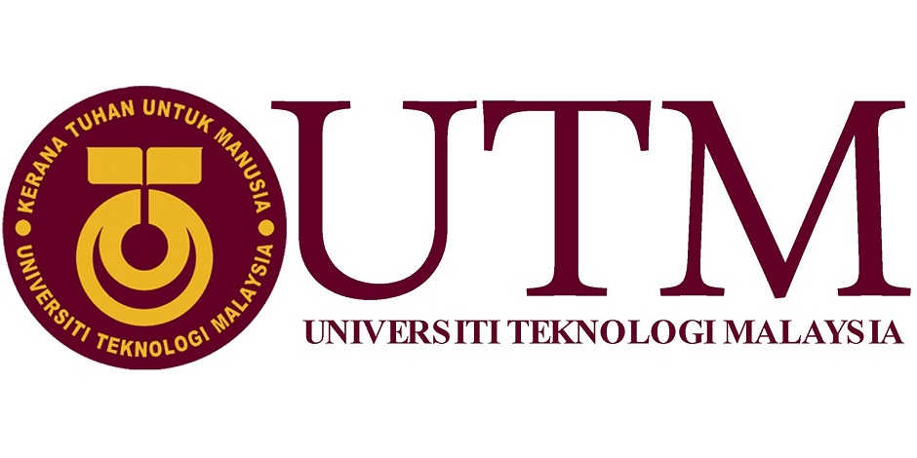

**1 SCSR, FACULTY OF COMPUTING**

**UNIVERSITI TEKNOLOGI MALAYSIA, 81310 UTM JOHOR BAHRU, JOHOR MALAYSIA.**

**Semester I 2018/2019**

**IOT OPEN DAY FKE 2018**

NAME : MUHAMMAD FAKHRUL HADI BIN NORAINI

MUHAMMAD SHUKRI BIN WAGIMAN

FAREL RIVALDO

AIN AFIQAH BINTI AGUS SALIM

SUBJECT : Technology and Information Systems (SCSP1513)

SECTION : 07 – Dr. Hairudin A. Majid

TASK : Industrial Visit 3 – IOT

DUE : 23th November 2018

Contents

**IOT OPEN DAY 2018** 2

**Aim of the report** 3

**Introduction** 3

**Details of Journey** 4

**Predictive Maintenance Gets an Extreme Makeover** 6

**Service that available on HPE and Maxis Berhad** 7

**Achievements of IOT in industry** 8

**Reflection** 9

How does this talk impact your GOALS? 9

What action that necessary to improve your potential in the industry 11

**Summary** 12

**Conclusion** 12

**Gallery** 13

# **IOT OPEN DAY 2018**

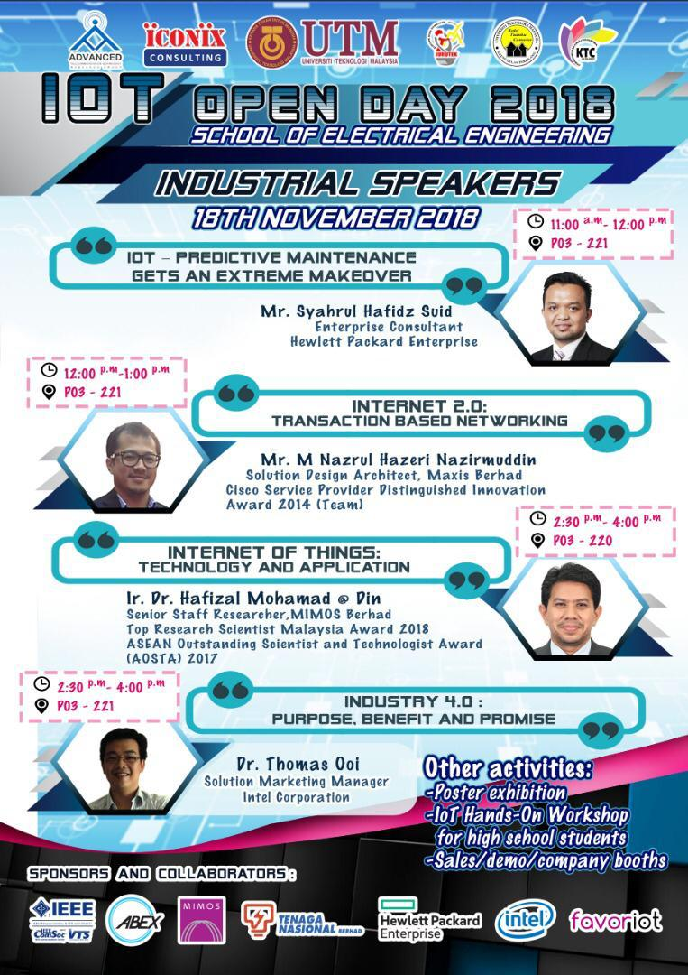

*Figure 1:* ***IOT Open Day 2018***

# **Aim of the report**

The aim of this report is to inform and educate people about the technology of the Internet of Things to the world. In this report, it will describe about the organization, types of services that is offered, the details during the visit and even the impacts of the organization and the trip. Methods of researching for the input that is used in the report includes the information delivered by the speaker, notes taken by during the visit and the usage of the Internet. This report also will tell you something that usually are not well known to the public like a few of services available that can be used for certain types of people.

# **Introduction**

On 18th November 2018, SCSP 1513 – section 07, school of computing was invited to attend the IOT open day from 11.00 am to 4.00 pm and take place at the P03 block at School of electrical engineering. There are a lot of organizers and collaborators of this event which is Iconix Consulting, KTC committee, Jurutek FKE UTM, and for the collaborators which is IEEE, ABEX, MIMOS, Tenaga Nasional, Hewlett Packard Enterprise, Intel, and favoriot. The industrial speakers for the day are Mr. Syahrul Hafidz Suid, Enterprise Consultant for Hewlett Packard Enterprise, Mr. M Nazrul Hazeri Nazirmuddin, Solution Design Architecht, Maxis Berhad, Ir, Dr, Hafizal Mohamad @ Din, Senior Staff Researcher.MIMOS Berhad, and Dr Thomas Ooi, Solution Marketing Manager Intel Corporation. Other than the industrial talk, there are also interesting activities such as poster exhibition, IOT hands – on workshop for high school students and demo company booth.

# **Details of Journey**

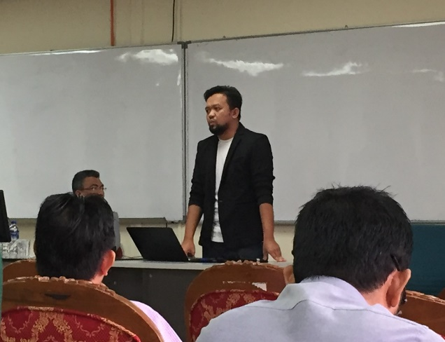 On 11 am at 18th November 2018, students from 1SCSR, School of Computing were attended to the second Industrial visit that held on Faculty of Electric, UTM. The first event for the industrial visit is we must go to the P03 -221 Seminar Hall and listen to the talk. The speaker of the talk is Mr. Shahrul Hafidz Suid. The talk is mainly about the Predictive Maintenance Gets an Extreme Makeover in this world.

*Figure 2 : Mr Shahrul*

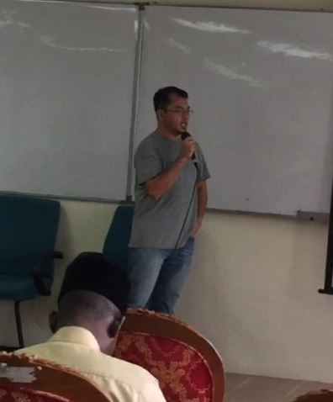

After the talk has end which is at 12 pm, all students can stay and hear another talk from Mr. M Nazrul Hazri about Internet 2.0. It is mainly about the blockchain of Internet.

*Figure 3 : Mr. M Nazrul Hazri*

After the talk ends at 1 pm, we must dismiss from the program because we have a class at 2 pm. Overall, we get a lot of information about an IOT to this world and the new technologies for the future.

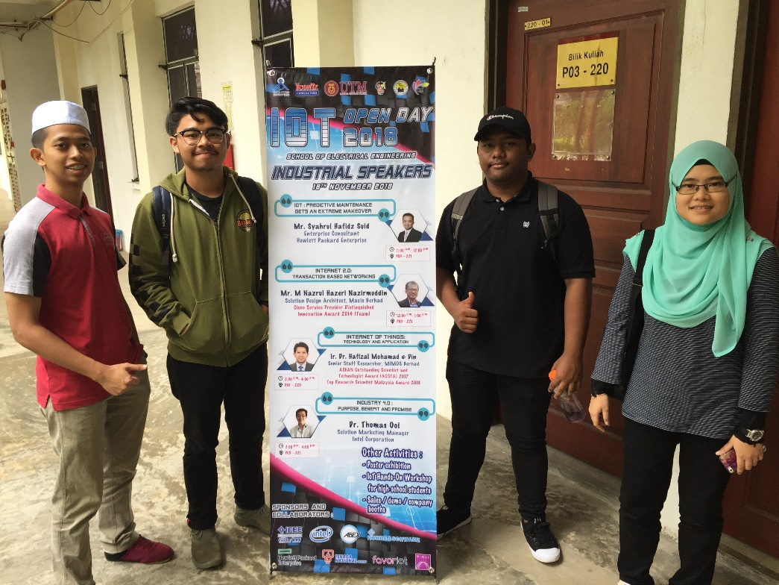

*Figure 4: (From left) Fakhrul, Farel, Syukri, Ain*

# **Predictive Maintenance Gets an Extreme Makeover**

Based on the talk given by Mr. Shahrul Hafidz Suid from Hewlett-Packard Enterprise, entitled “Predictive Maintenance Gets an Extreme Makeover” which is an example of IoT usage in industry. Predictive maintenance has been done since back when the worlds are having Industrial Revolution, but it was only by judging the appearance of the hardware and not by using the data gained from built in sensor in the hardware. When IoT being widely used in industry, new way of predictive maintenance has been created by using the software created and hardware that already built in the machine. By using the data gained from the hardware and using the software to calculate the time left, it is much easier and surely more accurate compare to the old method.

During the talk, Mr. Shahrul show a demo video about implementing Augmented Reality (AR) Technology to predictive maintenance to make it easier for a technician to a machine to check the time left of a certain part from the machine before it need maintenance. The video shows a man holding a tablet that have a rear camera and point the camera toward the demo machine and every data that being collected from the built-in sensor in the machine is being shown in the tablet. The most interesting thing is even the time before each part need maintenance is calculated and shown in the tablet. This could be the easiest way a technician can know when to do maintenance for each part of the machine only by having the software and pointing the camera toward the machine to get the result.

# **Service that available on HPE and Maxis Berhad**

Hewlet Packard Enterprise and Maxis Berhad offers many services to the people. One of the most important service of HPE is HPE Artificial Intelligence Transformation Workshop. The objective of this service is to quickly identify opportunities to maximize your return on data. This data dilemma is making artificial intelligence (AI), enormous information, and progressed examination the heart of big business advanced change. Indeed, these are the main three activities detailed by business leaders. Be that as it may, most associations don't accept they're set up for the following wave of advanced change, with 60% revealing they have no formal system in place. At HPE, they comprehend that AI, information, and investigation activities are on a continuum that is driven by business needs and objectives. Every association has an exciting way toward building an information establishment, creating progressed investigation arrangements, and trying different things with AI for select utilize cases.

Next, Maxis Berhad also make a blockchain enterprise – grade. A blockchain is a peer-to-peer distributed by ledger forged by consensus, combined with a system for ‘smart contracts’ and other assistive technologies. The objective of this service is to help you plan, design, and implement blockchain solutions and speed adoption while maintaining operational excellence. It's anything but painful to consider blockchain technology with regards to cryptocurrency. In any case, at its most fundamental dimension, blockchain is a dispersed, imparted database to time stepping, assembled on a decentralized model, and energized by an exceptional arrangement of financial aspects. There are 3 levels of blockchain which is:

* Blockchain 1.0: People transacting with people
* Blockchain 2.0: Enterprises transacting with enterprises
* Blockchain 3.0: Things transacting with everything

# **Achievements of IOT in industry**

One of many achievements by implementing IOT in the industry is the creation of the autonomous car. Autonomous car or self-driving car is created by merging many systems that already existed to create a new system to guide the car to the destination set by the user. A few examples are the system that being used to control the traffic lights and navigation system being merged to decide the fastest route to the destination. Other than that, the system that being used in motion sensor at the side of the car and the system to position the car being used together to make sure no collision with other car happens. This system is being widely used in Tesla which is an automotive company that create and sell car that has the Tesla Autopilot or Enhanced Autopilot. It is a feature that has self-lane centering and enable to change lane by itself with confirmation by the driver. This mean that the driver could experience how the system being used to drive the car.

# **Reflection**

# How does this talk impact your GOALS?

IOT according to Mr. Syahrul Hafidz will lead to better job prospects and more opportunities for students studying in the computer science field. While many job roles may become obsolete, this does not necessarily mean that there will be 800 million of us out of work. Although retraining may be required for a lot of people, new technology means new opportunities, and therefore, new jobs. The speaker also gave a thought about the development of the internet in the present era. there are many influences in this discussion, starting from a variety of predictions of employment opportunities for workers related to the internet and apply to IT operations.

Not only will the development of IOT be faster and better exponentially, but also the career choices regarding the topic of IOT, as the industry evolves. Ultimately, the point of automation is not to destroy the global economy, but to enhance it, as with all economic revolutions, this means a lot of change along the way.

The first thing to recognize about the shift to the internet of thinking is that our physical world is transforming into a range of increasingly intelligent environments. We can start thinking about what we will create in the future such as making something that is actually still impossible to do first but does not rule out the possibility that it can be created now.

It has a lot of similar thing with the industrial and computer/communication revolutions in previous years, IOT designed to increase productivity. Through connected technology and increased data, automated technology will be far more efficient, meaning less waste (both in terms of materials and workers’ time) and better results.

Better automation of previously human-intensive work means that, in theory, more individuals are freed up to invest time elsewhere, creating better productivity and therefore further opportunities.

IoT will potentially lead to huge developments across numerous industries, affecting many job roles. If this economic revolution follows in the footsteps of previous periods of change, however, then instead of being a cause for concern, the IOT could affect job prospects in a very beneficial way for those willing to adapt and embrace new opportunities.

# What action that necessary to improve your potential in the industry

After participating in the IoT open day and listened to the talk that was given by the speaker, I could say that we as the future engineers and IT specialist have to improve our soft skills including communication skills, leadership skills, scholarship skills and even our thinking skills. According to the speaker, the employers are searching for staffs that have attitudes more than the knowledge that they have. This is because it is hard to find staffs that have the ability to think outside of the box in order to solve complex problems and have good communication skills compared to applicants that aced in theoretical concept but do not have the ability to think critically and they were not able to work with other people due to the lack of soft skills. However, it is more preferred if the students can balance between the two aspect that is knowledge and soft skills. This not only will help them to communicate with people from other level, but also, they could increase their knowledge from their experience. Therefore, it is crucial for the students to build and polish their own soft skills that they can use to help them in earning jobs in the industry.

# **Summary**

To sum up the activities that have been done in the IOT open day, it has created awareness to the students about the development of technology in Malaysia and in the whole world. There was many information delivered by the speakers about what is IOT is about, what are the innovation that they are searching to keep developing the technology in industry and many more. The speakers also give useful information for the students to prepared themselves when entering the work industry especially things that relates with their skills and what is industry 4.0 is about. Next, the exhibition that being put up have given the idea in creating device that could help in daily life such as monitoring of construction cost, real-time secure asset online tracking system, smart vehicles monitoring and analysis system, smart home energy monitoring system and many more. The displays of robotic prototype explain how we can create robot that have the required function to fulfill our need and why is it necessary to have robotics application in completing tasks that out of human ability. Overall the program is very interesting to learn and lots of input were gained throughout the event.

# **Conclusion**

We can presume that the industry visits to IOT open day of Universiti Teknologi Malaysia have turned into an eye-opener to the new understudies about the advancement of innovation and data framework utilized in UTM especially. Amid the visit, there were numerous data conveyed by the speaker concerning the enhancement of system in UTM and the framework. Not to overlook, the fast improvement of innovations utilized in IOT office gave numerous motivations to the understudies to buckle down with the goal that they additionally find the opportunity to contribute for the movement of innovation either in UTM or out of UTM.

# **Gallery**

