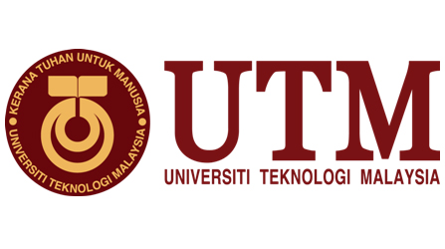

TECHNOLOGY INFORMATION SYSTEM SECTION 03

LECTURER: DR. HASWADI HASSAN

MEMBER:

TAI WEN JUN A19EC0207

MUHAMMAD RAFIY ATHALLA A19EC0267

DESMOND CHEING CHEE HONG A19EC0040

AMIR HAKIM BIN AHMED HAMIR A19EC0018

SHOAIB HOSSAIN A18CS30350

INDUSTRIAL VISIT-CICT REPORT

# 1. Introduction

Industrial visit is a one of the lesson in UTM for the students to understand the working plan and learn the organization in the company that they going to work in so that can prepare themselves both in physical and mental aspect. As a computer science student, we were led to CICT UTM as our industrial visit on 21st October 2019 by our lecturer Dr. Haswadi Hassan.

CICT UTM, Center for Information &Communication Technology is a center that offer and deliver ICT services to UTM students and staff. Their vision is to become digital university driver and their mission is strengthening academia-centric service delivery through data driven digital ecosystem. (UTM, CICT UTM, 2019)

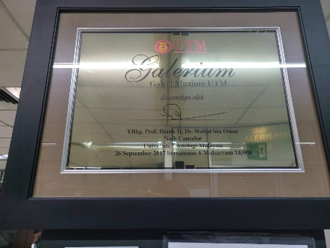

# 2. Details of Journey

My group and I was gathered at BK2 of N28 after the class technology information system at 3.00p.m. We were instructed by our lecturer to arrive at the fore of the Perpustakaan Sultanah Zanariah (PSZ) after the class. As soon as we reached there we were guided to the ground floor of the library to CICT gallery and given detail explanation on the old CPU and storage that was used by CICT UTM.

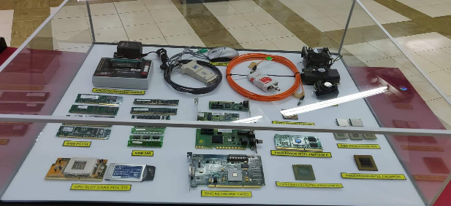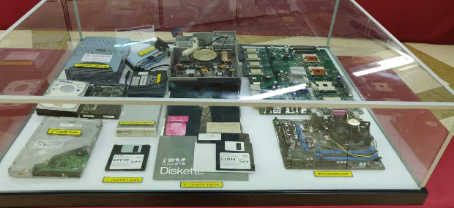

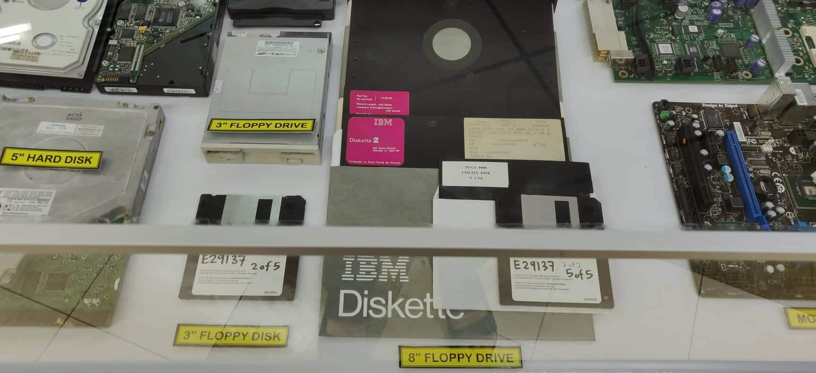

Among the components shown and explain is the floppy disk. It is a form of magnetic storage that sealed in rectangular plastic to protect it from dust particles. It must be used along with the floppy drive that compatible with it size which is can be 3 inches, 5 inches and 8 inches. The storage of the floppy disk is small and always must be used in large quantities so CICT UTM used CD as alternative after then.

# 3. Organization structure

CICT had divided itself into 6 department which is strategic management, application development, infrastructure and operation management, CICT Kuala Lumpur, IT academic fellow CICT JB, corporate management. PROFESSOR MADYA DR. MOHD SHAHIZAN BIN OTHMAN is currently the director of the CICT.

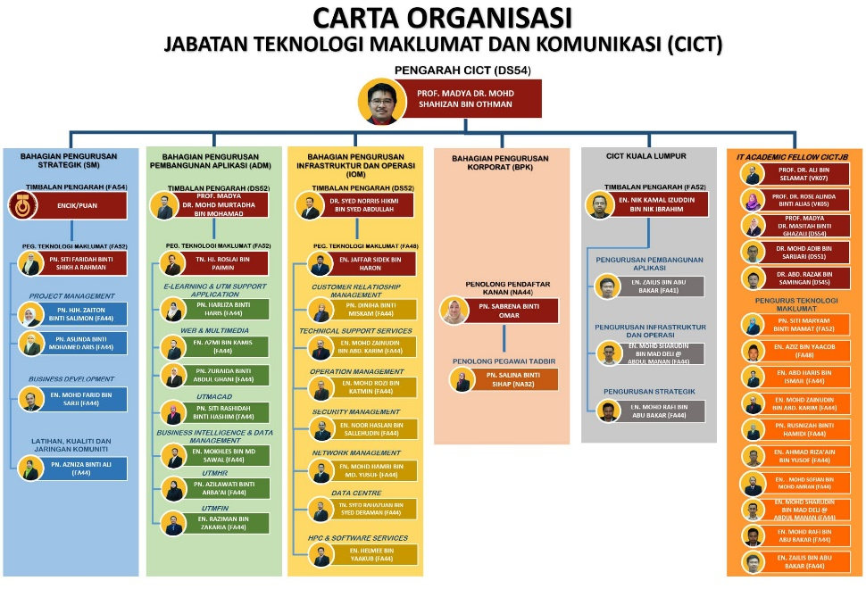

(UTM, CICT UTM, 2019)

# 4. Services

Services CICT UTM has provided services to the campus to support the digital education in the campus including infrastructure and security, internet, software, ICT support, application development and website management.

## Infrastructure and security

CICT UTM had prepare ACID of every utm students and staff to log into the university website and view their profile and manage their submissions for reports and assignments. Every staff have also their official UTM mail account for the students or coworkers to contact. To protect the information of the students and staff, CICT UTM is using Next Generation Firewall that come with lower cost of ownership and also in the complexity. They also implement High Availability concept with active balancing to optimize the functionality and efficiency.

## Internet

Internet is the most significant element in the class in this new era that link with the information with the rest of the world. CICT UTM has understand the important of the internet and prepare high speed and stable internet for the students and staff. CICT UTM has built gigabits backbone network for all the main building in the Kuala Lumpur and Johor Bahru campus. Students are able to experience free 100Mbps dedicated link to their college.

## Software

Due to UTM has encouraged the students to use licensed software, CICT as a service center licensed software was tasked to operate the software in the camput. CICT UTM is also managing the Microsoft website and software for free by Minister of Education to staff and students such as Microsoft office 365.

## ICT support

CICT UTM has provided dedicated team responsible for supporting all aspects of ICT within UTM including business intelligent, data management, ICT training, ICT consultation, Customer Relationship Management(CRM).

## Application development

CICT UTM has created and managed an app called UTMsmart that can be downloaded both in android and IOS that specialized in providing information in campus and attendance. Students can check for the opening hour of every department of UTM in the app and check the activity and news inside the campus. After UTM has find out students cheated with their attendance by helping their friend to sign the attendance, the UTMsmart has become the app that displayed a QR code every lecture for student to scan with their account in the app as attendance.

## Website management

To build a website, CICT UTM has to build the URL, website development, theme, organization and content architecture and implementation. They are using HTML, CSS, Dreamweaver, WordPress as tools to build up the website.

# 5. Achievement

On 22 November 2017, CICT UTM had prepare the best technical document and help UTM to receive the SAGA 2017 award (Standard Accounting System for Government Agencies) from Accountant General's Department of Malaysia. UTM was among the 59 from 416 agency that successfully receive the certificate of SAGA beside USM, UPSI, UMP, UPNM, UNISZA, UTHM and UPM

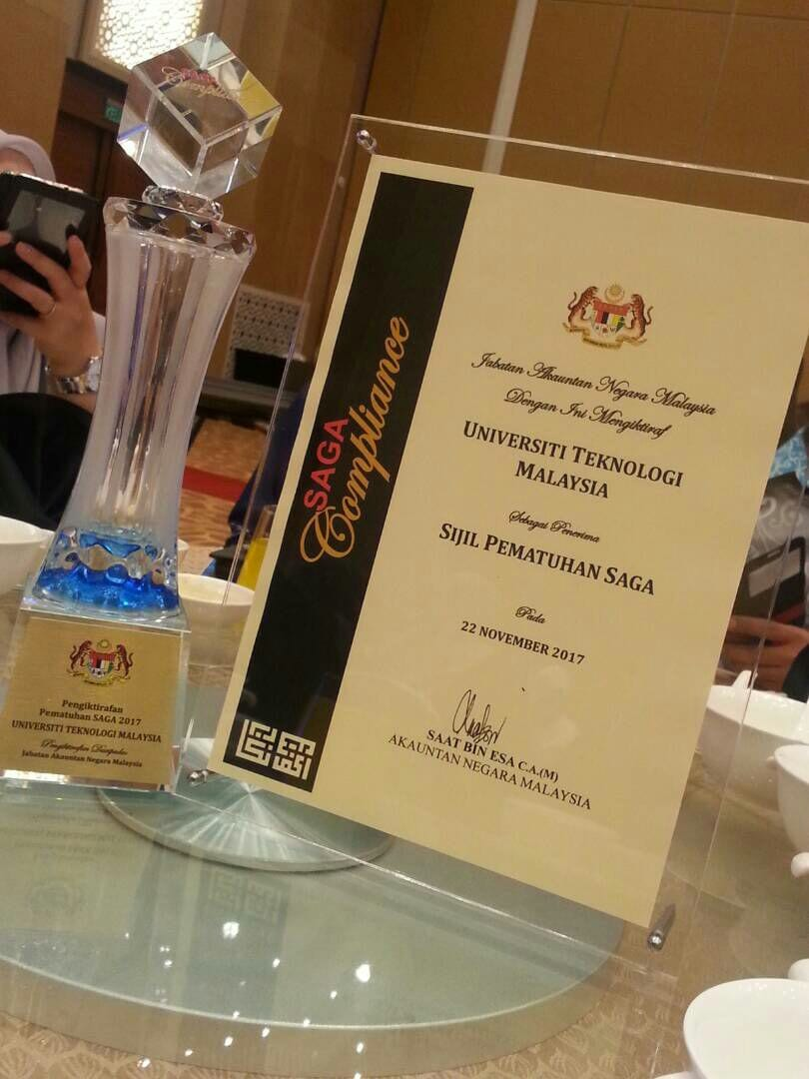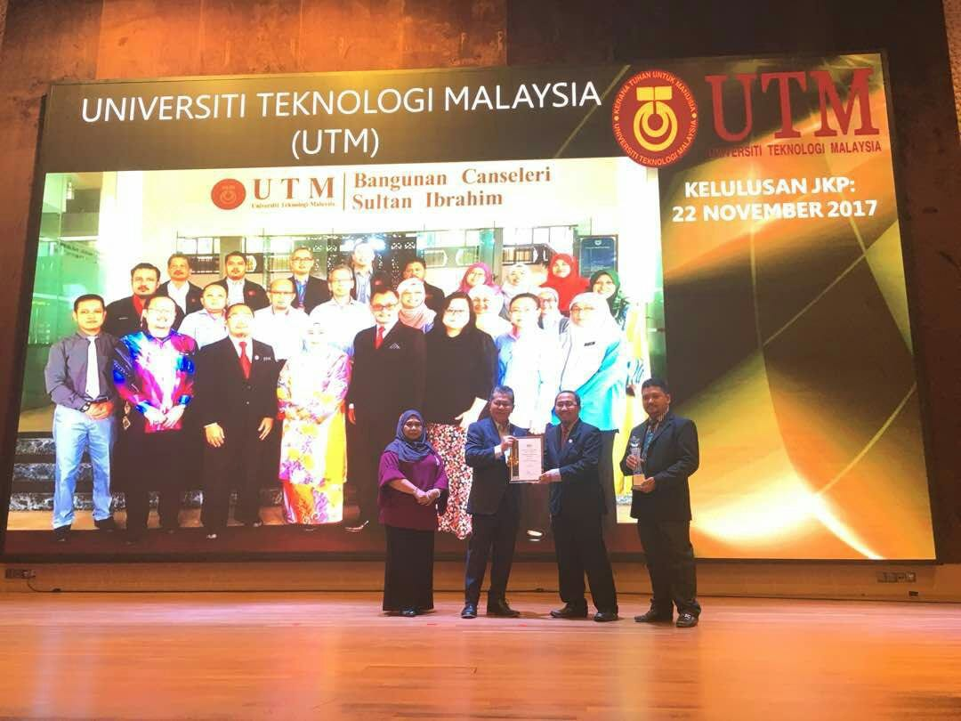

Images from (UTM, 2017)

UTM CICT had also awarded the PTJ most active “Senamrobik Perdana Siri 2/2017” for Zon Arcturus that been held in 7 February 2017 in Stadium Azman Hashim UTM Johor Bahru. UTM CICT was appreciated by the organizer to help them to success the event. According to the list, the attendance of CICT staff is 50 from 123 people which is 40.7% from all the staff.

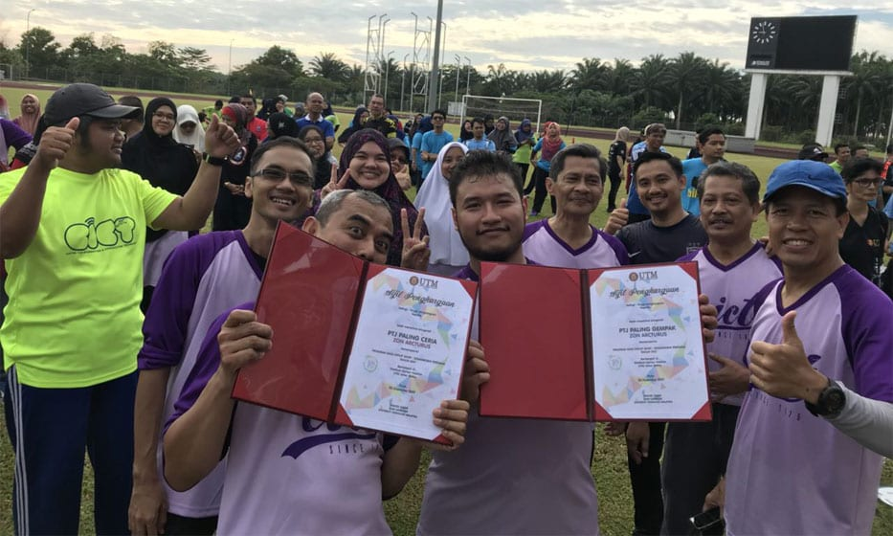

Image from (UTM, 2017)

# 6. Reflection

Our goal regarding this course is understand more deeply or thoroughly about the invention and history of electronic component including the RAM, processor, graphic card and hard disk. Besides, we wish we can understand more about the organization and structure of the IT company that we going to work in.

After this visit, we learn the organization and structure of the CICT UTM which also group as IT company which will help us to imagine our future working environment and help us prepare for it.

To improve our potential in the company, we must visit more related industry or company to prepare ourselves for future working in the IT company and also shape us into the well developed worker from skill and attitude aspect that need by the company.

After this visiting to the CICT, I understand that the hardness of the electronic component to evolution to current high speed and stable CPU

# 7. Task for each member

Tai Wen Jun -Report Writing

Desmond -picture taker

Amir -information gatherer

Rafiy -report checking

Sohaib -information gatherer

# 8. References

UTM, C. (2017). *CICT UTM* . Retrieved from achievement: https://cict.utm.my/ict-knowledge-repository-2/

UTM, C. (2019). *CICT UTM*. Retrieved from organization structure: https://cict.utm.my/organization-structure/

UTM, C. (2019). *CICT UTM*. Retrieved from CICT UTM: https://cict.utm.my/