INTRODUCTION
Obesity among teenagers is one of the major public health issue that need to be given a serious attention by the government and the society. According to a study, overweight children and teenagers have higher possibility to grow into overweight adult and increase the risk of being infected by non-communicable diseases such as diabetes, stroke, and heart attack in their later life. Therefore it is important to find out what causes obesity among Malaysian teenagers, so that we can take appropriate measures to solve this issue. With that in mind, our team decided to do a study about “Morning Routine Among UTM Students” for PSDA project to investigate the students’ morning routine in UTM focussing mainly on breakfast intake and physical exercise. As we all know, the teenagers nowadays are very busy with their hectic daily life either academically or career wise. Therefore, teenagers tend practise unhealthy morning routine. For instance, they tend to skip their breakfast to save time and not be late for work or school. Although there is no strong evidence stating that skipping breakfast can cause obesity but there is a significance between-study heterogeneity been noted. They noticed that the teenagers who take breakfast at least 5 days a week have a healthy physical look compared to those eating breakfast less than 5 days a week. Poor time management not only cause the teenagers to skip their breakfast, alternatively to prefer a more convenient western style breakfast choices such as breads and cereals thus not having a balanced and weighty meal which includes rice, wheat and rice noodles. Besides breakfast, skipping morning exercise is another factor that causes the teenagers nowadays to gain weight. Therefore, we had to identify if the students in UTM practise a healthy morning routine to maintain a healthy body both mentally and physically.

METHODOLOGY
The method we used to collect the primary data to for this study was through online questionnaire. To prepare the online questionnaire, our group choose to use Survey Heart platform rather than Google Form. This is because we want to try something new and much more professional way to conduct the survey. After done preparing the questions on Survey Heart, we send the online questionnaire to several Whatsapp groups to collect the data. The questions that has been asked to the respondents include their choices and behaviour while taking their breakfast and their daily routine in the morning. To make our question more interesting and in-depth, we divide the questions into 4 data types which are interval, nominal, ordinal and ratio. There were about 44 respondents who took part in the survey consisting of 21 males and 23 females who were all UTM students. After collecting information from the students for about 2 weeks, we decided to start analysing the data collected to understand the insights of the data collected. To understand the data collected much better, we make use of 6 different types of graphs to analyse the data collected which are pie chart, bar chart, stem-and-leaf, histogram, dot plot and boxplot by using R studio IDE. The graphs plotted helped us to summarize the data collected and understand the insights of the data regarding the morning routine among UTM students.

RESULT ANALYSIS AND DISCUSSION

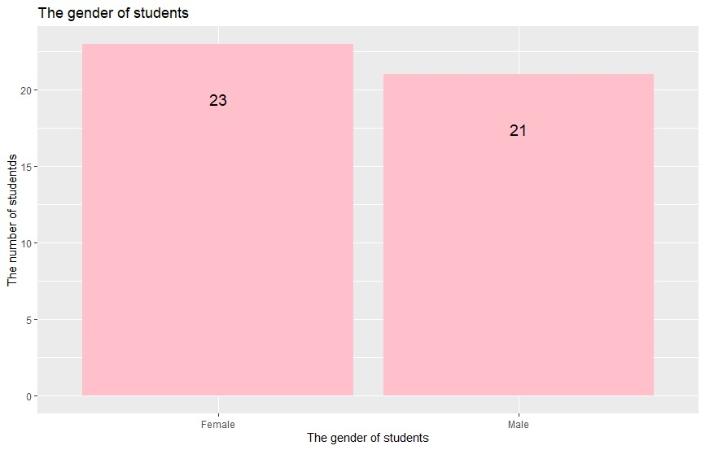

The above bar chart shows the number of the students in UTM that responded our questionnaire. The total number of responds we successfully obtained was 44 students from UTM and all of them are from “School Of Computing”. From the above graph we know that there are 23 (52.27%) female students and 21 (47.72%) male students participate in our survey about the “Morning Routine Among UTM Students”.

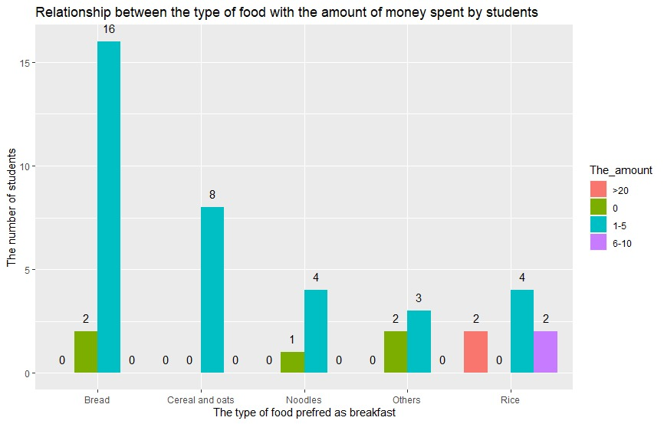

The above bar graph represents the relationship between the different choices of food preferred by students for breakfast and the total money spent for breakfast daily. According to the graph, for most of the respondents, the money spent for breakfast daily is between RM 1 to RM 5 for all the different types of food preferred by them. Among all, bread is the most preferred choice of food with 18 (40.91%) respondents saying that they spend between RM1-5 on breads for their breakfast. Besides, there are 8 (18.18%) of respondents choose cereal and oats as their choice of daily breakfast tend to spend between RM1-5. There are 8 (18.18%) of respondents choose rice which shares the second spot with cereals and oats for the preferred food for breakfast has three different range of money spent for the breakfast which are RM1-5, RM6-10 and greater than RM20. Moreover there are 5 (11.36%) respondents choose noodles and 5 (11.36%) respondents choose others food as their choices of breakfast. Although majority of those who preferred rice spend between RM1-5 for their breakfast, there are also respondents who spend between RM6-10 and also over RM20 for their breakfast expenditure daily and we find that most of the respondents love to choose bread as their choice for breakfast.
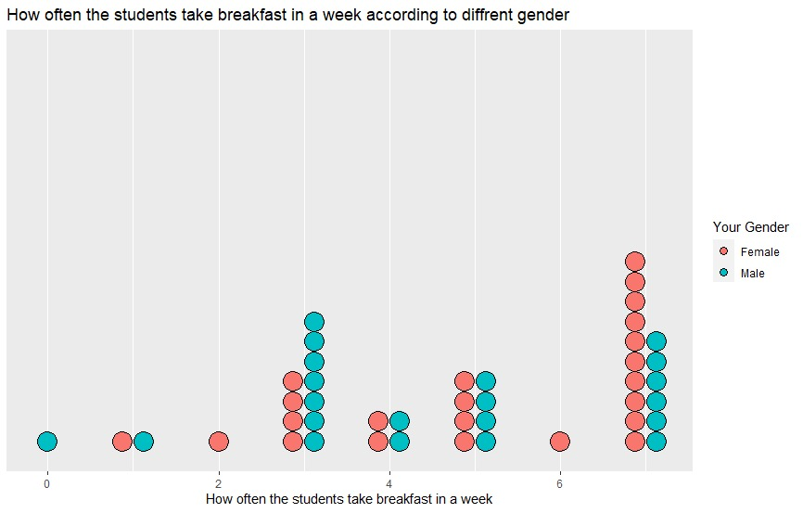
As we all concern, teenagers nowadays tend to skip breakfast as they are rushing to the class and at most times, they rather sacrifice their breakfast just for extra sleeping hour. To determine either UTM students also face such problem as well as to determine if the statement is true we use the dot plot graph to show how often the UTM students take breakfast in a week. From the graph we can see that there are 16 (36.36%) students taking breakfast daily or seven days per week. From the 16 students there are 10 female students and 6 male students. The second highest number of students is 11 (25%) students taking breakfast 3 days per week and there are 7 male students and 4 female students. Follow by 8 (18.18%) students who takes breakfast 5 days per week which include 4 female students and 4 male students. There are 4 (9.09%) students taking breakfast 4 days per week. While there are few students taking breakfast 0 days, 1 days, 2 days and 6 days per week. From the above data collected we can say that most of the students in UTM does not have the habit of skipping breakfast as majority of the students responded take breakfast every day.
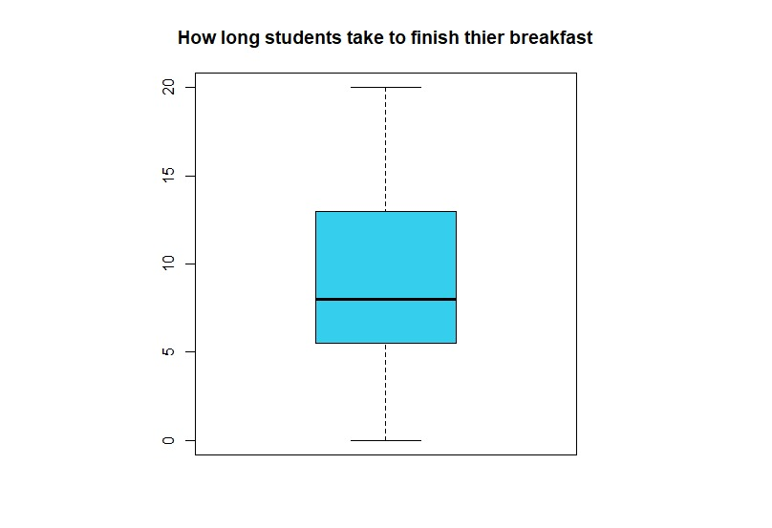
In average, a normal person will spend about 11 to 15 minutes to finish their breakfast. So how long do students in UTM needed to spend to finish their breakfast? This is an interesting question to be find out. The above boxplot graph was used to determine the time taken for the students to finish their breakfast. From the graph the maximum time taken for the students to finish their breakfast is 20 minutes and the minimum time taken is 0 minutes. The first quartile is 5 minutes and the median were 7 minutes followed by 14 minutes as the third quartile. The mean is about 8 to 11 minutes which means on average the students spend 8 to 11 minutes to finish their breakfast. Therefore, we can make a small conclusion that most of the UTM students spend 8 to 11 minutes to finish their breakfast.
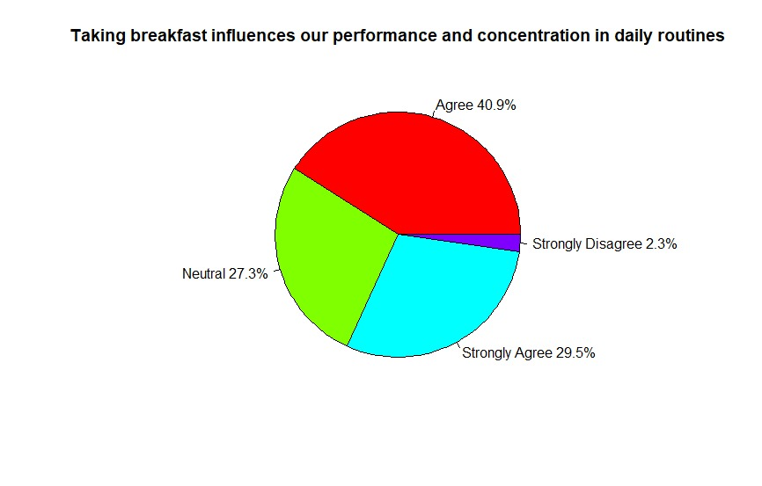

There is a study show that skipping breakfast will influence our performance and concentration in our daily routines. Studies show that the people who take breakfast have higher performance and higher concentration compare to the people that skipping breakfast. Therefore we are curious about what is the opinion of the students in the UTM regarding the above statement. From the above pie chart we can see that there are 40.9% of the students agree and 29.5% of the students strongly agree with the statement state that taking breakfast will influence their performance and concentration in their daily routine. While there are 27.3% of the students are neutral with the above statement. There are only 2.3% of the students strongly disagree with the statement that taking breakfast will influence the performance and the concentration in the daily routine. Therefore we can say that most of the students think breakfast is very important in their daily routine and it will affect their performance and concentration if they skip the breakfast.

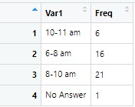
What time does the students in UTM taking breakfast? Are the students in UTM tend to eat breakfast too early or too late in the morning ? It is an interesting question to study about. From the above frequency distribution graph we can see that there are 21 (47.73%) students prefer to take breakfast between 8 to 10 am. This followed by 16 (36.36%) students tend to having breakfast at the time during 6-8 am. While there are only 7 students have the habit of taking breakfast after 10 am. From the above frequency distribution, we can say that 8 to 10 am is the most preferred time period for taking breakfast among the UTM students.

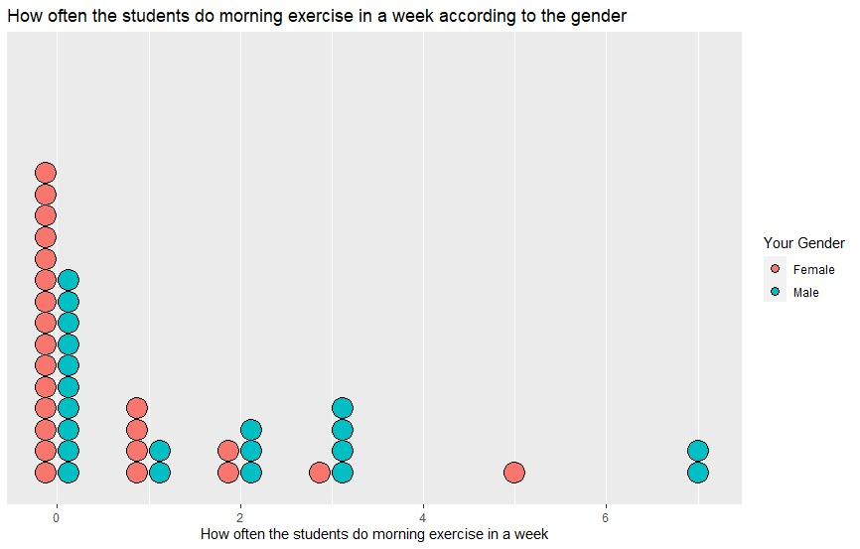

In order to identify how many of the students in UTM prefers to do morning exercises in a week, a dot plot graph was used identify how often does the students in UTM do morning exercises in a week according to their gender. From the above graph we can see that there are 25 (56.82%) students does not do any exercise in a week and most of them are female students which is 15 female students compared to 10 male students. While there are atleast 6 (13.64%) students with 4 female and 2 male students will do exercise atleast once a week. Next, there are 5 (11.36%) students who does morning exercise 3 times per week. There are also 5 (11.36%) students who does morning exercises twice a week with 3 male students and 2 female students. Besides, there are only 3 students will do morning exercise more than 4 days per week. Therefore we can say that most of the students in UTM does not prefer to do morning exercise as most of the class in UTM is at the morning and they rather choose to sleep rather than wake up early to do some exercise.

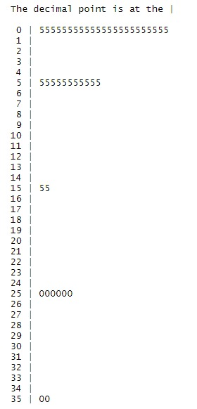
Key 0|5: 0.5minutes
How many minutes does the students in UTM spend on doing morning exercise? To solve our query, we use the stem and leaf graph to represent the data collected. We used the median to create the stem and leaf. Therefore, the time stated in the graph is the median time. The above stem and leaf graph is used to show how many minutes does the students in UTM spend on exercise in the morning. From the graph we can see that there are 22(50%) of the respondents spend 0.5 minutes on do the morning exercise. Which mean most of the students does not do morning exercise. Apart from that, there are 11 (25%) students spend 5.5 minutes on doing morning exercise. Besides there are 6 (13.64%) students spend 25.0 minutes on doing morning exercise which is the second longest time the students spend on doing the exercise in the morning. While there are 2 respondents spend 35 minutes on doing the morning exercise which is the longest time spent on morning exercise. There also have another 2 students spend 15.5 minutes on doing the morning exercise.

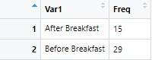

What if students in UTM are compelled to do morning exercise? Do they prefer to do the morning exercise before taking breakfast or after taking breakfast? That’s the other thing we were curious about. To answer the query, we used the frequency distribution table to collect the data and analyse the preference of the students either they prefer to do exercise after taking breakfast or before taking breakfast. From the above data collected we can see that there are 29 (65.91%) students prefer to do morning exercise before taking breakfast compare to 15 (34.09%) students who prefer to do morning exercise after taking the breakfast. Therefore, we can conclude that majority of the students in UTM like to do morning exercise before having breakfast.

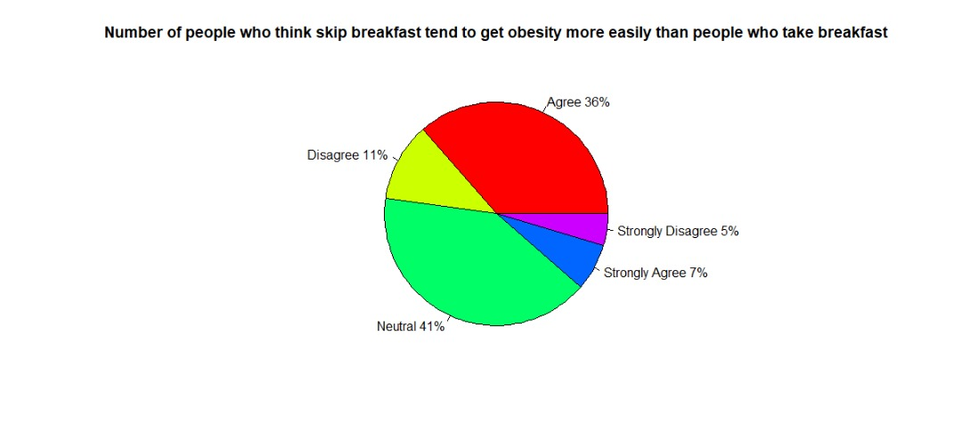
What is the opinion of the students in UTM with the statement that state the people who skip breakfast tend to get obesity more easily than people who take breakfast? Therefore we prepare a pie chart which we used to analyse the level of agreement by the respondents about the statement. From the above pie chart, we can see that there are 41% of the students who responded neutral with the above statement which mean they does not agree that skipping breakfast can cause obesity but they also does not agree that skipping breakfast will cause obesity because they think there are other factors that leads to obesity than skipping breakfast. However, 36% of the students agree with the statement that skipping breakfast will cause obesity and 7% of the students are strongly agreed on that. Besides, there are only less amount of the students which is 11% of the students disagree with the above statement stating that skipping breakfast can cause obesity and 5% of the students are strongly disagreed. Therefore we can conclude that most of the students are agreed that the statement is true.

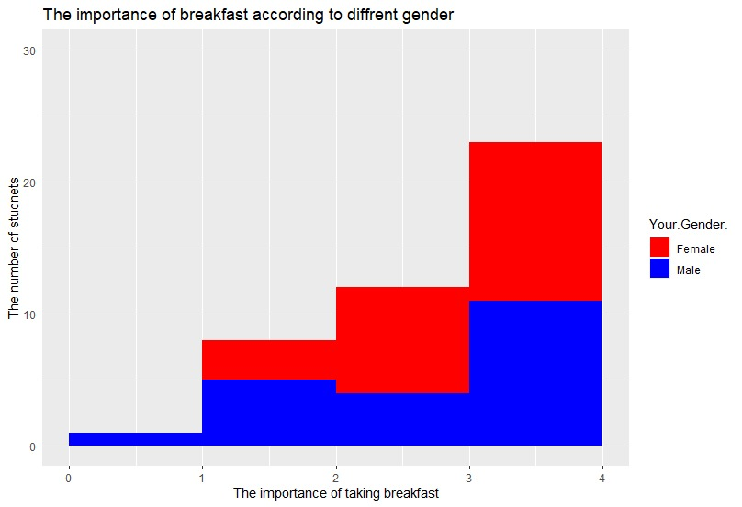
What is the opinion of the students about the importance of breakfast according to different gender? The above histogram shows the data collected from UTM students regarding the importance of breakfast to them represented according to the gender. From the above histogram, there are 23 respondents who think that breakfast is very important and they give a rating of 4 which is the highest rate. From the 23 students who give a rating of 4 there are 12 (52.17%) female students and 11 (47.83%) male students. While there are 12 students which consists of 8 (66.67%) female students and 4 (33.33%) male students gives a rating of 3. Moreover, there are 8 students give a rating of 2 in which 3 (37.5%) female students and 5 (62.5%) male students. There is only 1 male student who give a rating of 1 and there are 0 students who rated 0. Therefore, we can make a small conclusion that most of the students in UTM have a good concern about taking breakfast and the female students have the higher percentage compared to male students.

CONCLUSION

In conclusion we can conclude that majority of the students in UTM spend RM1 to RM5 for their breakfast and most of them prefer eat bread as their most preferred breakfast meal as the students lacks time and they prefer to take bread which is a more convenient and cheaper option. Most of the students in UTM take their breakfast daily and we can say that most of the students in UTM does not have the habit of skipping breakfast. Most of the students agree with the statement taking breakfast will influence their performance and concentration in their daily routine. The students tend to take their breakfast between 8 to 10 am as they think that’s the most suitable time for having breakfast. On average, UTM students spend 8 to 11 minutes to finish their breakfast. Most of the UTM students does not prefer to do morning exercise as majority of them did not do any exercise in the morning. If the students were given order to do morning exercise they tend to do the exercise before taking breakfast and most of them will only spend about 0.5 minutes on the morning exercise. Most of the UTM students agree that breakfast is very important and skipping breakfast will cause obesity.
To solve the problem of students in UTM skipping breakfast, the school authorities should organise awareness campaign and invite nutritionist to give explain about the importance of taking breakfast. School authorities also can organise free meals programme to encourage the students to have breakfast as their first meal in the morning. Students themselves also need to be responsible and have self-discipline by waking up earlier so they have enough time to have their breakfast before their classes.

