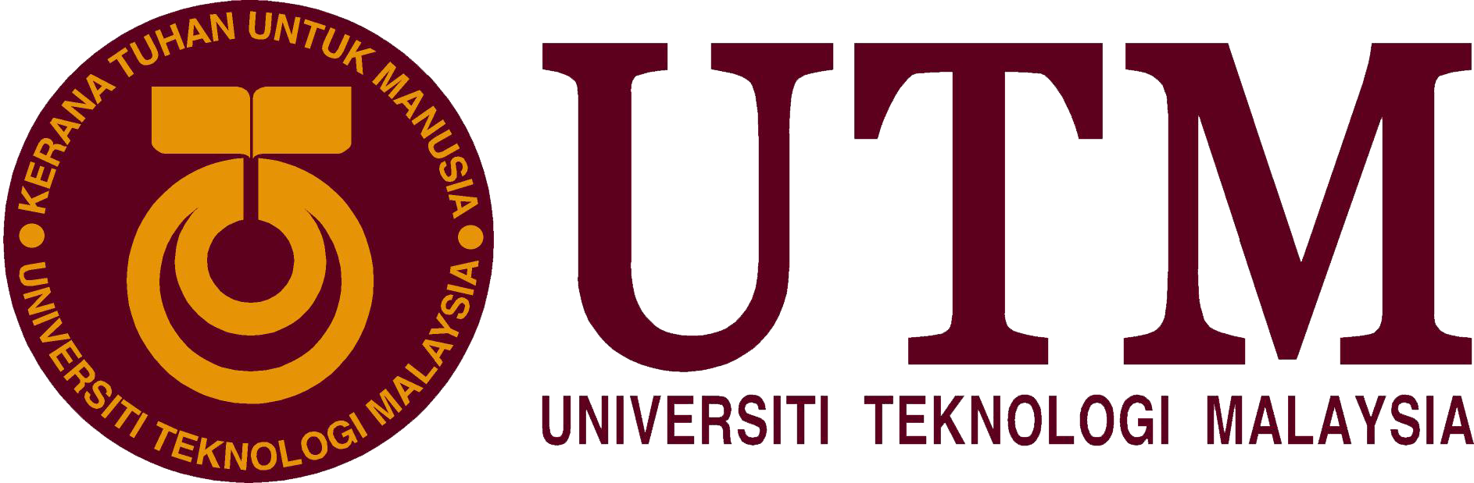

Design Thinking | Privacy, Security and Ethics

Technology and Information System

Manfred John Jason Dass | A19EC5238 |

Muhammad Shafiq Hanif bin Mohamad | A19EC0107 |

Noor Arinie binti Norhalil | A19EC0121 |

Li ZhaoSong | A18CS3069 |

**Introduction**

Privacy and security are both terms commonly used in this modern day and age where technology has become a big part of our daily lives. While both these terms are somewhat related, they are in no way interchangeable as there are some differences between the two. Privacy refers to your rights to control your personal information and how it is used. For instance, when you download a new app for your smart phone, you will usually be asked to read and agree to some privacy policies before you are able to use the app. On the other hand, security relates to how your personal information is kept safe and protected. More often than not, most people’s personal data can be found all throughout cyberspace, in government offices, at health care and insurance providers, at stores and restaurants, and in online accounts. This makes maintaining your privacy and security quite the challenge. Therefore, we feel that a solution must be designed to overcome this growing problem.

**Design Thinking**

The process of design thinking is divided into five main processes, which are: empathize, define, ideate, prototype and test. Our group decided to follow this process in order to have the best chance of creating a good product.

**Empathize**

The first mode, empathize, emphasizes on the human emotion of empathy, or in other words, the ability to understand and share the feelings of others. Empathy is the basis of a human-centered design process, which enables designers to observe, engage and immerse themselves in what their user will experience. This is great way to conceptualize an adequate design for a product, as designers will be able to meet the exact needs of the user. For this step, our group interviewed a member of staff in the Faculty of Computing in UTM, Dr. Ahmad Fadhil (senior lecturer). We wanted his input on the issues surrounding privacy and security in UTM as well as for regular individuals. His insight was very informative and helped us in identifying problems and later, coming up with solutions.

**Interview**

During the interview,Dr. Ahmad Fadhil had told something about the problems he met.Malicious program is what he experienced a lot during his student time.In order to download the free one,but mostly it was the virus one.Therefore,the PC had been corrupted.One of the measures he used was to install original antivirus.It worth it and was a smart investment even through it cost a lot of many.And also,making all the software was genuine and always updated.

UTM website had also been hacked before.However,they did not do any bad things and just put their signatures in the website in order to show or prove that they had the abilities to do so.When using the public account,it more likely lacked security and provided an opportunity for students to hack everything.So UTM WIFI provided security what we always needed to login when using it.One is for monitoring,one person would use about one tera per day or per 3 days.

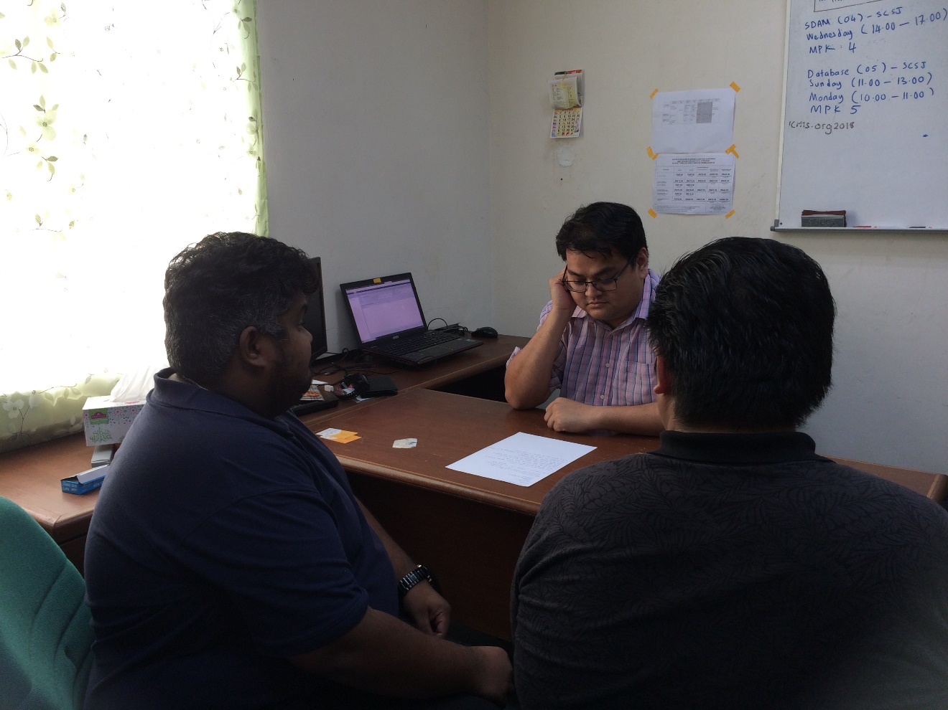

Figure 1.0 Interview with Dr. Ahmad Fadhil

**Define**

The second mode in the process is define. In this mode, we collected and processed all of our findings from the empathize mode. We needed to identify the problems regarding privacy and security which were brought up by Dr. Ahmad Fadhil and then decide on which problems we would tackle in the later phases of design thinking. The two main problems we identified were privacy and security for companies or corporations and privacy and security for individuals. After some deliberation, we decided to focus on privacy and security for individuals as they are far more vulnerable than companies and corporations when it comes to protecting their data. Individuals also less resources at their disposal to ensure that all their data is secured and protected.

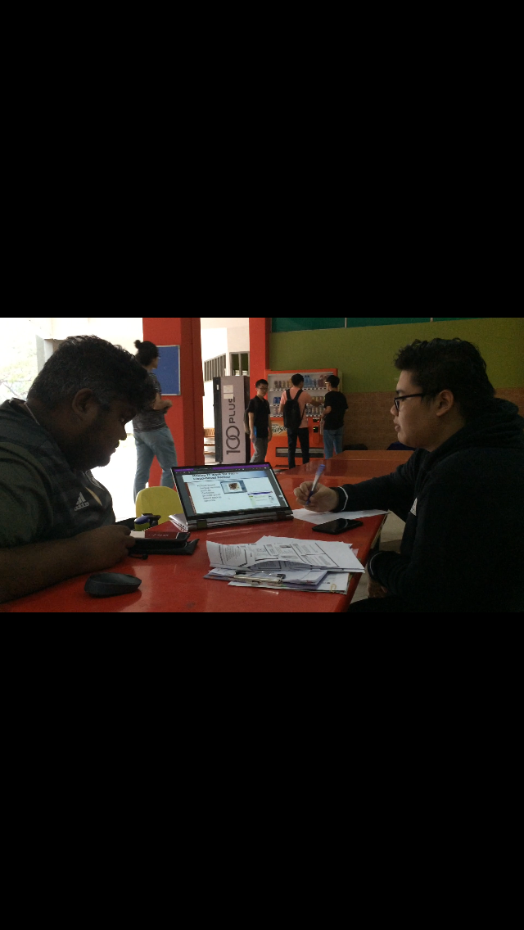

Figure 2.0 Define problem and find solution

**Ideate**

The next mode is ideate. The goal of this mode is to brainstorm and generate ideas which can be possible solutions to a problem. Casting a wide net when you are out fishing is a good analogy for the ideate mode. Here, we are trying to come up with as many and as diverse ideas as possible for our products. This gives us ample opportunity to pick and choose which idea would best suit the problem we have at hand. Our group sat down together and started throwing ideas around, some good ideas and some less good, which is the goal of the ideate mode. At the end of our idea generation session, we had come up with a few good ideas for our product and after some more discussion and deliberation, we decided on which prototypes to make.

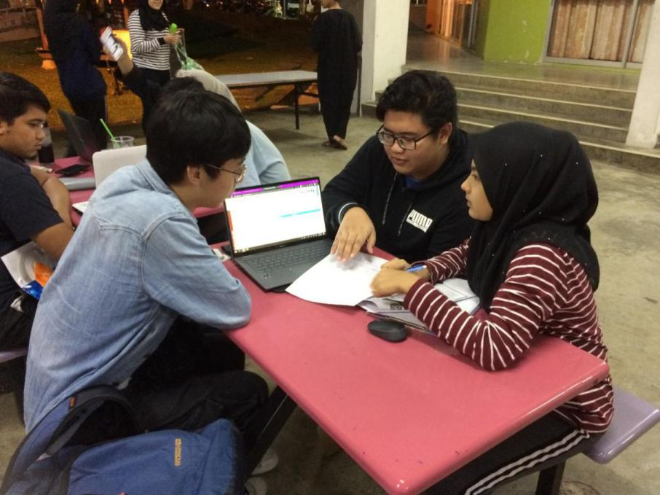

Figure 3.0 Group meeting and making prototype

**Prototype**

The following mode is prototype. This is when the ideas generated in the previous mode is brought into the physical world. Most of our group’s prototypes stayed as just scribbles and sketches on a piece of paper, while one in particular, which showed great promise, was made into a full-on physical prototype that could be interacted with by our team as well as others, when it becomes available for beta testing.

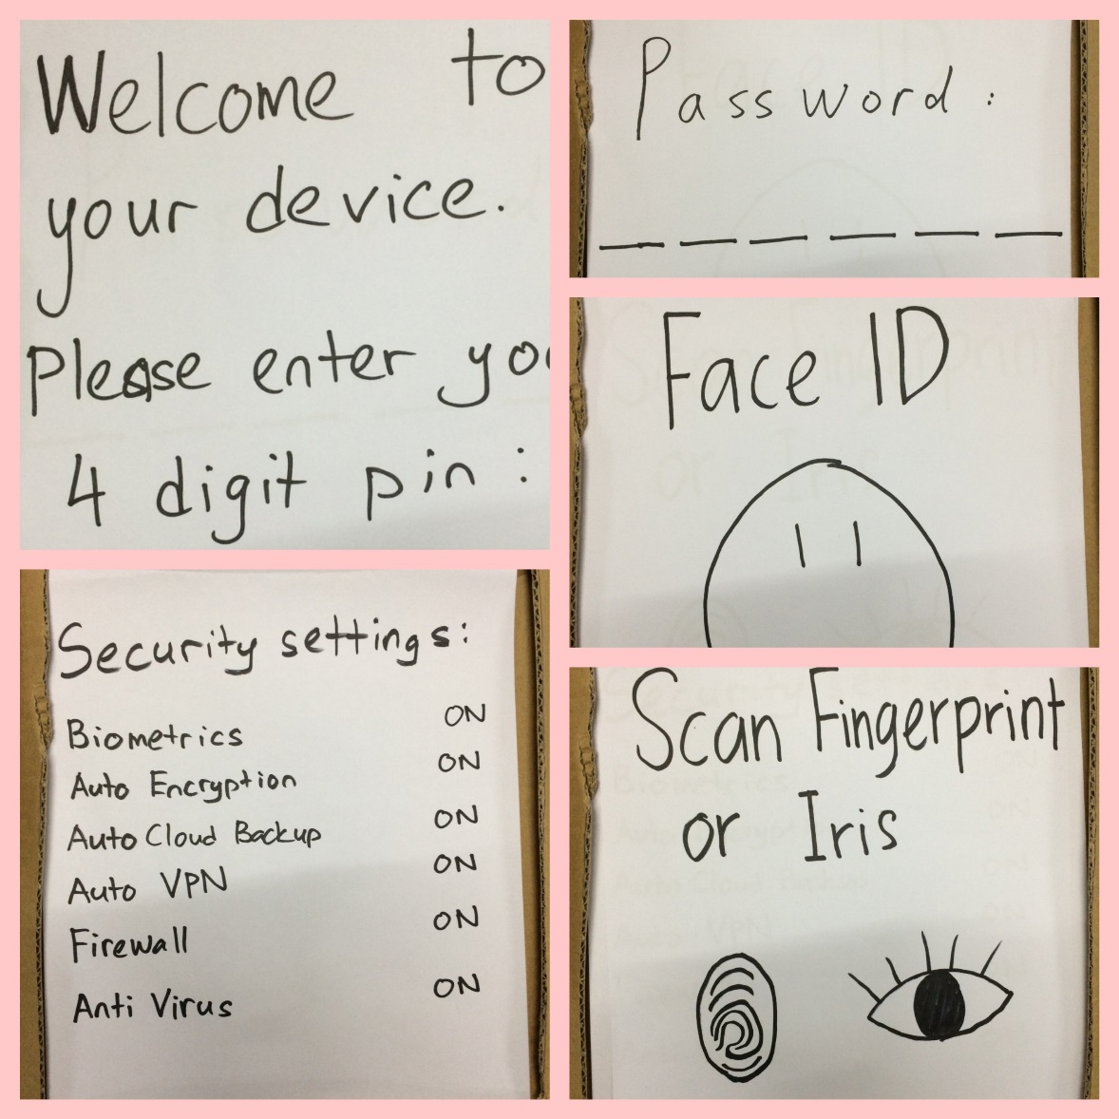

Figure 4.0 Prototype display

**Testing**

The final mode in the design thinking process is testing. This is the penultimate phase in the entire design thinking process where the prototype is tested to find faults and to refine and improve the product before it is commercially available. Testing should be rigorous and thorough so that the final product will be as complete and flawless as possible. After designing and building our prototype, the group tested the product to see if there were any major problems or obvious issues with it. Following the testing, we found that there were no major flaws with out prototype, but it was still very rough and needed to be refined before we made it available to the general public. While the testing process is the main phase where the product is assessed, it is important to note that assessments were carried out throughout the design thinking process, in between respective phases.

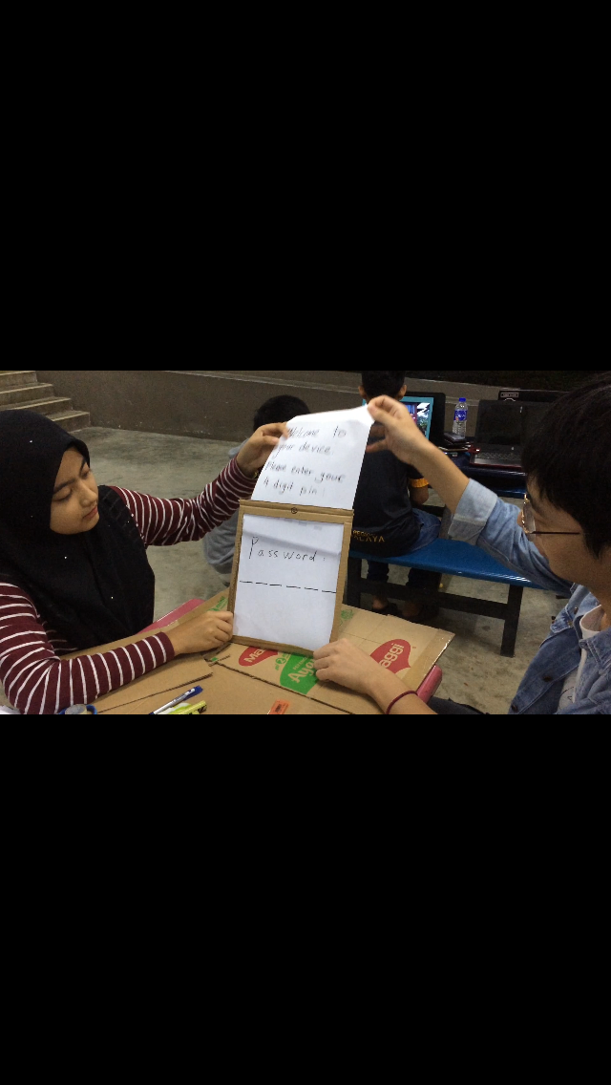

Figure 5.0 Prototype display

**Reflection**

Our goal regarding this program is to become a successful and a capable programmer. Successful is a vague term, but for us it means that we succeed in our studies, work and also in our personal lives. We also aim to have the capability to take on and complete any task that is given to us and, if necessary, adapt to any changes in situation and overcome any challenges that may arise.

Design thinking has given us an insight into the process of developing a particular product. For instance, as computer science degree students, there are some projects in which we are required to develop a particular program or a software. Through the design thinking process, we are able to come up with ideas and solutions for some problems present in our everyday life. This gives us a chance to greatly enhance our creative critical thinking ability, time management skills, communication skills and observation ability. These abilities are essential in becoming a good programmer. It does not change our goal of becoming successful programmers, it merely shows us how we will be able to achieve our goal someday.

There are several ways to improve our potential in the industry. Firstly, it is important to have good communication skills. People with the ability to work on their own and motivate themselves are great, we all need that ability, but we must not forget that, in the industry, we will not be working alone. The workplace will be filled with people from all sorts of different backgrounds and it is crucial that we are able to communicate well with them. Communication is also key to having a healthy working environment. Another imperative skill to have is adaptability, which means that we are able to adapt to any environment or situation. It is needed in a working environment as something like work pressure, stress, higher ups and client demands are something that could affect our working potential and efficiency in the industry. Other than that, we should always strive to learn new things and constantly improve ourselves. The industry does not want people who are stationary, they want people who are continuously moving forward towards the future.

**The task for each member**

Li ZhaoSong (A18CS3069)

•Video editor

•Filming

•Gathering topic related information

Muhammad Syafiq Hanif bin Mohamad Halim (A19EC0107)

•Report making

•Prototype Material gathering

•Design of prototype

Noor Arinie binti Norhalil (A19EC0121)

•Filming

•Design of prototype

•Prototype material gathering

•Note taking and idea listing

Manfred John Jason Dass (A19EC5238)

•Interview

•Design of prototype

•Report making

**Video Link**

<https://www.youtube.com/watch?v=IfcZLDJZI7Y&feature=youtu.be>