**TECHNOLOGY AND INFORMATION SYSTEMS**

**Course Code : SECP1513**

**PROJECT – Low Fidelity Prototype**

**Report Part 1**

**GROUP 6**

**GROUP MEMBERS :**

**MALLEYLENE PENEH (A21EC0052)**

**NASRUL AMIN BIN AB HADI (A21EC0099)**

**HARCHANA A/P ARULAPPAN (A21EC0028)**

**PUTERI NUR ELEEYA SYAFIKA BT MOHD ZABIDI (A21EC0124)**

**INTRODUCTION**

As we can see, Industry Revolution 4.0 or known as IR4.0 has been growing rapidly around the world especially in Malaysia. IR 4.0 Industrial Revolution 4.0 is about physical systems and cyber systems that can connect the digital world with biological systems that affect all areas of industry and economy such as bio printing using digital files to print objects such as organs using cells and biological materials. The key component of IR 4.0 include cloud computing, big data analytic, internet of things, autonomous robots, cyber security and system integration. This IR 4.0 implementation has an impact on operation, customer satisfaction and productivity.

There are various types of IR 4.0 technologies such as Machine Learning, IoT, Big Data Analytics, High Speed Mobile Internet and Artificial Intelligence. Here we highlighted artificial intelligence which is growing rapidly around the world. Artificial intelligence is the ability of a digital computer or computer-controlled robot that performs tasks commonly associated with intelligent beings. There are two ways artificial intelligence works which are symbolic based and another is data based which is called a machine learning. The goal of artificial intelligence is to mimic the human brain and create systems that can function intelligently and independent. Our project is a mobile app that is designed for low vision users using artificial intelligence. The main goal to develop this app is to make the world reachable for low-vision and blind people without relying on friends and family.

**SELECTION ON 4TH IR TECHNOLOGY**

After doing some research and observation, our group decided to choose artificial intelligence on 4th IR technology for our project. The type of artificial intelligence we use in this project is limited memory which uses historical, observational data in combination with pre-programmed information to make predictions and perform complex classification tasks. In our project, this application uses limited memory artificial intelligence to observe surrounding area and direction, helping them “read obstacles“ and adjust as needed such as using past observation to make a prediction like crossing the road. However, the memories are not permanently stored and limited. We chose artificial intelligence for our project because we need to use computer vision which is a field of artificial intelligence. Computer vision lets computers identify things using an algorithm train to collect predefined features helping them pick objects out of a crowd potentially millions of objects with faster recognition. This computer vision technique we call object detection that works to find illustrations of objects in image. This object detection is not only identified but also located in an image that allows for multiple objects to be recognized and located within the same image.

**Potential Client**

Based on the study and observations of our group, we see that the problem of visual impairment should be highlighted, especially in this technologically advanced day. Individuals' capacity to perform or manage after themselves was affected by vision loss, as are a variety of leisure activities such as reading and socialising. It is widely acknowledged that suffering from visual impairments can lead to a loss of independence, mobility, or the capacity to engage in daily routines. It is more difficult to perform essential self-care everyday activities, such as eating and dressing as well as shopping with vision impairment. As a result of this, our potential consumers are among the seniors and blind people because visual impairment makes the lifestyle more difficult. Elderly people with vision problems may be more likely to require long-term care. This is because they may have children who are too busy to notice them while they are alone or gone, which might put them at risk if no one is supervising them as they go about their daily activities. Blind individuals live regular lives, each with their unique way of doing things. They do, however, confront difficulties as a result of inaccessible infrastructure and societal constraints.

**Problem Scenarios**

For the problem scenarios, we will provide a few instances, such as an old person living alone who is experiencing eyesight problems as a result of ageing. He had to rely on spectacles to aid him with his vision, but this was insufficient because he couldn't accomplish his everyday chores like dressing and cooking as well as he wanted. Another example is older folks with eyesight difficulties who are unable to tell which medications should be taken at what time. This is a common problem for him, and it is dangerous if he takes the incorrect prescription at the dose range. The last problem scenario is that blind people have the most difficulty exploring locations on their own. Blind people can obviously go around their house without help since they are familiar with the placement of everything in the house. However, they will struggle to leave their residence due to a deficiency in their ability to detect environmental cues.

**Low Fidelity Prototype**

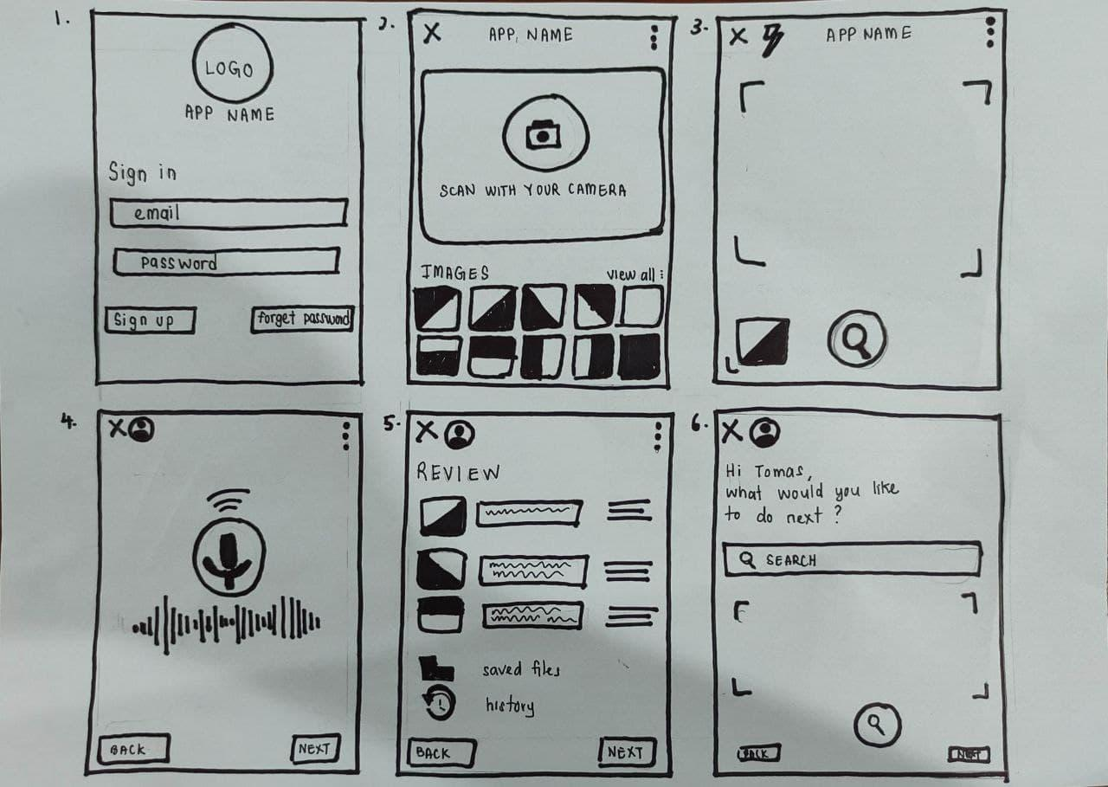

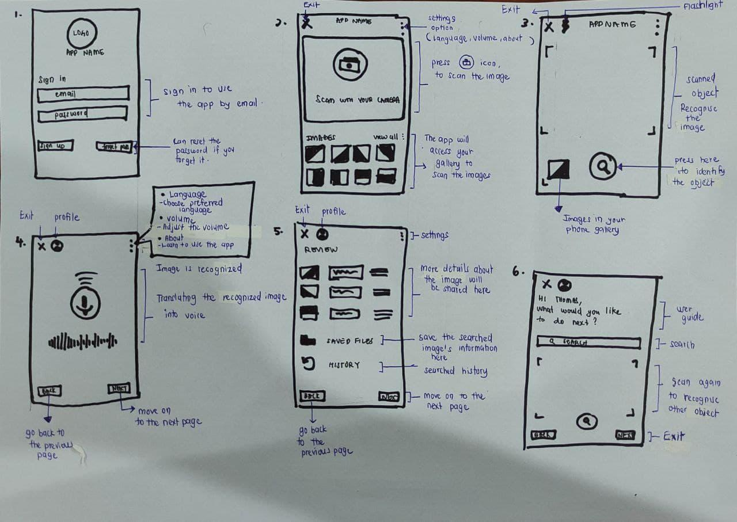

**ARCHITECTURE PLANNING**

The cloud computing architecture that we are going to use in this project are database and storage. We are going to use Amazon Web Services (AWS) as our main platform to do this project. We are suggesting to use Amazon DynamoDB and Amazon Relational Database Service (Amazon RDS) for databases. Amazon DynamoDB is a key-value and document database that promises performance in the single digit milliseconds at any size. It's a fully managed, multiregion, multimaster database for internet-scale applications that has built-in security, backup and restore, and in-memory caching. Amazon RDS makes it simple to set up, run, and scale a relational database in the cloud. It offers scalable and cost-effective capacity while automating time-consuming administrative activities including hardware provisioning, database setup, patching, and backups. It frees you up to concentrate on your applications, allowing you to provide them with the quick performance, high availability, security, and compatibility they require. For storage, we are going to use Amazon Elastic File System (EFS) and Amazon Simple Storage Service (S3). Amazon EFS is a simple, scalable, and elastic file system for Linux-based applications that can be used with AWS Cloud services as well as on-premises resources. It is designed to expand to petabytes on demand without interfering with applications, growing and shrinking dynamically as you add and delete files, ensuring that your applications have the storage they require. Amazon S3 offers simple administration capabilities that allow you to organise your data and establish fine-grained access restrictions to fit your unique business, organisational, and compliance needs.

**CONCLUSIONS**

In conclusion, this discussion has achieved some of the objectives we set such as helping seniors and blind people to further optimise their blurred vision so that they can perform their daily tasks better. We can say that this prototype will alleviate their financial concerns as well as their annual expenditure of producing pricey spectacles. However, we discovered certain limits in our project, including the difficulty of scanning or detecting microscopic things. This is due to the fact that identifying tiny things is one of the most difficult and critical difficulties in our project. Furthermore, tiny items are more likely to have data labelling mistakes, which may cause their identification to be overlooked. Small items are difficult to measure empirically. The difficulties of translating visuals to sound at night, as well as blurry images, might be included.