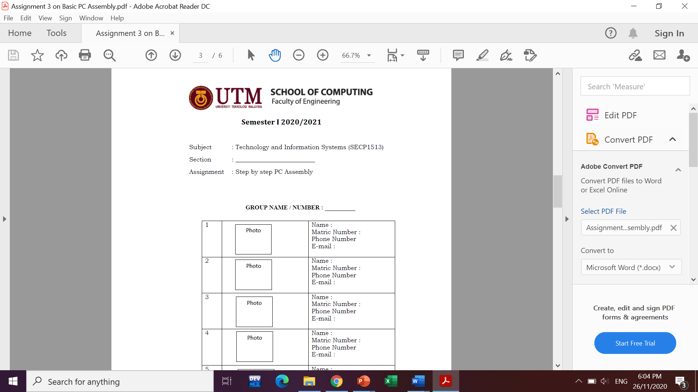

Subject : Technology and Information Systems (SECP1513)

Section : 01

Assignment : Cloud Computing Fundamentals – Literature Review on Cloud

Computing Service Providers.

GROUP NAME / NUMBER: 05

|  |  |  |
| --- | --- | --- |
| 1. |  | Name: Mek Zhi Qing  Matric Number: A20EC0077  Phone Number: 0167812448  E-mail: mekqing@graduate.utm.my |
| 2. |  | Name: Rohaizaazira binti Mohd Zawawi  Matric Number: A20EC0138  Phone Number: 0179573753  E-mail: rohaizaazira@graduate.utm.my |
| 3. |  | Name: Zereen Teo Huey Huey  Matric Number: A20EC0173  Phone Number: 0167293878  E-mail: zereen@graduate.utm.my |

**Study on the Top 3 Cloud Computing Service Providers**

Mek Zhi Qing (A20EC0077) mekqing@graduate.utm.my

Rohaizaazira binti Mohd Zawawi (A20EC0138) rohaizaazira@graduate.utm.my

Zereen Teo Huey Huey (A20EC0173) zereen@graduate.utm.my

1. Introduction

Nowadays, many people think cloud computing is a new model for free users to store, own, and maintain data and software. In cloud computing, there are three basic components which are the client, Internet, and service provider. Clients are corporations and end-users who want access to data, programs, and storage. (Studylib.net, 2021). The Internet provides connection between clients and providers while service providers are organizations with computers connected to the Internet that are willing to provide access to software, data, and storage. So, in this paper, we focus on many aspects such as the service model, their Virtual Machine (VM) instance types, storage, Operating System (OS) environment that offered, the security, their performance and scalability, pricing model, auto-scaling or elasticity and service provided if we want to own cloud computing. This paper can be divide into 5 parts. We will discuss about background of Cloud Computing, Cloud Model, Cloud Services, the strength of top leading providers, and our opinion to the Cloud Computing Service Providers.

2. Backgroud of Cloud Computing

What is cloud computing? Cloud computing is the delivery of computing services—including servers, storage, databases, networking, software, analytics, and intelligence—over the Internet (“the cloud”) to offer faster innovation, flexible resources, and economies of scale. (Microsoft Azure, 2021). With it, we can be cost-effectiveness as we just need to purchase for the service we had use and we no need to be overbarget to buy the computing components for future use. Next, the security of our data can be protectted by using this cloud computing platform as the special data storage system and have the data backup stored in the cloud to prevent the loss of data.

3. Cloud Models

The cloud models can be divided into public cloud, private cloud and hybrid cloud. First, the public cloud as the most common form of cloud model, it is located on the premises of company. It is more accessible and make the process of backup of data become easier. Since it is a public cloud, the data can stored in a shared environment and available for all of the users. Second, the private cloud means using a clod infrastructure which is not shared the data to others people. It can let us control over the security. For a comparison, public cloud is open to all organization but the provate cloud is open to the users of a single organization. The hybrid cloud is a combination of public cloud and private cloud. It provide the purpose of public cloud and private cloud and with the help of private cloud, the securiy of hybrid cloud can be improved.

4. Cloud Services

Same as the cloud model, the cloud service also can divide into 3 part which are Infrastructure as a Service (IaaS), Platform as a Service (PaaS), and Software as a Service (SaaS). First, IaaS provide a virtual environment for system admin so that the multiple users can access them. Next, PaaS is a service for developers based on the programming language execution environment to manage the data and application resources. For SaaS, it is an independent platform for multiple end users as we no need to install the software required to use and just pay when we use the software based on the on-demand service.

5. Top Cloud Computing Providers

The top three cloud computing providers are Amazon Elastic Compute Cloud (Amazon EC2), Microsoft Azure and Google Cloud Platform (GCP).

For Amazon Elastic Compute Cloud (EC2), it supports all operating system and is rank as the top platform for the IaaS because of its reliability and well performance when carry out task (Jeff. P, 2020). It provides a huge variety of virtual machine instance types which differs according to general purpose, compute, memory, accelerated and networking resources. The Amazon EC2 enable the users to easily acess to computing power and store data. Through Amazon EC2, the user can launch many virtual servers that fulfil their requirements, configure security and networking, and manage storage (Amazon,2021).

For Google Cloud Platform (GCP), Google Compute Engine is an IaaS, Google Application engine is PaaS, while SaaS provides backup and test data management service. The virtual machine of GCP is different according to general-purpose, memory-optimized, and compute-optimized families. In the secrity side, GCP provide a vey best platform to the development as the data is protected by multilayer protection. GCP security also combines the performance and scalability with sharing capabilities. Google Cloud Platform is a cloud computing services that provided by Google. This platform offers a range of services for compute, storage and application development that run on Google hardware (Margaret, R.).

For Microsoft Azure, the virtual machine in Microsoft Azure is different according to general purposed, compute, memory, storage, GPU, and high-performance compute. It provide a few data services and the great function of Microsoft Azure is it can auto scale according to the demands of the application usage which influences by increasing or decreasing the resources of application. Microsoft Azure provides a cloud solution for everyone in many fields including business for storing data. (Acronis,2017).

|  |  |  |  |
| --- | --- | --- | --- |
| Features | Amazon EC2 | Google Cloud Platform | Microsoft Azure |
| Virtual machine instance types offered | nano, micro, small, medium, large, and extra-large | micro, small, and medium | according to general purposed, compute, memory, storage, GPU, and high-performance compute |
| Storage | Simple Storage Service (S3), Elastic File System (EFS), Amazon FSx for Windows File server, Amazon FSx for Lustre file storage, and Elastic Block Service (EBS) | block, network file, and object storage | Azure Blobs, Azure Files, Azure Queues, Azure Tables, and Azure Disks |
| OS environment offered | supports Linux, macOS, Raspbian and Windows server | CentOS, Container-Optimized OS, Debian, Fedora Core OS, Red Hat Enterprise Linux, SQL Server, SUSE Linux Enterprise Server (SLES), Ubuntu and Windows server | Linux and Microsoft Windows |
| Security | prevent, detect, respond, and remediate | helps in the aspect of infrastructure, network, endpoint, data, application | security and audit dashboard, Azure resource manager, Azure monitor, Azure application firewall and Azure advisor |

|  |  |  |  |
| --- | --- | --- | --- |
| Pricing model | On-Demand, Savings Plans, Reserved Instances, Spot Instances and Dedicated Hosts | can get $300 in free credits for over 20 products to run, test, and deploy workloads | Pay as You Go model |
| Monitoring tools | automated monitoring tools, manual monitoring tools | Cloud Monitoring agent | Microsoft Monitoring Agent, System Center Operation Manager and Azure monitor |

6. Comparison on the general strength of Amazon EC2, Google Cloud Platform and Microsoft Azure

We will choose Amazon EC2 as our service provider since it is more reliable compare to two other platform. For the storage of Amazon EC2, it supports object storage, lustre file storage and block storage which can hold and organize the data in different ways. The security of this provider can be protected by filter the web request, and this feature is not found in another two providers. Amazon EC2 provide 4 operating system and is more than Microsoft Azure but is less than GCP. We are free to use this provider compare to other two in the first 12 month for trier and for further using, Amazon EC2 has provide 5 different ways to pay which are flexible based on the users’ need. On the scaling part since the Amazon EC2 can automatically adjust capacity, it provides us to carry out function in the lowest cost which is not exist on other two providers. Lastly, the monitoring tool for Amazon EC2 can be divided into automated and manual. It can help to check system status and give report on the problem found. The manual monitoring tool carries out function except the function of automated monitoring tool, and this become one of the reason we choose Amazon EC2 as it provide overall cover the monitoring function.

7. Conclusion

Amazon EC2, Microsoft Azure, Google Cloud Platform are utilized for a similar reason. They are offering nearly similar types of assistance. It underpins all the stages, working frameworks, and structures Amazon EC2, Microsoft Azure, Google Cloud Platform are having the distinction that is recorded previously. Some are having contrasts just in name however their usefulness is nearly the equivalent. While choosing the providers, the proposal is to utilize the free preliminary form and watch what one suits the client's necessities most viably. It intends to utilize it and pick it.

References:

Acronis. *What is Microsoft Azure.* Retrieved January 17, 2021, from <https://www.acronis.com/en-eu/articles/what-is-microsoft-azure/>

Azure.microsoft.com. *What Is Cloud Computing? A Beginner’S Guide | Microsoft Azure*. Retrieved January 13, 2021, from <https://azure.microsoft.com/en-us/overview/what-is-cloud-computing/>

Ecoursereview. *Cloud Computing Pros and Cons for Business and IT Professionals.* Retrieved January 19, 2021, from <https://ecoursereview.com/cloud-computing-pros-and-cons-for-business-it/>

Jolene Rutherford. *5 Reasons Why Cloud Computing Is Important for Your Business.* Retrieved January 19, 2021, from <https://zegal.com/blog/post/cloud-computing-for-business/>

Margaret, R. *Google Cloud Platform.* Retrieved January 17, 2021, from <https://searchcloudcomputing.techtarget.com/definition/Google-Cloud-Platform>

Microsoft Azure. *Microsoft Azure overview.* Retrieved January 17, 2021, from <https://azure.microsoft.com/en-us/overview/what-is-azure/>

Saunders, B., 2020. *Who's Using Amazon Web Services?.* Retrieved from January 13, 2021, from <https://www.contino.io/insights/whos-using-aws#:~:text=According%20to%20Amazon%2C%20the%20number,least%2010%25%20of%20that%20total.>

Singh, K. *What is the difference between Public, Private and Hybrid Cloud?.* Retrieved January 19, 2021, from <https://karansinghreen.medium.com/what-is-the-difference-between-public-private-and-hybrid-cloud-a41bba631479>

Studylib.net. *Chp 2 Powerpoint Solution*. Retrieved from January 13, 2021, from <https://studylib.net/doc/10133552/chp-2-powerpoint-solution>