

Technology and Information Systems (SCSP1513)

SEMESTER1 (2018/2019)

|  |  |
| --- | --- |
| Group | 13 |
| Name | RISSHE A/L PETER  FATHI MOAHMED FATHI REZQ BEKHIT  HABIB HADMY ZULKAFFLI  HARIES HASHEMEEN ALIAS |
| MATRIC NO | A18CS0241  A18CS0301  A18CS0067  A18CS0070 |
| LECTURER | DR. ARYATI BINTI BAKRI |
| SECTION | Section 9 |

**TABLE OF CONTENT**

1 INTRODUCTION 3

2 IOT – PREDICTIVE MAINTENANCE GETS AN EXTREME MAKEOVER 4

2.1 INTRODUCTION 4

2.2 INDUSTTRY 4.0 TECHNOLOGY TRENDS 4

2.3 ADVANTAGES 4

3 INTERNET 2.0: TRANSACTION BASED NETWORKING 5

3.1 INTRODUCTION 5

3.2 BLOCKCHAINS 6

4 BIBLIOGRAPHY 7

**TABLE OF FIGURES**

Figure 1 Poster of IOT event 3

Figure 2 Transaction of Bitcoin using Blockchains 5

Figure 3 ways of Blockchain functions 6

# INTRODUCTION

On 18th November 2018 an event was held at P03 Faculty of Science which is IOT Open Day 2018 with Industrial Speakers. All SCSV student in Technology and Information Systems (SCSP1513) had to attend the event and make report about the talk given on that day. We had to make report for two talk about IOT-Predictive Maintenance Gets An Extreme Makeover and Internet 2.0: Transaction Based Networking. IOT is a new way of controlling the security of variety of things such as data, network and others by using internet. IOT use internet to the full of it benefit and advantages to make security or cybersecurity more efficient with the help of new technologies such as AI (artificial intelligent) easily that provide more security in securing data transfer between servers. Commonly IOT is searching new way of resources for Internet statistics, trends, and demographics.

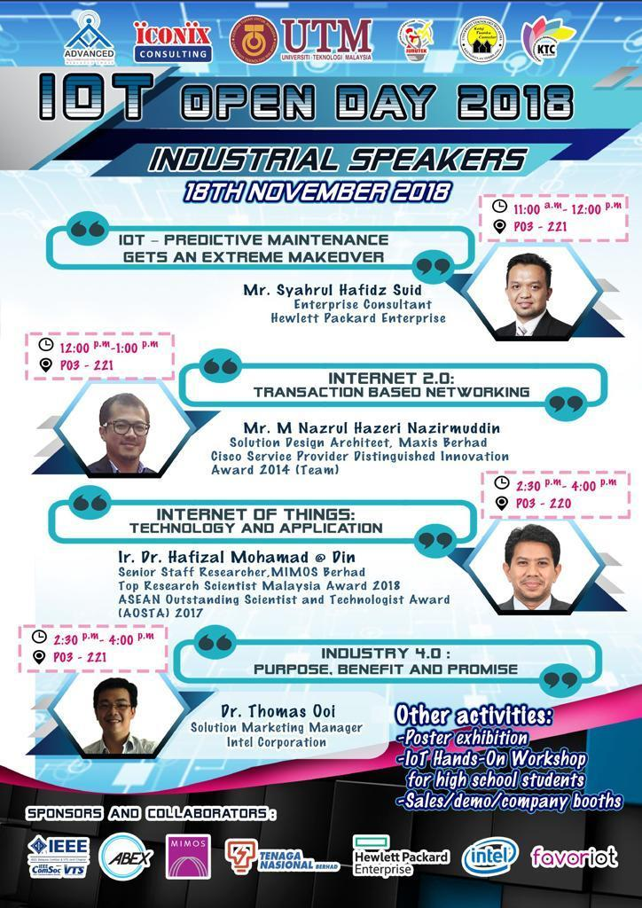

# IOT – PREDICTIVE MAINTENANCE GETS AN EXTREME MAKEOVER

## INTRODUCTION

The talked was given by Mr. Syahrul Hafidz Suid an Enterprise Consultant of Hewlett Packard Enterprise for about an hour at P03, 221. Predictive maintenance consists of five elements which are The things itself, Data acquisition, Analytics engine, Historian system and Human interface. The thing itself means a machine that performs an important function. Data acquisition refer to a sensor on a machine that collect and transmit time-series data to a data acquisition system then convert it to a format that can be understand by analytical system. Analytics engine takes data from acquisition system and generate it into events. Database that receive and store the same data that goes into the analytics system. Human interface refers to the system visualizes its information through an asset management, business process, field maintenance and others.

## INDUSTTRY 4.0 TECHNOLOGY TRENDS

|  |  |
| --- | --- |
| TYPES | EXPLAINATION |
| Autonomous Robots | Robots are evolving for even greater utility |
| Simulation | Simulations will leverage real-time data to enhance the physical world in a virtual model |
| System Integration | Companies, departments, functions, and capabilities will become much more connected and cohesive |
| Big data | The collection and comprehensive evaluation of data from many different solutions sources |
| Internet of things | Devices connected in 2015 – 4.9 million. Forecasts 8.4 million in 2018 and 20.8 billion in 2020. |

## ADVANTAGES

Thanks to the existence of lower sensor costs, there are still new horizons to be explore, especially in consumer products. The analytics of IOT will make our works easier more into analytical projects or works. The privacy of our internet usage and data will be more secure by the new IOT technologies provided.

# INTERNET 2.0: TRANSACTION BASED NETWORKING

## INTRODUCTION

After the talk with Mr. Syahrul Hafidz Suid, Mr. M Nazrul Hazeri Nazirmuddin started to give his speech at 12.00 pm about internet 2.0. He mainly talked about transaction based networking. Mr. M Nazrul Hazeri Nazirmuddin is a solution design architect for Maxis Berhad. He is also one of a member of the team that won Cisco Service Provider Distinguished Innovation Award 2014.

He started his talk by introducing us to a concept called man-computer symbiosis. Basically, what man-computer symbiosis is a partnership between humans and computers. “Men will set goals, formulate hypothesis, determine the criteria and perform evaluations. Computing machines will do the routinize the work that must be done to prepare the way for insights and decisions in technical and scientific thinking.”- J.C.R Licklider.

Continuing on he talked about the evolution of internet which is Internet 2.0. He said that the cause of this evolution is a technology called blockchain. A blockchain is a peer-to-peer digital ledger which enables simple coding of contracts which can be activated when a specific condition is met. This is also known as smart contracts. Blockchain is originally invented for bitcoin mining and transaction but others saw the potential of the technology and decided to use it in other area especially in transaction based networking. Blockchain functions by distributing data all over the network and updating regularly.



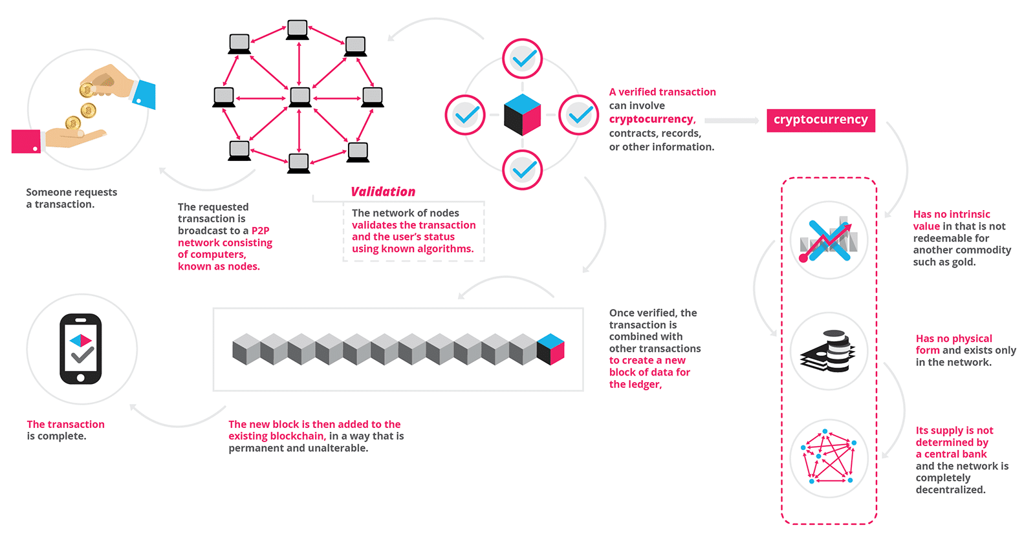

## BLOCKCHAINS

There are two types of blockchains which is open public blockchains and permissioned enterprise blockchains. Public blockchains can be said it is equivalent to internet and permissioned enterprise blockchains is equivalent to intranet. Public blockchains can be downloaded and used by anyone but permissioned enterprise blockchains can only be accessed by a selected group of people. Usually, permissioned enterprise blockchains is faster and it is used by companies. Every transaction is transparent and can be identified unlike public blockchains which is anonymous.

Blockchain got many benefits. One of them is governance. As blockchains functions by sending data all over internet and is not centralized, it is truly public. Transactions are transparent but anonymous. Everyone can see the data and user has power over their data. Other than that, the files stored through blockchains are more secure as decentralized data storage, hackers find hard to hack the files as it is all over the network. It also allows peer-to peer payment. This function is very important to sharing companies like Uber. User can pay directly to the Uber driver through this.

In conclusion, blockchains is a revolutionary technology which can protect the identity of the user during transactions which is visible to everyone. Nobody can say that a transaction did not happen as there is witness all over the network. People also have power over their data as no data is monopolized by any big companies.

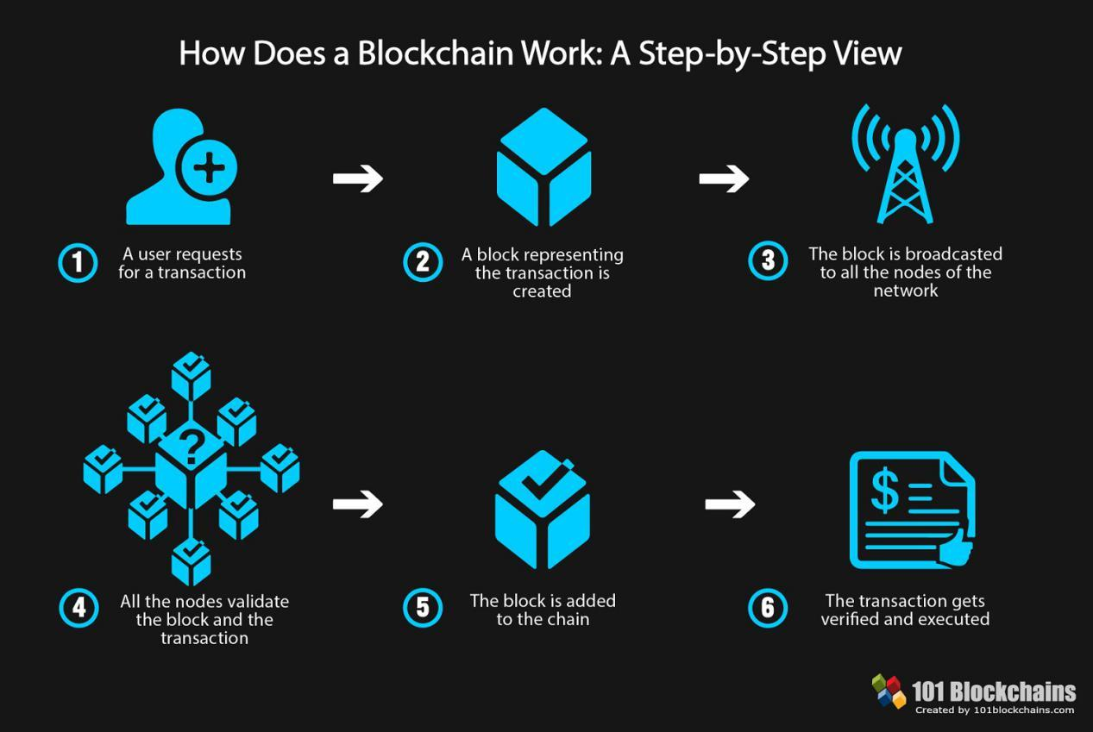

# REFLECTIONS

From attending this talk, I learned that the Industrial Revolution 4.0 that occurring now will be changing everything as we now. Even the internet is undergoing evolution with blockchains in the center. I also learned that the digital world is undergoing change every day and I need to be up-to-date to be able to keep up with the changes that occurring now. I need to start my research and look deeper in things like IoT and blockchains, so that I have a better understanding of them as they are the future we are heading to.

I hope that I will can utilize the things that I learned today in the future. I will learn new things and try to be creative and innovative, so that I will be able to create new things using the emerging technologies in the upcoming future. I also realize that I need an open mind to succeed and to adapt to changes that will be occurring soon because of the Industrial Revolution 4.0.

# BIBLIOGRAPHY

* <https://blockgeeks.com/guides/what-is-blockchain-technology/>
* <https://blockchainhub.net/blockchains-and-distributed-ledger-technologies-in-general/>
* <https://www.internetsociety.org/iot/?gclid=CjwKCAiAlvnfBRA1EiwAVOEgfBntOipcz7jn7eaqxbKmiWfNJjZv2MathxEYiLvASyV_noYOP3g6ShoCR4cQAvD_BwE>
* <https://internetofthingsagenda.techtarget.com/definition/Internet-of-Things-IoT>
* <https://www.hpe.com/us/en/insights/articles/thanks-to-iot-predictive-maintenance-gets-an-extreme-makeover-1705.html>