PROGRAM 8.1
Question 1
HAM JING YI A19EC0048
a)
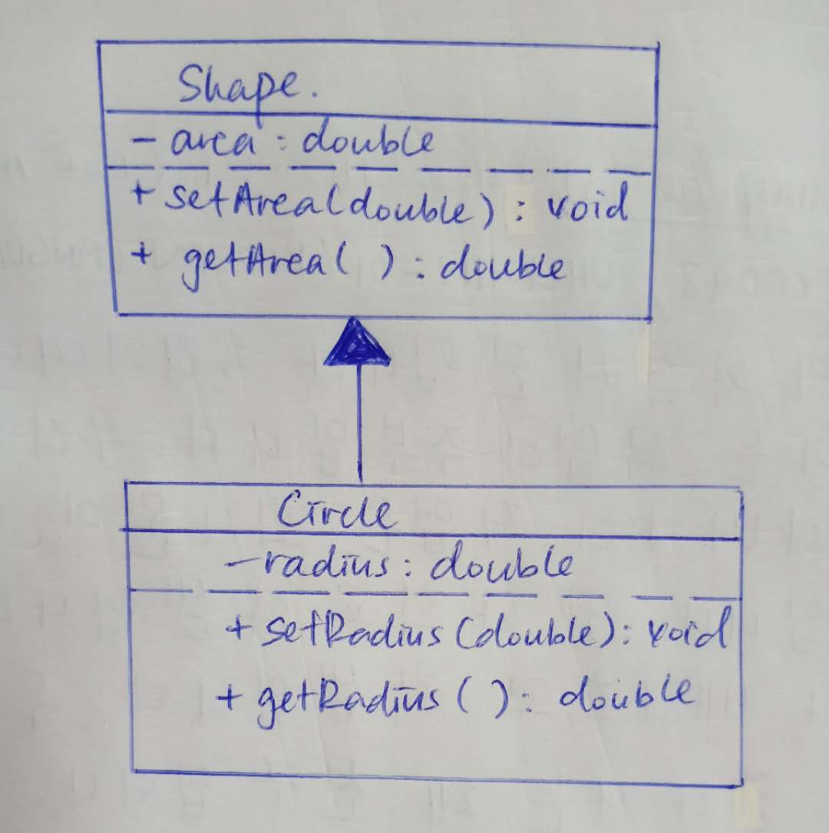
b)
void setArea(double);
double getArea();
void setRadius(double);
double getRadius();
c)
double area;
void setArea(double);
double getArea();
d)
legal
illegal
legal
legal

