

**GROUP REPORT**

**IOT AND INTERNET 2.0**

**(INDUSTRY TALK)**

**TECHNOLOGY AND INFORMATION SYSTEM**

**SCSP-1513/09**

**Dr. Aryati Bakri**

**GROUP 11 MEMBERS:**

1. P’NG YI (A18CS0231)

2. SYAFA NABILA MAULIDYA (A18CS0328)

3. PREMA KARIRA ANAS SULAIMAN (A18CS0320)

4. UMAIR BIN ZAINAL KIFLI (A18CS0269)

**Table of Contents**

1. Introduction 3

2. Summary of Talk 7

3. Reflection 10

4. Bibliography 11

**Table of Figures**

Figure 1: Internet of Things (IoT). Taken from https://internetofthingsagenda.techtarget.com/definition/Internet-of-Things-IoT. 3

Figure 2: Internet History 4

Figure 3: Blockchain Technology. Taken from https://www.coindesk.com/information/what-is-blockchain-technology. 4

Figure 4: Smart city monitoring. Taken from https://www.geospatialworld.net/blogs/pan-city-solutions-smart-solutions-for-smart-cities/. 5

Figure 5: Flood monitoring and warning system. Taken from http://www.advantech.com/success-stories/article/d02fa2f6-a668-4611-91ca-2956161fe569. 6

Figure 6: Speakers of the talk. 7

Figure 7: Posters about the uses of IoT. 7

Figure 8: Slide about the worldwide CIO Agenda 2019 Predictions by IDC. 8

Figure 9: Industry 4.0 Technology Trends – by BCG. 10

# Introduction

Internet of Things (IoT) is a new era in digital transformation. So, Internet of Thing (IoT) is a concept where an object has the ability to transfer data over a network without requiring human-to-human or human interaction to a computer.

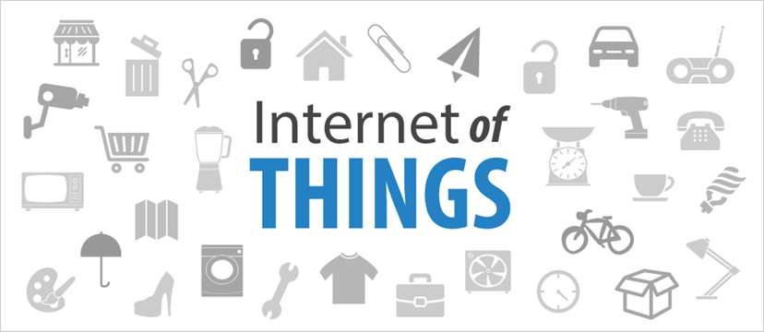

Figure 1: Internet of Things (IoT). Taken from <https://internetofthingsagenda.techtarget.com/definition/Internet-of-Things-IoT>.

The benefits of IoT are improving the development of the IT world that can facilitate all human activities, everything we do will be easier, faster and more efficient, can bring new innovation and data collection can be done using sensors. Examples of IoT are:

* Internet Transaction Based Networking
  + Man-Computer Symbiosis

“Man-computer symbiosis is an expected development in cooperative interaction between men and electronic computers. It will involve very close coupling between the human and the electronic members of the partnership.”

* + - J.C.R. Licklider
* Blockchain strenghts, Weaknesses, Opportunity & Threat
  1. Strenghts : Hardworking, open-minded, thoughtful and drawing.
  2. Weakness : Very busy, impatient, get bored quickly, writing essays
  3. Opportunities : Decide on an idea I am, happy to work with, plan ahead and

create exciting concepts for final, show off the skills I have

learned throughout the course.

* 1. Threats : Lose enthusiasm in project, take too long to make

a start on the project, rush and put time over quality, fail

course.

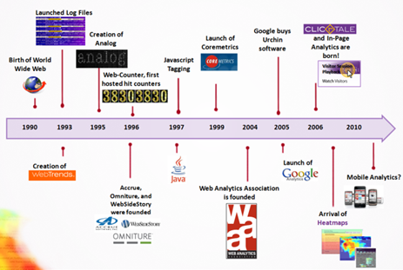

Figure 2: Internet History

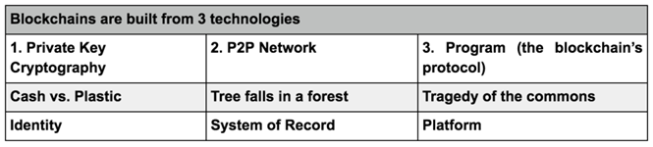

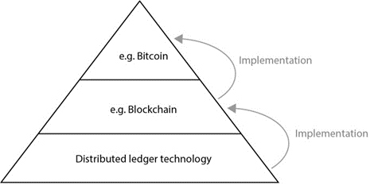

Figure 3: Blockchain Technology. Taken from <https://www.coindesk.com/information/what-is-blockchain-technology>.

* IoT Based Noise Monitoring System (NOMOS)
  + Noise is an unwanted and disturbing sound to humans. Nowadays, technology is increasingly advanced and can be overcome using IoT (Internet of Things). IoT refers to network of physical devices, vehicles, electronic appliances and other items embedded with sensors, software and connectivity which anables these things to connect, collect and exchange data without requiring human-to-human or human-to-computer interaction.
  + Objective:
    1. To implement the concept of Internet of Things (IoT) by designing and creating a circuit of noise monitoring system using Raspberry Pi 3
    2. To monitor the sound level in particular areas
    3. To alert the authorities if the sound level exceeds the limit
  + Methodology:
    1. Microphone (sound sensor) that is connected to Raspberry Pi 3 will measure the sound level
    2. The data that is recorded will be sent to the cloud server and the user can access the data using apps
    3. Raspberry Pi 3 is used instead of Arduino because it has many advantages such as built in Wi-Fi and Bluetooth, can run multiple programs at a time and highly customizable
    4. Other component that is used for this project is 16 x 2 LCD display to display the output
  + Advantages:
    1. Can monitor the sound level remotely
    2. Less time consuming for authorities to do their jobs
    3. Less labour works required

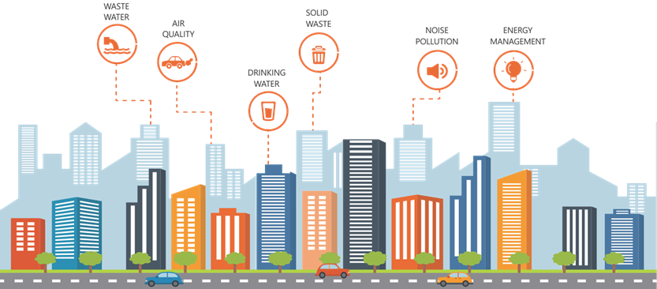

Figure 4: Smart city monitoring. Taken from <https://www.geospatialworld.net/blogs/pan-city-solutions-smart-solutions-for-smart-cities/>.

* Smart Home Energy Monitoring System
  + Flood disaster has caused a lot of destruction to environment and human mankind due to lack of real time early warning system. The implementation of internet of things (IoT) in flood monitoring system has allowed the users to update about latest flood information very fast in wireless technologies.
  + In order to prevent more destruction, LoRa communication network is chosen as a communication protocol due to its unique features as one of the emerginf IoT application. Lora is known as long range communication which can cover up wide area especially in rural area.
  + However, the range is not sufficient even using LoRa in a single hop. Thus, multi hop communication is used to get low latency and energy saving while keeping network reliability during transmitting data.
  + Problem Statement
    1. Existing system uses cable to connect the siren with a sensor at a river.
    2. High cost due to long cable length and installation.
    3. Alternatively, use wireless connection (LoRa).
    4. LoRa can cover from 12-15 km (insufficient range)
    5. Need

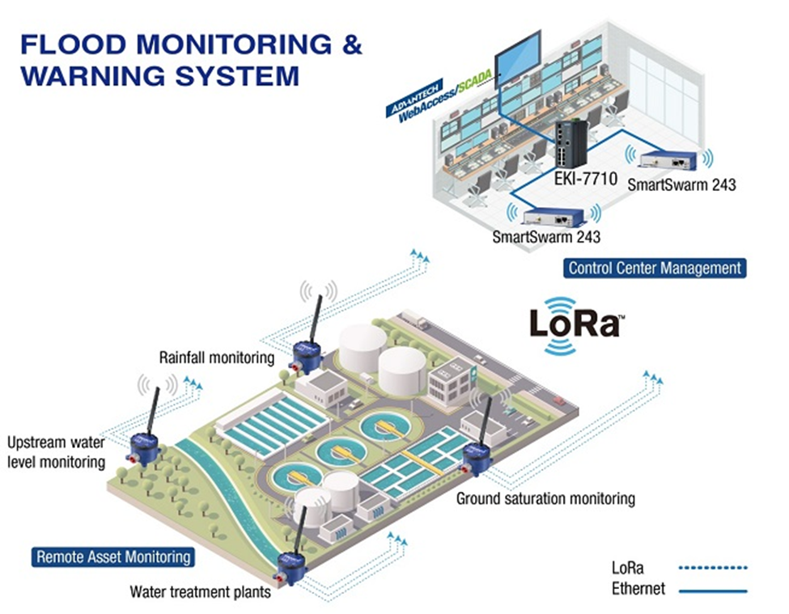

Figure 5: Flood monitoring and warning system. Taken from <http://www.advantech.com/success-stories/article/d02fa2f6-a668-4611-91ca-2956161fe569>.

# Summary of Talk

This report was commissioned to explain about IoT, what are the examples, what are the benefits and how does it work. The industrial talk that was held in P03-221, Universiti Teknologi Malaysia (UTM), by Intel & Mimos (November 18, 2018) explained the topic of IoT & Internet 2.0, from 11:00 AM until 1:00 PM. Other than the industrial talk, there were also many posters of examples and devices of the IoT on the outside of the room.

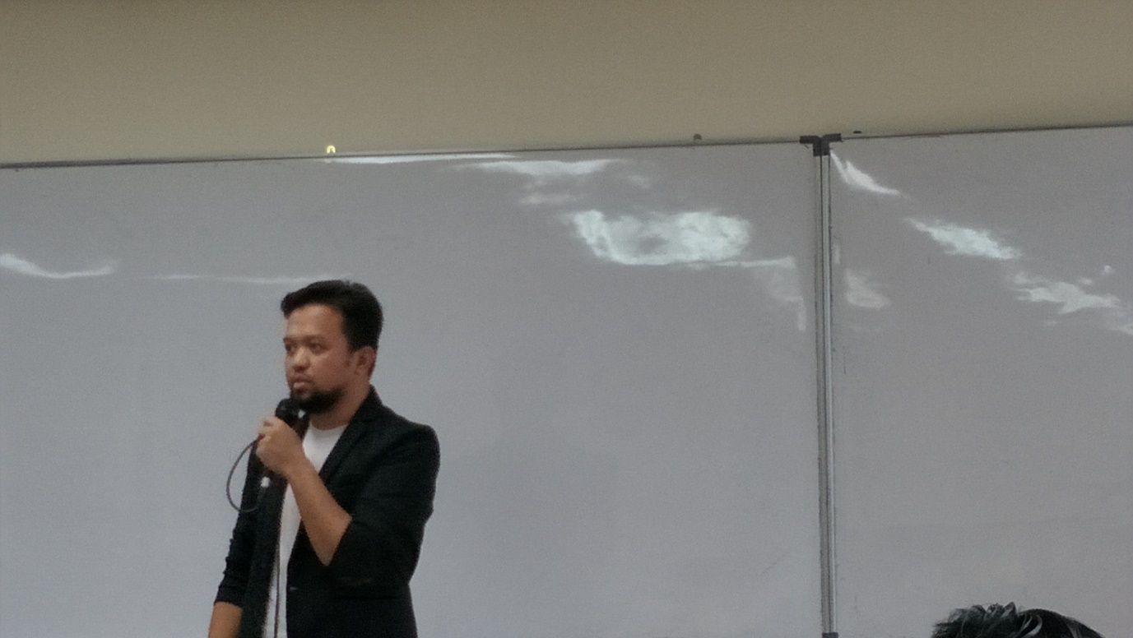 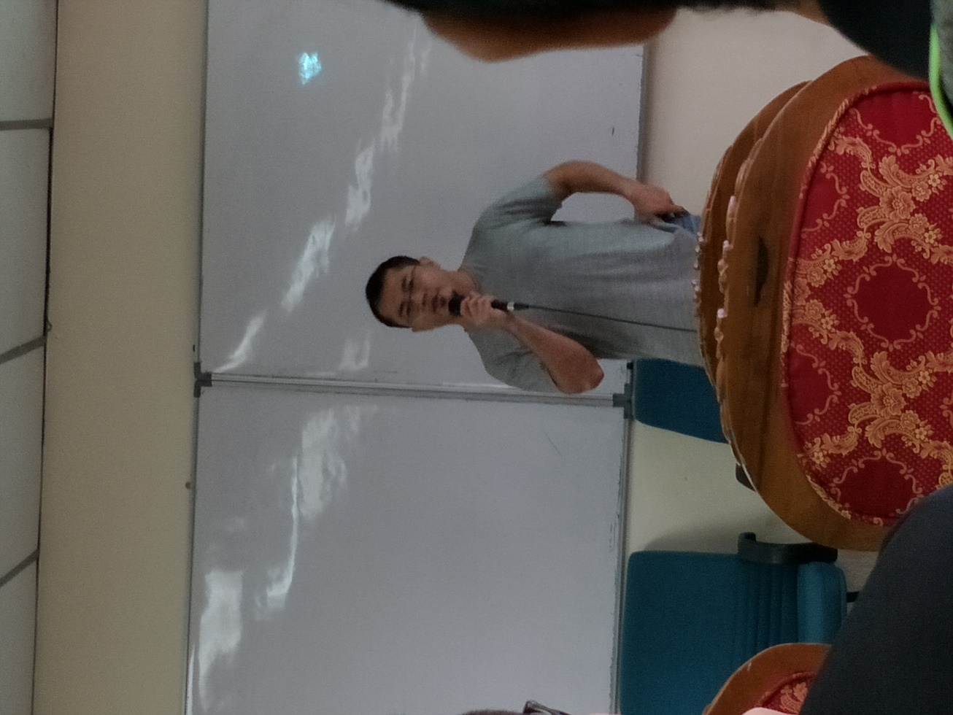

Figure 6: Speakers of the talk.

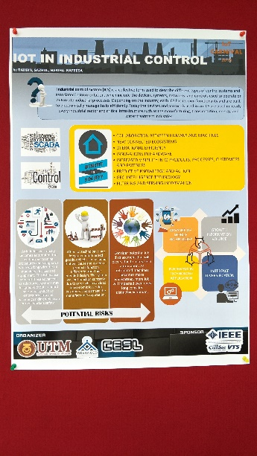 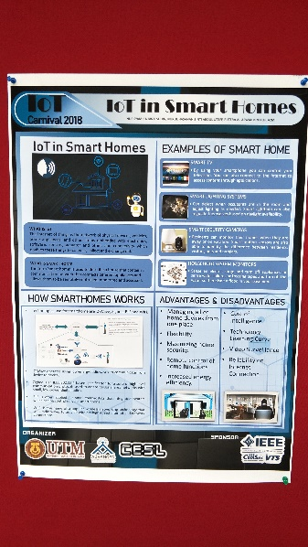 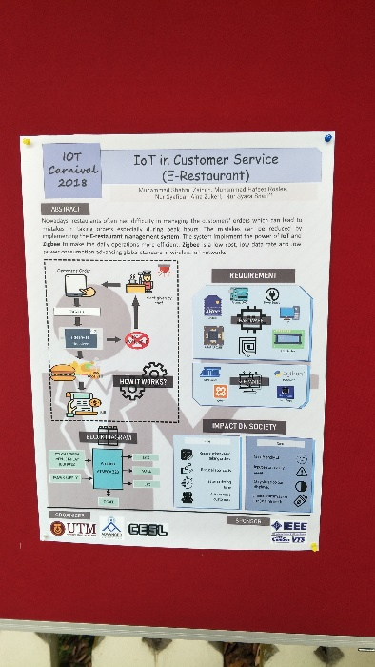

Figure 7: Posters about the uses of IoT.

A new device called IoT (Internet-of-Things) is a giant network with connected devices. As examples, it can be an air conditioner that can be controlled with a smartphone, or a smart car that gives the shortest route, or even a smart watch that can tract our daily activities. It can be a fitness tracker, a thermostat, a lock or appliance, or even a light bulb.

IoT is a system of interrelated computing devices that are provided with unique identifiers and the ability to transfer data over network without requiring human-to-human or human-to-computer interaction. IoT encourage companies in thinking how to approach their businesses, industries and markets. IoT also provides the tools to improve their business strategies. And there are also many other benefits of the IoT.

The co-founder of the Auto-ID Center at MIT, Kevin Ashton, first mentioned the internet of things in a presentation that he made to Procter & Gamble (P&G) in 1999 and called his presentation “Internet of Things” to incorporate the cool new trend of 1999. IoT has evolved from the convergence of wireless technologies, micro-electro-mechanical-systems (MEMS), micro-services and the internet. Although Ashton’s was the first to mention the IoT, the idea of connected devices has been around since the 1970s.

Then, the IoT evolved from machine-to-machine communication (machines connecting to each other via a network without human interaction). The IoT is also a natural extension of Supervisory Control and Data Acquisition (SCADA), a category of software application program for process control, the gathering of data in real time from remote locations to control equipment and conditions.

This system includes software and hardware components. The hardware gathers and feeds data into a computer that has SCADA software installed in it. It is then processed and presented in a timely manner. However, the concept of the IoT ecosystem didn’t really come into its own until the middle of 2010.

IDC FutureScapes present information about technologies, markets, and ecosystems that help CIOs better understand future trends and their impacts on the enterprise. They also present guidance on complex, fast-moving environments and offer prescriptive, actionable recommendations.

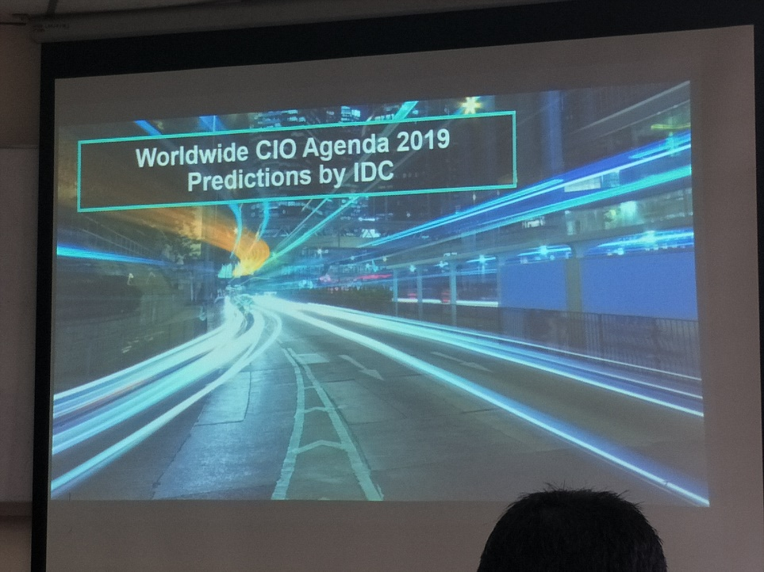

Figure 8: Slide about the worldwide CIO Agenda 2019 Predictions by IDC.

Every year, IDC identifies the key external drivers that will influence businesses in the coming years. A FutureScape establishes ten predictions derived from these drivers, analyses the impacts on the IT organization, and proposes recommendations for the next five years. The predictions from the IDC FutureScape for Worldwide CIO Agenda are:

* Prediction 1 : By 2021, driven by LOB needs, 70% of CIOs will deliver "agile

connectivity" via APIs and architectures that interconnect digital

solutions from cloud vendors, system developers, start-ups, and others.

* Prediction 2 : Compelled to curtail IT spending, improve enterprise IT agility, and

accelerate innovation, 70% of CIOs will aggressively apply data and

AI to IT operations, tools, and processes by 2021.

* Prediction 3 : By 2022, 65% of enterprises will task CIOs to transform and modernize

governance policies to seize the opportunities and confront new risks

posed by AI, ML, and data privacy and ethics.

* Prediction 4 : Through 2022, 75% of successful digital strategies will be built by a

transformed IT organization, with modernized and rationalized

infrastructure, applications, and data architectures.

* Prediction 5 : By 2020, 80% of IT executive leadership will be compensated based

on business KPIs and metrics that measure IT's effectiveness in driving

business performance and growth, not IT operational measures.

* Prediction 6 : By 2020, 60% of CIOs will initiate a digital trust framework that goes

beyond preventing cyberattacks and enables organizations to

resiliently rebound from adverse situations, events, and effects.

* Prediction 7 : By 2022, 75% of CIOs who do not shift their organizations to

empowered IT product teams to enable digital innovation, disruption,

and scale will fail in their roles.

* Prediction 8 : Through 2022, the talent pool for emerging technologies will be

inadequate to fill at least 30% of global demand and effective skills

development and retention will become differentiating strategies.

* Prediction 9 : By 2021, 65% of CIOs will expand agile/DevOps practices into the

wider business to achieve the velocity necessary for innovation,

execution, and change.

* Prediction 10 : By 2023, 70% of CIOs who cannot manage the IT governance, strategy,

and operations divides between LOB-dominated edge computing,

operational technology, and IT will fail professionally.

# Reflection

After attending an industrial talk about IoT, we learned about the IoT itself (what is IoT, how does it work, what are the examples, and what the benefits of IoT are). And from the examples given, like Internet Transaction Based Networking, IoT Based Noise Monitoring System (NOMOS) and Smart Home Energy Monitoring System, we know that we can control our own digital footprint and actively participate in the market, we can take a quick action by the help of a device that can monitor the surrounding noise level of particular area or a device that can monitor floods and will notify the authorities.

This way, we don’t have to be worried about a sudden disaster or how to control and handle things from far away. The device will help us in handling all the problems in our daily activities.

From the question and answer session in this talk, we also get lots of knowledge in how to create or design a new invention that can help our daily activities. Other than using other people’s inventions, we can also learn more about the human needs and start creating our own inventions.

Our goal is to understand what IoT is and how to use it in a smart way or even to create one of the IoT devices that can simplify and help a job that was once impossible to accomplish to be done.

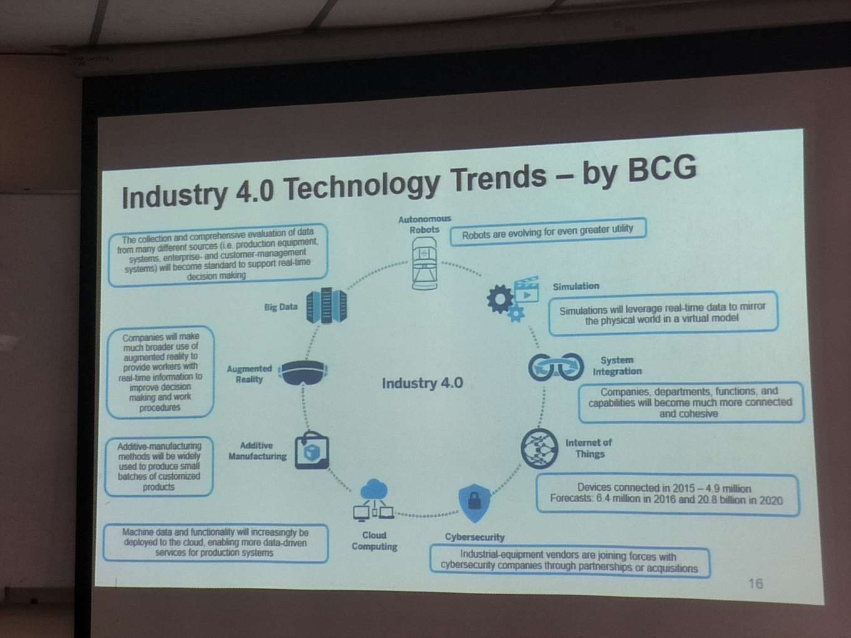

Figure 9: Industry 4.0 Technology Trends – by BCG.

# Bibliography

* IoT Agenda. (2018). What is internet of things (IoT)? - Definition from WhatIs.com. Retrieved from https://internetofthingsagenda.techtarget.com/definition/Internet-of-Things-IoT
* Worrydream.com. (2018). Retrieved from http://worrydream.com/refs/Licklider%20-%20Man-Computer%20Symbiosis.pdf.
* CoinDesk. (2018). What is Blockchain Technology? - CoinDesk. Retrieved from https://www.coindesk.com/information/what-is-blockchain-technology.
* Geospatial World. (2018). What is Pan City Solutions for smart cities. Retrieved from https://www.geospatialworld.net/blogs/pan-city-solutions-smart-solutions-for-smart-cities/.
* Advantech.com. (2018). Advantech LoRa Private Solution for Flood Monitoring and Warning System. Retrieved from http://www.advantech.com/success-stories/article/d02fa2f6-a668-4611-91ca-2956161fe569.
* IDC: The premier global market intelligence company. (2018). IDC Reveals Worldwide CIO Agenda 2019 Predictions. Retrieved from https://www.idc.com/getdoc.jsp?containerId=prUS44420918.