**FACULTY OF ENGINEERING, SCHOOL OF COMPUTING**

**COURSE: SECP1513 (SECTION 03)**

**TECHNOLOGY & INFORMATION SYSTEM**

**ROBOKAR: ROBOT PROGRAMMING WORKSHOP REPORT**

**LECTURER: DR HASWADI HASSAN**

**GROUP MEMBERS:**

**HUSNY MUSHARRAF BIN SHAMSUL KAMAL A19EC0051**

**AMJAD BIN RUSHDAN A19EC0021**

**RAKESH A/L KANNAPATHY A19EC0153**

**NUR ADILAH SYAZA BINTI MOHAMAD NAJIB A19EC0200**

**NADIAH BINTI MOHD HANIM A19EC0111**

**YASMEEN BINTI ABU BAKAR A19EC0212**

**ROBOKAR : ROBOT PROGRAMMING WORKSHOP**

**Introduction**

On Monday, 9 December 2019, Technology and Information System course has proposed and arranged a robokar workshop for the first-year students of Software Engineering from Section 03. The lecturer of Section 03, Dr. Haswadi Hassan, has explained to the students in detailed regarding this workshop beforehand in order to ensure that all students are well-prepared for this program. There were 37 students from Section 03 that have involved in the workshop. The venue of the workshop named ‘Robokar : Robot Programming Workshop’ is at Active Lab Learning which is located at Level 3, N28, School of Computing. The presenters of this workshop are Nurul Nazihah binti Jamal and Muhammad Irsyad bin Kamil Riadz.

**Details of Journey/Work Plan**

|  |  |
| --- | --- |
| **Time** | **Event** |
| 2.00 PM | * Arrival of Students of Section 03 * Registration |
| 2.20 PM | * Introduction to RoboKar * Brief description about the workshop and presentation * Concept of RoboKar Programming |
| 2.40 PM | * Students starts to program RoboKar within their group * Students are given tracks to test their RoboKar * Each group needs to prepare their RoboKar for the Final Track |
| 4.00 PM | * Students gathered at level 2 for the Final Track agenda * Each group were given 3 minutes to complete the final track |
| 4.30 PM | * Prize giving ceremony by Dr Haswadi Hasan * Photography session |

**Detailed Description (Content/Information given during the workshop)**

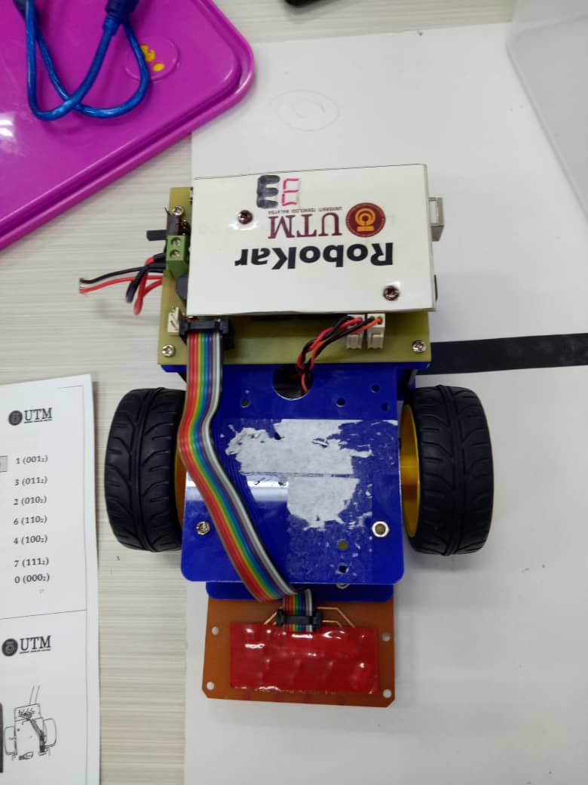The presenter has started the presentation by explaining briefly about Robokar. The presenter also explain the history of the club and how they vision to help the community. Robokar’s brain is made of Arduino. Arduino is an open-source platform used for building electronics projects. In the aspect of Robokar, Arduino is used as a platform to control the movement of the Robokar by using ArduinoIDE in Programming.

They also have mentioned that Robokar is slightly different from Robotar. The invention of Robotar has different kind of senses and also uses more advanced programming languages such as JAVA and more. Meanwhile, Robokar uses low level programming language of C or C++. Next, in order to make the robot move, we, the programmers are the ones who need to create a program for the robot to execute and carry out the process to solve the problems on the track.

We also learnt the benefits of participating in the workshop. This Robokar workshop promote generic skills among students, enhance teamwork in a group and also increase communication skills of an individual.

During the workshop, each group was required to bring their own laptop to install the ArduinoIDE software. This programming software uses C programming language. Before we started to write the coding for the robots, we were given a module as a guide to write the coding. The module explains a lot on how the sensors in the robot work. These sensors represent binary numbers that eventually can be instructed by the coding on what it has to do. The module also explains the functions of the user-defined functions created in the program. There are three types of speed that the programmers could program to apply it to the robot, which is slow, intermediate and fast.

Each group needs to learn how to solve the problem which is making the Robokar moving along black line. Basically there are 4 challenges for the Robokar to pass which is a straight line , 4 way intersection , sharp turn and soft turn. The goal is to complete the given course which consist of these 4 challenges as fast as we could. Each group was given an incomplete pathway for testing the movement of Robokar. The presenter helped us out on how to use the already defined functions from the Robokar library. The Robokar library has many functions that we can work on which is moving forward, backward, left and right, and could even make a honking sound.

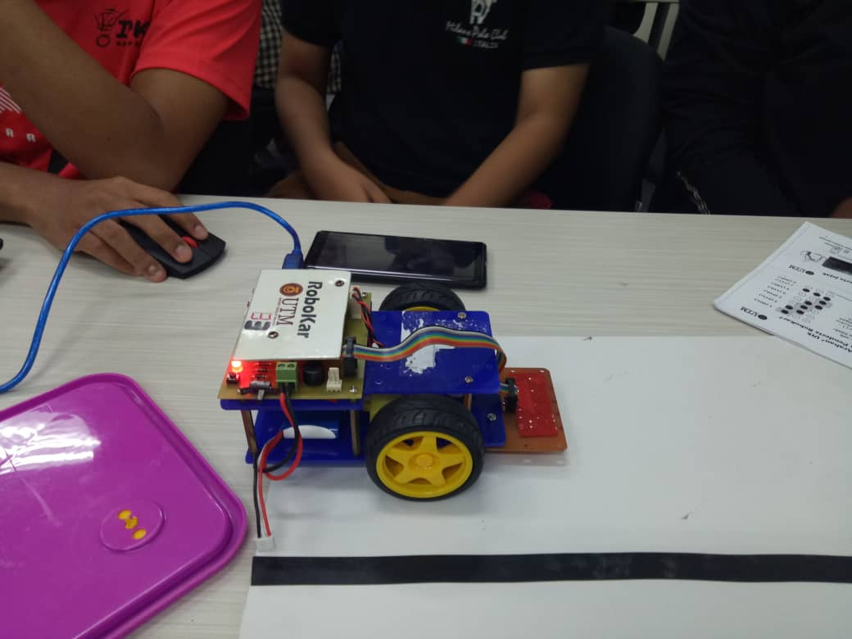

This is the coding for our ROBOKAR. At first we thought the coding would be complicated as we have studied things that is beyond our level. However, the coding is pretty simple, the Robokar have three sensors each detects a route, all we do is code when and how fast for the Robokar to move. For instance, in the code says if sensor detect number ‘2’ it goes straight which basically the code is simple as that.

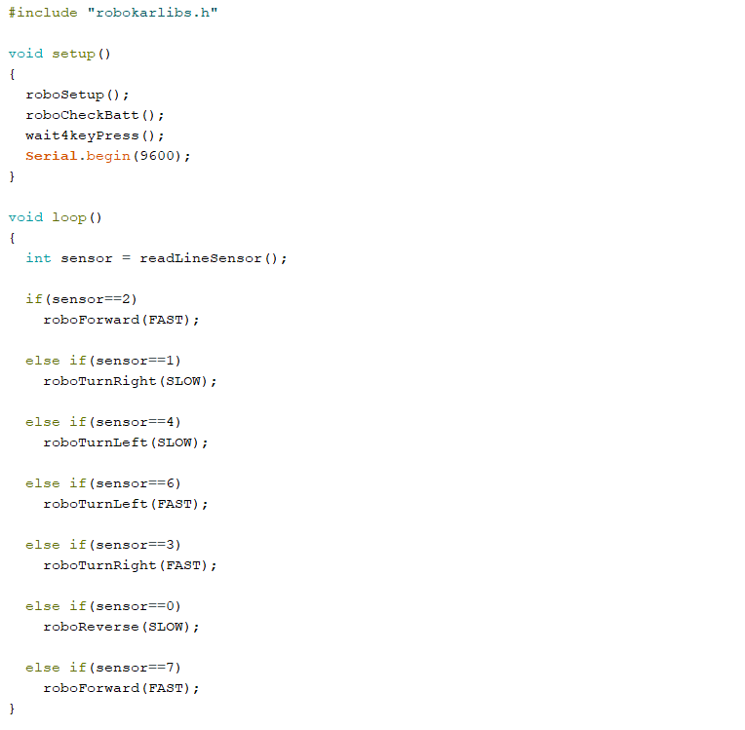

**Students’ Feedback (Reflection)**

**What you have learnt from the workshop?**

This workshop has benefited us in a lot of ways. Firstly, this workshop has highlighted the importance of creative and critical thinking in solving problems within a short period of time. Majority of the groups’ robots passed the obstacle course. However, there were two groups’ robots that run very smoothly and without doubt faster than others. This explains a lot on how creative and critical thinking in writing the program will give the finest results. Secondly, this workshop has given everyone the opportunity to be involved in a robot related activity. The presenters did a good job in explaining how the robots work with the program written. Other than that, we have also learnt on how to program a simple robot, which is a wonderful experience that might help us as learning how to code is the fundamental of software engineering. We also learnt that we have to learn from our mistakes in order to improve. Each time we upload the codings into the robokar, we would test it afterwards just so we can take a mental note on how it works and how it could be improvised.

The workshop also improves team-working skills which is an important skill that should be sharpened in order to secure a better job. Everyone was entitled to their own opinions on how the robokar should be coded. Thus, we ended up testing each of the codings suggested just so we could come to a mutual agreement at the end. It was when we combined our ideas that we were finally satisfied. Even though it was not perfect, but everyone was happy that the robot managed to complete the obstacle course. Teamwork skills were definitely sharpened during the workshop. Through that, I learnt that teamwork makes the dream work. This workshop was an eye opener to some of us since it helped us not only learn more about programming, but also made us want to try advanced stuff related to these kind of style. Some of us joined the robokar team because of it.

Moreover, we learnt that every problem in life has a way of completing it, it was not always one way in order to complete a certain problem. When it comes to redoing a work that has been done before, many people thought that there is no other way of doing it rather than the way it was done before. Not everything in life must be done in one way, if it works, it works!

**How does this workshop impact on your goal/dream with regard to your program?**

It cannot be denied that by participating in Robokar: Robot Programming Workshop, we have successfully gained new knowledge that surely will impact us as the future software engineers. First and foremost, the workshop has made us realize that our program, Software Engineering acts as one of the important forces for the human being to achieve success in terms of technology. On top of that, the inventions of great software and programs are also the primary factors that have and will help the human to create new inventions of technology that are beyond the expectations. For instance, in our group, some of us have never been involved in any kind of program related to robot programming workshop. All of us were very excited during the process of programming the Robokar. Each of us brainstorm and discuss on how to make the perfect program in order to make the Robokar move smoothly on the track given. It made us realize that Software Engineering does not solely focuses on one thing. It is in fact, very wide and that we should explore more about it. It also made us realize that we will be dealing with the future. With this prior knowledge of robotic programming, it must be useful. Especially when the world will rely on machines and robots soon in the future. We were often told that we are the future. Because of that, we should be working harder to satisfy the helpful needs of the future generations.

**What is the action/improvement/plan necessary for you to improve your potential in the industry?**

Our plan to improve our potential in the industry is by participating in a lot of workshops related to software engineering. By participating in these kinds of workshops, we can gain new skills that cannot be obtained from lectures. Lectures and classes mainly teach us theoretical inputs. By participating in these workshops, we can get more insight on how this industry works. These workshops can also teach us to think creatively and critically in problem solving. Moreover, we believe that we have to gain more knowledge regarding the issues influencing technology throughout the world and that we must try to be more open minded and listen to the users’ concern regarding technology to be able to relate to them and create a solution. It would also be better if we pay some contributions to projects for experience and to enhance our credibility. In order to be successful and noble employees, we should never look down on the ethical values we need to implement when dealing with technologies. We develop technologies or applications with the sole purpose of helping people and to ease their work. It should never be something that could bring disadvantages and lead to non-moral activities. In this case, it all depends on us whether to use our potential for the good things or be hooked to the bad side. Thus, it is necessary to improve on implementing good values in ourselves.

