**CURRICULUM VITAE**

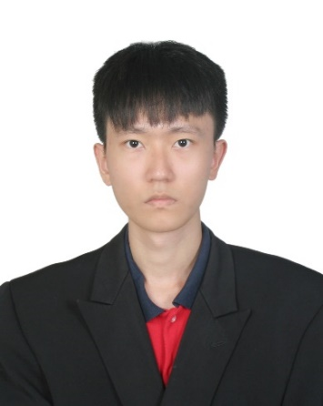

**PERSONAL PARTICULARS**

Name : Lau Jia Ming

I/C no. : 951227-01-5981

Citizenship : Malaysia

Age : 23

Marital Status : Single

**CONTACT INFO**

Address : 16, Jalan Hulubalang 7,

Taman Ungku Tun Aminah,

81300 Skudai, Johor.

Email : [lau_jiaming@ymail.com](mailto:lau_jiaming@ymail.com)

Telephone : +6075579253 (home)

+60189426110 (mobile)

**EDUCATIONAL BACKGROUND**

2015 – Now Bachelor of Engineering (Mechanical-Materials)

University : Universiti Teknologi Malaysia (UTM)

CGPA of semester 1- 5 : 3.93

Current GPA (semester 5) : 3.85

Major courses : Engineering Mathematics, Differential Equation, Programming for Engineers, Engineering Drawing, Statics, Dynamics, Mechanics of Solid, Mechanics of Fluid, Thermodynamics, Applied Thermodynamics and Heat Transfer, Material Science, Mechanics of Machine & Vibration, Manufacturing Process, Control Engineering, Component Design, Industrial Engineering.

2013 – 2014 Sijil Tinggi Persekolahan Malaysia (STPM)

Institute : Maktab Sultan Abu Bakar (English College), MSAB (EC)

Field of Study : Physics

CGPA : 3.67

2008 – 2012 Sijil Pelajaran Malaysia (SPM)

Institute : Maktab Sultan Abu Bakar (English College), MSAB (EC)

Field of Study : Science stream

Grade : 7A 3B

**LEADERSHIP**

2013 Secretary, Form 6 Ping Pong Competition, MSAB (EC)

2013 – 2014 Treasurer, Bulan Sabit Merah Malaysia PBS-19, MSAB (EC)

2013 – 2014 Chief of Planning Department, Ping Pong Club, MSAB (EC)

2014 Coordinator, Ping Pong Competition (Johor Bahru District), MSAB (EC)

2016 – 2017 Treasurer, UTM-IMM Student Chapter, UTM

2017 Director, UTM-IMM Community Service, UTM

2017 Technical Committee, MPIT 2017, UTM

2017 Protocol Committee, UTM Archery Workshop and Tournament, UTM

2017 – 2018 Vice President, UTM-IMM Student Chapter, UTM

**ACHIEVEMENT**

2014 Champion of MSAB Foot Drill Competition

2014 Smart Tutor for STPM Mathematics

2014 Credit in Australian Mathematics Competition (Senior Division)

2015 – 2017 Dean’s List holder for semester 1, 2, 3, 4

2016 – 2017 Anugerah Mahasiswa Terbaik

**SKILLS**

IT : Familiar with Word, Excel and PowerPoint

Basic knowledge in SolidWorks and C programming

Languages : Mandarin, English, Malay