

TECHNOLOGY AND INFORMATION SYSTEM (SCSP1513)

**DESIGN THINKING**

**INPUT AND OUTPUT**

PREPARED FOR:

DR. ARYATI BINTI BAKRI

PREPARED BY:

KHAIREENNUR KHALIESHA BINTI MOHAMAD JAIS

(A19EC0300)

LOKESSH A/L PATHMANATAN

(A19EC0077)

MUHAMMAD HALIM BIN JOHAR

( A19EC0097)

CONTENTS

INTRODUCTION 3

DETAIL STEP 4

A. Discussion 4

B. Brainstorm the idea. 4

DESIGN THINKING EVIDENCE. 6

A. EMPATHY: 6

B. DEFINE 9

C. IDEATE 9

D. PROTOTYPE 9

THE TASK FOR EACH MEMBER 11

REFRENCES 12

# INTRODUCTION

Our goal in this project is how we solve the problem for input and output. Also we want to

get more information about input and output. Input and output, or formally known as IO is the communication between an information processing system, such as a computer, another human, the whole world and also possibly another information processing system. Inputs are the signals that are received by a system and output are the signals/data sent from it. Input devices convert what we understand into what the system unit can process. Output devices convert what the system unit has processed into a form that we can understand.

Output devices can received data from another device and generated output with data, but it cannot send data to another device. Examples of output device include the following. Types of output like text, graphics, videos , audio.

Most devices are only input devices or output devices, as they can only accept data input from user or output data generated by a computer. However, some devices can accept input and display output, and they are referred to as I/O devices(input/output devices).

The aim in this project is how we find a problem on input and output and the process solving it. We solve the problem with the design thinking method. Beside, it make us thinking more creatively and effectively.

# DETAIL STEP

## Discussion

* We make a discussion together about this report. Identify the problem and make a brainstorming.

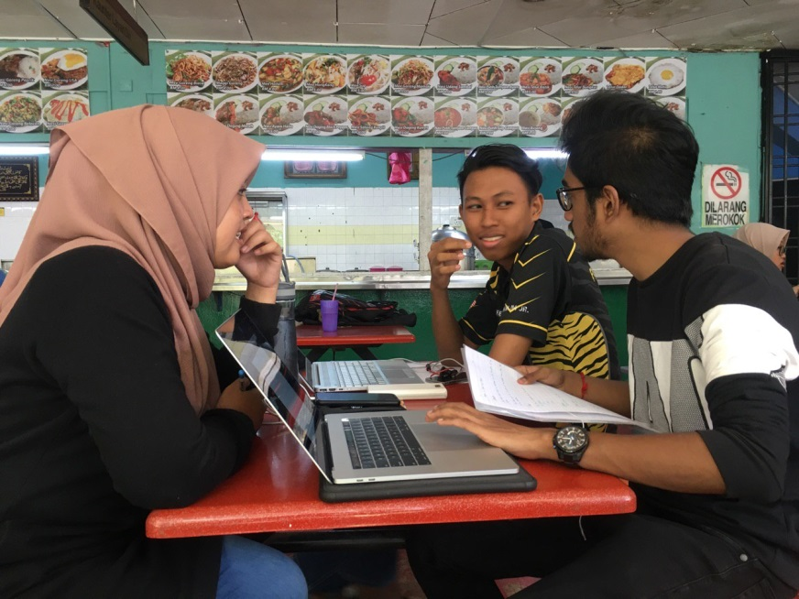

*Figure 1 Discussion about the problem*

## Brainstorm the idea.

* We combine all the idea onto the paper. We write the problems, the solving and else.

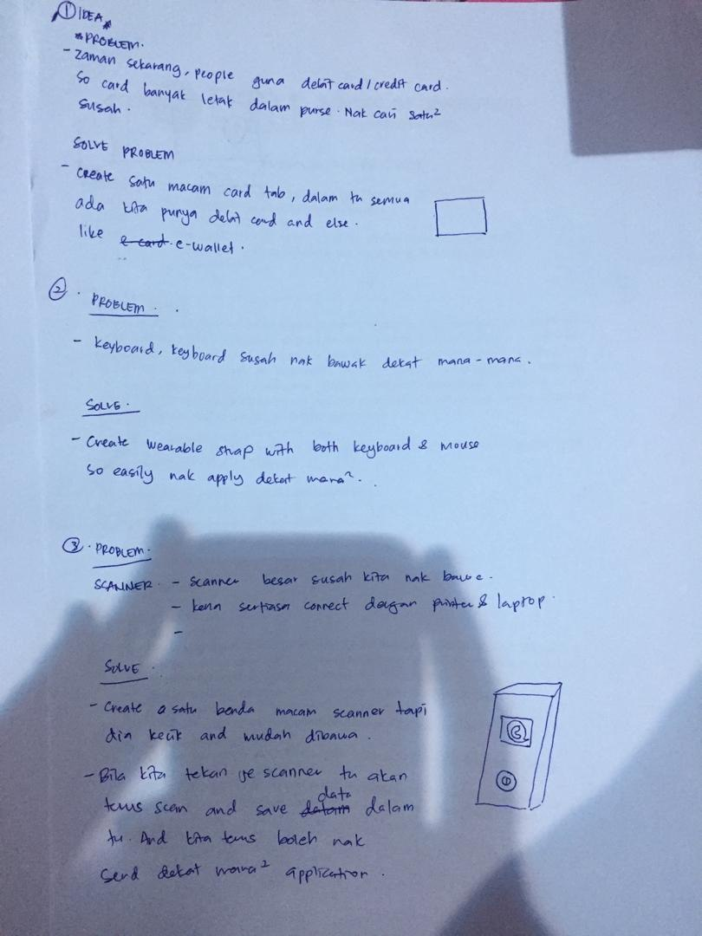

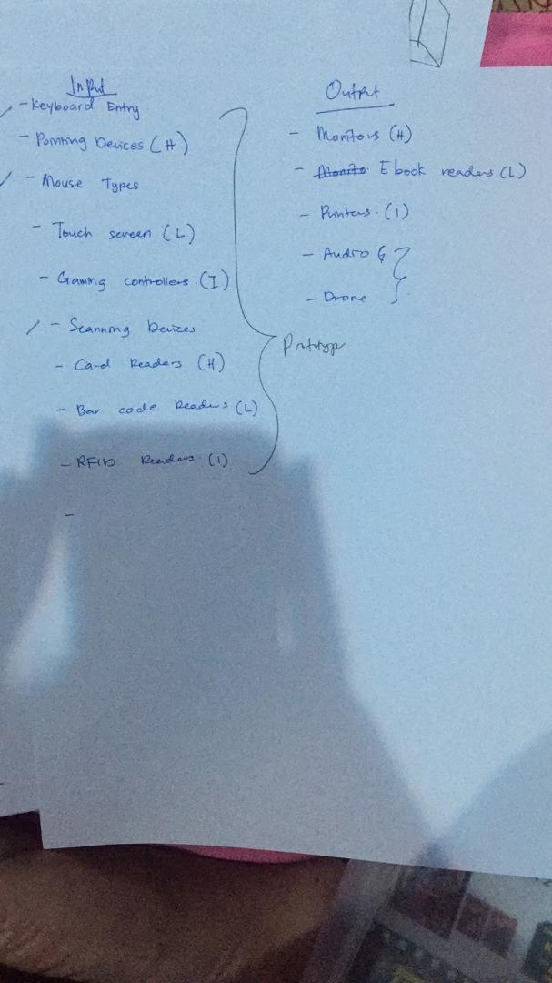

*Figure 2 and Figure 3 Brainstorm idea*

* We already write the input and output devices on that paper, already list the function of that device. We find the problem of each devices, and the trying to solve the problems. For the example we just choose scanner for input and output. For us, scanner is to big and heavy to bring anywhere. Scanner must be connected to computer every time that you want to used it. So it make burden when you want to use urgently.

# DESIGN THINKING EVIDENCE.

## EMPATHY:

* Questions for user:
* What did you know about input and output?
* How long did you use input and output?
* What the problem when you use input and output?
* What is your suggestion for improvement to input and output?
* Users 1
* Name: Mrs. Siti Hajar Binti Mohamad Noh
* Age: 40 years old.
* Department: Multimedia Unit At CICT.
* 1)What did you know about input and output?

“Input is the things that what we send to output, and the output is the

Result that we get from input.”

* 2) How long did you use input and output?

“According to my experience, I’ve been used input and output everyday. Right now, I and my team are build a mobile app. Mobile app input is come from API (Applications Program Interface) in mobile. For example, when filling in an online form, the input comes from the user itself. But for information that is already being displayed on the web, that is considered as an output because the input has already been done by another user.”

* 3) What the problem when you use input and output?
  + - * + “The problem that we are faces when we used the mobile apps is the rapid increase in the development of technology. The easiest and clearest example is our UTM app itself in the Google Play Store and Apple AppStore. For those users who are on the older versions of the software, they can't download the app, and thus not being able to stay up to date with the latest information. “
* 4) What is your suggestion for improvement to input and output?
  + - * + “ For me, to make improvement for mobile context, mobile is a things that use for a new technology and must be use using IOT. If for new technology like we do, can be links with the devices like a sample, when we used the mobile app we can control the Air-conditioner, control the projector and else. With input and output, like any types of mobile devices such as Samsung or apple, they have a applications that can be use like trace your phones.”
* User 2
* Name: Mr. Mohamad Jais Bin Mohd Jamil
* Age: 51
* Department: Multimedia at Hal Ehwal Koprat
* 1)What did you know about input and output?
* “ Firstly when we look at input is convert what we understand into what the system unit can process, while output for me is convert what the system processed into a form that we can understand. For the example like output is printer, VGA through projector and HDMI used for output.
* 2) How long did you use input and Output?
* “ I’ve been working in Multimedia and I’m used for input and output. Because it is in my scope job. Input that I’ve be used like microphone , HDMI cable , mouse and else. And for the output , we will use HDMI for projector to display.”
* 3) What the problem when you use input and output?
* “ The problem when I use input and output is like out of battery for mouse wireless. And for the VGA pins, the pins always broken. And there is certain computer need to set up or need to adjust for input and output. That all for the problem in input and output.”
* 4) What is your suggestion for improvement to input and output?
* “My suggestion for improvement to input output is, they need to make more input output devices more wireless, so its easy to bring and use anywhere”

## DEFINE

From the results of our interviews, we found that the problems faced were improvements in input and output. They want input and output from time to time, as it can ease their burden. They want the all the devices are wireless and can bring anywhere without need to be charged. Other than that, for system

## IDEATE

After the discussion about the problem, we agreed to make an innovation for input and output. With an idea example scanner. Scanner is so big and its cant be bring to anywhere. Beside, scanner must be connected to computer to scan data and save to the computer. So, we agreed to make innovation that we want do a wireless scanner that can be bring to anywhere, and can be used in anytime.

## PROTOTYPE

First we sketch onto a paper. And then using box and papers we create it and then we cut it and it will become a rectangle boxes. After that, we make it like a wireless scanner.

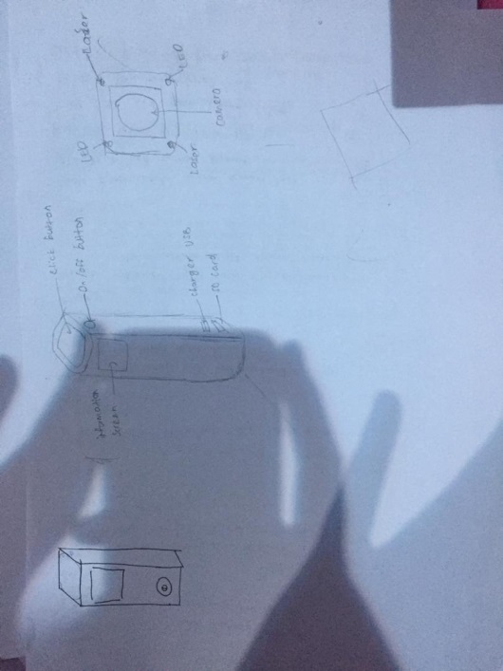

*Figure 4 The idea for the prototype.*

REFLECTIONS

So my goal is to make sure that I understand every part of my course by the time I graduate. I am determined to excel at programming and try my very best to enjoy every part of my 4 year journey in the university. My one and only dream is that, I want to be able to do coding just by reading the question and not use any reference materials.

Design thinking helped me to think ‘out of the box’ more often than I usually do for all my other works. It helped me learn more on doing proper research, being more creative on solving any problems and also revising materials beforehand to ensure that I can understand every part of the topic to have a better understanding and thus give better explanation to others. This helped me for my graphics and multimedia course too, by helping me think harder and deeper on new ways to come up with ideas, instead of just recycling old ideas and making slight alterations to further enhance its features.

To further improve myself, I have learned that I have to do more reading and research on the existing technologies and have a better thought process on what new things that could be done in the future to help improve people’s life. I also have learned that I need to do more practical work instead of just depending on theories and explanations.

# THE TASK FOR EACH MEMBER

1. Khaireennur Khaliesha Binti Mohamad Jais A19ECO300

* Report making
* Filming
* Prototype material gathering

1. Lokessh A/L Pathmanatan A19EC0077

* Report making
* List of ideations
* Design of prototype

1. Muhammad Halim Bin Johar A19EC0097

* Videographer
* Filming
* Prototype material gathering
* List of ideations

# REFRENCES

Video link : <https://www.youtube.com/watch?v=kNdQQr-brrU&feature=youtu.be>