

**UBSS1032 - 40**

**INTRODUCTION TO ENTREPRENEURSHIP**

**EXPERIENTIAL ENTREPRENEURIAL ACTIVITY**

**GROUP NAME :** VIOLETTE

| **NO.** | **NAME** | **MATIRC NO.** |
| --- | --- | --- |
| 1 | KONG JIA ROU | A20EC0198 |
| 2 | NAYLI NABIHAH BINTI JASNI | A20EC0105 |
| 3 | MADINA SURAYA BINTI ZHARIN | A20EC0203 |
| 4 | FARAH IRDINA BINTI AHMAD BAHARUDIN | A20EC0035 |

**LECTURER :** FAUZAN KHAIRI BIN CHE HARUN

**Table of Contents**

**1.0 Introduction** **3**

1.1 Goal, Vision and Mission 3

**2.0 Description of Products and Price** **4**

2.1 Product 1 : Crunchy Chocolate Chips 4

2.2 Product 2 : Sambal Chegu 6

**3.0 Organization Chart** **8**

**4.0 Sales Report** **9**

**5.0 Social Media Visibility** **18**

5.1 Teaser 19

5.2 Promotion (Posters) 20

5.3 Hard Sell and Soft Sell 22

**6.0 Business Registration** **23**

**7.0 Conclusion** **24**

# 

# 1.0 Introduction

Our group, Violette Enterprise, is selling a variety of chocolates and sambals. It is made from nutritional mixes that have a natural, halal nutritional value and can be served as a student or employee's snack. It is incredibly healthy and fits a student's or employee's nutritional requirements. It comes in the form of a bar, has a delightful taste, is easy to carry around and is simple to keep.

Our targeted customers are children, school pupils, university students, employees, the elderly, the forgetful, and individuals who get tired and nervous rapidly. This is because it is a nutritious product that enhances mental vitality, increases memory recall, relieves stress, improves self-confidence, and offers a filling, unique, and stimulating IQ and mind.

## 1.1 Goal, Vision and Mission

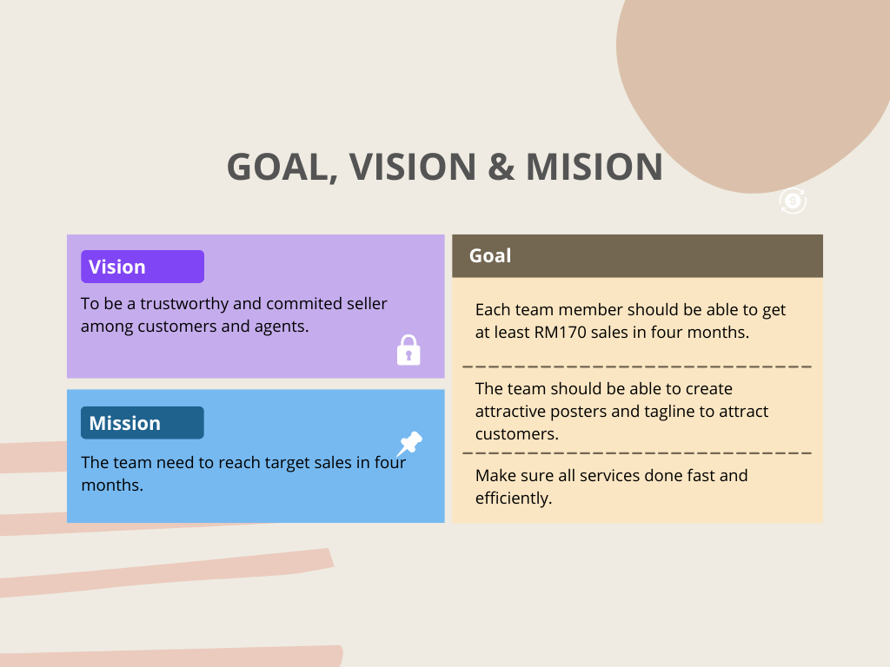

# 

# 

# 

# 

# 2.0 Description of Products and Price

Two major products we sold in our business are Crunchy Chocolate Chips and Sambal, a special product promoted during Ramadan.

## 2.1 Product 1 : Crunchy Chocolate Chips

Brand name : Cocodamia

Company name : Pelangi Network Management Sdn Bhd

Sales gallery : GO JB Chocolate

| **Product** | **Description** | **Variation** | **Weight/g** | **Price/unit** |
| --- | --- | --- | --- | --- |
|  | Pieces of crunchy dark chocolate chips : 30 pieces  Ingredients :  Sugar, Vegetable fat, Whey Powder, Cocoa Powder, Full Cream Milk Powder, Cornflake, Emulsifiers, Natural Vanilla  May contain trace of nuts | Dark | 300 | 20.00 |
|  | Pieces of crunchy milk chocolate chips : 30 pieces  Ingredients :  Sugar, Vegetable fat, Whey Powder, Cocoa Powder, Full Cream Milk Powder, Cornflake, Emulsifiers, Natural Vanilla  May contain trace of nuts | Milk | 300 | 20.00 |
|  | Pieces of crunchy mocha-flavored chocolate chips : 30 pieces  Ingredients :  Sugar, Vegetable fat, Whey Powder, Cocoa Powder, Full Cream Milk Powder, Cornflake, Emulsifiers, Natural Vanilla  May contain trace of nuts | Mocha | 300 | 20.00 |
|  | Pieces of crunchy yam-flavored chocolate chips : 30 pieces  Ingredients :  Sugar, Vegetable fat, Whey Powder, Cocoa Powder, Full Cream Milk Powder, Cornflake, Emulsifiers, Natural Vanilla  May contain trace of nuts | Yam | 300 | 20.00 |
|  | Pieces of crunchy banana-flavored chocolate chips : 30 pieces  Ingredients :  Sugar, Vegetable fat, Whey Powder, Cocoa Powder, Full Cream Milk Powder, Cornflake, Emulsifiers, Natural Vanilla  May contain trace of nuts | Banana | 300 | 20.00 |

## 2.2 Product 2 : Sambal Chegu

| **Product** | **Description** | **Variation** | **Weight/g** | **Price/unit** |
| --- | --- | --- | --- | --- |
|  | Ingredients :  Petai, anchovies, onion, chili, salt and sugar  Freshly-made Sambal, suitable to store in cool places after opening. Ready to eat. Suitable to eat with white rice, fried rice, fried noodle, roti canai and more. | Sambal cili padi bilis petai | 220 | 20.90 |
|  | Ingredients :  Salted mackerels, onion, dried chili, salt, sugar and seasoning.  Suitable to store in dry places under room temperature. Ready to eat suitable to eat with white rice, fried rice, porridge and more. | Sambal tenggiri masin | 160 | 19.90 |

# 

# 3.0 Organization Chart

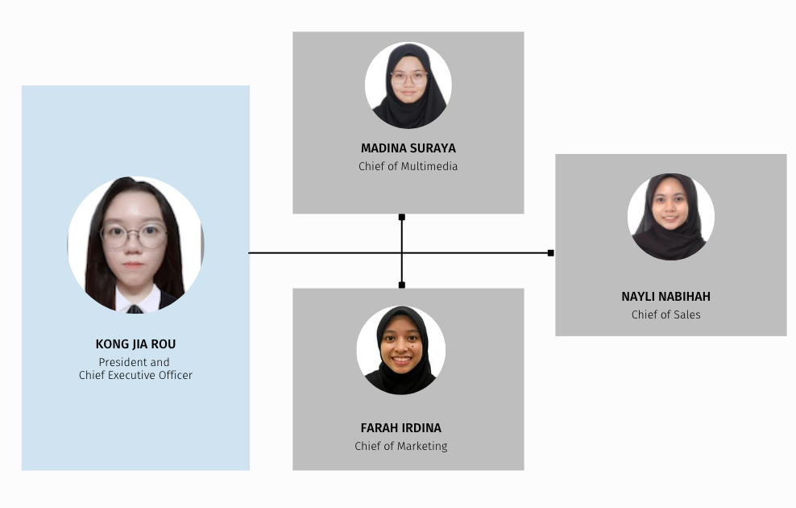

President and Chief Executive Officer

* Distribute task for each members
* Communicate with supplier
* Business registration
* Receive and drop orders

Chief of Multimedia

* Designing posters for product promotion
* Distribute posters and do promotions on social media

Chief of Marketing

* Upload posts on instagram
* Promote in stories on instagram
* Update latest news on instagram

Chief of Sales

* Keep on track with the sales details
* Manage the calculations from the orders

# 4.0 Sales Report

| **NO.** | **Customer Information** | **Order Details** | **Payment Receipt** |
| --- | --- | --- | --- |
| 1 | | **Name :** | | --- | | Marza Yahya | | **Address :** | | No 14 Jalan 15/2B Seksyen 15, 43650 Bandar Baru Bangi, Selangor | | **Phone no :** | | 0123136850 | | **Email address :** | | dina_zharin@yahoo.com | | | **Order date** | **:** | 25/04/2022 | | --- | --- | --- | | **Order ID** | **:** | 90872872 | | **Tracking no.** | **:** | 650329023235 |  | **Items** | **Qty** | **Price/unit** | **Total/RM** | | --- | --- | --- | --- | | Coklat kerepek (Dark) | 2 | 20.00 | 40.00 | | Coklat kerepek (Mocha) | 2 | 20.00 | 40.00 | | Sambal Tenggiri Masin | 1 | 19.90 | 19.90 |  | **Subtotal** | **:** | RM 99.90 | | --- | --- | --- | | **Shipping option** | **:** | Pos (J&T) | RM 8.00 | | **Shipping fee** | **:** | RM 16.00 | | **Total payment** | **:** | RM 115.90 | |  |
| 2 | | **Name :** | | --- | | Farah Irdina | | **Address :** | | Lot 4410, Jalan Menteri, Off Jalan Tunku Bendahara, 09000 Kulim, Kedah | | **Phone no :** | | 0135335997 | | **Email address :** | | farraedna56@gmail.com | | | **Order date** | **:** | 14/05/2022 | | --- | --- | --- | | **Order ID** | **:** | 91458280 | | **Tracking no.** | **:** | 650330770033 |  | **Items** | **Qty** | **Price/unit** | **Total/RM** | | --- | --- | --- | --- | | Coklat kerepek (Dark) | 3 | 20.00 | 60.00 | | Coklat kerepek (Mocha) | 3 | 20.00 | 60.00 | | Sambal Cili Padi Bilis Petai | 1 | 20.90 | 20.90 | | Sambal Tenggiri Masin | 1 | 19.90 | 19.90 |  | **Subtotal** | **:** | RM 160.80 | | --- | --- | --- | | **Shipping option** | **:** | Pos (J&T) | RM 8.00 | | **Shipping fee** | **:** | RM 20.00 | | **Total payment** | **:** | RM 180.80 | |  |
| 3 | | **Name :** | | --- | | Yasmin Hannah | | **Address :** | | Kolej Kediaman Kinabalu (KK 8), Universiti Malaya, 50603 Kuala Lumpur | | **Phone no :** | | 0164270634 | | **Email address :** | | yasminhannahz@gmail.com | | | **Order date** | **:** | 13/05/2022 | | --- | --- | --- | | **Order ID** | **:** | 91380104 | | **Tracking no.** | **:** | 650330768609 |  | **Items** | **Qty** | **Price/unit** | **Total/RM** | | --- | --- | --- | --- | | Coklat kerepek (Mocha) | 1 | 20.00 | 20.00 |  | **Subtotal** | **:** | RM 20.00 | | --- | --- | --- | | **Shipping option** | **:** | Pos (J&T) | RM 8.00 | | **Shipping fee** | **:** | RM 8.00 | | **Total payment** | **:** | RM 28.00 | |  |
| 4 | | **Name :** | | --- | | Nur Izzati binti Saharizal | | **Address :** | | No 96,Jalan Terus, Kampung Sri Pantai,86800 Mersing,Johor | | **Phone no :** | | 011-12742537 | | **Email address :** | | nurizaati120@gmail.com | | | **Order date** | **:** | 14/05/2022 | | --- | --- | --- | | **Order ID** | **:** | 91458586 | | **Tracking no.** | **:** | 650330769023 |  | **Items** | **Qty** | **Price/unit** | **Total/RM** | | --- | --- | --- | --- | | Coklat kerepek (Dark) | 1 | 20.00 | 20.00 |  | **Subtotal** | **:** | RM 20.00 | | --- | --- | --- | | **Shipping option** | **:** | Pos (J&T) | RM 8.00 | | **Shipping fee** | **:** | RM 8.00 | | **Total payment** | **:** | RM 28.00 | |  |
| 5 | | **Name :** | | --- | | hani nursyamira | | **Address :** | | Mahallah Asma, Universiti Islam Antarabangsa Malaysia, Jalan Gombak, 53100, Selangor. | | **Phone no :** | | 01124401684 | | **Email address :** | | hanisyamira11@gmail.com | | | **Order date** | **:** | 14/05/2022 | | --- | --- | --- | | **Order ID** | **:** | 91458793 | | **Tracking no.** | **:** | 650330769398 |  | **Items** | **Qty** | **Price/unit** | **Total/RM** | | --- | --- | --- | --- | | Sambal Tenggiri Masin | 1 | 19.90 | 19.90 |  | **Subtotal** | **:** | RM 19.90 | | --- | --- | --- | | **Shipping option** | **:** | Pos (J&T) | RM 8.00 | | **Shipping fee** | **:** | RM 8.00 | | **Total payment** | **:** | RM 27.90 | |  |
| 6 | | **Name :** | | --- | | Nur Anis Asyiqin | | **Address :** | | VG 24, Ground Floor, Jalan Plumbum V7/V, Pusat Komersial Seksysen 7, 40000 Shah Alam, Selangor.  Phone Number : 0132240910 | | **Phone no :** | | 0132240910 | | **Email address :** | | anisasyiqin910@gmail.com | | | **Order date** | **:** | 16/05/2022 | | --- | --- | --- | | **Order ID** | **:** | 92147609 | | **Tracking no.** | **:** | 650333102699 |  | **Items** | **Qty** | **Price/unit** | **Total/RM** | | --- | --- | --- | --- | | Sambal Tenggiri Masin | 1 | 19.90 | 19.90 |  | **Subtotal** | **:** | RM 19.90 | | --- | --- | --- | | **Shipping option** | **:** | Pos (J&T) | RM 8.00 | | **Shipping fee** | **:** | RM 8.00 | | **Total payment** | **:** | RM 27.90 | |  |
| 7 | | **Name :** | | --- | | Luqman Ariff | | **Address :** | | MA4 KTDI, UTM | | **Phone no :** | | 0136683008 | | **Email address :** | | luqmanariff2001@gmail.com | | | **Order date** | **:** | 25/5/2022 | | --- | --- | --- | | **Order ID** | **:** | 92678742 | | **Tracking no.** | **:** | - |  | **Items** | **Qty** | **Price/unit** | **Total/RM** | | --- | --- | --- | --- | | Coklat kerepek (Mocha) | 4 | 20.00 | 80.00 |  | **Subtotal** | **:** | RM 80.00 | | --- | --- | --- | | **Shipping option** | **:** | Self collect | | **Shipping fee** | **:** | N/A, combine with Order#8 | | **Total payment** | **:** | RM 80.00 | |  |
| 8 | | **Name :** | | --- | | Nayli Jasni | | **Address :** | | MA4, UTM | | **Phone no :** | | 0192463571 | | **Email address :** | | naylinabihah@graduate.utm.my | | | **Order date** | **:** | 25/05/2022 | | --- | --- | --- | | **Order ID** | **:** | 92678742 | | **Tracking no.** | **:** | - |  | **Items** | **Qty** | **Price/unit** | **Total/RM** | | --- | --- | --- | --- | | Coklat kerepek (Mocha) | 1 | 20.00 | 20.00 | | Coklat kerepek (Banana) | 1 | 20.00 | 20.00 |  | **Subtotal** | **:** | RM 40.00 | | --- | --- | --- | | **Shipping option** | **:** | UTM | RM 3.00 | | **Shipping fee** | **:** | RM 3.00 | | **Total payment** | **:** | RM 43.00 | |  |
| 9 | | **Name :** | | --- | | Iman Jasni | | **Address :** | | F-3-4 KUARTERS KERAJAAN JALAN DUTA, NO.1, JALAN DUTAMAS 3, 50480 KUALA LUMPUR | | **Phone no :** | | 019-2463571 | | **Email address :** | | naylinabihah1911@gmail.com | | | **Order date** | **:** | 12/6/2022 | | --- | --- | --- | | **Order ID** | **:** | 93374618 | | **Tracking no.** | **:** | 650330751278 |  | **Items** | **Qty** | **Price/unit** | **Total/RM** | | --- | --- | --- | --- | | Coklat kerepek (Mocha) | 1 | 20.00 | 20.00 | | Coklat kerepek (Banana) | 1 | 20.00 | 20.00 | | Sambal Tenggiri Masin | 2 | 19.90 | 19.90 | | Sambal Cili Padi Bilis Petai | 4 | 20.90 | 20.90 |  | **Subtotal** | **:** | RM 163.40 | | --- | --- | --- | | **Shipping option** | **:** | Pos (J&T) | RM 8.00 | | **Shipping fee** | **:** | RM 16.00 | | **Discount** | **:** | Last call discount   * Free shipping * 8% discount | | **Total payment** | **:** | RM 150.00 | |  |

# 5.0 Social Media Visibility

# 

## 

## 5.1 Teaser



## 5.2 Promotion (Posters)

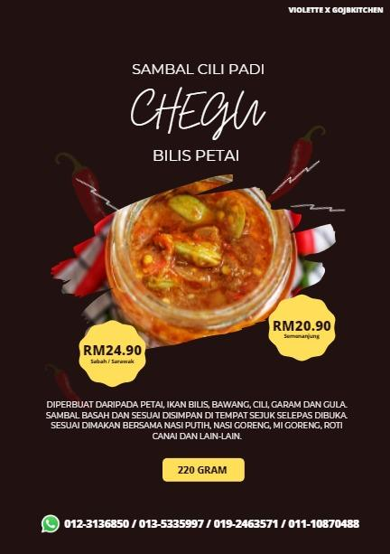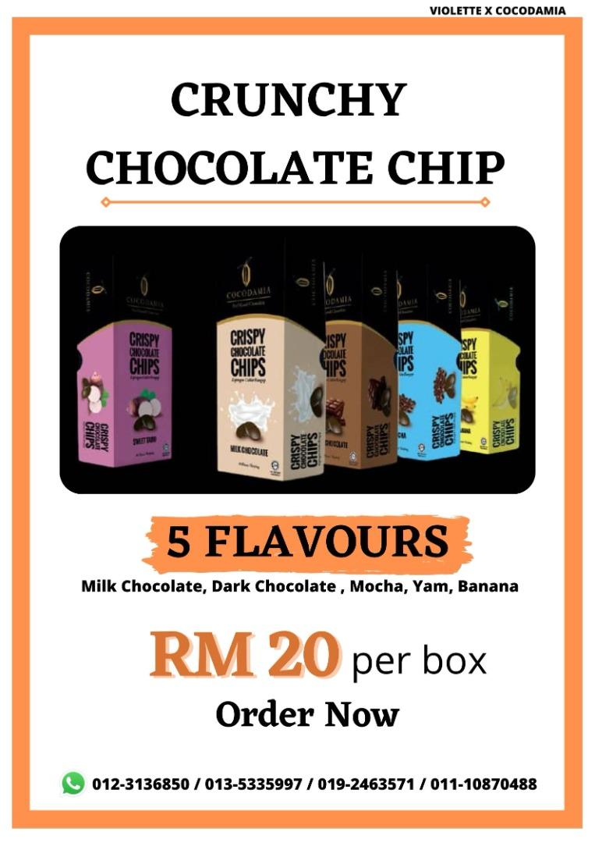

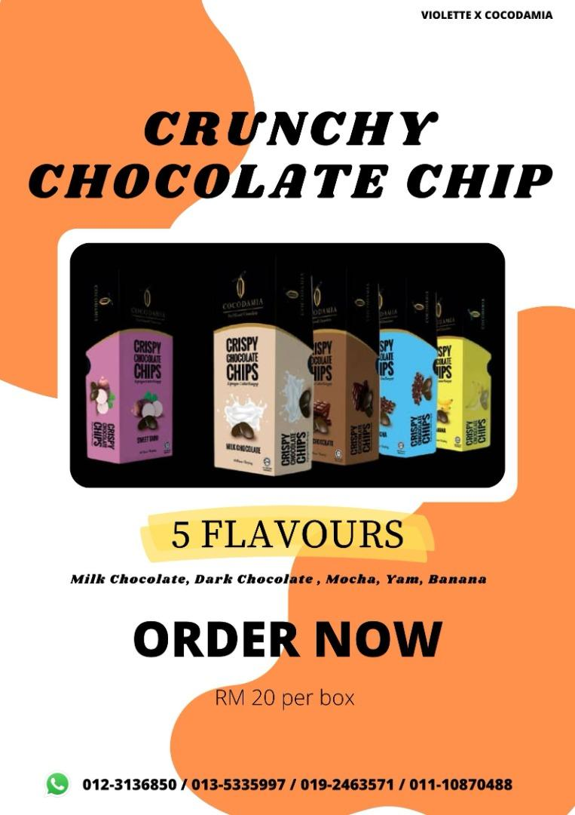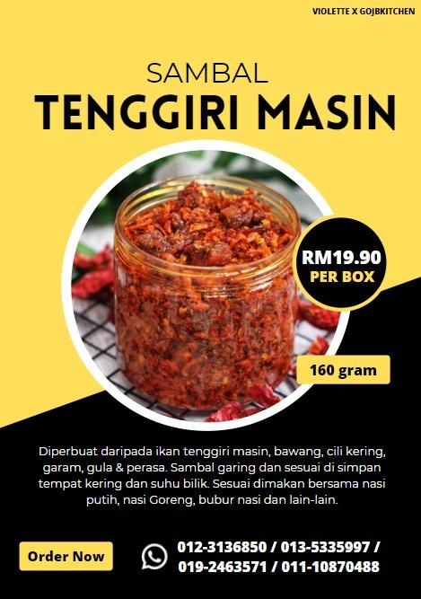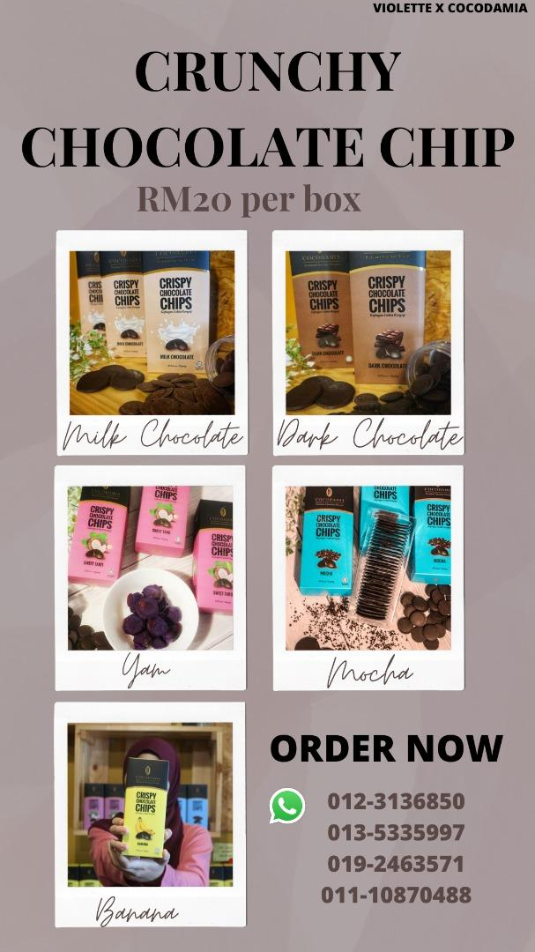

## 

## 5.3 Hard Sell and Soft Sell

# 6.0 Business Registration

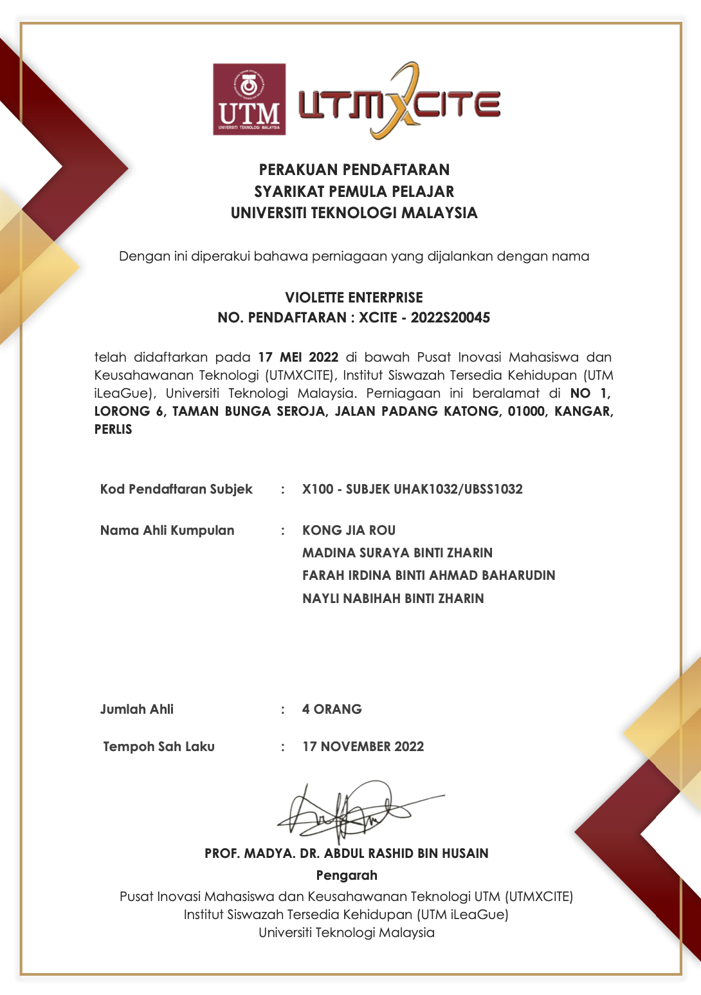

# 7.0 Conclusion

By experiencing the Experiential Entrepreneur Activity, we as a group have gained a new level of knowledge and skills on entrepreneurship that can be applied in the future. This activity has exposed us on how to think as an entrepreneur when it comes to the strategies on creating sales for our own benefits. From the first stage of the process up until the last stage, we have experienced what most entrepreneurs have done, such as creating a marketing plan and financial plan, to ensure our business can sustain and grow bigger. Behind the success of this assignment, not only we as a team have given our best commitments, our lecturer, Dr. Fauzan also has helped us to achieve our goal. With his help, we have managed to gain more tricks and knowledge on how to be better than our competitions. In conclusion, this course has widened our perspectives in the business field as we experience the challenges of managing our own business from the beginning. Overall, we surely can use the knowledge we have learned from this course in our future life.