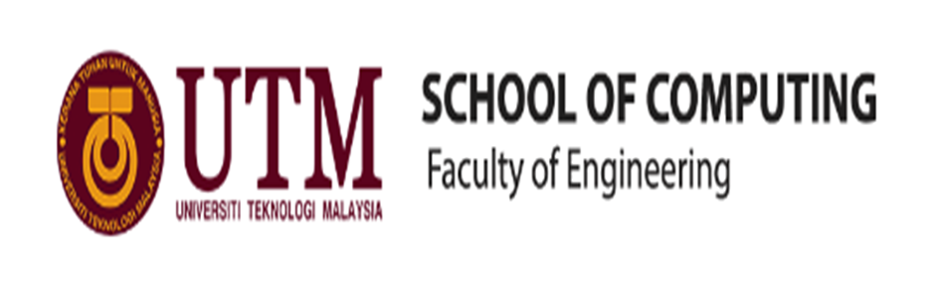

**INDUSTRIAL VISIT – CICT UTM**

**SEMESTER 1 2017/2018**

**TECHNOLOGY AND INFORMATION SYSTEM**

**(SCSP1513 – 09)**

**LERTURE DR. ARYATI BINTI BAKRI**

**BY:**

**LEE CHEN HONG**

**MUHAMMAD ALIFF SOLAHUDDIN BIN NORDIN**

**NUR ASNANI BINTI HASSAN**

**DATE: 1ST OCTOBER 2018**

**VENUE: SEMINAR HALL, LEVEL 4, CICT**

**REPORT DATE: 21ST OCTOBER 2018**

**Table of Contents**

1. Introduction 3

2. Details Of Journey 4

3. Details Description 5

3.1. Organization Structure of CICT 5

4. Services 6

5. Achievements 7

6. Information Systems That Have Been Developed and Maintained By CICT 8

7. Reflection 9

7.1. Goals and Dreams 9

7.2. Impact of Your Goal to Your Course 9

7.3. Impact of Your Goal to Your Course 9

8. Bibliography 10

# Introduction

Centre for Information & Communication Technology (CICT), is located at Universiti Teknologi Malaysia, Block D07, Lingkaran Ilmu, 81310 UTM Campus Johor Bahru. The Centre for Information and Communication Technology (CICT) is responsible to ensure that staffs and students have access to teaching, learning, and research ICT resources by providing the University’s Infrastructure, acquiring, developing and supporting and emerging technologies and system. Plus, CICT also providing access to digital resources across the University’s campuses.

The vision of CICT for UTM is to be “Digital University’s leading provider of academic-oriented services”. The mission of CICT to lead in development of an entrepreneurial digital by fostering innovative digital professionals and promoting collaboration in digital services.

There are 6 objectives of CICT is established. First objective is to increase the adoptation of Information Technology in all University activities. Second objective is to provide guaranteed ICT infrastructure and facilities. Third objective is to become a Reference Center in ICT Service in the University. Fourth objective is to become a Center of Software and Application development in the UTM. The fifth objective is to explore the new technologies in ICT services and implementation. The last objective is to increase ICT competencies of University’s community in UTM.

# Details Of Journey

The journey was held at UTM CICT on 1st October which is starts from 2:00 p.m. until 4:00 p.m. Student who taking course Technology and Information System must attend to this program. In the beginning of the program, a talk was given by Mister Mohd Zahari Zainal Abidin, the staff of CICT at Dewan Seminar. There were many content during the talk such as the history of the CICT, the vision and mission of the CICT and others.

Then, the staff from the CICT bought all of the students to the PPCTP room. The PPCTP room showed the place for staff of the CICT working. After that, students were bought to gallery of the CICT. The gallery shows that the history of machine that had been created such as supercomputer, mainframe, IBM magnetic tape unit and many more.

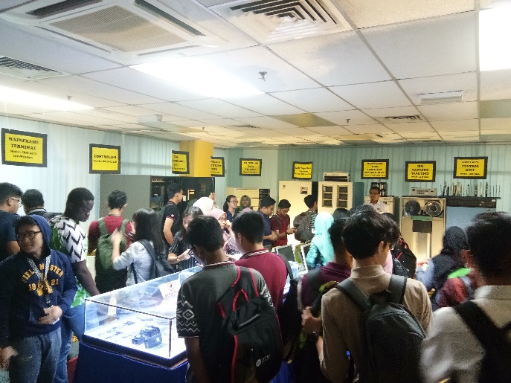

Figure 1 - Gallery of CICT

# Details Description

## Organization Structure of CICT

The head of all the operations in CICT is the director. The director of the CICT is PM Dr. Mohd Shahizan Othman. Another senior management are include Mr. Dr. Mohd Murtadha Mohammad as Deputy Director ADM, Mr. Dr. Syed Nomis Hikmi Syed Abdullah as Deputy Director IOM, Mr. Samsudin Nyat as Deputy Director SM and Mr. Nik Kamal Izuddin Nik Ibrahim as Deputy Director CICTKL.

There are also other senior management such as Mr. Roslai Paimin as CTO, Mr. Jaffar Sidek Haron as CCO, Mrs. Zaiton Salimon as Project Management, and Mrs. Sabrena Omar as Senior Asistant Registrar.

Other member including staff in Application Development Management, Infrastructure and Operation Management, Strategic Management, IT Manager, IT Senior Fellow, IT Academic Fellow and CICT Kuala Lumpur.

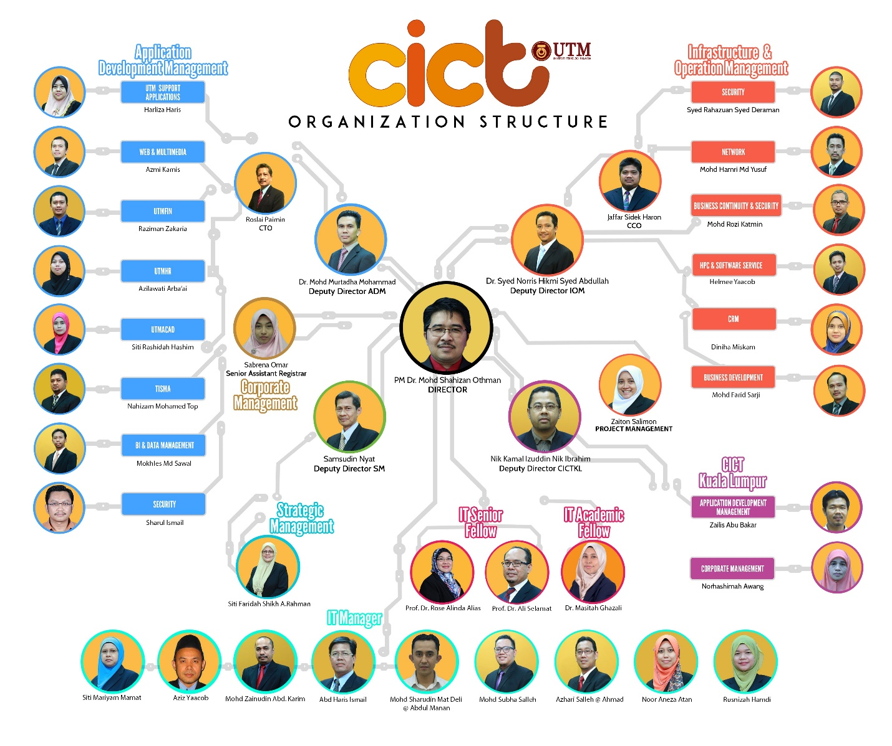

Figure 2 CICT Organisation Structure Chart taken from http://cict.utm.my/organization-structure/

# Services

There are many services that provided by CICT. One of them is ICT services for students which includes ICT services, portal myUTM and software. ICT services include student lab, UTMID, Wi-Fi, and VPN. Firstly, facilities that available at student lab of CICT are have provided 100 Windows Platform computers, has 3 areas project discussion for students, and Specialize Multimedia and Content Authoring Production Lab (SMAL). At student lab also provides services for printing, scanning, CD/DVD burning, binding and laminating but this facilities has charge if you want to utilize it. However, students must be obeyed to UTM Dress Code because at student lab, UTM Dress Code is strictly observed here and students also need wearing matric card to make staffs at CICT easier to known the student’s name. Secondly, Specialize Multimedia and Content Authoring Production Lab (SMAL) has provides software available includes Final Cut Pro, DVD Studio Pro, Sound Track Pro, Color, Aperture, Motion, iLife, adobe Suite, Roxio Toast and SDK. For example, Mac pro, lightning and Chroma key, whisper room, DVD printer and mixer. Thirdly, UTMID /ACID which represent to Academic Computing ID is an unique User ID for UTM community to login to most of University main application system. The users for UTMID are for all full-time and part-time students and the url for ACID is http://acid.utm.my. Fourthly, Wi-Fi UTM to access UTM intranet and internet for UTM Skudai Campus. The step to connect with UTM Wi-Fi are turn on wireless device and select UTMWiFi from wireless then , open internet browser and key in ACID account. Fifthly, Virtual Private Network (VPN) is for students to access UTM intranet services from outside UTM campus such as software repository and database from UTM library. Note, UTMID is use to login to use VPN.

There are 4 UTM Wi-Fi Acceptable Usage Policy. Firstly, the service provided is a privilege and not a right. All students, staff and guest are expected to practice responsible computing and internet accessing and to adhere to ICT Policy when accessing UTM Wi-Fi network. Secondly, user are need to comply with Malaysian copyright law and the copyright policy of UTM. Copying, downloading or electronic transferring of copyright materials without proper authorization is prohibited. Thirdly, any misuse or abuse of the network services and facilities that constitutes a violation of UTM ICT Policy could result in disciplinary procedures through UTM Legal Office. Fourthly, the Wi-Fi UTM network connection may be subject to monitoring for security, legal or troubleshooting purposes by the Office of CICT, UTM. This may include monitoring for bandwidth and quota usage, security related incident, or a request from law enforcement authorities.

Other than that, ICT Services for students that provided by CICT is portal myUTM which includes students management services and ICT instructional services. Academic Information Management System (AIMS) and Students Financial System are some example of student management services while e-Learning, e-PPP and e-Portfolio are example for ICT Instructional Services. E-learning is an educational portal that assists student and lecturers in the teaching and learning process to be more effective and flexible plus ACID also needed to use for login this website. E-PPP is a web application for the Lecture’s Teaching Evaluation which enables students to evaluate and give comments on lecturer’s teaching performance. E-Portfolio is an online compilation of documents that is flexible and is based on artifact evidences of which students are directly involved in a continuous reflection process towards their own learning, reporting the progress of their achievement on knowledge, technical and generic skills, and plan their personal, academic and career development.

# Achievements

There are many achievement that CICT has earned. Firstly, on 22 November 2017, the CICT team has successfully provided the best technical documents and at the same time bring the University received the SAGA (Standard Accounting System for Government Agencies) 2017 Award which was submitted by the Accountant General of Malaysia. UTM is among 59 of 416 agencies that have successfully received SAGA Compliance Certificate recognition other than USM, UPSI, UMP, UPNM, UNISZA, UTHM and UPM. The impacts from SAGA certification are system integration, consumer access control, secure data security, and UTMFin-innovation products recognized by the Accountant General.

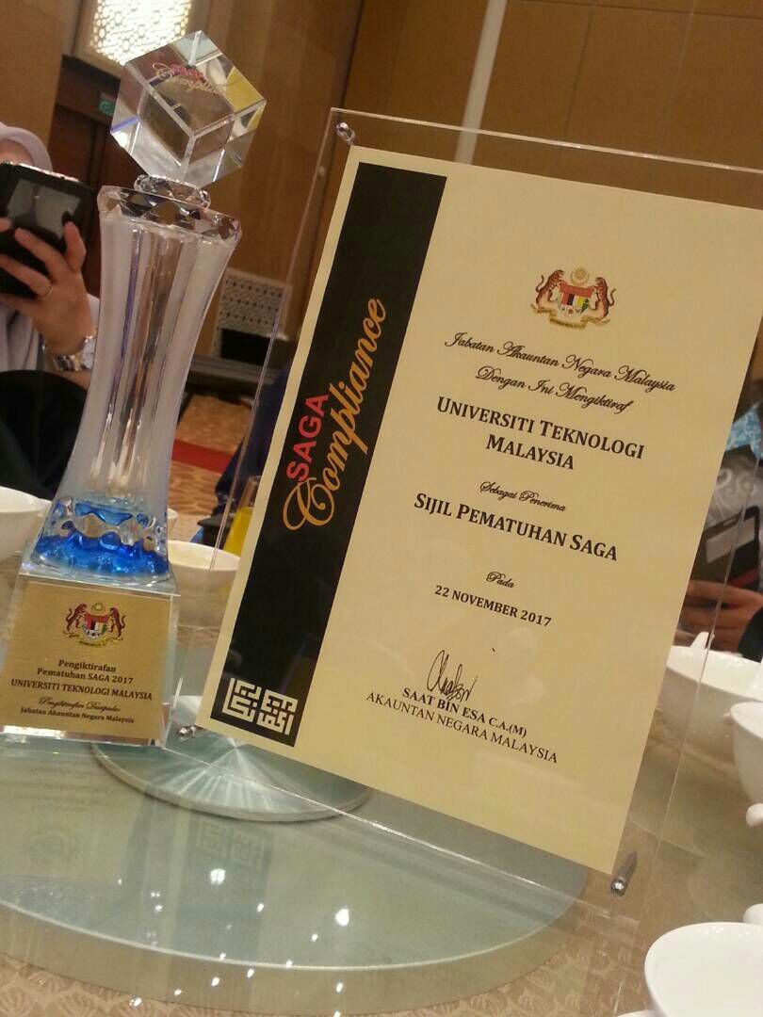

Figure 3 SAGA Compliance Certificate taken from <http://cict.utm.my/ict-knowledge-repository-2/>

Besides that, on 7 February 2017, at the Azman Hashim Stadium in UTM Johor Bahru Centre Information and Communication Technology (CICT) for being the most active PTJ at ‘Senamrobik Perdana Siri 2/2017’ for the Arcturus Zone. This is because commitment and enthusiasm of all CICT residents who have made this program a success.

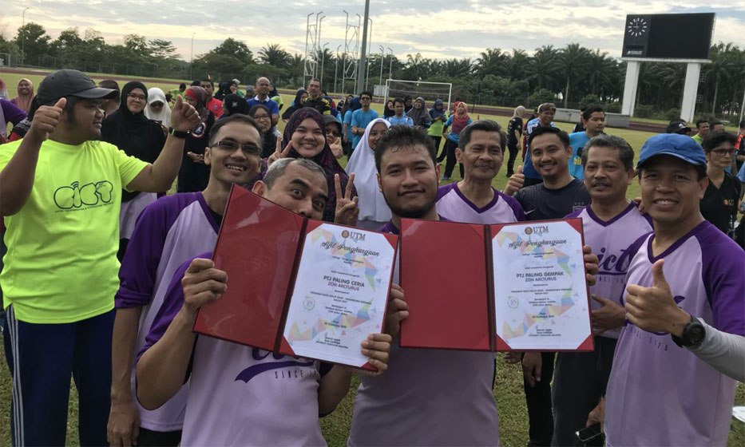

Figure 4 PTJ Gempak taken from <http://cict.utm.my/ict-knowledge-repository-2/>

Furthermore, on 1 December 2017 CICT which UTM Data Centre successfully awarded Certified Datacenter Design Tier (About vision and mission CICT, 2018) (About Achievement CICT in 2017, 2017)3. The facilities that have at UTM Data Centre are network room, server room, genset, computer room air conditioning system, and DCIM (Data Center Infrastructure Monitoring).the impact for the UTM Data Centre are green technology and longer lifetime for ICT equipments.

# Information Systems That Have Been Developed and Maintained By CICT

There are many system development had been done by CICT. Example of the developed system are Administrative Applications Development Tools and Technology, Teaching and Learning Applications Development, Support Applications Development, Web Applications Development, Montage and Video Production, User Requirement Specification, Documentation preparation, Mobile & Web Programming.

The tools used in development including PHP, HTML5, JavaScript, JQuery Mobile, PhoneGap, ASP.Net and Java Programming. Another applications used are Android Studio, XCode, AppBridge, Ionic Framework, MySql, Oracle and XAMPP.

# Reflection

## Goals and Dreams

After had listened to the talk, we had thought to have some goal and dream to the future of ourselves and CICT UTM. Firstly, we hope we can join ourselves in the development of information system of CICT. We also hope it can help CICT to improve it service to the users of UTM members. We also hope that there are some new services and technologies will exploited by CICT UTM that benefit to all users in UTM.

## Impact of Your Goal to Your Course

The impact of this program to our course is we can know the evolution of all the machine that were showed during visit the CICT. As a computer student, this basic knowledge is very important to know the history of computer. When we gain this knowledge, we can know how the machine works and use them in our daily life.

Being a computer science major also involves identifying a problem and coming up with a technological solution to address it. This requires having strong analytical skills that enable us to understand the issue we are dealing with and solves different solutions in order to find the one that best fits our needs.

## Impact of Your Goal to Your Course

The impact of this program to our course is we can know the evolution of all the machine that were showed during visit the CICT. As a computer student, this basic knowledge is very important to know the history of computer. When we gain this knowledge, we can know how the machine works and use them in our daily life.

Being a computer science major also involves identifying a problem and coming up with a technological solution to address it. This requires having strong analytical skills that enable us to understand the issue we are dealing with and solves different solutions in order to find the one that best fits our needs.

# Bibliography

1. *About Achievement CICT in 2017*. (2017). Retrieved from Centre for Information & Communication Technology(CICT) : http://cict.utm.my/ict-knowledge-repository-2/

2.  *About Organization Structure of CICT*. (2018). Retrieved from Centre for Information & Communication Technology(CICT): http://cict.utm.my/organization-structure/

3.  *About vision and mission CICT*. (2018). Retrieved from Centre for Information & Communication Technology(CICT): http://cict.utm.my/vision/

4. CICT. (2015). *About Students ICT Services*. Retrieved from file:///C:/Users/carlos/Downloads/Documents/Student_Ict_Service-2015_UGc.pdf

5. CICT. (2018). *About Services Information of CICT*. Retrieved from Centre for Information & Communication Technology: file:///C:/Users/carlos/Downloads/Documents/CICT-Services-Information-2018.pdf