TYPE WRITER AND KEYBOARD

The type writer keyboard was developed and patented in [1868](https://www.computerhope.com/history/1800.htm) by [Christopher Sholes](https://www.computerhope.com/people/christopher_sholes.htm) and is considered to be the first typewriter but it only become famouse usage in office until mid-1880s.

The type writer keyboard is a mechanical or electromechanical machine for writing similar character. It has an array of keys and each of it can causes different type of single character which can be produced onto the paper.Also, the Type-Writer introduced the [QWERTY](https://www.computerhope.com/jargon/q/qwerty.htm) layout, which is still used on almost all US keyboards today.

The typewriter which present in the library were used in the library during the early 1976s until early 1980s. Before the application of computers in1985, these application were used in administration tasks such as printing letters.

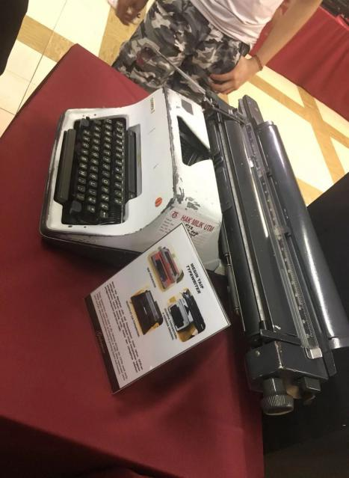

With the development of technology, the keyboards began to resemble what we use today and were heavy mechanical keyboards or converted electric typewriters by IBM company. But the qwerty keyboard continues to be the standard used in computers too. In 1986, IBM released the Model M keyboard that resembles what most keyboards look like today with the [function keys](https://www.computerhope.com/jargon/f/funckeys.htm) across the top of the keyboard. The Model M is still a highly regarded keyboard even today, as it introduced the 101-key standard US layout that is used today for full sized keyboards. It has also been adapted to the 104-key layout for Windows keyboards with the [Windows keys and Menu keys](https://www.computerhope.com/jargon/w/winkey.htm). As time goes on, the keyboard also has been in changes which changes is moving from a mechanical [switch](https://www.computerhope.com/jargon/s/switch.htm) to a membrane. A membrane makes it much easier and cheaper to manufacturer computer keyboards. A membrane keyboard also makes the keyboard quieter, lighter, and thinner than the first mechanical keyboards.

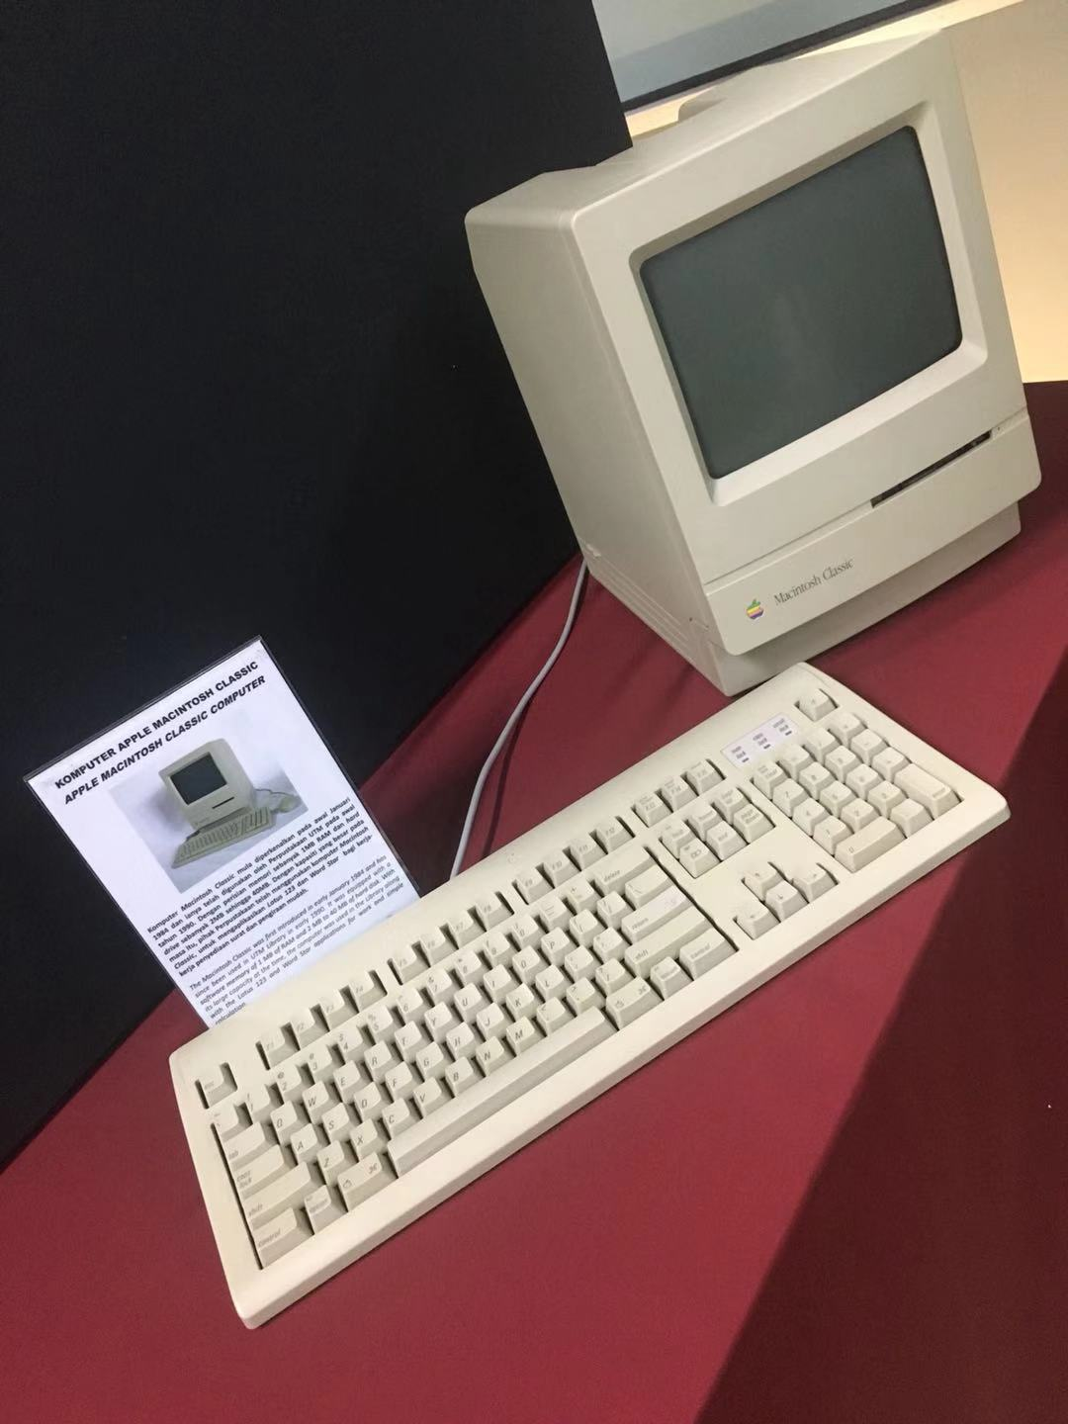

MAINFRAME DATA STORAGE

Model : IBM(9345B22)

The usage of Mainframe System at UTM began in the 1970s at Computer Centre, UTM Campus, Kuala Lumpur. It served as a data control of students and staff information.

The mainframe has been used for almost 20 years for different components and functions. It included for the processing, storing, securing, and printing the University’s information data.

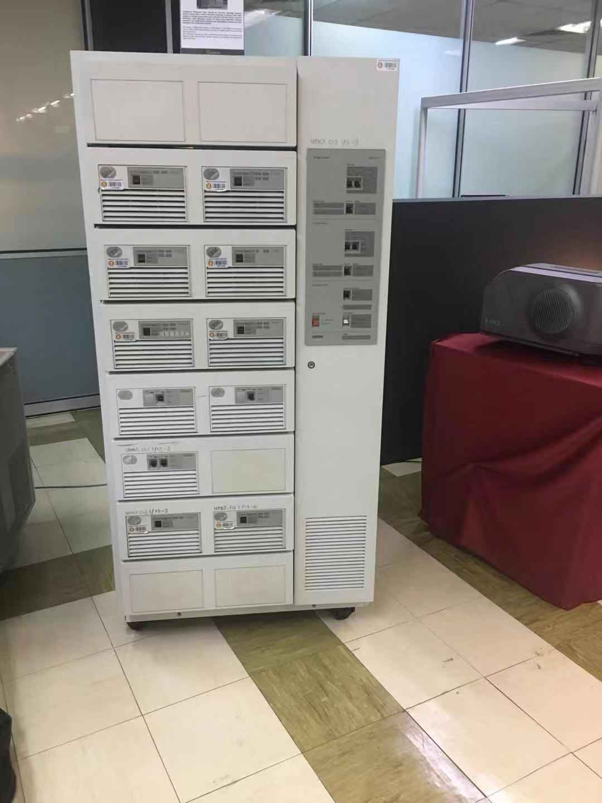

Whether you need to store more data and gain faster insights by applying AI and big data, to deploy applications in containers to improve data mobility in hybrid multicloud environments, or to improve your cyber resiliency and data protection, IBM Storage provides solutions to address all modern data requirements

* Modernize and secure your hybrid multicloud infrastructure with AI-infused, automated data storage solutions.
* Unleash developers with API support to manage complex environments.
* Avoid unplanned outages and achieve cloud-like reliability.

COMPUTER MOUSE

Computer mouse is a hand-held [pointing device](https://en.wikipedia.org/wiki/Pointing_device" \o "Pointing device) that detects [two-dimensional](https://en.wikipedia.org/wiki/Two-dimensional_space" \o "Two-dimensional space) motion relative to a surface. This motion is typically translated into the motion of a [pointer](https://en.wikipedia.org/wiki/Pointer_(user_interface)" \o "Pointer (user interface)) on a [display](https://en.wikipedia.org/wiki/Computer_monitor" \o "Computer monitor), which allows a smooth control of the [graphical user interface](https://en.wikipedia.org/wiki/Graphical_user_interface" \o "Graphical user interface). It was invented by Douglas Engelbart in 1964.

A computer mouse with the most common features :

two buttons (left and right) and a scroll wheel, which can also act as a third button.

In addition to moving the cursor, the computer mouse also has one or more buttons to allow operations such as selecting menu items on the display. Mice typically also have other elements, such as touch surfaces and "wheels" that allow for additional control and size input.

