UNIVERSITI TEKNOLOGI MALAYSIA
SCHOOL OF COMPUTING
SESSION 2019/2020 SEMESTER 2

COURSE CODE
SCSV 2113 – Human Computer Interaction

LECTURE’S NAME
DR AIDA ALI

GROUP ASSIGNMENT
TITLE

Project part #1: Project proposal

STUDENT’S NAME
AZRIANA BINTI ZAINAL ABIDIN
NOR HAFIYZHA BINTI MD HUSNI
LEE TONG MING
AHMAD ZULHAKIM BIN ZAINAL
SAHARULNIZAM HAKIMY BIN SHOBRI

MATRIC NO
A19EC0027
A19EC0124
A19EC0069
A19EC0179
A19EC0205

SECTION
SECTION 01
URL BLOG: fabolousfive.wordpress.com
Problem
1) Cleanliness Of Toilet
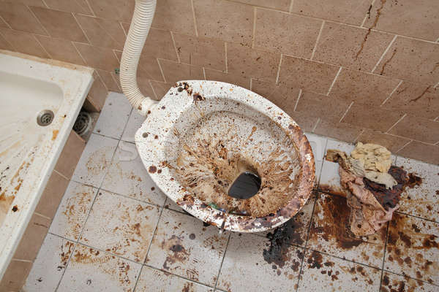
As we know public toilets will always have the cleanliness problem .”Disgusting” .That phrase is often heard when it comes to any public toilet in Malaysia. Sometimes we will always think many times before using the public toilet. the Malaysian public toilet has a really bad reputation. According to a 2013 analysis, only 61% of 10 thousand public toilets are reported to be in a satisfactory condition. The level of cleanliness of the public toilet reflects the civilization of a society. The dirty toilet does not mean that the cleaner does not do their job but it shows that the public is less concerned about hygiene and is less responsible for maintaining the cleanliness of public toilet facilities. Based on usability goals, the main reason to have a clean toilet is to give satisfaction to the society and to give them an effective usage when using those public toilets. Effectiveness is more related to how after one understands the functionality. It should be easy for users to carry out their tasks. This can be said because here are some tasks that a user can accomplish completely due to some factors.

2) Water Waste
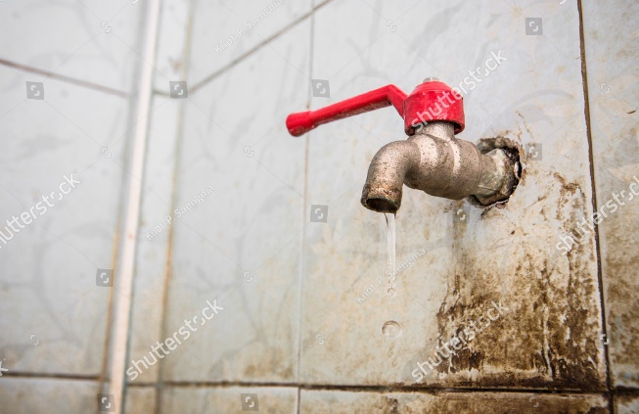
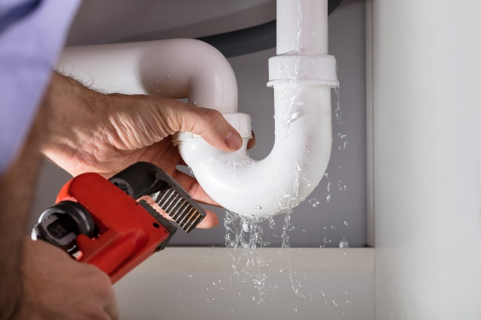
There are several reasons why a toilet may be wasting water. First and foremost, the average of a person uses the toilet is 5 times per day, if each irresponsible user uses an extra 2 gallons of water including a flush, a bunch of users will waste more than a billion gallons of water per day. Next, the leaking toilet pipe because of the lack maintenance of the toilet itself, as we know, a drop of leaking water per day could waste a gallon of water per month. It shows that, rubber pipe or metal pipe could affect the water waste. In order to encouraged the user to save the water, the model of the toilet should be improvised
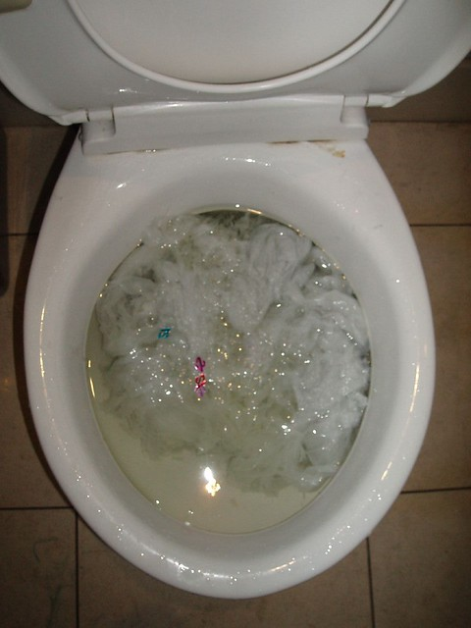
3) Dreaded Clogs
Clogs are one of the most common toilet problems. There are several tools could help to clear the clogged drain but in order to fulfil the user satisfaction and the effectiveness of the toilet, the designer should come out with a better design and problem solving to solve this kind of problems. Just imagine, our toilet bowl full of mess because of the clogs prevent the waste to be flushed out. This could affect the user experience in using the toilet.

Proposed Solution
Our solution for this critical problem is to build a smart toilet system which is V-Aqua Smart Toilet with a few features which is
1) Disposable plastic cover around toilet bowl
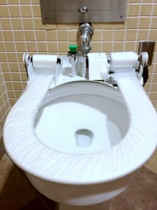
Basically, it is a thin sheet of transparent plastic and the size of the plastic is similar to the shape of the toilet bowl. Each time a new user press button a new roll will cover the toilet seat so you will be the first to use the plastic. Besides that, it is disposable so that this will prevent the reuse of the same roll by destroying the used plastic. Moreover, to keep the user feel safe while using the smart toilet we will provide the thinnest plastic on the seat cover. The structure of the plastic is polyethylene(P.E) and it is also anti-allergic. This feature shows that this smart toilet is easy to use because, with only one touch, that plastic firm will turn around the seat ring and after will be cut by a blade located at the waste section preventing the reuse of the same plastic.

2) A bidet controlled by a side controller
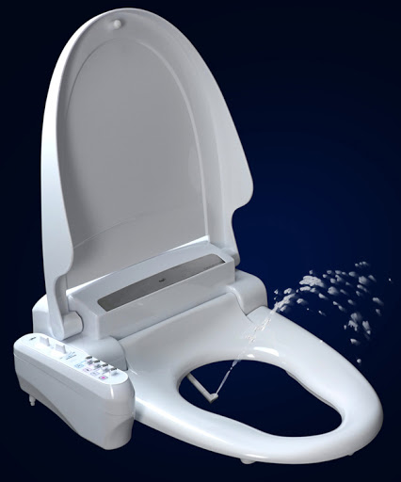
A study from USA Government shows that by using a bidet for each of the toilet could save more than 4 billion gallons of water per day. This is because, a bidet could control the amount of water needed by the user instead of the user wasting more water for the cleaning process. Why didn’t we use toilet paper instead? In order to save both water and nature, we decided to use a bidet instead of toilet paper that can cause a bunch of tree loggings that will affect the environment. It also a user friendly for Malaysian since they preferred to use water instead of toilet paper. This solution could fulfil most of the usability goals especially the efficiency since it has a minimal steps to perform the function and high satisfaction of the user.
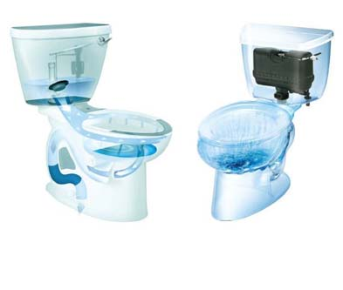
3) Double Jet System
This double jet system has a high pressure to push all the loads in the toilet bowl. The pressure creates a strong flow of water that cleans the bowl better, removes all the dirt and flushes more completely than a typical toilet jet. These smart toilet with high pressure have a pressure tank inside that works like a big water balloon. Water will fill the tanks and held under the high pressure. When the flush is press, pressure and gravity combine their power to flush the toilet. Automatically this will increase the effiency to use of this product that will attract more people to use public toilet.

Target Users
- Elderly
One of the common health’s condition faced by the elderly is physical injury because aging causes bones to shrink and muscle to lose strength and flexibility. Hence, they are more vulnerable to losing their balance and to injure their body. So our smart toilet are designed with features that can support the elderly and give them a gentle care such as ergonomic seat, appropriate bowl height, temperature control, auto-bidet features, and auto-cleaning bowl to maintain its hygiene.

- The Disabled People
We all know that it is very troublesome for the disabled people to go to the toilet. Our smart toilet would benefit the disabled people, as we try to limit the movement of the users by installing toilet bidet which will only need users to press on the remote control to use. Users can control the water temperature and the water flow speed. The water flow is warm, gentle and relaxing hence the users need not worry about comfort problems. This toilet bidet function is also more hygienic because it not only reduces the need to use hands to perform toilet hygiene, but also reduces the use of toilet paper, which is eco-friendly.

- Children
While this smart toilet is healthier, more hygienic, and has self-cleaning function, we understand that the installation of remote controls might be somehow confusing and difficult to operate for young children because the wrong operation might lead to toilet malfunction. Hence, we designed our smart toilet to be more children-friendly and easier to use. One example is that we have the auto flush function, hence children will never have to worry about which button to press after using the toilet as our smart toilet will flush automatically all waste left in the toilet bowl once users get up and move away.

