**INTRODUCTION**

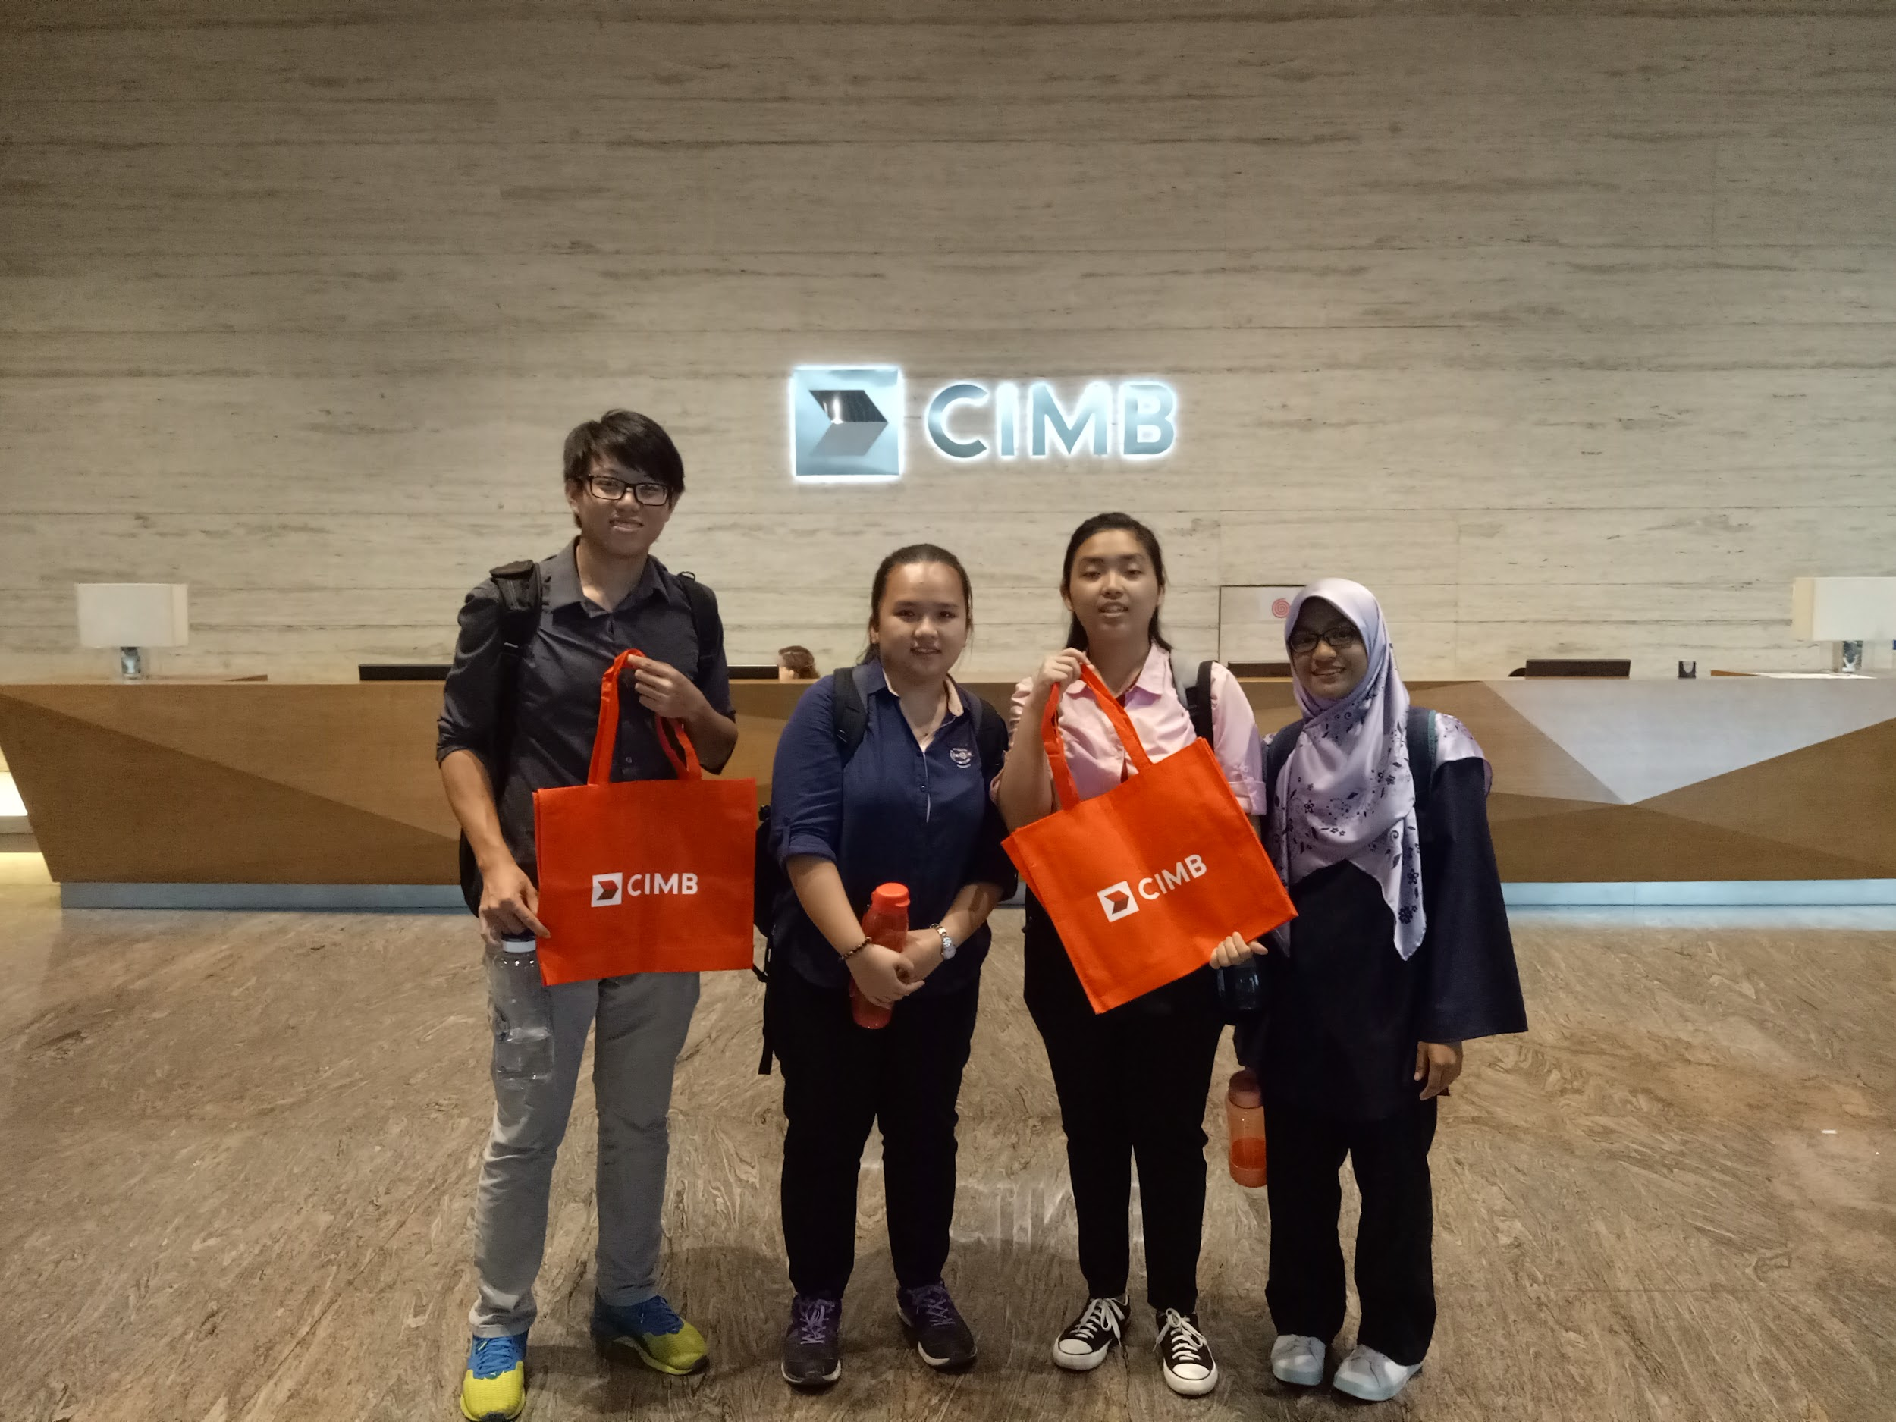

Picture 1

Picture 1 shows the group members of the CIMB report.

On 27.10.2018 (Saturday), the department from the School of Computing organised an industrial visit for all the data engineering students and some of the software engineering students. The students were given a chance to explore Commerce International Merchant Bankers Berhad (CIMB) bank which located in Kuala Lumpur. When the students arrived CIMB bank, the person-in-charge brought the students to have a visit in the CIMB departments. After that, the students were given some briefing by Mr. Qasmal Noor and Mr. Ahmad Affzan bin Mokhtar Anuar.

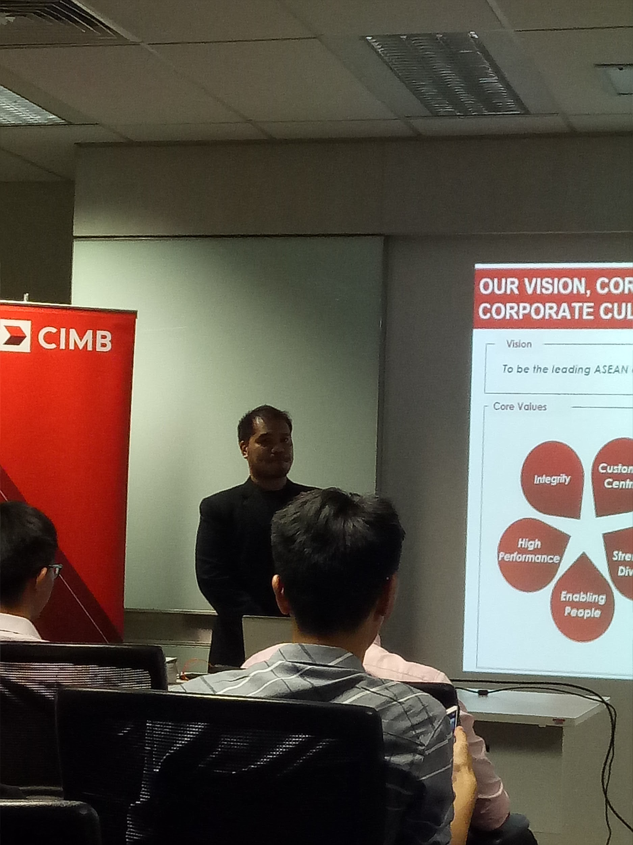

Picture 2

Picture 2 shows the photo of Mr. Qasmal Noor during the briefing session.

Mr. Qasmal Noor works as an assistant manager of the section graduate and campus engagement under the group of human resource. He introduced the history of CIMB bank to the students and also explained the vision, core values and the corporate culture to the students. According to Mr. Qasmal, he said that CIMB is a leading KL-headquartered ASEAN universal bank as it is one of the largest investment banks in Asia and also one of the largest Islamic banks in the world. CIMB is the 5th largest ASEAN bank compared to the other ASEAN banks and it consists of more than 900 branches in the world. He also mentioned about the products and services offered by CIMB bank. CIMB bank also provides graduate opportunities to the students. For example, the students from the universities can have their intern in CIMB bank. Mr. Qasmal also briefed the students regarding the programmes offered by CIMB bank such as “The Complete Banker” (TCB) programme, Internship programme and CIMB fusion.

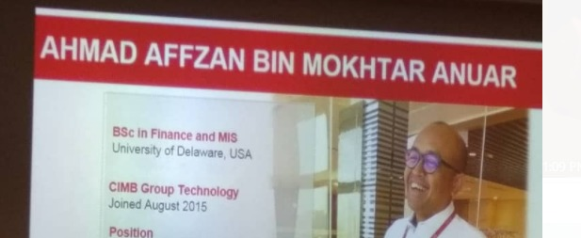

Picture 3

Picture 3 shows the photo of Mr Ahmad Affzan during the briefing session.

Mr Ahmad Affzan bin Mokhtar Anuar works as a Head of Production Support Director in CIMB bank. He graduated as Bachelor of Science in Finance and Management Information System from the University of Delaware, USA. He explained to the students that the elements that consist in Group IT under the management of the bank which are applications, infrastructure, service management, IT security, risk and compliance and financial and administration. He gave some relevant examples to each of the elements so that the students will understand more about the operation of IT in the bank.

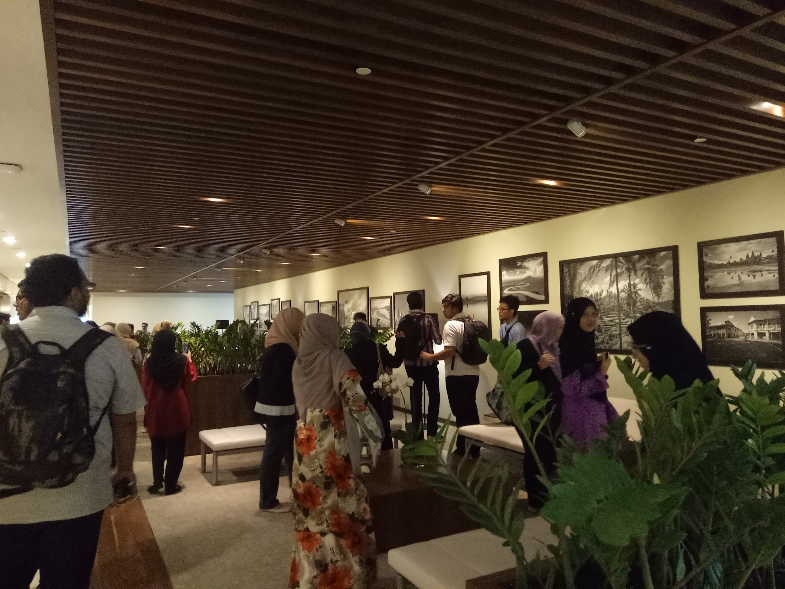

Picture 4

Picture 4 shows the situation during the visit session.

<https://www.cimbbank.com.my/en/personal/index.html>

**Requirements & Job specification needed for a job in IT (financial field)**

The demand of computer science graduates is high-reaching currently. Many graduates will target well-known enterprise or company for a job. CIMB Bank is a superb choice to get ourselves a job there. So, a lot of graduates will ask that what is the requirement and job specification needed for a job in financial field enterprise and company. Let me answer the questions.

Firstly, I would like to introduce the typical job, software developer. Software developer designs and programs the computer and mobile applications. Software developer needs to learn variety of computer programming language so that he can fulfil the job requirement. Software developer need to create and design some application to ease users to complete certain tasks. CIMB Bank hires software developer to help them create and maintain the application. CIMB Clicks is an example of mobile application that created by software developer.

Next, information security analysts is another choice of job. Information security analysts is responsible for making sure the data in the company website and server are secure from theft and fraud. The demand on this job is increasing rapidly since we are relying information technology in our daily life. The data must be secure especially the banking company like CIMB Bank. Information security analysts will prevent fraud from getting the data of clients because clients’ privacy is important. In addition, they will enhance the firewall from time to time and upgrade the server so that it is secure and unable to penetrate from outside of server.

Furthermore, database administrator is needed to manage the data of the server. Database administrator will monitor all the data and in charge to manage them. Database administrator is required in a lot of enterprise and company because data is a kind of asset. With the data, database administrator can generate luxury income and solve problem efficiently. Database of CIMB Bank is huge and massive so they require database administrator to manage them. Database administrator is important so that all the data is organise.

Lastly, web developer is responsible to design and program websites. Web developer maintains and modify the website according to the requirement from the company. If there is any problem occurs in the website, web developer must solve it as soon as possible so that user can continue using it. Thus, website is designed by referring user interface and experience so that it is more user friendly and convenient. CIMB Bank need web developer to help them maintain and manage the website. CIMB Bank make announcement and promote with the website. Therefore, CIMB Bank needs web developer so that the information in the website must be clear and organise to everyone.

REFLECTION

This event leaves us such good memories and impacts on our dreams regarding our study. As we entered the building, the CIMB staff welcomed us with a warm greeting. Then they brought us a tour to CIMB Gallery and to their café lounge. Seeing the never ending smile on their face, plus a question about how the work environment and the stress level to work for a bank, they answered that stress is a normal thing, it is different by the way you cooperate with it. Thus, it realised us that every work has pro and cons. The advantages are there for those who learn to dance in the rain. Next, as we visit the CIMB Data Centre, we were exposed to the criteria that needed to become a part of the CIMB family. In the past, the workers were hired based on their certificates and grades. Now, even a self-learner can fill the CIMB application form online. They will hire the one suitable for the job based on the good attitude and soft skills they own. Hence, the competition among us will be much higher where we need to develop ourselves with these attitudes and skills along with our education to get a place. In addition, we will learn about analysis of data but it will be useless if it cannot be applied to our life decision-making. That is the reason for us to need the understanding of business and the outcomes for the analysis of data so that we can identify the opportunities and take a step ahead of everyone else. To conclude, the visit to CIMB gives us impact on cooperate with stress regardless anything we do and never give up, be a multitask person and develop the soft skills, also have a strong understanding on what we are study and will work on.

**Conclusion**

Information technology makes a huge impact in this modern era. Banking sector is affected as well. The revolution of traditional banking to online banking is an obvious change by the influences of information technology to banking sector. Banking sector has modernised their service with information technology such as online banking, mobile banking and online payment or third-party transfer. Information technology has transformed the banking sector into speed, secure and reliable in financial operation. The services of banking sector have simplified and ease the financial operation for clients. Nowadays, banking sector focus in gathering, processing, analysing and providing information to fulfil the requirement of clients. Therefore, computer science graduates are in high demand in the job market currently. The graduates are having a lot of job opportunity and even internship programs are provided by companies or enterprise. Even though the demand is high but the requirement and expectation of the jobs is high as well.

After the industrial visit, I found that we must keep improving ourselves in order to meet the criteria of the job. Computing skills, information technology knowledge, soft skills, critical thinking and problem solving are the basic requirement as a graduate to get a job in the banking sector. We must identify our strength and weakness. For example, a database administrator must learn how to manage and organise the database. Gathering, processing, analysing, interpreting the data is everyday task for them. So, they need to enhance their skill of these aspect. Soft skills are obtained while communicating with the team members. With excellent soft skills, I believe that the flow and progress of the project will go smoothly. After the visit, I had reflected on the future goal and target. I must possess the basic skills in order to get a suitable job.

In conclusion, information technology is a field where it improves and changes day by day, so we must keep learning so that we will not be left behind. Lifelong learning is essential. The industry will develop following the upgrade of information technology, thus we must catch up the pace as well. Decide a goal and strive for it.