*TEAM MEMBERS:*

* *NUR MAISARAH BINTI AZIZUL (A17MJ0219)*
* *NURUL NAJIHAH BINTI MOHD RAZALI (A17MJ0122)*

**BEER PRODUCTION**

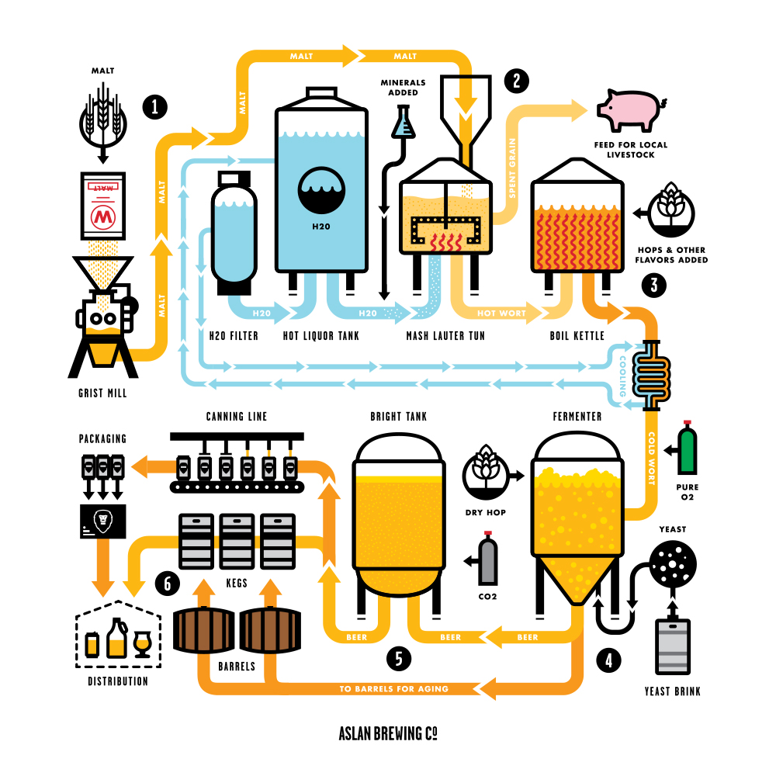 *FIGURE 1 BEER PRODUCTION PROCESS*

*FIGURE 2 FLOWCHART PROCESS FOR BEER PRODUCTION*

Figure 3 shows the process involved during the mashing process in a Mash Lauter Tun. Mash Lauter Tun is responsible to mix the crushed malt with a very hot water. Malted grain has gone through a controlled germination stage that breaks the endosperm down and creates enzymes. When subjected to hot water of a very specific temperature, those enzymes become active. When active, they convert the readily available starches and malt into sugars (maltose) and dextrins. Once complete, the liquid is separated from the now spent grain and transferred to the boil kettle. The spent grain is then given to a local farmer to use as livestock feed.

UNDESIRED PRODUCT (C)

MASH LAUTER TUN

FEED (A)

FEED (B)

PRODUCT (D)

*FIGURE 3*

A: MALT

B: WATER

C: SPENT GRAIN

D: HOT WORT