**Database Design thinking**

Nowadays Database is of great demand provided the fact that billions of user’s personal information such as email address, National Id, passwords and credit card pin code are all stored in it. It does not only help us having a much fast forward life rather it has some demerits and privacy issues as well that can have disastrous effect on a user if not addressed properly. But first of all lets discuss some basic key topics regarding the design thinking report.

**WHAT IS A DATABASE?**Database is an organized collection of data stored and accessed electronically for a computer system.

**WHAT IS DESGN THINKING PROCESS?**

Design thinking concept is a cognitive, strategic and practical process by which design process is readily created by designers mostly for providing a better and enhanced performance of a system.

**DESIGN THINKING PROCESS**

**EMPATHY-**This process consists of mainly interviewing a database user in order to define the unfulfilled needs.

* **INTERVIEW-**

We interviewed an undergraduate student of UTM who is currently studying computer science and has database course.

**Questions and Answers Session Of the Interview-**

* Have you ever used a database system before?  
  **Answer**- Yes I have. Actually I am building a prototyping database system based on SQL.
* Have you ever had any problem related to the database system?  
  **Answer-**Currently we are having a problem regarding the design of the database system. We are yet uncertain is it fit to be used by an individual.
* What are the generally used database system and the problems related to it?  
  **Answer**- I think one of the common database systems is Cookies. When I am searching online these cookies store my personal information such as email Id for the own benefit of the third party applications such as Online shopping wbsites.

**Defining Problems-**

Cookies store all the personal information of a user such as email address, password, contact number, and even debit card pin. If the database management system is not secured and well encrypted when transferring user information to store in cookies the following issues might arise.  
  
**Privacy Harassment-**

* User might end up sharing his or her Ids, passwords and even contact number to third party applications or an organization that may not be worthy of trust. User may be sent irrelevant materials through her email or social media Ids.
* **IDEATE SOLUTIONS-**

Ideating solution is based on three categories-

1. Practical
2. Intermediate
3. Radical

Practical solutions is an easy-to-do version of a solution that we can implement into the database system.

Intermediate solutions has to be more specific and higher tech version of the practical solution with overcoming major needs of the users.

Radical solution has to be the best solution we can provide to the users. It has to solve all the problems a user has at any cost without failure.

We decided making four solutions of which one of them; Single Restriction mode goes to practical whereas Cookie Verifier is Intermediate and Data Encryption and Concealable Hard drive Rack are Radical.

* **Data Breach-**

If the database information is not well encrypted there are high chances cyber attacker might breach into the database system taking advantage of the poorly encrypted data. This can have a disastrous affect on user since the user’s personal information is stored in the database. Worst case scenario the attacker might easily decrypt the user’s debit card pin easily and loot the bank account.

**PROTOTYPE-**

* **SINGLE USER RESTICTION-**  
  Database system comes with three common layers- View, Logical, Physical.  
  Physical layer is where we store information about the physical data sources in the database system. It contains connection pool, schema folder, table ,column keys.

Logical Layer contains the structure and constraints for entire database such as control classes.  
  
Viewing layer consists of external view of the data by user based on their input.

We should implement this simple yet effective design which is called single-user log in into our prototype. We have to make sure that access to the conceptual view layer is very restricted so that only authorized user get to see limited information stored in the database. This will allow the user to work on browsers without fearing that his or her email might be stored in the cookies and later be used to send irrelevant materials.

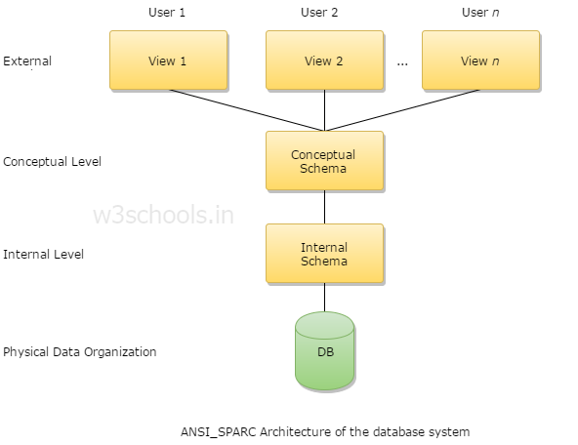

Fig 2: Three layers of database architecture.

The single-user restriction mode is implemented by setting the restrict access option in Database software to single. After that only one user at a time have access to the database server. As a result there is no chance of any other user accessing into the same database server and stealing the data that has been input by the other user.

* **DATA ENCRYPTION-**

Data encryption is undoubtedly necessary when sending or storing information online especially database. We have to encrypt data based on the **HSM** method which is by far superior than others in case of protecting confidential information on database from cyber attacker.  
  
An HSM is a co-processor which have all the components of storage , memory, and processing capabilities. HSM provides dedicated encryption services that areoffline from host itself. Since it is dedicated to processing encryption the server memory cannot be dumped to gain access to key data. Besides the user cannot also see the data in plain texts so it is ensure that a trusted path exists between an application and encrypted data elements.

HSM has tamper-proof seals to prevent cyber attacker stealing data from database using electronic snooping or radio frequency.  
   
Fig 1: HSM co-processor

Fig 3: Database design using HSM and other methods.

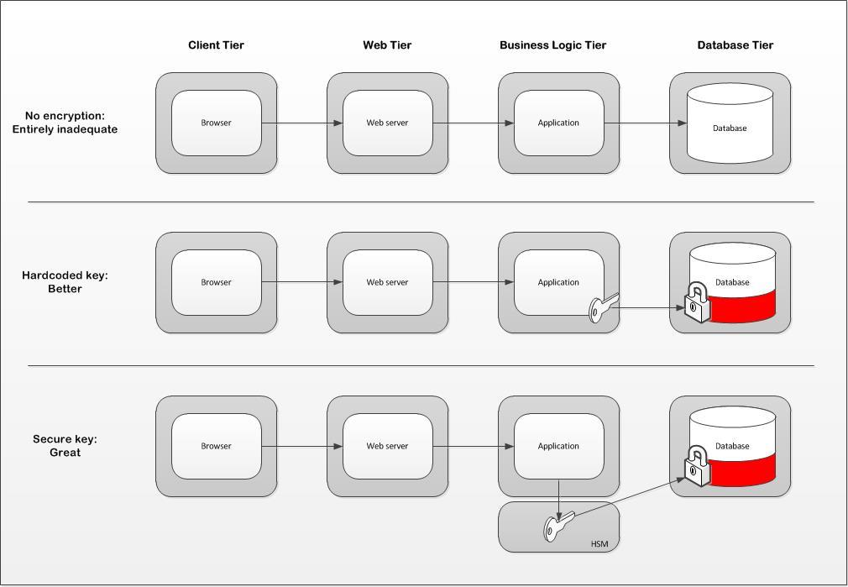

* **COOKIES VERIFIER-**

Cookies are helpful for users when not in the wrong hands but if once, through fake malicious cookies attacker can steal active cookies and pretend to be that user, thus can perform any action that the administrator type user has permission to do.

Cookie verifier verifies the URL of the website that the user want to retrieve and match with the original URL of that website. If it matches then it allows the cookie to interact with the browser otherwise chances are the to malicious websites the user can get attacked by cyber attacker.

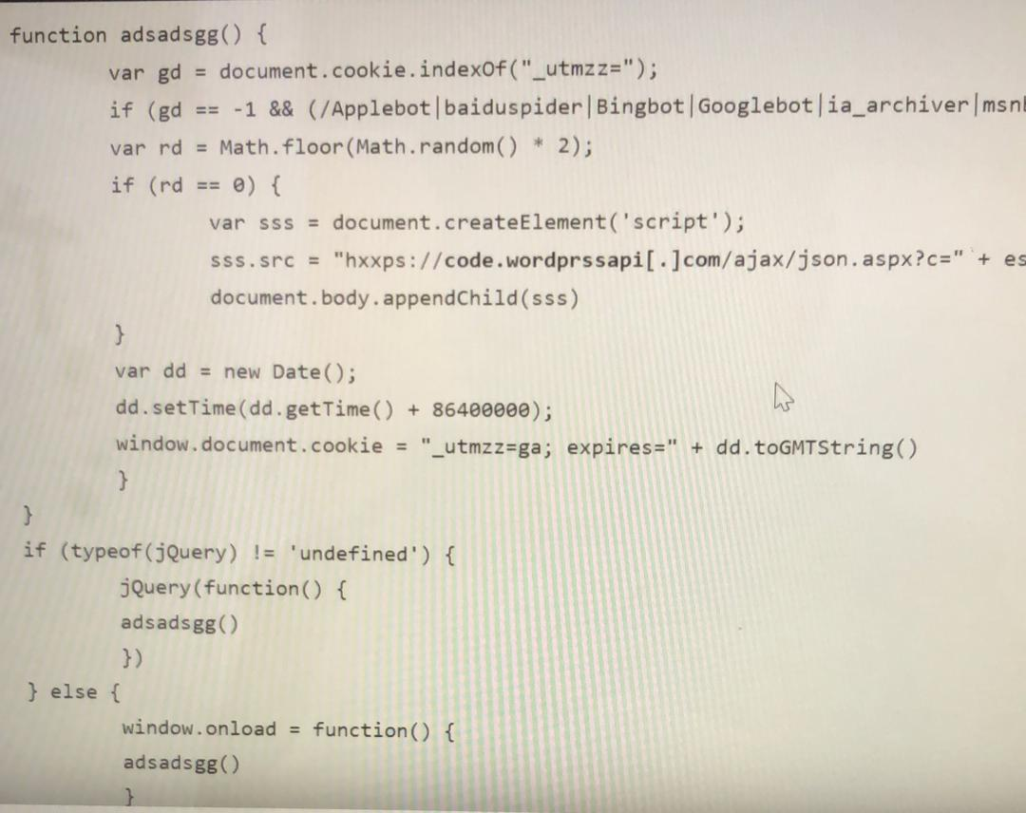

Fig 4: Cyber attacker injecting malicious codes to send user information to non-trustworthy websites.

* **PROXY SERVER-**

Another one of our solutions is an app that creates a database of All the websites the user visits. And collects and learns what data the websites are storing from the user- asides from what we are already certain and aware from. Which can be his location, IP address, his computer model, his browser and even some of his identity info. The app then presents the user with whatever form of data is being collected from the websites he visits and Allows the user which of his information would he like being disclosed to the public interface. As we came to the conclusion in the interview that not all data/cookies being collected is harmful. And if the user prefers complete anonymity we will provide along side or app the ability to connect to our proxy server, which will give mask/hide the user’s ip address and prevent him from being tracked in the first place.

* **SUDOS-**

**TESTING-**

DESIGN THINKING **ASSESSMENT-**

**REFLECTIONS-**Our goal is simply to be a skillful professional software developer through which we can enhance the quality of people’s life using high-tech and high performance application as well as system.  
Design thinking has an enormous impact on our goal as a software engineer. Firstly, we are to build applications and websites for users as a result we eventually have to provide a very safe and privacy based database system to store user’s private information as well as in a very well encrypted form. Design thinking helps us understand these necessities in all aspects and details.  
As a software engineer it is crucial to maintain one’s potential in the industry because in this specific field the criteria to fulfill the demands of the end-user changes on a daily basis and very abruptly. Thus we believe in the twentieth century besides providing the mass end-users with software systems and applications we must provide a secured database system so that their performance and user experience on the web flourishes.

**TASK FOR EACH MEMBER**-

Shadman Rahman basically wrote the whole report with the help of Nahda regarding how further can a database system be made more private and how to implement Web Crawling method.

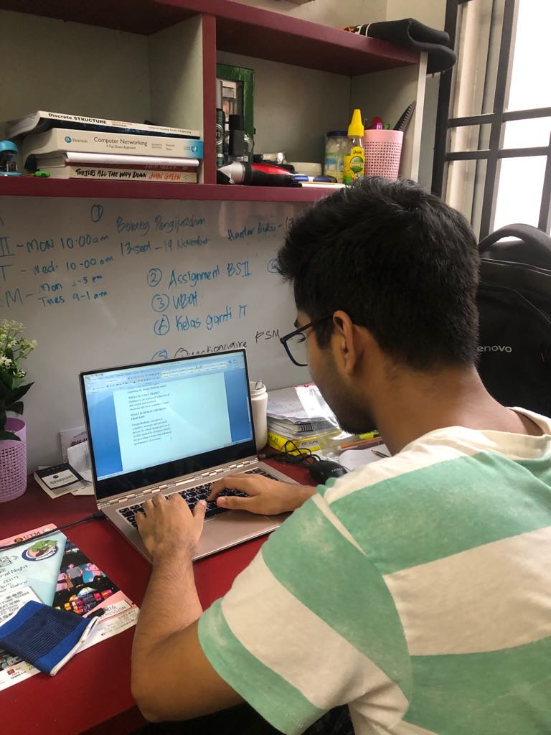

Fig 4: Shadman working on the report writing.

Nahda worked for presentation slides as well as interviewing the database user regarding the unfulfilled demands and how we can redesign.

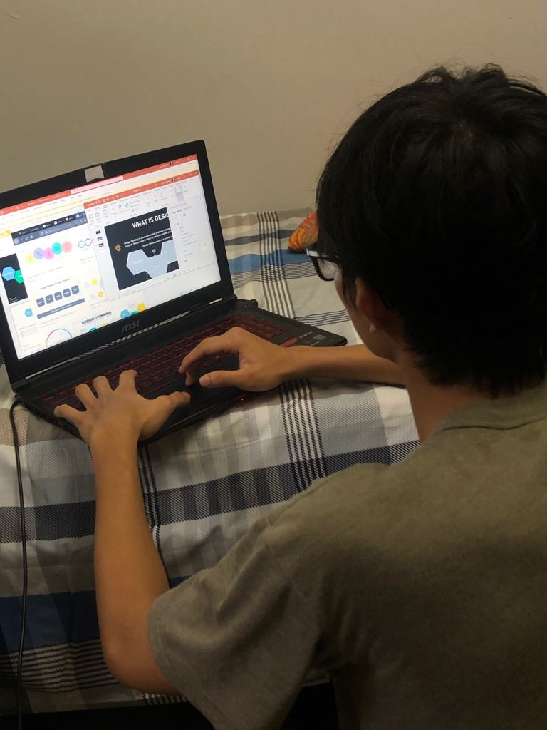

Fig 5: Nahda working on his presentation slides.