

***Group Number: GROUP-3-I2***

***Name: 1. NABIL RAYHAN-(A20EC9107)-(L)***

***2. TANSHIBA NOARIN PRAPTI-(A20EC4051)***

***3. SHAKIB SAHARIAR SHOWMIK-(A20EC9108)***

***Lecturer: DR. ZURAINI BINTI ALI***

**DESIGN THINKING TOPIC: SYSTEM SOFTWARE**

**REPORT WRITING**

INTRODUCTION:

*Design Thinking is a thoughtful innovation which involves designer’s toolkit to implement based on the need of the people, possibilities of technology and the requirements for business success. Our design thinking project focuses on the tragic death issue due to road accident, faced almost every day in most of the parts of the globe. We have come out with an idea to implement a software in the vehicle’s system, which will give an emergency alert to the nearby hospitals and police stations.*

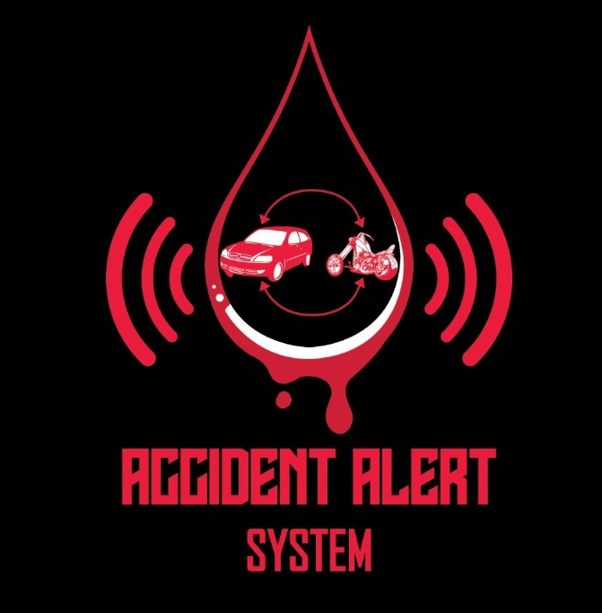

STEPS OF DESIGN THINKING:

* **Empathy:** Empathy denotes the ability to be sympathetically aware of other people’s feelings and prioritize their point of view regarding the problem. The most important step of design thinking is to understand the objective, wishes and need of the people through observation. By gathering insights from different people, our team decided to highlight the seriousness of measurable road accident death and providing a technological idea to solve this tragic social issue at a certain rate as possible.

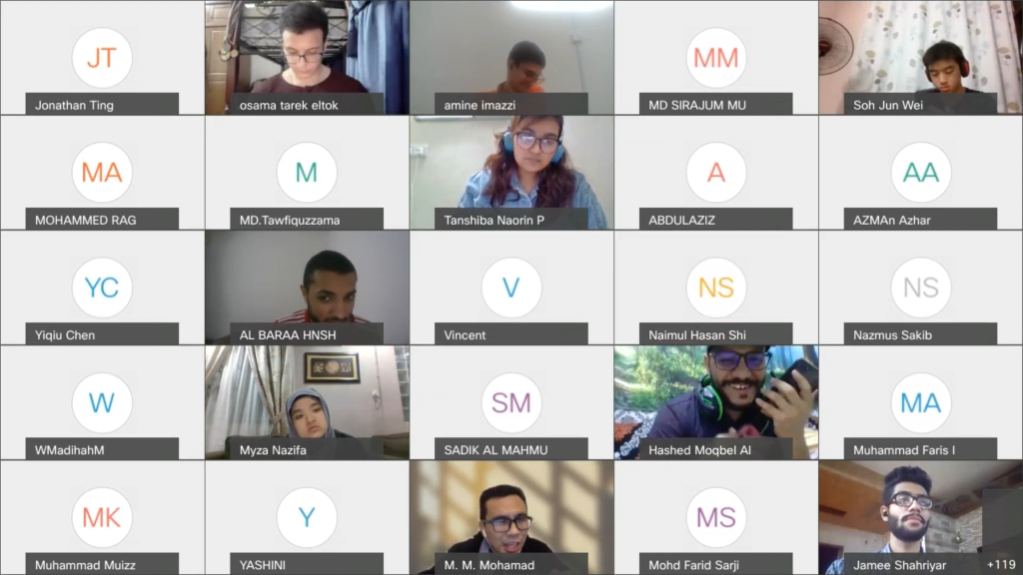

* **Define:** This is the second phase which includes how to identify the problem on the basis of the difficulties that people face. By empathizing the problem of road accident, we found that the death rate is somehow higher due to late arrival of the ambulance in the accident spot. So, the team decided to work on the issue basing on the perspective of technological change and give a solution accordingly.

* **Ideate:** To start up something and innovate to bring some changes, cracking up ideas to solve the problem is the initial step. After analyzing the problem, ideate initiates the designer to think considering some facts focusing on the requirement of the user and the impact of the solution. So, hearing the problem from the people and studying various statistics of past few years, we understood that maximum of the accident death cases is due to the late arrival of ambulance. Then finally, we intend to ideate something big which was to create a system software for the vehicles. This software will perform to send emergency alert to the nearby hospitals and police stations and the arrival time should be maximum 5 minutes. This way the victim could be rescued as soon as possible and taken for the treatment.

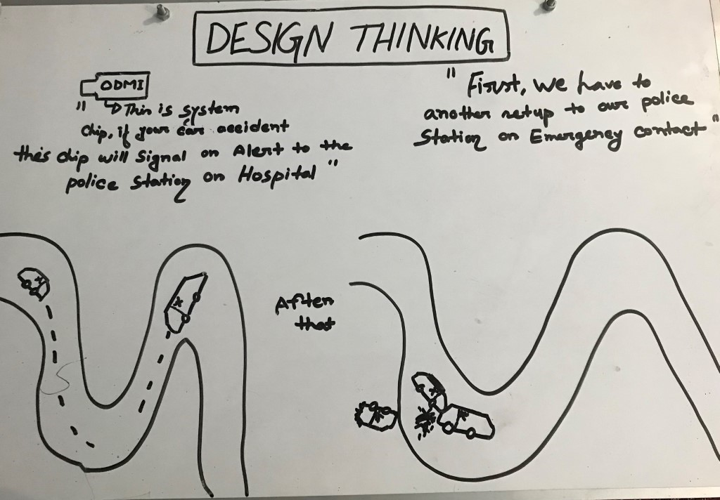

* **Prototype:** Prototype is the practical representation of the idea for the solution. This step is a formal phase to promote the idea of the designer. Before making the prototype, we have discussed with some experts and figured out how to design the prototype. Our team designed a sample car using cardboard and paper to provide the idea how a software can be installed in the vehicle to send alert signal to the emergency units.

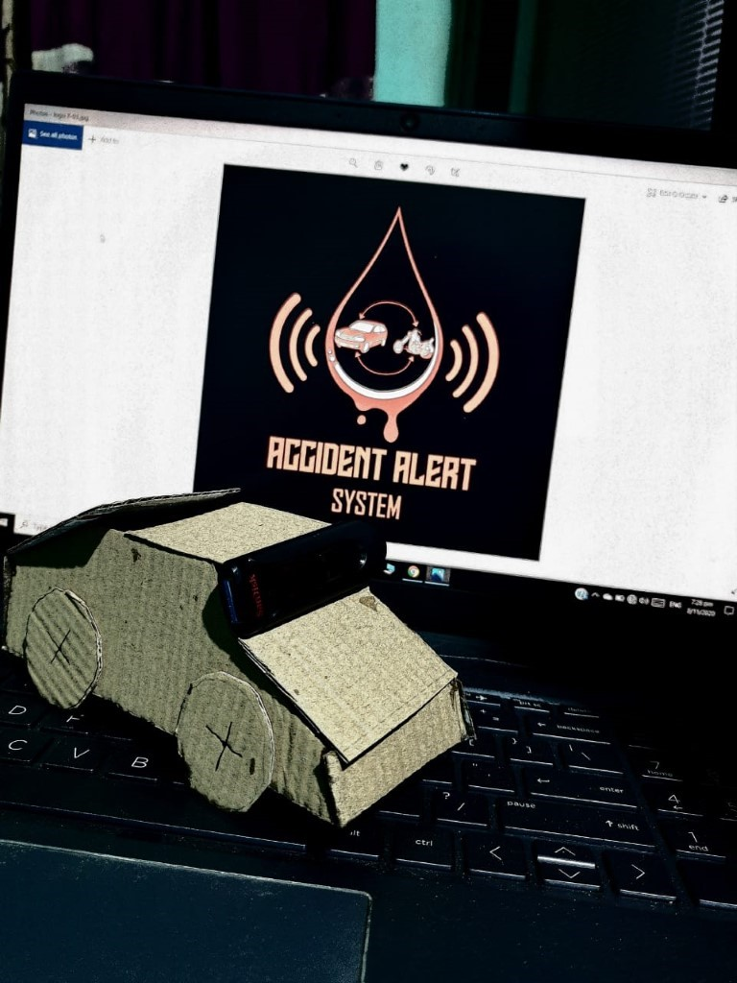

* **Testing:** There is a saying that “All’s well that ends well”. If you cannot succeed in testing part, your idea will be flop and useless. Testing is the final and most significant step to implement the design thinking project. This stage of the project also involves reviews and experience of the users. As our project is an uncertain action based, so it was difficult for us to present the idea physically. So, for the testing part, we have used animation and took reviews from one of our fellow mates who had experienced such problem before. And her feedback was on behalf of our idea and she really appreciated to implement this idea in the vehicle system as soon as possible.

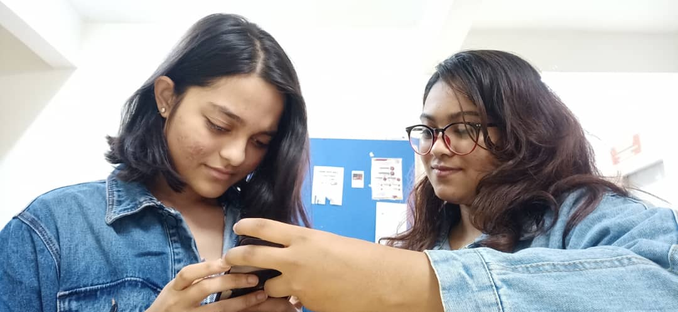

PROBLEM & SOLUTION:

* **Problem:** Road accidents happen every now and then in almost every part of the world. Studying the statistics and reports, the rate of the accident deaths is increasing mostly because of not getting treatment in time. According to the statistics of WHO, *Malaysia* holds the third highest death rate caused by road accidents. In one of the reports, the Health Ministry stated that the recent cases where ambulance reached lately or were ill-equipped, leading to two men dying. In a Facebook post it was claimed that a man in Subang Jaya died after an ambulance took 35 minutes to arrive. Moreover, an accident victim died while being transported in an ambulance in Jelebu, Negri Sembilan. His family claimed that the ambulance arrived after 20 minutes. (collected) A lot of cases are frequently seen in countries like Bangladesh, India, China and many more. People dies and no one even knows.

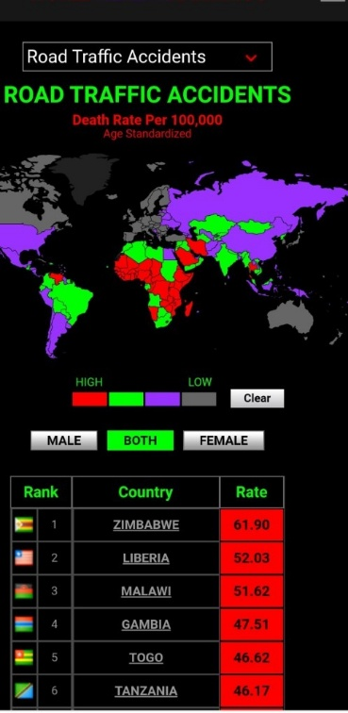

* **Solution:** Every problem has a solution. Execution of the solution is the most difficult task for the process to be continued. For the serious issue like road accident cases, in spite of taking some strict measures, the issue is still not resolved, rather the death cases are increasing at an alarming rate mostly because of not providing treatment to the victim in time. So, our team decided to come up with an idea so that the victims can at least receive required emergency treatment before it's too late. Insertion of an accident signal sending software in the vehicle’s system can save a lot of lives. The software will be installed in all the hospitals and police stations of the country too. It will function as an auto digital tracker which will itself create an alert when accident will happen. And the nearby emergency unit must arrive within maximum 5 minutes after the alert was sent. We believe that our idea might help to reduce the death rate.

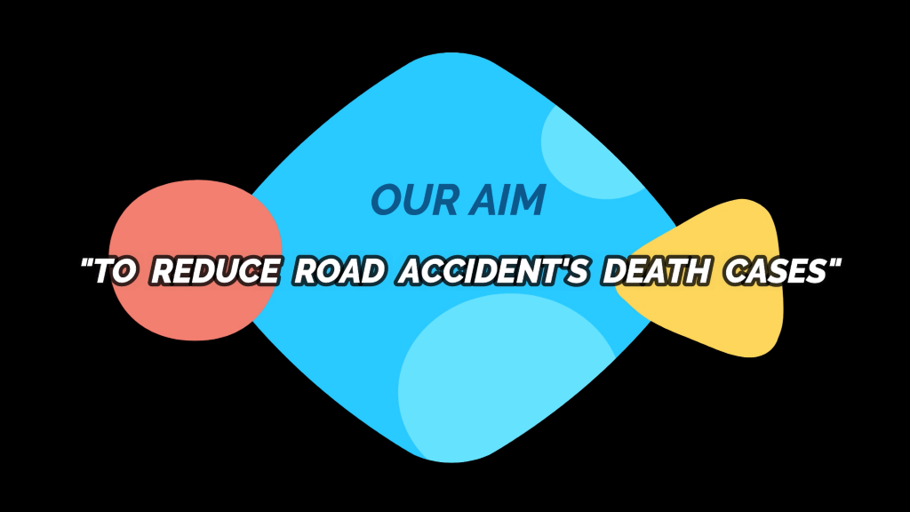

DESIGN THINKING EVIDENCE:

For the design thinking project testing, we have made an animation. One of the team mates made the animation video. Making animation was a difficult task to execute.

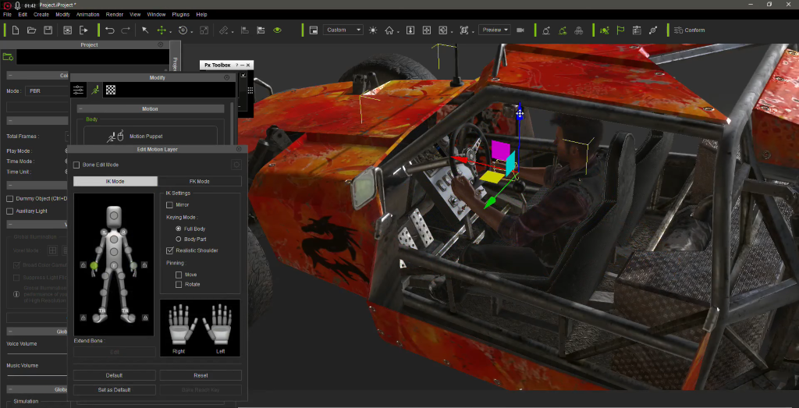

A snap of Animation Making

The most important step of virtual representation of an idea id video Editing. All the pictures and interviews and animation were collaged in this video editing.

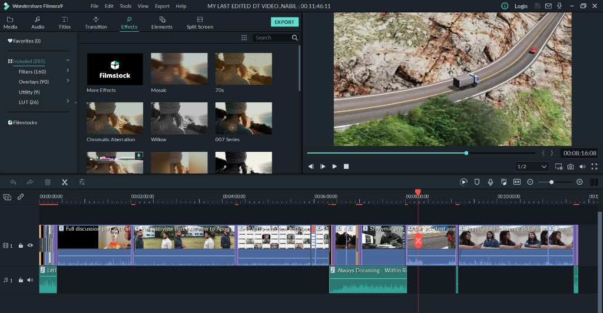

Video Editing by one of the team mates

Here a team mate is working for the project and creating content to add up in the design thinking presentation.

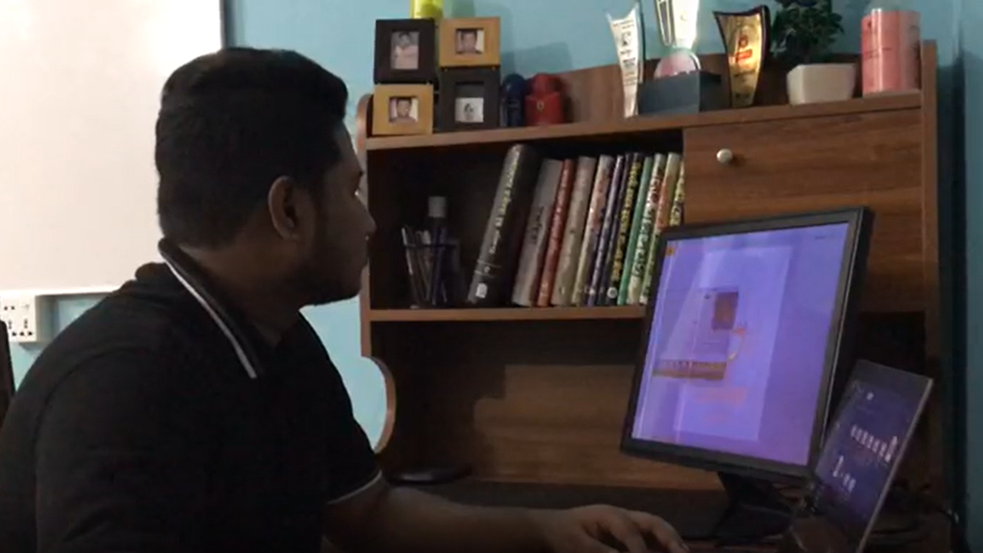

Team mate working

Prototype making was another breathtaking task for us. We have used cardboard and paper to design our project prototype.

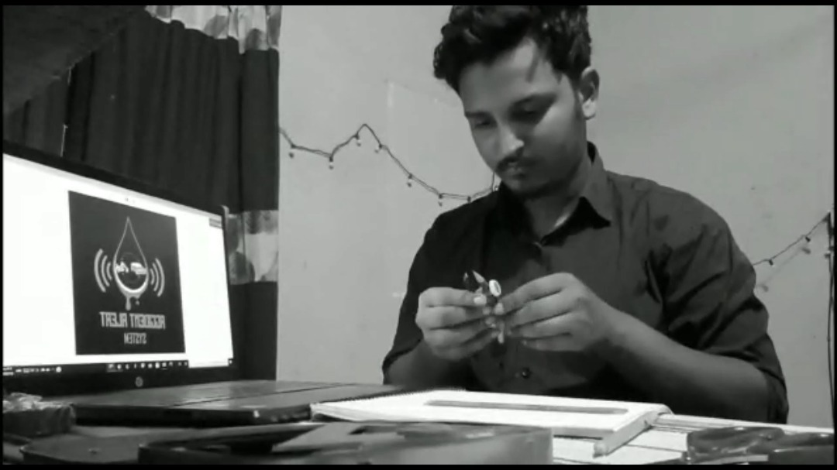

Prototype Designing

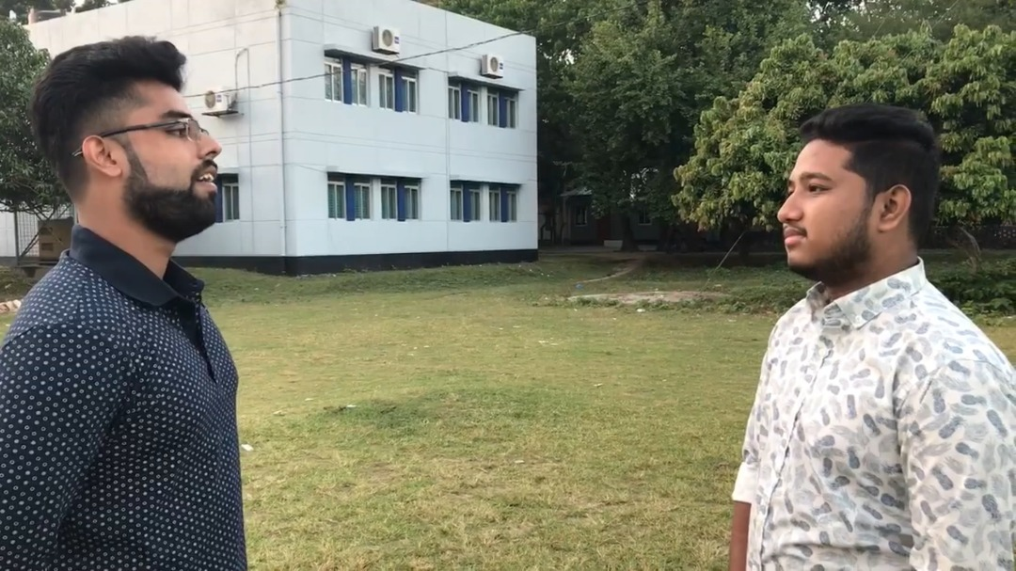

Hearing problems from a fellow

We have asked one of our fellow mates if he had experienced or seen such accident death issues or not. Our findings about road accident from him was very heartbreaking and devastating. He himself was the victim of road accident and he was badly injured and there was no one to help him. He had to go through multiple surgeries. He also shared that his condition became more intense due to late arrival of ambulance and not getting any help in time.

TEAM WORKING:

As a team we have worked for almost 10days on this project. Our discussion and ideas were always for the welfare of the people. We tried to figure out multiple ideas with a motivation to help reducing accident death rate in a great extent.

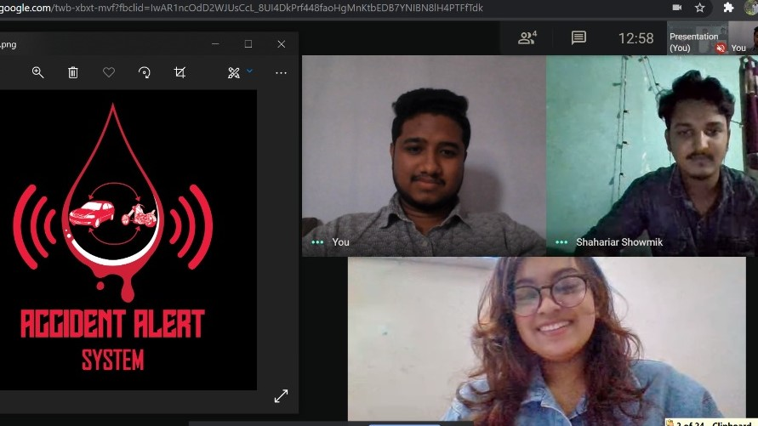

A snap from our team discussion

REFLECTION:

* *The course (Information and Communication Technology) teaches me how to develop my creative thinking skills and transform it in a productive method. My goal/ dream with regard to the course is to enhance my knowledge on technological dependency.*
* *Design Thinking gave a different outlook to solve social problems with the involvement of technology. Design Thinking will bring a huge impact on student’s technological ideas.*
* *I think the present world has already reached the advanced era of technology. The significance of technology is immense in our day-to-day life. I expect this course will be very effective to develop my potentials and provide me with confidence to interact and think in a professional way in the corporate sector. I also think my observation skills and problem-solving ideas will be worth taking for my company.*

TASK FOR EACH MEMBER:

NABIL RAYHAN (A20EC9107): Interview (asking problems), animation making, DT full video editing.

SHAKIB SAHARIAR SHOWMIK (A20EC9108): Prototype designing, logo designing, problem solving slide making.

TANSHIBA NAORIN PRAPTI (A20EC4051): Content writing, Interview (from expert), Interview (hearing problem and feedback), Report writing.